March 2026

Dear Parent/Carer,

External Examinations A Level and GCSE 2026

Your child will be taking external A Level or GCSE qualifications in Summer 2026.

Examination Dates

The main summer 2026 exam series begins on Thursday 7th May 2026 and runs until Friday 19th June 2026 (although some exams may take place prior to 7th May and the proposed exams and dates can be found on the published timetable detailed below). Students will not have examinations every day but will need to remain available throughout the series.

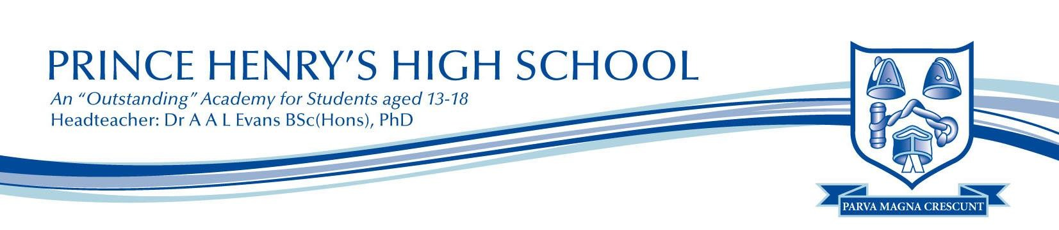
The published GCSE and A Level timetables collated from the awarding bodies are available on the main school website: Our School> Curriculum> Exams> Summer 2026. Students will be provided with personal exam timetables, detailing the examination paper, the date and time of the exam, their exam room and seat number. Personal timetables will only vary from the generic timetable if a student has more than one exam scheduled at the same time. The exams department will resolve any clashed exams before personal timetables are issued after Easter 2026.

Absence from Exams
Students must attend their exams on the correct date and at the correct time. Prince Henry’s High School facilitates examinations on behalf of the awarding bodies and cannot change the published timetable schedule. If a student misses an examination or arrives late, depending on the circumstances, this may result in withdrawal from the qualification and a fine.

Any absence or lateness must be reported to the exams department at Prince Henry’s High School as soon as possible to avoid negative repercussions.

Exams Contingency dates summer 2026
The awarding bodies have allocated a contingency session to the Summer 2026 examinations series as follows:
Wednesday 24th June: AM & PM

This date has been set to enable the awarding bodies to manage the exam timetable in the event of a major national or local disruption to the published examination timetable. The awarding bodies have requested that all students taking examinations during Summer 2026, remain available up to and including Wednesday 24th June 2026 should an awarding body need to invoke its contingency plan. Please note that a contingency date cannot be used for individual students’ illness or absence.

Review of Centre Assessed work.
Coursework and non-examined assessments (NEA), completed by students as part of their A Level or GCSE qualification, will be marked by Prince Henry’s High School teaching staff before it is sent to the awarding body for moderation.

Candidates will be working on their coursework/NEA over the duration of their course and will receive opportunities to make improvements to their work. Teaching staff and awarding bodies use automated AI detection devices to check whether AI has been used.

Each subject with coursework/NEA has a deadline set which all students are aware of and know they must work towards when completing their internally assessed work.

Student work is marked by their class teacher and moderated by department colleagues, to ensure the marking system has been applied fairly across the subject.

Before the marks are sent to the awarding body, students will be informed of their mark, which will be a numeric figure; staff are unable to relate this mark to a grade as grade boundaries alter every year (any grade suggested would be an estimate and could change after external moderation by the awarding body).

If students are unsure of the mark awarded or believe their mark may be incorrect, they should speak with their class teacher in the first instance. If they are still unsure, they should contact the exams department at school for further support.

Once the marks are sent to the awarding body, they repeat the moderation process to ensure the marking is fair across the country. This can result in marks changing for students and potentially affecting overall qualification grades. This process is outside the control of Prince Henry’s High School.

A level Key Exam Dates | GCSE Key Exam Dates
Internal Assessment timetables can be viewed in the exams section of the main school website under each year group tab. | Internal Assessment timetables can be viewed in the exams section of the main school website under each year group tab.
A level results: Thursday 13th August 2026 | GCSE results: Thursday 20th August 2026
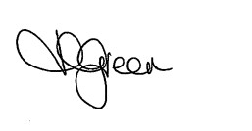
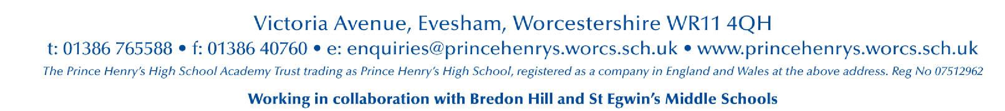
Kind regards
Mrs H Green
Examinations Officer

