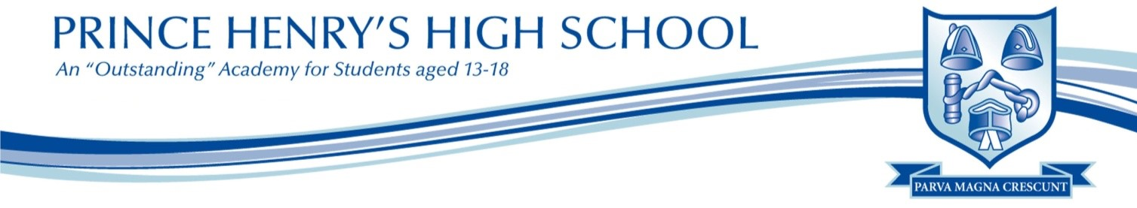
HOMEWORK: CITIZENSHIP
Homework is a vital part of student’s progress, as they reinforce the skills they have gained in the classroom and learn how to work independently. For homework to be beneficial students should ensure that they spend sufficient time and care on all homework set.
It is essential that students use Show My Homework, as this allows for parents to monitor work set and allows students to contact their teachers to ask for guidance. Homework should also always be recorded in their homework diaries.
Homework activities
Homework will be set according to the homework timetable. This means that students will receive 1 x 30 minute homework every fortnight.
We aim to use a range of homework activities:
- Flipped Learning – Students will conduct research or complete activities which will support them in upcoming lessons.

- Exam Questions – Students will be required to complete GCSE style questions as a way of using material learnt in lessons to practise the skills that are required in exams.

- Research - A good knowledge of current events is extremely beneficial for Citizenship. Homework tasks may involve watching news broadcasts or reading newspaper articles.

- Revision – Students will complete end of topic assessments and mock exams which will use GCSE questions. Research materials are located in the Citizenship folder on PHHS.

