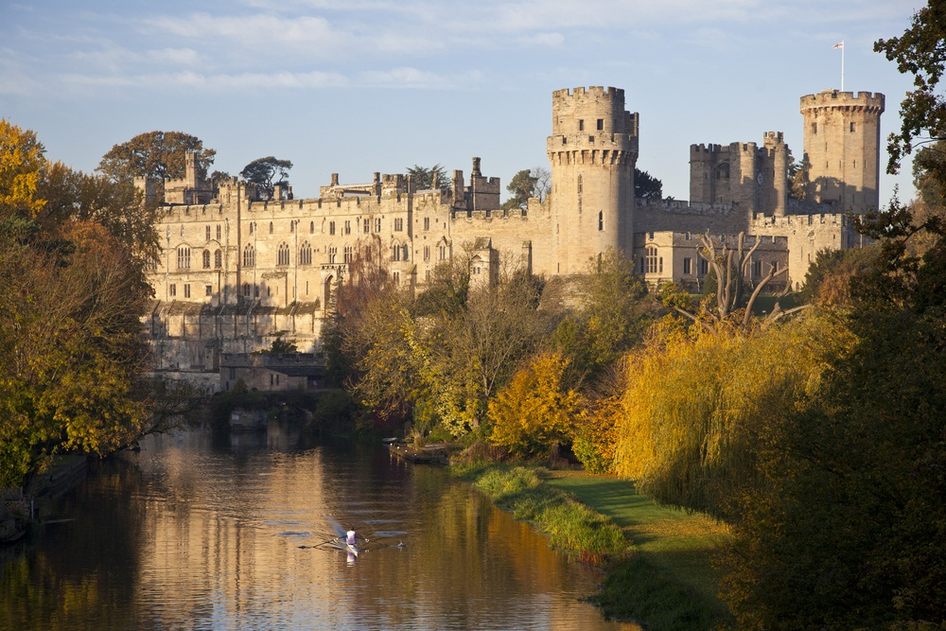
Paper 2 – Richard and John – Course Booklet

Unit 1 – Life and government in England 1189-1216
Unit 2 – Involvement overseas 1189-1204
Unit 3 – King John’s 1205-1216

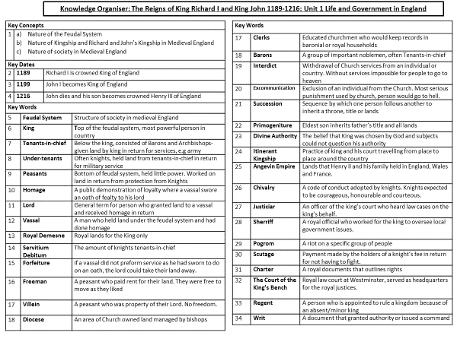

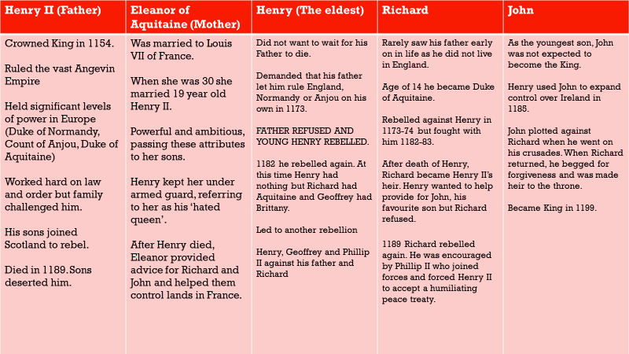
Meet the family

The Feudal System

England was very different in 1189 – The amount of power you had was shown by how much LAND you had owned. The hierarchy (Order of importance) was the following.
- King (Owned 100% of the land, kept 20% of it to hunt on)
- Tenants in Chief (Kept 75% of the land if they provided the King with advice and an army)
- Knights (Kept 5% of the land if they fought for the country)
- Peasants (Kept 0% but had to work on it)
EVERYONE HAD TO DO SOMETHING FOR THEIR LAND – APART FROM THE KING!
Quick quiz
- What does hierarchy mean?
- What % of the land did the King keep? Why?
- What % did Tenants in Chiefs keep, how did they keep it?
- What did Peasants have to do?
Facts about each group
King
- Most important person
- Owned 100% of the land
- Had to spread it out to help him control.
- Demanded obedience off the people
- Needed the Feudal System as an army was too expensive to make.

Tenant in Chief
- They had to raise an army for the King
- They had to give advice to the King
- They were called Barons
- Religious people could be Tenants in Chief (Archbishop)

Knights
- Would have to work for 40 days a year.
- Would be provided with a sword and knighted.
- Would be able to give land to peasants in return for food.
- They would have to pay for their own weapons and horses.

Peasants (Villeins, Freemen, Cottars)
- Lowest rank in society.
- The Villein would have to work for 3-5 days a week (WEEK WORK)
- The Villein would have to do extra work at harvest (BOON WORK)
- The Freeman would be free and pay rent and work one day a week
- The Cottar would work for 2 days a week.

How was land distributed?
- Each piece of land the King gave out was known as a FIEF
- When a fief was given out, the person had to pay Homage – This was a public declaration of loyalty, a promise to do his job.
- When the person gave their oath, they would become a Vassal (A man who owns land)
- If the Vassal broke the oath, they would be killed in public.
- The Kings own land (20%) was known as the Royal Demesne, people were not allowed on this land without permission.
Key Words
Fief –
Homage –
Oath-
Vassal –
Royal Demesne -

Knight Service | Labour Service (Peasants)
Would work for 40 days a year for the King and provide his own weapons.  They may have to raise money for a ransom if the King was kidnapped.  Across the whole of England, there were around 5,000 knights who performed Knight Service. They would have to protect the empire for the King.  The knight would be presented with a sword and belt and struck gently on the back of the neck with their sword, this was known as dubbing.  They were not necessarily rich. | Lower rank of society as they did not own land and would have to work on their Lords land, their Lords would be a Knight.  They would have to work in agriculture (farming) providing the food for the nation.  Peasants did not owe military service, it was the duty of their overlord to protect them.  The Cottars worked one day a week on their Lords land, the Villeins worked 3-5 days a week. The Villeins would work extra days in time of harvest.

Exam Question: Describe 2 features of the Knights Service (4) GIVE 2 EXTENDED FACTS!
Feature 1:

Feature 2:

Influence of the Church

The Church was incredibly important in the Middle Ages, people believed that their life purpose was to go to heaven. People believed their soul went to 1 of 3 places:

- Heaven (Live a life with no sin)
- Purgatory (Undecided whether you go to heaven or hell, you need people to pray for your soul after death to go to heaven)
- Hell (Committed ultimate sin)
How did you spend less time in Purgatory?
Could be done by everyone | Could be done by the rich
When alive, go to Church and pray regularly.  Go on a Pilgrimage (a religious march) to say sorry for your sins, this could be to Canterbury (England), Jerusalem (Holy Lands) or Rome (Italy)  Go on a Crusade (religious war) to try and claim back Jerusalem. Jerusalem was captured by Muslims and the Pope wanted Christians to gain it back as it was very important as it was believed that Jesus was buried there before he went to heaven. | Give money to the poor to make their lives better.  Leave money in your will to the Church so they can pray for your soul AFTER death.  Leave money for a Chapel to be built especially for prayer for your soul.

Answer the following:
1. What were people in the Middle Ages life purpose?
2. What is a Pilgrimage? Where could you go?
3. Why was Jerusalem so important to Christians?
4. Who was in change of Catholic religion in Europe?
5. Why would the Pope be a problem for the King of England?

Structure of the Church in England
Pope (Controlled Christianity in Europe)
King
Archbishop of Canterbury (MOST IMPORTANT Archbishop)
Archbishop York (Supported Canterbury, meant religion was looked after NORTH AND SOUTH)
Bishops (Managed a diocese)
Priests and Monks - THESE WOULD HELP DELIVER THE SERVICES ON A SUNDAY FOR CHURCH!

What would happen if the Pope was unhappy with someone?
If you got into a quarrel (argument) with the Pope, he could do 2 things:
- Interdict – Ban all religious services in an area
- Excommunicate – Ban an individual from the Church

Exam Practice: Describe 2 features of the Church in the Middle Ages (4)
Feature 1:

Feature 2:

Role and duty of King

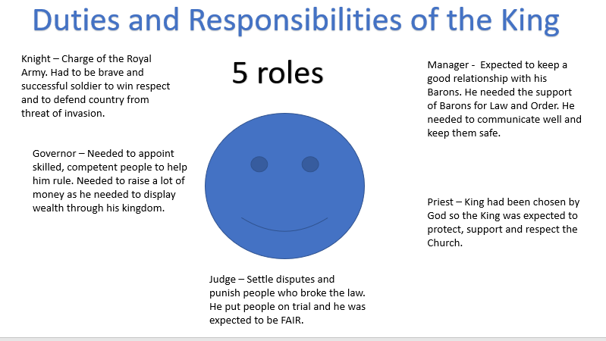
Key Words
Primogeniture – Means the eldest son becomes king and inherits land.
Oath – King had to make a promise to protect his people and maintain law and order
Civil War – A war in the same country, this may happen if a King made decisions that made others unhappy.
Coronation – An event which makes the King official, he would be anointed with holy oils as he was chosen by God.
Crown-wearing – The King would wear his crown 3 times a year in different areas to show his power. Gloucester at Christmas, Winchester at Easter and Westminster at Witsun.
Itinerant kingship – King and the court travelling the country to hear cases.
To be a successful King in England you needed to make sure:
- You did not raise taxes too much, you needed to keep people happy.
- You were a strong warrior who protected the people.
- You kept the Barons on your side
- You respected religion and made sure souls were protected.
- England was wealthy
- Law and order was maintained and justice was served but FAIR

Richard I – Claim, secure and character 1189-99

Explain why Richard become King in 1189? (12)
Richards Claim | Richards character | Richard’s military and political experience
Primogeniture – This was the idea that the eldest son inherited their fathers land and titles. This helped Richard become King as he was the eldest son to Eleanor of Aquitaine and Henry II, allowing him to inherit his fathers title and death following his death in 1189.  John’s weaknesses also helped Richard’s claim. John was made King of Ireland in 1177 however failed in this venture, failing to visit the country until 1185. John mocked his subjects and constant rebellions occurred. Even though Henry wanted John to be King, he showed he was not capable and Richard was A LOT stronger. | Richard was highly educated and interested in other cultures. This was important as understanding other cultures would ensure he did not insult others (like John!) ensuring that rebellions were kept at a minimum.  Richard was very charismatic, other men wanted to follow him which would have been important. If men followed him then the Feudal System would be easier to control as people would not take advantage of their land if they have respect for their King.  Richard showed that he would do anything for power, including breaking his feudal oath 3 times by going against Henry II. This shows that even risk of death did not faze him.  Chivalric values were followed by Richard, meaning he protected the vulnerable. As England had 1.5 million peasants he swore an oath to protect and ensure they were safe from foreign invasion and to ensure locally that he kept the peace and that law and order was followed.  Richard was focused on the religious importance of the country. He went on Crusade. These would be important as religion was vital to England and Jerusalem being protected would have allowed more Christians to go on Pilgrimage for them to get to heaven. | Richard became the Duke of Aquitaine at the age of 14. This was a huge responsibility as Aquitaine was part of the Angevin Empire and was subject to constant attacks from Philip II of France. Richard gaining experience at an early age was important to ensure that he could control the entire Angevin Kingdom when he became the King in 1189.  When Richard was in control of Aquitaine he dealt with numerous attempts of people trying to overthrow them. For example, in 1175 and 1183 when his Brother John tried to invade.  1179 was a key year in showing Richard’s strength as he used Siege Warfare to capture Tailiebourge from Geoffrey de Rancon. This area was never previously captured and was seen as an impossible area to capture.  Richard was also an incredible warrior who showed extreme stubbornness in battle. For example, in 1174, Richard lost 460 men but carried on, showing he was willing to do anything to ensure success in battle.

How did Richard I secure the throne when he became the King?
Richard was coronated on the 3rd September 1189. He appeared in gold from head to toe and took the carnation oath, swearing to protect his kingdom.
- RICHARD WANTED TO GO ON CRUSADE SO HE NEEDED TO SECURE HIS KINGDOM
- He made peace with the men who had fought with his father against him.
- He appointed William Longchamp as chancellor
- He gave John and Geoffrey land and banned them from England for 3 years.
- Richard made John Count of Mortain, in Normandy but he did not give him control of any castles

What happened when Richard went on Crusade? 1189-1191
When Richard became King he raised money by selling off lands and titles, he even said he would sell London. HE MADE £31,000 FOR THE CRUSADES WHICH WAS A LOT MORE THAN HIS ANNUAL INCOME OF £25,000.
- Richard made an agreement with William the Lion to free him from his homage.
- Richard provided his brother with titles and land to ensure he was away from England, he was banned for 3 years due to this.
- Richard also appointed William Longchamp whose duty it was to manage government using charters and writs. He also became the justiciar.
- Charter – Document that outlines people’s rights
- Writ – Issues a command
- Justiciar – In charge of the court

King John’s rebellion and Richard’s capture 1191-1194
In 1191 John returned to England which Richard was on Crusade. THE PEACE HAD BEEN RUINED!!!!
- John set up his own court which undermined Longchamp.
- John collected taxes on his own behalf.
- John seized control of Nottingham and Tickhill Castles.
- Baron’s who hated Longchamp joined John. They hated Longchamp due to him paying £3,000 for his title.
- In October 1191 – Barons decided that John should be regent (person who is voted in by Barons)
- John became regrent and Walter of Coutances became Chancellor
- Richard was captured in 1192 and a huge ransom was needed, John taxed people heavily to pay this.
- John announced that Richard was dead and he was the legitimate king onto to be caught out by a letter that arrived from Germany.
- John allied with Philip II of France to seize Richard’s land near France.
Anti-Jewish Pogroms 1189-90
Explain why there were Anti-Jewish Pogroms in the years 1189-90 (12)
Pogrom = persecution/attacks
In 1189, there were around 5,000 Jews living in England’s towns. They were very important in economic life and they were protected by the King. WHY? THEY COLLECTED A LOT OF MONEY AND THE KING COULD TAX THEM.
So why were they attacked in 1189?
Anti Semitism/ role as money lenders. | Richard’s coronation | Crusades
Jew’s became money lenders as they were banned from many occupations.  When people borrowed money, they charged interest. CHRISTIANS WERE NOT ALLOWED TO DO THIS.  Due to being money-lenders , vast amounts of money were owed to Jews. For example Aaron of Lincoln was owed so much money that a separate exchequer (counting house) was set up to deal with debts owed to him after he died. This led to jealousy from the population and a possible reason why pogroms occurred.  The fact that some English people owed so much money led to these Pogroms. As the Pogroms included burning down Jew’s homes, it meant that they burned evidence of debts that were owed to them. | England was an incredibly Anti-Semitic country. When Richard I was coronated the Jewish community of London gave Richard a gift. Christians believed this was an insult to the new King, in response the Christians began a riot and began killing Jews. Slaughter spread across London and Jew’s houses were burned down.  30 Jews lost their lives following the coronation. Richard ordered attacks not to occur and that punishment would be severe. | When people were asked to go on Crusade, propaganda told people that they were saving Jerusalem from Muslims AND Jews.  When Jerusalem was captured by Saladin, the Jews were scapegoated (blamed). There were outbreaks of violence in East Anglia during February 1190. These riots spread to King’s Lynn, Norwich, Stamford, Bury St Edmunds and Lincoln. Property was burned, and Jews were killed.
Task: Give 5 reasons why the Pogroms occurred (Include places)
1.
2.
3.
4.
5.

What happened between 1194-99?
Richard returned in 1194 and John threw himself to his brothers mercy. Richard embarrassed the 27 year old John by calling him a child.
Richard appointed a new justiciar (Hubert Walter who was Archbishop of Canterbury) and he kept the piece by using Knights. IT WAS PEACEFUL IN ENGLAND UNTIL 1199.
Exam Practice: Richards reign was wholly successful during the period 1189-99, how far do you agree? (12) You may use the following in your answer:
- Richard securing the throne
- John’s rebellion

John – Secure, claim and character
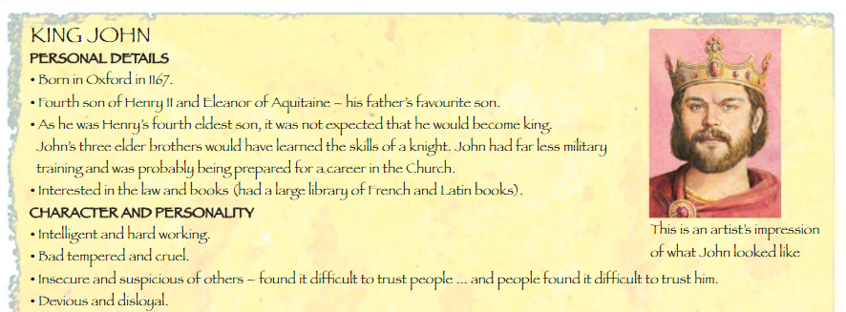

47

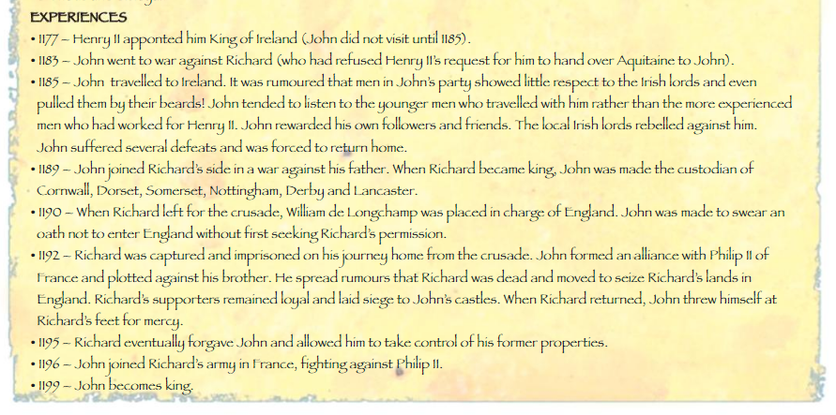

Johns Claim | How did John secure the throne? | Murder of Prince Arthur
John was the 5th and last son of Henry and Eleanor of Aquitaine.  He was given no land compared to his brother, hence why he got the nickname ‘Lackland’.  He was made King of Ireland in 1177, however his overall control was poor and his Lords insulted the Irish.  John’s claim was a lot more complicated than Richard, however he did have some positives:  - His claim was supported by Eleanor of Aquitaine.  - He was also supported by William Marshall (MOST IMPORTANT KNIGHT) and Walter Hubert (Archbishop of Canterbury)  - English and Norman Barons preferred John.  - He was at prime of his life at 31 and showed at times during 1194-99 that he could be strong warrior.  HOWEVER:  - His elder step-brother Geoffrey had a son who had a better claim due to primogeniture. The son was Arthur  - Barons in Brittany and some in Anjou (BOTH PARTS OF ANGEVIN EMPIRE) preferred Arthur’s claim.  - Philip II preferred Arthur’s claim. | Arthur’s claim was dismissed as he was only 12 and was regarded as a foreigner by the English.  On 27th May 1199 he was crowned and promised to protect the Church, abolish bad laws and do justice to his people. JOHN SHOWED HIS RELIGIOUS DEVOTION BY VISITING THE SHRINE AT CANTERBURY.  4 weeks after his coronation John went to France to secure a relationship with the King of France. In May John arranged a peace treaty with Philip II, this said:  - John would give Philip II some Angevin Empire land.  - Agreed to do homage to Philip II and pay Philip II 13,500 pounds.  - Philip II agreed to drop his support for Arthur. | By 1200, John and Philip II truce was over.  Arthur joined Philip II WHICH BROKE A FUEDAL OATH BECAUSE JOHN GAVE ARTHUR LAND!!!!  In August 1202, Arthur was captured: THE FOLLOWING EVENTS DAMAGED JOHN’S REPUTATION.  - According to chivalric values, John should have RANSOMED Arthur.  - OR HE COULD HAVE TRIED HIM AS A TRAITOR.  However, John did neither and told Gaolers to castrate and blind Arthur, they said no!  Sometime after this, Arthur was murdered, possibly by John! He was stabbed to death and his body was dumped in the River Seine with a rock tied around him. THIS LED TO PEOPLE TURNING ON JOHN AS HE WAS SEEN TO MURDER HIS OWN NEPHEW!!!

Royal fines and revenues

Explain how Richard I and John raised revenue during their reigns (12)
You may use the following to answer your question:
- Royal Revenue
- Fines
You must use information of your own.
Both Richard and John made huge demands from the people for money, they did this for a range of reasons:
- Ransoms that needed paying
- Crusades
- War with France
- Debasement (Value of money falling)
- Prices of goods rising
SO HOW DID THEY MAKE MONEY?
Royal revenues | Feudal incidents (fines) | Revenue from justice
Royal Demesne – ROYAL LAND  Royal land had villages attached to it, the King could charge high rents for this piece of land.  There would also be towns in the Royal Demesne and the King would charge for goods that were sold in the town.  Tallage – Compulsory land tax paid by tenants of the Royal Demesne. These tenants included townspeople and peasants.  This tax was only paid by people of ‘lower-class’ and not by Barons or Knights.  No appeal was allowed when it was demanded.  No fixed sum, it would change every time depending on the event.  1207 tax on moveable incomes – John developed a new method of taxation. He demanded tax based on the income of every man. He made this tax to pay with wars with France.  The tax was one shilling in every mark  A mark was worth 13 shilling – THE TAX CAME TO BE KNOWN AS THE THIRTEENTH.  Raised £60,000 for John but was hated and he did not collect often! Only for one year. | Medieval Kings could call upon their Vassals to make certain payments when they needed money, these were known as FEUDAL INCIDENTS.  Wardship – One of the most profitable  If a Baron died while he heir (son) was under age, the King would take control of the land and the heir became WARDS to the King.  King was responsible for the wards until the heir turned 18. King would decide where they live, as well as the education their received. WHILE THE KING LOOKED AFTER THE WARDS LAND, HE KEPT ALL MONEY IT RAISED.  When the ward was old enough, the King would charge them to take over the land. John charged 300% more than Henry II.  King could also charge the ward to get married!  Forest fines – Under the King’s rules, people were not allowed to hunt, live or work in the Forest. If found to do so you would get fined heavily. Fines mainly effected peasants who may search for wood for fuel or animals for food. | To start a case in court you would need a writ from the King, he would charge for this so you could take a case to court.  John would sometimes use justice by interfering and making more money. One situation was in 1207 when he told one party that if they gave him 3 horses, he would let them free.  Scutage – Payment made by the Knights in return for not having to fight. This was used to pay for foot soldiers and bowmen. HOWEVER, the Knights would still be used to besiege castles (LESS DANGER).  King used the scutage to pay for more soldiers as the Feudal system did not raise a big enough army.  King John demanded 11 scutages in 16 years. BARONS HATED THIS AS THEY BELIEVED TAX SHOULD ONLY BE DEMANDED IN A TIME OF SEVERE EMERGENCY.

How were taxes collected – THE ROLE OF THE SHERIFFS
- In Richard I time, Sheriffs were set a certain amount of tax they had to collect. Any extra they could keep, this was known as TAX-FARMING.
- Tax farming meant that Sheriffs could become very wealthy.
- Richard made a lot of money for Crusade by selling Sheriff offices.
- Tax-farming continued under John, however John prevented them from becoming rich as he insisted he got the greatest share. HE MANAGED HOW MUCH MONEY THEY HAD COMING IN!

Read the following information and complete tasks:
Middle Ages – Village
Types of Peasants
Most of the population lived and worked on a farm in the Middle Ages – THE LIFE EXPECTANCY WAS LOW, 40 YEARS OLD – LOWER FOR THOSE IN A VILLAGE, this was due to poor working conditions.
There were two main types of peasants:
- Villeins – Lowest rank and property of a Lord. Lord could punish and sell the Villein
- Freeman – Could move freely and could not be controlled by a villain
- Cottar – Only helped around HARVEST TIME.

Manorial Estate – Made up of one or several villages surrounding the Lord’s house (Which may be looked after by a Bailiff.
- Land on the Manorial Estate would be spread out between peasants for farming.
- Work on the Manorial Estate land would be supervised by a Reeve (Supervisor of the farm work!). If the peasants were not doing their work they could be reported to the Bailiff (Took care of the Lord’s land) and be punished.
- Villeins would work on the land for 3-5 days a week. Freeman would only occasionally work as they paid rent for their land. THIS CHANGED OVER TIME AS VILLEINS PAID RENT TOWARDS END OF 1200’S.
Task: - COPY OUT QUESTION AND ANSWER IN BOOK: Describe 2 features of the Manorial Estate (4): (REMEMBER – EVIDENCE AND EXPLAIN IT.) 2/3 lines for each
Farming Activities
Activities depended on the quality of the land
Village farming land was split in 2 or 3 pieces of large open fields. One was left FALLOW (EMPTY) so it could recover for future farming. BAD HARVEST COULD HAVE BEEN A DISASTER AS IT COULD LEAD TO STARVATION.
Land was split into strips, peasants had strips in different fields, sometimes their strips would be huge walking distance apart. THIS WAS SO THAT PEASANTS HAD A SHARE OF GOOD AND BAD LAND.
Fields were PLOUGHED, SOWN AND HARVESTED by villeins.
Every villein had to grow the same crop. The type of crop depended on the field. Once grown the Villein had to take crops to the village mill to be ground. THEY HAD TO PAY FOR THE MILL.
Peasants sometimes had animals. A peasant may have a cow for milking and some sheep. These animals would be used to graze (eat) on the common land to eat crop roots. Animals would be kept in the house overnight. KEEPING ANIMALS FED IN THE WINTER WAS DIFFICULT AND THE AMOUNT OF MILK PRODUCED DROPPED IN WINTER.

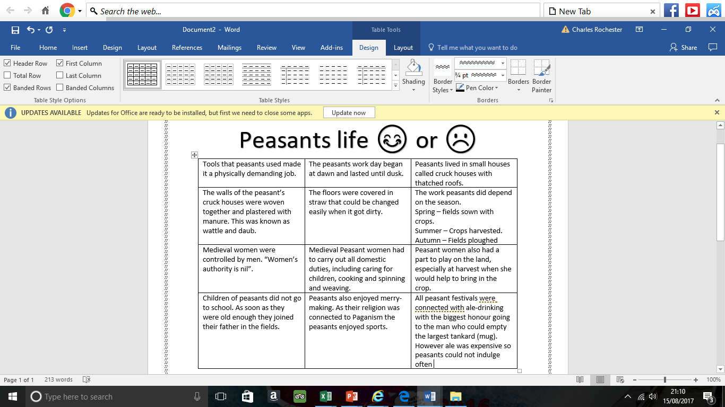
Task 1 : Put a 1 next to positives, 2 next to negatives.

Task 2: Describe 2 features of life of a Peasant woman (4) COPY OUE QUESTION AND ANSWER IN BOOK.

44

Middle Ages – Town
Town government
- Towns were not controlled by a Lord
- Towns had law courts and their own self-government. TOWNS WOULD PAY LARGE SUMS.
- People who lived in towns would not have to pay certain taxes.
- London was the biggest town, it had elected people called aldermen, who rules the town and the courts.
- Each alderman was given responsibility for a part of a town. TWELVE OF THEM SAT IN COURT TO MAKE JUDGEMENT.
- London given more freedom in 1215 when John allowed them to elect a mayor.
- IF A VILLEIN RAN AWAY AND STAYED IN A TOWN FOR A YEAR AND A DAY WITHOUT BEING CAUGHT, THEY BECAME A FREEMAN!
Task: Answer the following questions
- What were towns not controlled by?
- Why would towns have more freedom?
- What was an alderman?
- What was the biggest town?
Town Guilds
A guild is a group of workers – To be part of a guild you had to pay for it and swear an oath that you would pay taxes. There were many types of work who had guilds – goldsmith, bakers, carpenters.
If you were part of a guild you could trade in a town. THE MOST IMPORTANT GUILD IN THE 1100’S WERE WORKERS WHO MADE CLOTH BECAUSE IT WAS ENGLANDS RICHEST INDUSTRY. English cloth was sold across Europe and made them incredibly wealthy, was vital for the King.
Why were towns important in the economy?
All goods that were sold in towns had taxes that were important which were important to the monarch.
Buying and selling was carried out in local markets – All sellers had to keep a record of what they sold, and taxes and rent was collected based on what you sold – THE MORE YOU SOLD THE MORE YOU WERE CHARGED!
Towns meant more bridges and roads were needed – However so many people travelled on these they became damaged and slow.
TOWNS WITH PORTS WERE THE MOST IMPORTANT AS THEY ALLOWED GOODS TO BE BROUGHT AND SOLD FROM OTHER COUNTRIES. Also allowed quick trade between coastal towns in England.
Task: In your book do a spider diagram or list – HOW ARE TOWNS DIFFERENT TO VILLAGES - USE FOLLOWING TO COMPLETE
Annual fairs would be held on important dates of Christian calendar. They would attract high numbers and traders from other countries. | During fairs, trade would occur. Towns paid a huge amount of money to the King for these fairs to be held – it would make a town a lot of money in tolls. | All townsmen were free.
Children could become apprentices in trades for 5-9 years from the age of 14. This allowed children to have a career different to their family, unlike the villages. | Women could work in a trade however they still supported their husband. Some women allowed to join guilds. | Disease was more common in town due to large numbers. Chamber pots were emptied in streets.
Would live in wooden houses on narrow streets with shops at the front. Shops opens at 6am until 3pm. There was a curfew at 9pm | There was a system of policing known as watchmen at night, people and animals were protected. | Towns were protected by huge stone walls – Keeping them separate from villages as they were wealthier.

Richard’s motives
The three leaders of the Third Crusade
Fighting Overseas 1189-1204 – Unit 2
Task: Use Page 47 – Summarise Richard’s reasons for going on Crusade

Richard I
Philip II
Frederick

Task: Using the handout – Write 3-5 facts about each leader of the Crusades: Consider
- Country they were from
- Strengths
- Weaknesses

Read the following information:
Why did Richard fail to capture Jerusalem? Events before
Frederick’s journey to the Holy Land
- Frederick sets off
May 1189 – Frederick decided to travel by land, leading his forces through Hungary and then the Byzantine Empire
- Frederick faces problems in Anatolia
April 1190 – Frederick entered the territory of the Seljuk Turks who ambushed the German army. Frederick’s army suffered from starvation and thirst. In May 1190, the German army reached the Seljuk capital of Iconium. They captured the city before continuing towards Armenia.
- Disaster!!!!
June 1190 – Frederick had almost reached the Holy Land when he drowned trying to cross a river. With their leader dead, many German knights headed home. This was a terrible blow to the Crusades.

Task: List 3 mistakes Frederick made on his quest to the Holy Land:
Mistake 1:

Mistake 2:

Mistake 3:

Richard and Philip II’s Journey to the Holy Land
- Richard’s first decisions
Richard decided to travel to the Holy Land by sea. Building and hiring ships was very expensive but sea travel was safer and quicker.
Richard’s army was well-disciplined and strict punishments were introduced for anyone who caused problems. A crusader who attacked someone with a knife would have their hand chopped off.
Richard did not trust Philip so there was a delay in setting off until both Kings agreed to leave at the same time. THEY AGREED THAT ALL LAND THEY CONQUERED ON THE WAY WOULD BE SHARED 50/50
Richard and Philip left on the 4th July 1190 . At Lyon (In France) their armies divided and agreed to meet in Sicily (Italy)

Task: Highlight
Richard’s strengths
Richard’s mistakes

- Sicily – They meet!!
In September 1190, Richard arrived in Messina, the capital of Sicily to a grand display, celebration, with a hero like reception. Philip had arrived a week earlier to pure silence.
The Crusaders and the population of Messina highly disliked one another. To overcome this Richard started a war in October 1190, resulting in Richard seizing control of Messina. Philip refused to help during this battle and was annoyed because Richard put banners up with his name on after his win. Philip stropped, and Richard agreed to take them down. Richard gave Philip one-third of the money that he made from a peace deal with the leader of Sicily.
In April 1191, Richard’s huge army (17,000 soldiers and 200 ships) left Sicily.

- Conquest of Cyprus
3 days after leaving Sicily there was a bad storm. Most of the fleet were safe but 3 ships were forced a ground and had their cargo stolen (In Cyprus). The leader of Cyprus refused to co-operate with Richard. Richard decided to invade the island. Richard and his army invaded the island and they surrendered on the 1st July 1190. Richard’s conquest was important as it was a good link between mainland Europe and the Holy Land. Philip got stroppy again! Richard refused to give him half as he did not help. However eventually Richard was able to sell this island for 100,000 gold coins and gained full control of the islands grain supply.

Task: Complete the following table:

Signs of Richard’s strength/great leadership | Signs of Richard’s weakness/poor leadership

Acre, Arsuf and a big fall out!

Acre and Arusf – Both within the Holy Land, vital to go through here to get to Jerusalem.
Battle of Acre
Acre had fallen to Saladin in July 1187! It was the largest town and the main port in the Kingdom of Jerusalem. Qaragush was in charge of defending the city, he was one of Saladins most trusted commanders.
Crusaders were already attacking Acre when Philip arrived in January 1191. He was content to join in and continued to bombard the walls of the town.
Richard was sailing towards Acre in June 1191 when he saw a huge ship with supplies and reinforcements for Saladin’s army in Acre. Richard’s army SUNK the ship, severely weakening the army in Acre.
Richard arrived in Acre one day later to a hero’s welcome. He conquered Cyprus, sunk the main ship of supplies and brought over thousands of soldiers to help with the Crusading effort. The bombardment was increased and the walls of Acre were being worn down.
A turning point occurred with Philip’s men tunnelled under and collapsed a section of the wall, however it was beaten back by the Muslim army. By this point, Saladin’s army was exhausted. They were getting no sleep and they constantly had to fight. Richard and Philip had so many men they could take rest breaks.
On 11th July Richard’s men attacked coming very close to success. It was at this point Saladin’s army decided to give up! On July 12th they surrendered and gave the entire city and its contents to the crusaders, including ships, stores and artillery. Richard and Philip banners were raised above the walls of the city! Due to the victory an agreement was reached with Saladin:
- Muslims would hand over their weapons and ships and pay 200,000 gold coins.
- Christian prisoners would be handed over.
- Saladin would return the Christians ‘The True Cross’ that he stole at the Battle of Hattin.
Saladin did not follow through with his promise! He did not release prisoners, he did not hand over the cross and he gave a piece of paper saying IOU the money!!!!!
Richard responded on the 20th August by taking 2,700 Muslims captive. Richard’s men beheaded all 2,700men. It was barbarous and many people believed a stupid move as he could have ransomed them. However, some believe it was Saladin’s fault as he used these men to buy himself more time to defend the rest of his empire.
Task: Complete the table
Reasons for success – Richard | Reasons for success – Philip II

Extension: Is there anything that shows that Richard may not be as heroic as we think? Explain
______________________________________________________________________________________________________________________________________________________________________________________________________________________________________________________________________________________________________________________________________________________________________________________________________________________________________________________________________________________________________________________________________________________________________________________________
Aftermath of Acre – Philip and Richard fall out and Philip GOES HOME?! :o
Even though Philip and Richard had just been successful at Acre, the arguing continued! There were many reasons for this:
- Philip was getting jealous of Richard’s successes in Sicily and Cyprus and Philip did not like it when Richard put banners up in Sicily when he captured the capital.
- Richard paid his Knights more (4 gold pieces), which means some of Philip’s men moved over to Richard’s army as they got paid more (only got 3 gold pieces from Philip).
- They constantly argued over who should be King of Jerusalem if they captured Jerusalem back. Philip wanted Conrad of Montferrat while Richard supported Guy of Lusignan
- Richard got married while he was in Cyrpus to Berengaria of Naverre. Richard was planned to marry Philips daughter, Alice. This humiliated Richard however he did it so he could secure the southern areas of the Angevin empire.
- However, many believe that Philip left because of the death of the Count of Flanders at Acre, Philip believed he could go back home and take control of the rich lands that the Count controlled, while bordered France. Richard tried to persuade Philip to stay, Philip agreed IF RICHARD GAVE HIM HALF OF CYPRUS, RICHARD SAID NO!!!
- On the 3rd August 1191 Philip left to go home. This would concern Richard as he was worried Philip may try to conquer the Angevin Empire while he was on Crusade.

Task: Explain why Richard and Philip fell out after the Battle of Acre in 1191, summarise in 1 paragraph:
______________________________________________________________________________________________________________________________________________________________________________________________________________________________________________________________________________________________________________________________________________________________________________________________________________________________________________________________________________________________________________________________________________________________________________________________

The Battle at Arsuf – September 1191
When Richard left Acre, he marched his troops South towards Jaffa. His expertise as a military lead was shown on this march… WHY?
- Weather was hot, distance was great and they were constantly attacked… So Richard marched the men near the sea, next to supply ships who dropped off supplies to keep them alive.
- Richard was so successful on the march that Saladin realised he would have to battle Richard to stop him.

Saladin gathered a huge army on the plain of Arsuf. This is where Richard showed he was a superb warrior and leader… WHY?!
- He set up the formation of his army and ordered them to wait for his signal before they attacked.
- He intended to lure the Muslim army so that he could defeat it in one great charge. There were problems with this as two knight’s broke ranks and formation was broken.
- RICHARD DEALT WITH THIS QUICKLY BY LEADING A MIGHTY CHARGE INTO THE CENTRE OF SALADIN’S ARMY AND FORCED MUSLIMS TO FLEE.
- Richard lead his men into Jaffa where he began to settle in the city, the next stage … JERUSALEM
Attempts to take Jerusalem and failure

Task: Read through the text and highlight REASONS FOR FAILURE using the following key
Richard I decisions
Army supplies
Military failures
Jerusalem defences
Exam Focus: Explain why Richard failed to recapture Jerusalem from Muslim control, you may use the following:
- Army Supplies
- Jerusalem’s defences.
Attempt number 1 – October 1191-January 1192
Richard began marching the crusader force towards Jerusalem. Their progress was slow because of heavy rain, violent hailstorms, with mud becoming a serious issue. . Some of the Christians did not want to advance to Jerusalem so quickly, this was because:
- They feared Saladin’s forces would surround them.
- Worried that their supplies would be cut off if they moved away from the coast.
- Jerusalem was heavily protected by a strong of fortresses that were controlled by Muslims, and a strong outer wall that would take effort and planning to break through.
- They believed that if they did take control, Saladin would win it back as they had a lack of supplies.
As a consequence of these fears, Richard ordered a retreat in January 1192. Ordinary soldiers were very disappointed. Richard went to an area called Ascalon, with a much smaller army to rebuild the area and prepare for the second attempt on Jerusalem

Attempt number 2 – June-July 1192
Richard and his men started the second attempt more successfully. The Crusaders reached Beit Nuba (which was only 12 miles from Jerusalem!!) in 4 days. THIS TOOK 2 MONTHS IN THE FIRST ATTEMPT!! Saladin panicked and fearing an overthrown, he poisoned all wells in Jerusalem.
Richard and his men were in a great position to attack and potentially win back Jerusalem. However, Richard was having second thoughts. He was concerned that the resources on the coast of Jaffa were so low that if they did conquer, they would run out of resources incredibly quickly. The remaining French soldiers wanted to continue, Richard decided to turn back. Richard did not known that Saladin had panicked however, he was thinking the long-term issues. A lot of the crusaders would want to go home and the chance is, if they did win back Jerusalem, they would not be able to keep it. Furthermore, Jerusalem’s defences were incredibly strong, if the Crusaders made it to Jerusalem, they would have faced an onslaught of Muslim attack, which could have easily overpowered Richard.
Richard ended his Crusade on the 9 October 1192 after making a deal with Saladin, the TREATY OF JAFFA SAID:
- Saladin kept control of Jerusalem
- Crusaders could keep Jaffa and Acre
- Muslims and Christians could go through each others land without hurting one another.
- Christian pilgrims were allowed to go to the Church of the Holy Sepelchre in Jerusalem

Exam Focus: Explain why Richard failed to recapture Jerusalem from Muslim control, you may use the following:
- Army Supplies
- Jerusalem’s defences.
Plan the answer below

Aftermath of the Third Crusade

Richard was __________ to get back to his empire. While he had been on crusade, his brother _______ had teamed up with ___________ and attacked Richard’s continental lands. Furthermore, Richard’s enemies had been giving him a _____ name in Europe, accusing him of _________ that he did not commit. Richard found that there was no _____ route that could take him back home. He headed to a range of places and realised he could not go through ________ as it was full of ____________.
In November 1192, Richard was ________ and had to carry on the journey through land. He disguised himself as a __________ but he was eventually _____________. Richard was arrested and imprisoned by Leopold of Austria and sold to Henry VI, Henry wrote to Philip II to tell him of the great news. Richard’s life was not at risk due to __________ values, however the huge sum of _________ marks was set for Richard’s ransom. The ransom money would be split between Henry and Leopold.
Key words paragraph 1: enemies, anxious, John, safe, Italy, murders, Philip II, bad
Key words paragraph 2: pilgrim, chivalric, 100,000, recognised, shipwrecked.

The Burden of the ransom – How was it paid?
First – THIS RANSOM WAS HUGE (EQUIVILANT TO 2 BILLION IN TODAYS MONEY!) AND PUT ENGLAND IN GREAT FINANCIAL DIFFICULTIES DURING JOHN’S REIGN!!!
How was Richard’s ransom money paid?
- £1,350 given from the King of Scotland
- Eleanor of Aquitaine took control of the ransom – John was trying to hinder it, asking people to never release his brother.
- 25% tax on all moveable goods in England
- A land tax on EVERY land owner.
- A tax from Jews of £3,375 per Jew.
- A year of wool crop of Monks
- Gold and silver plate from every Church in England

The fact this money was raised shows how wealthy England was. It took 6 months to collect. HOWEVER, IT HAD A HUGE IMPACT ON ENGLAND FOR MANY YEARS.
Richard returned to England in February 1194. He was imprisoned for 1 year and 6 weeks, The ransom was not the only agreement. Richard agreed to give Henry VI the English crown and to receive it back as a Vassal. Richard arrived in England and crushed his brother’s rebellions. Richard made Hubert Walter (Old Archbishop of Canterbury) the head of government. Richard turned his attention to securing his lands in the Angevin Empire. In May 1194, Richard left England, never to return again!

Richard, John and the loss of Normandy
Normandy was so important to Richard, John and Philip for many reasons:
Economic | Strategic | Political
Normandy was a wealthy area the revenue it brought the Angevin crown were close to the total raised from the whole of England.  Normandy paid a lot of money to Richard’s ransom.  England and Normandy had strong trade links. Meaning goods could be traded | If the French King gained control of Normandy he could use it to invade England.  Normandy was a one-day ride from Paris. Paris was NOT part of the Angevin Empire  Key region was an area known as the Norman Vexin. This area lay between the two centres of power – Paris for the French King and Rouen for the Duke of Normandy. | Many leading Baron’s controlled lands in Normandy as well as England.  Loss of Normandy could damage the leading English baron’s confidence in their King’s ability to protect his people and provide stability.

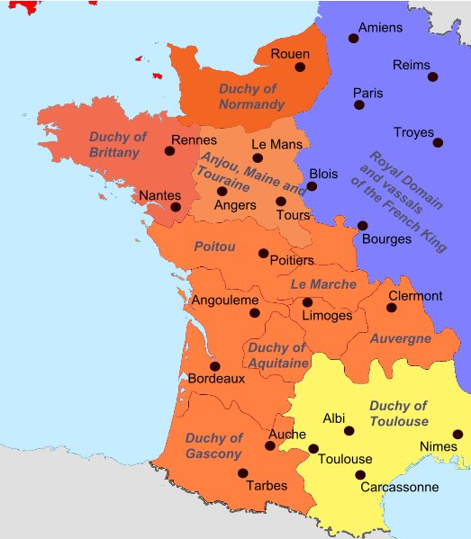
When Richard returned from ransom in 1194, Normandy was weak as John tried to overthrow it with Philip while he was away. What problems did Richard face?
- Philip convinced some of Richard’s barons who held castles on border between France and Normandy to switch sides to France.
- Philip and John had conquered much of western Normandy, meaning they had control of trade routes.
- Philip also took control of the strategically important Vexin. John did not stop him.
- Philip also gained some incredibly powerful castles as Gisors. It was vital to the defence of Normandy because it was positioned between French capital and the Norman capital of Rouen.

How did Richard deal with these problems?
John
When coming face to face with John, he threw himself at Richard’s feet, begging for forgiveness. Richard forgave John and blamed Philip for misleading his brother. RICHARD GOT RID OF ONE ENEMY, JOHN JOINED RICHARD. Some historians say Richard was encouraged by his mother to forgive John.
Philip II
John betrayed Philip II and attacked his forces at Evreux. Richard and John then fought siege after siege on the Norman borders and paid lords for their allegiance (side taking)
By the winter of 1195-96, Richard had enjoyed such a run of victories that Philip pulled his troops out of Aquitaine in order to concentrate his forces in the North.
Philip did achieve some victories – He took nine year old Arthur of Brittany into his custody. As succession was based on primogeniture, then Arthur would be the heir to Brittany, therefore allowing Philip a base to attack Normandy.
Richard constantly bribed vassals to change sides, therefore Philip lost A LOT of support. Richard also used a trade embargo (restriction on trade) to persuade Count of Flanders to support his empire.
Task: On the map below, highlight key areas and explain why they were important using the information above:

How important was Chateau Gaillard to Richard keeping Normandy?
- Chateau Gaillard was a castle on the River Seine, overlooking the Vexin.
- The castle was built in two years (1196-98) at a huge cost of £12,000. This is huge as Richard only spent £7.000 on EVERY castle in England.
- Chateau Gaillard was a defensive structure and a royal palace where Richard could hold court.
- Defences of the court were seen to be the best in Europe. It was built hundreds of feet above the toward and made it difficult to tunnel under walls. It had round walls which also made it stronger. Made it hard to attack.
- Historians say that C.G was potentially built for defence however recent arguments are that it was used for an aggressive strategy. The castle was on a direct route from Rouen, the capital of Normandy, from which supplies could be transported to troops at C.G.
- The castle was very important to restoring his empires.

Exam Practice: Describe 2 features of Chateau Galliard
Feature 1:

Feature 2:

Death of Richard
During 1199 Richard was in the process of making a truce with Philip II. Richard decided to visit his troops who were besieging a castle in Limoges. He went out without his armour and from the Limoges Castle he was shot with a crossbow in the shoulder. Richard snapped off the arrow shaft, however the bolt was still in his shoulder. It got infected and on 6th April 1199, Richard died.

Why did John use control of Normandy in 1204?
Stage 1: Johns position in 1199 – Read through the statements, highlight things in JOHN’S favour and things in PHILIP’S favour
John’s favour
Philip’s favour
- When Richard died, the leading barons in Normandy and England showed their support for John
- There were Barons who owned land in Normandy and England and would want to keep the land together.
- Philip was an experienced military leader and cunning diplomat.
- By 1199, Philips’ wealth grew and he could compete with John financially.
- Normandy was well defended thanks to Richard and the use of C.G
- John had a promise of support from Otto IV the man most likely to become new ruler of Germany.
- Richard’s alliances transferred over to John so he could count on key alliances such as the Count of Flanders and the Count of Boulogne.
- Some of the taxes introduced by Richard had meant people in England were discontent (unhappy) in 1199.
- Some people in Normandy did not trust John as he went against his brother in 1193.

John losing Normandy – 3 stages
Exam Practice: Explain why John lost Normandy in 1204 (12)
Task: Highlight evidence with the 4 factors below
Factor 1: Philip being a strong and skilful opponent
Factor 2: John’s military mistakes
Factor 3: John’s poor diplomacy (International relationships)
Factor 4: John suffering from bad luck

Stage 1 – 1199-1200
- After Richard’s death, Philip invaded Normandy.
- John acted with impressive speed and was quick to get his authority recognised in the Angevin Empire.
- John was crowned on the 27th May 1199 and by the end of June he was in Rouen with a large army and pushed Philip back.
- In May 1200, John made peace with Philip through the Treaty of Le Goulet
- Philip recognised John as Richard’s heir.
- John agreed to pay 20,000 marks for his territory in the Angevin Empire. This was given to Philip.
- John agreed to not align with Count of Flanders and Count of Boulogne – Undid all the work Richard did.
- John remained in control of Chateau Gaillard.
- John agreed that Philip would be his OVERLORD (In charge of him)

- John triggered more issues in 1200 when he married Isabella of Angouleme. This was a problem as Isabella was promised to one of John’s vassals. John did not give him compensation and he switched allegiance and appealed to Philip II for help.

Stage 2: 1200-1202
Philip attacks Normandy
- Philip ordered John to court for marrying a woman who was promised to one of his vassals (HUGH OF LUSIGNAN). John refused and it gave Philip an excuse to attack his lands in the Angevin Empire
- For failing to appear at court, John was sentenced to forfeit ALL of his continental lands.
- In 1202, Philip attacked John’s lands in Normandy and captured Gournay in July 1202. Philip cleverly burst the walls of a large dam that lay up river, causing a flood to burst the defensive walls.
John loses allies
- John’s greatest supporter in the region, his father-in-law (Count of Audemar) died.
- This meant that John had to face Arthur and the Lusignan’s on his own.
- John’s other potential ally, the Count of Flanders, left to go on a Forth Crusade.
- Other previous allies had switched to Philip’s side (Count of Boulogne and Toulouse)
John’s daring rescue
- Eleanor of Aquitaine saw that her son was in a difficult situation.
- She travelled to help John in Poitiers and defeat Arthur (HER GRANDSON)
- She was besieged by Arthurs army and she became hostage to her grandson.
- John gathered soldiers quickly (travelled 80 miles in 48 hours!) to rescue his mother. He surprised Arthur with speed of attack and took him and Hugh de Lusignan prisoners.

Stage 3 – 1203-04
Arthur disappears
- Arthur was captured in 1203 and there were different arguments as to what happened to him.
- John attempted to blind and castrate Arthur.
- John killed his nephew and threw his body into the River Seine tied down with a rock.
- John had taken Arthur out on a boat, killed him with a sword before dumping corpse overboard.
- This whole event lost John A LOT of trust. Barons in Brittany believed that John was responsible for killing Arthur and joined Philip.
- Majority of Poitevin nobility had friends or relatives taken prisoner by John. They were shocked that John kept high-ranking people chained up in prison.
- Due to Arthur’s death, many men deserted John.

1203- Success for Philip
- In 1203, Philip conquered Anjou and Maine before turning north towards Normandy. Philip also obtained Conches, Les Andelyse and Vaudreuil. THESE AREAS HAD A WELL-STOCKED ARMY AND SUPPLY FORCE.
- John’s own commanders helped in Philip taking areas so easily by simply handing over castles.
Philip attacks Chateau Gaillard
- C.G was the main area standing in Philip’s way from obtaining Normandy. C.G was high on a rock bend in the River Seine. At the foot of the rock was a fortified town, Little Andely and opposite the town was a long narrow island (Isle of Andely)
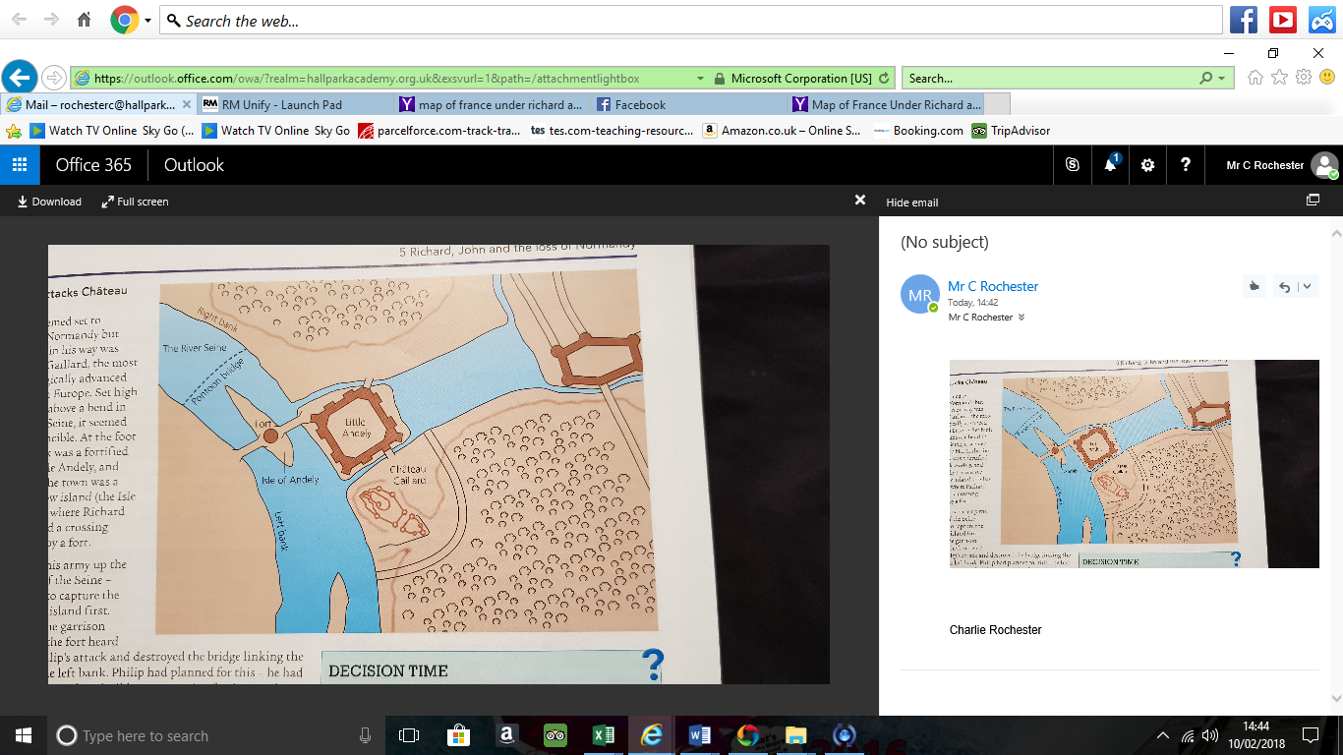

- Philip led his army up the left bank of the Seine – Intending to capture the fort on the island first. However, the garrison (army) defended the fort by destroying the bridge so Philip and his army could not get across.
- Philip had a plan for this, he brought his own supplies and built a new crossing further up the river. HE WAS ABLE TO BUILD A PONTOON BRIDGE and lead majority of his men across the eastern bank of the Seine.
- Richard tried a daring rescue by attacking the French at night and smashing the pontoon bridge. By the time his troops arrived the French protected the bridge and two of John’s ships were sunk, two were captured and the rest retreated. THE FRENCH WERE IN TOTAL CONTROL OF THE AREA SURROUNDING C.G

Fall of Chateau Gaillard
John decided that rushing to defence of C.G was too dangerous. He came back to England to try and persuade more Barons to join him. JOHN NEVER RETURNED TO NORMANDY.
John left at a time where Normandy needed a leader the most. The fact he did not go back to Normandy showed a lack of loyalty as a lot of his men were trying to hold on, for example Roger de Lacy was holding on to C.G against Philip.
In February 1204, Philip II was ready to storm C.G. Siege machines were brought close to the castle walls and French soldiers were able to mine under the foundation of one tower and eventually it collapsed, leaving a hole in which French could storm. The English were defended by the keep which was 8 foot thick. Philip sent a siege machine known as a SCROFA. This seriously weakened the walls
Once C.G was overrun, Philip was able to overrun Normandy. Town after town fell to him. On 24th June 1204 Rouen surrenders to Philip. John had adapted the nickname SOFTSWORD as he was unable to defend his duchy. HE SPENT THE NEXT DECADE TRYING TO GET NORMANDY BACK.

Consequence of the loss of Normandy
- Collapse of the Angevin Empire
- Financial Problems
- It shaped how John ruled England
- Discontented Barons
- Threat of invasion
- Damaged reputation

King John’s Downfall – Unit 3
Lesson 1 – King John’s dispute with the Papacy (Pope)
Task 1: Complete the spider diagram

Why was religion important in England? Give 5 reasons

King John’s reputation was highly judged due to the dispute with the papacy in the years 1205-1213. At this time history was recorded by monks and they were highly critical of King John. There were causes and consequences that led to a Civil War.
What were the causes of the dispute with the Pope?
- John and the Pope (Innocent III) had a severe clash of personalities.
- John wanted to control the church and force the Pope to accept his demands.
- Pope Innocent III was one of the most energetic and forceful popes of the Middle Ages and expected all Kings to see him as the head of the Church and religion, they HAD to follow him. He was 37 years old and for a Pope he was VERY young.
- Dispute began in 1205, when Hubert Walter (Archbishop of Canterbury) died. John saw this as a chance to appoint his own Archbishop of Canterbury – An important person who would advise John in his government.
- Archbishop was elected by the monks of Canterbury, but John thought he could persuade them to choose who he wanted. THIS IS WHAT RICHARD AND HENRY II DID.
- HOWEVER, the monks chose their own candidate JOHN DE GRAY. John and the monks of Canterbury appealed to the Pope but HE CHOSE HIS OWN ARCHBISHOP – A man called Stephen Langton.
- John was furious – He saw Langton as an enemy because he was teaching in Paris. John was also fuming that the Pope was ignoring his power. Innocent III did not back down and appointed Langton.

Task 2: Read the above text – explain why the following people are important in the dispute:
- Hubert Walter:
- Innocent III:
- Monks of Canterbury:
- John De Gray:
- Stephen Langton:
- John:

Task 3: Read the following information and choose the right answer
John reacted well/badly to the Pope interfering. He immediately punished/praised those to be guilty of undermining his authority/weakness in choosing the next priest/archbishop of Canterbury/York.
- John refused/accepted Stephen Langton into the kingdom.
- John expelled the Canterbury monks/priests from their monastery.
- John seized all the land/power from the Italian clergy in England. This was to punish the Pope for his interference in the English Church.
John thought his actions would put pressure on the pope to change his mind and let John choose his own Archbishop John De Gray/Langton. Innocent was just as stubborn/crazy as John. The Pope also had 2 powerful weapons he could use to force John into submission, an interdict and excommunication.

Task 4: The Interdict and its impact on everyday life
Pope Innocent sent 3 Bishops to England to persuade John to accept Stephen Langton as Archbishop of Canterbury.
JOHN WOULD NOT GIVE IN!!!!!
In March 1208, Innocent responded by placing England under a sentence of Interdict. This was a serious punishment. It meant that England were denied access to the Christian SACRAMENTS.

Task 5: Complete table using Pages 71-72
Make sure you include the following key words: Sacrements, Bishopric, Abbacy
Consequences of Interdict | John’s reaction to Interdict

Task 6: Excommunication of King John – Highlight the following
- Excommunication was positive for John
- Excommunication was negative for John
Excommunication was much more dangerous that the interdict. In November 1209, John was excommunicated. His excommunications meant that all Christians no longer had to obey his, this meant that his Barons were no longer obliged to obey him, likewise to the population of England.
Most Barons found it VERY difficult to turn away from John as John could confiscate their land and property if they did not fulfil their feudal oath. In the end most Barons ended up carrying on following John. They were angry with him for putting them in an impossible decision.
The excommunication at first benefitted John as he grew richer as he was claiming the income from 7 bishoprics and 17 abbacies. It was estimated that John was making around £13,500 from confiscated church land. HOWEVER… JOHN NEEDED SUPPORT AS IF THE POPE CALLED A CRUSADE, PEOPLE COULD ATTACK ENGLAND AS JOHN WAS TECHNICALLY NOT PART OF THE CHRISTIAN CHURCH. John had to reconcile with the Pope.

Task 7 – Reconciliation
In early 1213, John sent envoys to Innocent III to agree terms. Innocent agreed to life the Interdict and excommunication if John agreed to the following:
- Langton becomes the Archbishop of Canterbury.
- All the Bishops who left during this time could come back to England and get their land back.
- John was to pay £27,000 in compensation to the Pope.
- If John broke the agreement he would NEVER be allowed to appoint Churchmen again.
- John also agreed to give all the land of England and Ireland to the Pope and he became a Vassal and the Pope became Johns LORD.
- John also agreed to pay the Pope £675 per year for life.
THIS WAS ALL TO HELP JOHN JUST IN CASE AN INVASION OCCURRED!
In July 1213, Langton arrived in England. After John paid £4,000 to the Pope, Langton lifted the Interdict. EVEN THOUGH THIS SEEMED TO BE A NEGATIVE, JOHN BENEFITTED HUGELY:
- He showed himself to be a shrewd politician.
- He now had full support from the Papacy in a time of crisis.
- He could appoint whoever he wanted in England now with Bishops.
- OVERALL A VERY WISE AGREEMENT IN THE LONG-TERM EVEN THOUGH IT COSTED JOHN FINANCIALLY!

Exam Practice: The excommunication of King John was the main consequence of the quarrel between King John and Innocent III in the years 1205-1213. How far do you agree?
Agree – Excommunication – Describe and explain who it would have upset.
Disagree - 3 OTHER CONSEQUENCES OF THE DISPUTE
- Interdict
- Barons discontent
- Royal Revenue increase
- John’s reconciliation

1213
1205

Task: Make a timeline on John and the dispute with the Pope. Just with key events.
Why did Johns relationship with the Barons get worse? 1205-onwards
Two possible exam questions:
Explain why John’s relationship with his Barons worsened between the years 1205 and 1215 (12)
King John’s financial policies did the most damage to John’s relationship with his Barons, how far do you agree? (16)
4 F’S (Finance, favourites, fairness, France)
Reason number 1 – Finance
John had lost a lot of finance for a few reasons:
- He lost Normandy which provided A LOT of extra money.
- Inflation occurred which meant John’s money became worth less.
- John was also a lavish spender, spending around £700 on robes (bear in mind, a knights salary was £20 a year)
What did John introduce in terms of finance? | What were the consequences? This caused anger because….
Sheriffs were put under pressure to collect more money from the counties | Sheriffs became incredibly unpopular. People could not afford constant tax.
In 1207, John introduced a new tax called the Thirteenth. Everyone had to pay a ‘thirteenth’ of their wages to the King. | John’s officials become unpopular by raiding people’s homes to make sure they were not hiding taxable goods.
John introduced the Thirteenth without the Barons agreeing | Barons felt John was becoming a tyrant (dictator) by not consulting them.
John took large taxes from the larger towns, mainly Lincoln and London. | Anger grew in towns. Lincoln and London became rebel bases where lots were angry.
John made such exchequers calculated exactly what barons owned. If Barons could not afford it, their land would be confiscated. | Barons felt very insecure and feared their land could be taken at any time.
John restricted what people could do in the Royal Forest. | Resentment and anger grew from people, especially in the North.

Reason number 2 – Favourites
- John found it very difficult to trust his Barons. He meant he tended to rely on people who were closest to him for advice. John rewarded his royal ‘favourites’ handsomely. THIS LED TO MANY BARONS FEELING EXCLUDED FROM POSITIONS OF POWER.
- Barons felt John was using his power arbitrarily – meaning he was taking decisions that did not benefit everyone!
- Barons expected John to use his powers of patronage to reward a wide circle of people. However, John tended to reward only those close to him.
- What made it worse is that a lot of John’s ‘favourites’ were not English, such as Peter des Roches who came from Touraine.
- THIS WOULD ALL CAUSE BARON DISCONTENT AND ANGER.

What do the following words mean?
Arbitrary:
Patronage:
Discontent:
Reason number 3 – Fairness
Fairness number 1 – Treatment of William de Briouze
John’s treatment of Baron’s that owed him money was also a reason why Barons got angry at him.
William de Briouze – Was a Baron who John favoured at the beginning of his reign. John gave William land in Ireland. In return, William promised to pay John 5,000 marks, at 1,000 marks per year. In 5 years, William had only paid John 700 marks.
In 1208, John tried to force William to pay him his money he owed by seizing his possessions. William resisted this and his lands were taken into the Kings hands, he ran away to Ireland with his wife and son (WHO WAS ALSO CALLED WILLIAM).
John went to Ireland in 1210, William de Briouze (Father) ran away to France, while his wife and son ran off to Scotland. John had his wife and son captured, where he had them starved to death. He believed this punishment was acceptable due to the fact that de Briouze had not paid his debts.
Fairness number 2 – John’s use of arbitrary power
Johns actions against Briouze showed that he thought he could do what he wanted, when he wanted. John thought he could act with no respect to the law or the barons themselves. THIS WAS KNOWN AS ARBITRARY POWER.
John’s use of arbitrary power made the Baron’s feel very vulnerable. He introduced harsh fines and raised taxes without negotiation with or consulting the barons. John showed little concern for the Barons rights and nature of punishments was decided by the King. John’s treatment of Briouze’s wife and son was big news and spread quickly around the Kingdom. It sent out a clear message to Barons who owed John money or fell out of royal favour. IF JOHN COULD TREAT SOMEONE WHO USE TO BE SO CLOSE IN THIS WAY, THEN NOBODY WAS SAFE!
Fairness number 3 – 1212 plot to assassinate John
Between 1209-1212, John faced threat from Scotland and Wales and successfully dealt with threats (including forcing William of Scotland to give him his 2 daughters as part of a peace treaty!!). As a total surprise in the SUMMER OF 1212, 2 of the most important men in Britain , De Vesci and FitzWalter plotted to assassinate John. The barons involved in the ploy had planned to murder John in Wales or desert him during a battle. They then intended to elect a new King. JOHN ACTED, BRINGING IN FOREIGN SOLDIERS TO DEAL WITH IT, WITHIN 10 DAYS OF FINDING OUT, JOHN HAD TAKEN VESCI’S CASTLE. VESCI RAN OFF TO SCOTLAND AND FITZWALTER RAN OFF TO FRANCE, THIS STOPPED AN OPEN REBELLION.
Consequence of the plot
- John was made aware of the threat of the Barons. JOHN KEPT HIS FAVOURITES CLOSE AND EVERYONE ELSE FURTHER AWAY.
- Led to John’s reconciliation with Pope in 1213.
- Plot encouraged Philip II to continue with his plans to invade England and placing his son Louis, on the throne.

Task: Write down who the following men are:
Philip II:
Louis:
De Vesci:
FitzWalter:
William De Briouze:

Reason number 4: Failure to recapture FRANCE (Normandy)
John felt confidence of reclaiming Normandy in 1214 because:
- John had alliances with some of the leading figures of France.
- John was joined by a number of Barons from England, as well as knights.
- John had the money to supply a large army and buy in foreign soldiers.
- John had enough men to attack from two fronts. EARL OF SALISBURY WAS SENT WITH AN ENGLISH FORCE TO FLANDERS while JOHN LANDED IN THE SOUTH.

Why did things go wrong?
- STARTED WELL – John captured many castles and gained control of much of Poitou.
- John and Louis met and John’s allies were not willing to risk everything in a battle and backed out. John fled and left behind weapons and valuables.
- John was forced right back and the attempt was a complete failure.
- Battle of Bouvines (1214) – John was not involved in this! This was the other battle in which the Earl of Salisbury was fighting. German soldiers were second from killing Philip however, a French soldier rescued Philip II. This led to a counter-attack which led to a surrender and the Earl of Salisbury was taken prisoner. JOHN’S CHANCES OF GETTING NORMANDY BACK WERE OVER!!!!

Consequences of not regaining Normandy
- French dominated and became the leading power in Western Europe. Philip gained a lot of land and John lost out hugely!
- Barons turned on John – Barons were displeased that John spent a huge sum of money on a failure. EVERYTHING JOHN HAD PLANNED FOR (FOR NEARLY 10 YEARS!!) WAS IN RUINS. The events led to the Barons meeting with John in January 1215 and this led to a rebellion!!!!!!

Task:
King John’s financial policies did the most damage to John’s relationship with his Barons, how far do you agree? (16)
Go through the text and pick out 3-5 pieces of evidence for each and EXPLAIN why the Barons would have got angry at it!
Finance | Favourites | Fairness | France
Magna Carta and the First Barons War 1215
Events of the Barons’ rebellion of 1215
Event | Description
1 | Late 1214 – At the end of John’s failure in Normandy some of the leading barons met. They had a copy of Henry I’s coronation promise which said he would protect the rights and freedom of people
2 | January 1215 – John agreed to meet Barons in London. Barons made demands, mainly on the charter (see above!). John refused to accept them but he did agree to meet up with them again in April
3 | Early 1215 – John started to prepare for war against the Barons. He restocked his castles and began recruiting foreign soldiers.
4 | March 1215 – John agreed to go on a future crusade to the Pope. In return, the Pope promised to support John.
5 | April 1215 – By April, the barons lost faith in John and they wanted more than before! They sent John another set of demands.
6 | 5th May 1215 – John did not respond to the demands. The Barons broke their homage to John and declared FitzWalter as their leader and marched to Northampton. THE REBELS FAILED TO TAKE NORTHAMPTON CASTLE.  John said that if the rebels were to get anywhere, the Pope had to support them.
7 | 12th May 1215 – John ordered that all Barons who went against him had their land seized. By May 1215, 39 Barons declared themselves as rebels and the same number took the Kings side. A LOT OF BARONS STAYED OUT OF IT AT THIS STAGE TO WAIT TO SEE WHO BEGAN TO WIN.
8 | 17th May 1215 – Barons made their way to London, where they opened the gates to other rebels. They gained control of the capital. THE PEOPLE OF LONDON JOINED THE SIDE OF THE BARONS.  This was a huge problem for John as London was so rich.
9 | Summer of 1215 – Norfolk and Suffolk were under control of the Barons. A rebel army also gained control of Lincoln, although the castle did not fall. John was not in a position where he HAD to listen to the Barons or he would be overthrown.

Magna Carta
John agreed to meet the Barons in June 1215 at Runnymede. The Barons presented Johon with the “Articles of the Barons” which would form the MAGNA CARTA. There were 63 chapters of the Magna Carta. The meeting between Barons and King went on for days. The Magna Carta was authorised on the 15th June – JOHN DID NOT SIGN IT – HE APPROVED IT WITH THE ROYAL SEAL.
On 19th June – The Barons performed homage to the King. THIS MEANT PEACE WAS DECLARED. However, the Barons were to hold London until August 15th while John proved he could keep to it. SOME OF THE KEY AREAS OF THE MAGNA CARTA WERE:
- Barons could not be fined more than £100
- Kings demands for tax were limited.
- English Church was to be free, elections were free from interference by the king.
- King appoints sheriffs who were not corrupt.
- Barons could not be fined until a proper trial occurred.
- No foreign army can be kept during peace

Task: Answer the following questions
- Give 3 events that triggered Baron anger towards John

- What is the Magna Carta?

- Why was John in a better position than the Barons following Magna Carta being signed?

The First Barons War – 1215-1217

Task: Read through the following information – Highlight turning points
At the end of each event – Write who is in control and why

Event 1 – Rebels take Rochester Castle
- In London, rebels feared that John may attack at any moment.
- Rebel knights led by d’Albini took control of Rochester Castle
- Rochester Castle was important as it stood on the road from Dover to London – being in control wold help defend London from attack
- John headed straight there with a castle
Who is in control and why?

Event 2 – Rebels surrender Rochester Castle – November 1215
- Rochester Castle had high walls that were 12 feet thick. Rebels hoped to keep hold of it long enough so reinforcements came from France.
- However, Albini only had 95 knights
- John’s men quickly captured the town of Rochester and attempted to take control of castle.
- John set up siege machines and they pounded the castle walls
- The castle was under attack for 6 weeks – John’s army were well fed while the rebels were exhausted. They fought bravely.
- John then ordered pig fat to be sent to his men – The pig fat was used to create a fire strong enough to burn through the hole in which John’s men had dug – THE REBELS SURRENDERED IN NOVEMBER 1215
Who is in control and why?

Event 3 – December 1215 – French soldiers start to arrive
- French started to arrive to assist the rebels.
- Louis promised to arrive with his main force in the new year.
- The French brought equipment, money and siege equipment.
Who is in control and why?

Event 4 – Early 1216 – John’s campaign in the North
- John needed to gain control of the North to ensure the rebels did not gain control.
- John’s reputation had been enhanced due to what happened at Rochester.
- Hearing of the King’s approach, many castles held by rebels were left as the rebels ran away, fearing for their lives.
- John gained control of the north BUT THE REBELS CONTINUED AS THEY SURVIVED.
- A lot of rebels stayed in Scotland as they realised that John could not stay North long. When John left for the south, rebels attacked again.
- Some historians believe John should have gone straight to London and not the north of England – John’s own people began to turn against him as foreign soldiers began to loot churches to be paid.
Who is in control and why?

Event 5 – May 1216 – Louis arrives
- Louis arrived in Kent with a large French army.
- John tried to block Louis’ journey but the weather prevented his ship from blocking the French from arriving.
- John decided against meeting Louis in battle. Instead, Louis arrived and was unopposed.
- Louis took control of most of Kent and then headed for London.
- By the summer of 1216, many of John’s own men had deserted him. Even 17 of his own knights joined the rebels.
Who is in control and why?

n

Event 6 – Summer of 1216 – Louis takes control
- Middle of July – Louis and the rebels took over Essex, Norfolk and Suffolk. They also took control of Yorkshire and Lincoln.
- Louis moved to Dover Castle to try and capture the castle that his father Philip II had told him was the “key to England”.
- John had control of Dover and it stood in the way of the French from landing in England with supplies.
- John set out aiming to draw the enemy away from their siege of Dover.
Who is in control and why?

Event 7 – October 1216 – John’s death and succession
- September 1216, John was in Lincoln where he broke up the siege of the Castle.
- On the 18th October 1216, John died in Newark – 3 days after contracting dysentery.
- John’s death caused a huge problem – His son, Henry, was only 9 years of age. No child had been crowned King of England for nearly 240 years. This was a time in which England needed a strong leader.
- A child king needed a PROTECTOR who could command respect and maintain royal authority.
- Situation in England was precarious because country was in middle of a civil war and Louis controlled half the country. To make matters worse, the rebels-controlled London.
- The only positive was that royalists held the most important castles (such as Lincoln)
Who is in control and why?

Event 8 – William Marshal becomes Protector
- Just before John died, he placed the kingdom and his son, under the protection of William Marshal.
- On 11th November – Barons named William Marshal as protector while Henry III was named regent.
- Marshall decided to take the young king to Bristol , where they reissued Magna Carta. This was to tempt rebel barons back onto the king’s side.
- In 1217, William Marshal’s energetic and experienced leadership lead to the royalists beginning to fight back.
Who is in control and why?

John’s actions during the First Baron’s war could be deemed a success. How far do you agree?
You may use the following in your answer:
- Rochester Castle
- Role of Louis and the French

Condition of England in 1216

- England was ruled by a Protector William Marshal
- England’s King was 9 years old
- England was in the middle of a civil war
- Town life and trade had been disrupted!
- Kingdom was bankrupt
- Welsh had seized some of England’s land.
- Scottish ruled areas of the north.
- Louis of France controlled half of England

