Western Front revision guide

- Medicine before WW1 – X-rays, Blood Transfusions and Aseptic Surgery
- Construction of a Trench
- Battles of WW1
- Transport and Communication
- Medical Problems
- Evacuation Route on the Western Front and underground hospital at Arras
- Surgery and Medicine on Western Front

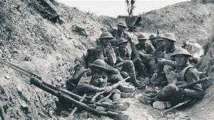

Aseptic Surgery
Medicine before WW1
- Lister first used Carbolic Acid in 1865, based on Pasteur’s Germ Theory
- All medical staff had to wash their hands, faces and arms before entering operating theatre.
- Rubber gloves and gowns were worn, decreasing rates of infection.
- Air was sterilised by being pumped over heating system to kill germs
- Use of steam sterilisation. Machine called an autoclave was invented in 1881 by Charles Chamberland. Sterilised surgical instruments.

Exam Practice – Describe 2 features of Aseptic Surgery (4)
Feature 1:

Feature 2:

X rays - Development
- Developed by Wilhelm Roentgen in 1895.
- Led to radiology departments opening in a number of hospital in 1896. Glasgow Royal infirmary was able to produce images using an x-ray.
- Birmingham General Hospital took it one step further – Dr Hall-Edwards made a diagnosis based on x-ray when he located needle in a woman’s hand. THIS WOULD HELP ON WESTERN FRONT. XRAY BEFORE TREATMENT.
- Radiation was a problem – 1,500 times more than today. Patients could be burnt or lose hair.
- Glass tube used could break easily and the machines were very difficult to move around as they were so large
Exam Practice – Describe 2 features of x-ray development (4)
Feature 1:

Feature 2:

Blood Transfusions
- Average body contains 5 litres of blood. If you lose too much you could go into shock and die
- James Blundell – First blood transfusion with pregnant women 1818-29 (11 transfusions – 50% success rate)
- Blood could not be stored, had to be used straight away. To begin with donor and patient had to be connected by a wire. Led to rejection of blood or clotting problems.
- Blood groups were unknown until 1901 by Karl Landsteiner – This prevented blood being rejected. A, B and O were the main blood groups.
Key Word | Definition
Communications Trench | Ran between other trenches to allow people to discuss and pass messages.
Reserve trench | 100 metres behind the support trench and was where reserve troops could be mobilised for a counter-attack if the front-line trench was captured.
Frontline trench | Attacks would be made from here. MOST DANGEROUS AREA.
Support trench | 80 metres behind the frontline trench and the troops would retreat here if the frontline trench came under attack.
Dugout | Would be dug in the side of the trench where men could take protective cover if needed.
Artillery emplacements | Very rear where the weaponry was kept.
Forward listening post | Men would stay here to spy on the enemy to try and work out their next move or tactics.
No-mans land | Area which men would cross if they went over the top.
Barbed wire | This would be used to slow down the enemy attack.
Company HQ dugout | Area in which generals would discuss their tactics.
Firebay | Where troops did their shooting, they would be protected by sandbags
Duckboard | To prevent soldiers from standing in water. Possibly preventing Trench-foot
Firestep | Allows the soldiers to fire towards the other trench as they were 2.5 metres in depth.
Parapet | Low protective wall
Ammunition shelf | Area in which ammo was kept near the firestep
Construction of a Trench

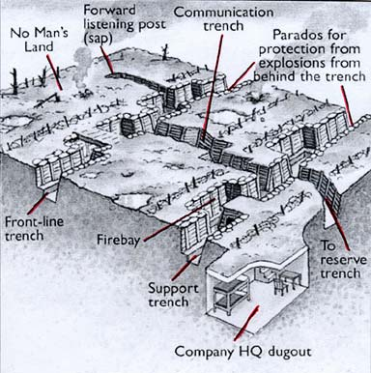
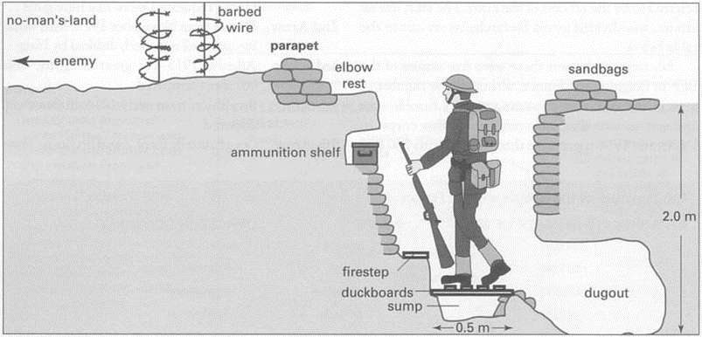

The main aspects of fighting occurred in the areas of Belgium and France – A key area of fighting was Ypres (EEPS) – This was a salient – surrounded on 3 sides by the enemy
Battles of WW1
Battles | Facts
1914 – First Battle of Ypres | Key Events:  - In autumn 1914, Germans launched attack on British positions to east and north-east of Ypres.  - Battle went on 12 Oct-11 Nov.Result:  Result:  - British lost over 50,000 troops in battle.  - British held on to Ypres.  Significance:  - British controlled English Channel ports, so supplies and reinforcements could be provided.
Mines at Hill 60 | Key Events:  - Germans captured this man-made hill to south-east of Ypres in Dec 1914, giving them strategic advantage.  - British dug tunnels into hills (offensive mining), placed five mines in tunnels and blew top off hill.  Result:  - April 1915- British took it back.  Significance:  - British took back strategically important position.
1915 – Second Battle of Ypres | Key Events:  - Sequence of battles 22nd April-25th May 1915.  - Happened straight after the Battle for Hill 60  Result:  - British losses of 59,000 men.  - Germans moved 2 miles closer to town of Ypres on eastern side.  Significance:  - First time Germans used chlorine gas on Western Front.
1916 – Battle of Somme | Key Events:  - Launched 1st July 1916 and ended November 1916.  - Aim to take land back from Germans.  Result:  - Enormous casualties. On first day, British casualties over 57,000 with death totalling around 20,000.  - Estimated Britain suffered over 400,000 casualties in total.  Significance:  - Tried two new strategies which would both contribute to increased casualty rates; the use of the creeping barrage and the first use of tanks.
1917 – Battle of Arras | Key Events:  - April 1917, 24,000 men hiding in tunnels attacked the Germans with aim of breaking through German lines.  Result:  - British advanced about 8 miles in first few days but the advance then slowed by May.  Significance:  - Large number of casualties (160,000 British and Canadians).
1917 – Third Battle of Ypres | Key Events:  - Throughout June 1917, British prepared for main attack in Battle of Messines (driven Germans off ridge that formed part of Ypres salient).  - 31st July- launched attack, marching east from Ypres towards Passchendaele.  - Campaign ended in November.  Result:  - Advanced about 2 miles on first day.  - Began to rain and ground became waterlogged- many men fell and drowned.  - Estimated 245,000 British casualties.  Significance:  - British moved edge of salient back by about 7 miles.
1917 – Battle of Cambrai | Key Events:  - Launched 20 October 1917.  Result:  - Tanks able move easily across barbed wire and their machine guns were very effective.  Significance:  - Effective change strategy- artillery barrage changed so less warning given to Germans of coming attack. First large-scale use of tanks.

Problems of Transport and Communications
Transport and Communication
- Constant shelling left landscape full of craters and destroyed many roads.
- Land often waterlogged.
- Had been farmland, so lots of fertiliser in soil. Meant was lots of bacteria that could infect wounds.
- Stretcher bearers exposed to shelling and gunfire. Physically tiring work.
- Beginning war, military leadership decided not to send any motor ambulances but horse-drawn wagons couldn’t cope with numbers casualties.
- Horse-drawn wagons were shaky and often made injuries worse.
- Lack of transport led to soldiers being left to die or taken prisoner.
- Motor vehicles couldn’t operate in muddy terrain.

Solutions for Transport and Communication issues
- Following public appeal for donations, made by The Times newspaper, had enough money to buy 512 ambulance wagons within 3 weeks.
- First motor ambulances sent to Western Front in October 1914, as result of work by Red Cross.
- Four men would be used to stretcher-bear, rather than 2.
- In worst areas, six (rather than the usual two) horses would be used to pull ambulance wagons.
- Wounded men also transported by train or canal in final stage of evacuation to the Base Hospitals on French coast.
- Originally used French good trains but first ambulance train arrived in France in November 1914 (spaces for stretchers). Some later trains even had operating theatres.
- Some of wounded being carried on canals by-passed Base Hospitals to be transferred directly to ships transporting the wounded to Britain.
- Put more evacuation hospitals in France, better equipped with operating theatres and other appliances.

Condition | Facts  Condition/injuries requiring treatment in the trenches
Shells and Shrapnel | Statistics?  - Responsible for 58% wounds.  - 60% shrapnel injuries to arms and legs.  How caused injury/death?  - Explosion kill/wound immediately.  - Scattered shrapnel (fragments of metal in casing) over wide area.
Trench-foot | How caused injury/death?  - Painful swelling turned to gangrene (decomposition of body tissue due to loss of blood supply)  How attempted limit impact?  - Prevention- whale oil, keep feet dry and change socks regularly.  - Amputation only treatment for gangrene (stop spreading).
Trench-fever | Statistics?  - Effected est. half a million men on Western Front.  How caused injury/death?  - Flu-like symptoms- high temperature, aching muscles, headache.  How attempted limit impact?  - By 1918, cause identified as lice, so delousing stations set up. Led to decline in cases.
Shellshock | Statistics?  - Suggested around 80,000 British troops experienced shellshock.  How caused injury/death?  - Tiredness, headaches, nightmares, loss of speech, uncontrollable shaking and complete mental breakdown.  How attempted limit impact?  - For some, treatment back in Britain. Craiglockhart Hospital in Edinburgh treated 2,000 men.  - Condition not well understood. Some accused of cowardice and even shot!
Bullets | Statistics?  - Bullets responsible 39% wounds.  How caused injury/death?  - Machine gun bullets could fracture bones or pierce organs.  How attempted limit impact?  - Soft caps replaced by Brodie helmets (steel helmet with strap to prevent it being thrown off in explosion) from 1915. Estimated that helmet reduced fatal head wounds by 80%.
Infection | How caused injury/death?  - Shrapnel and bullets carried fabric from clothes into wound. Soil full of bacteria from fertiliser use.  - Soil contained bacteria for tetanus and gas gangrene (produces gas in gangrenous wounds).  How attempted limit impact?  - Use of anti-tetanus injections from end 1914 reduced impact tetanus.  - No cure for gas gangrene- bacteria spread quickly and could kill a person in one day.
Gas Attacks | Statistics?  - Only about 6,000 British soldiers died as result of poison gas.  How caused injury/death?  - Chlorine (first used by Germans in 1915 at second battle Ypres). Led to death by suffocation  - Phosgene (first used at end 1915 near Ypres). Similar to chlorine but faster acting- killed exposed person within two days.  - Mustard (first used in 1917 by Germans). Odourless gas worked within 12 hours, causing both internal and external blisters.  How attempted limit impact?  - Soldiers soaked cotton pads with urine and pressed them to faces.  - Troops given gas masks from 1915.

Evacuation Route
RAMC – Royal Army Medical Corps – Responsible for medical card – was Founded in 1898.
FANY – First Aid Nursing Yeomanry – Founded in 1907 – Voluntary organisation that sent women to the Western Front. Provided frontline support including driving ambulances and helping with emergency first aid.
Stretcher Bearer
- Recovered the dead and wounded, sometimes during breaks in fighting and under fire.
- Carried basic medical equipment such as bandages and morphine.
- 16 bearers per 1000 men.
- 4-8 men it took to carry a stretcher depending on the terrain.
- Often never enough stretcher bearers.

RAP (Regimental Aid Post)
- Very close to the front line (200 metres), or in communication trenches or deserted buildings. Could be dug out in a trench.
- There would be a battalion regimental medical officer whose job was to distinguish difference between lightly wounded and those needing serious medical attention.
- If you could not be treated in RAP you would be sent to a dressing station.
- Men would walk in themselves or be walked in by other soldiers.
- Poorly lit and always under fire – Would have a team of 30 orderlies and stretcher-bearers for each battalion.
Dressing Stations (ADS and MDS)
- ADS would be around 400m from the RAP and MDS a further half a mile back.
- Dressing stations were set up by Field Ambulances (large medical unit)
- DS would be in tents or derelict buildings.
- Cases would be separated into more and less serious cases. This was known as triage.
- Serious cases sent to CCS via motor or wagon ambulances.
- Each station would be staffed by 10 medical officers, orderlies and stretcher-bearers.
- To get here you would work or be carried in by stretcher.
- Could deal with 150 men – However the more serious the battle, the higher numbers (1916, Somme)
Casualty Clearing Station (CCS)
- First large, well-equipped medical facility the wounded would see.
- 7-12 miles away from fighting, usually in series of tents or huts. Some were in schools or factories. Would be near railway lines to allow next stage to happen quickly.
- CCS closest to the front-line would operate on the most serious injuries, such as chest injuries. When arrived they would be separated into 3 groups.
- Walking wounded.
- Hospital treatment
- No chance of survival.
Base Hospitals (Also known as General or Stationary Hospitals)
- Located near the French or Belgian Coast so that wounded could be transported back to Britain if needed.
- CCS were more important than Base Hospitals. CCS operate, and men would recuperate in Base Hospital.
- Base Hospitals experimented with new techniques which were used in CCS’s. For example, they divided patients up into different wards so each doctor could specialise in injuries. Could deal with 2,500 men. Base Hospitals did more surgery towards end of war
- Operating theatres, X-ray departments and has poison treatment would be seen here.

Underground Hospital at Arras
- November 1916, tunnelling began under the town of Arras. In 800m of tunnels a working hospital was created so close to the Front-line that it was, in reality, a dressing station.
- It was sometimes called Thompson’s Cave after the RAMC officer who was responsible for equipping it.
- Waiting rooms
- 700 spaces for stretchers to be placed as beds.
- Operating theatres
- Rest stations
- Mortuary for the dead

Preventing infection from spreading
Surgery and medicine on the Western Front
- Wound excision or debridement – Cutting away dead, damage and infected tissue around the site of a wound. HAD TO BE DONE QUICKLY. Close by stitching.
- Amputation – By 1918, 240,000 men had lost limbs, it prevented death from infection.
- Carrel Dakin method – Antiseptics, such as Carbolic lotion were ineffective when treating gas gangrene. By 1917, the Carrel-Dakin method which involved using a sterilised salt through a tube, was the most effective alternative. Solution only lasted for 6 hours so had to be used quickly after being made.

Thomas Splint
- 1914-15 – Gunshot or shrapnel wounds to legs only had 20% chance of survival. THIS WAS BECAUSE THEY CREATED A COMPOUND FRACTURE that pierced the skin.
- Thomas Splint stopped joints from moving. The survival rate improved from 20% to 82% due to this.
Mobile x-ray units
- Marie Curie – When war broke out she understood the importance of x-ray for detecting shrapnel and was responsible for equipping 20 mobile x-ray vans to work in French area of Western Front.
- Used to identify shell fragments and bullets in wounds.
- 2 X-rays would be taken from different angles.
- X-rays could not identify all objects in the body.
- Length of x-rays wound cause serious problems – Could take several minutes.
- X-ray machines could only be used for 1 hours at a time due to overheating. Three machines would be used in rotation. Tubes improved in 1917 by the USA however this was too late for some key battles. (Somme and Ypres).
Blood Transfusions and Blood Bank at Cambrai
1915 Use of blood transfusions in British sector on Western Front pioneered by Canadian doctor, Lawrence Bruce Robertson, in the Base Hospital at Boulogne. He used the indirect method, where a syringe and tube was used to transfer the donor blood to the patient.
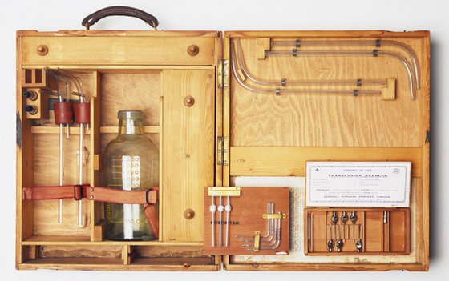
Geoffrey Keynes, a British doctor and lieutenant in the RAMC, designed a portable blood transfusion kit that was used to provide transfusions close to the frontline in a Casualty Clearing Station. However, it could not use stored blood as there was no available refrigeration. He added a device to the blood bottle which helped prevent clotting. Keynes claimed that his work saved countless lives.
American doctor, Richard Lewisohn discovered that by adding sodium citrate to blood, the need for donor-to-donor transfusion was removed. Patients no longer needed to be in the same room as the donor.
Richard Weil discovered that blood with sodium citrate could be refrigerated and stored for up to two days.
1916 Francis Rous and James Turner found that by adding a citrate glucose solution to blood, it could be stored for a much longer period- up to four weeks.
1917 Blood transfusions were also being administered in the Casualty Clearing Stations as a routine measure in the treatment of shock.
Before the Battle of Cambrai, Oswald Hope Robertson, a British-born American doctor, stored 22 units of universal donor blood in glass bottles. He built a carrying case packed with ice and sawdust and called this a “blood depot”. During the battle, he treated 20 severely wounded Canadian soldiers (none of whom were expected to survive) with 26 day old blood. 11 of the 20 men survived. This was the first time that stored blood had been used to treat soldiers in shock.

Head injuries/Plastic Surgery
Brain Surgery – Harvey Cushing
Experimented with use of magnet to remove fragments from the brain.
Use local rather than general anaesthetic to prevent swelling of brain.
Careful observation:
- Quick to operate= more likely survive SO… specific CCSs used as centres for brain surgery.
- Dangerous to move men too soon post-op SO… Patients remained at CCSs for three weeks.
- It might look minor but could still be severe SO… ALL head wounds carefully examined.
1917- Harvey’s survival rate was 71% compared to general rate of 50%!

Harold Gillies – Plastic Surgery
- Gillies interest in facial reconstruction but lack of experience led him to devise new operations to deal with problems as they confronted him.
- August 1917, Queen’s Hospital in Sidcup, Kent established. Gillies involved in designing the hospital, so it matched his needs.
- Countless intricate operations carried out.
- By end of war, nearly 12,000 operations had been carried out.

