GCSE History
Knowledge Booklet

The History of Medicine is about some of the most important questions in the whole of history. Today we live far longer than our ancestors did. We are healthier and have more chance of surviving major illness. So why has medicine- and our health - changed so much over the centuries? This paper is about why there were changes and continuities throughout the ages.

Examples of Factors that causes change and continuity.


Key Topic 1: c1250–c1500: Medicine in medieval England
Key Topic 1.1 Ideas about the causes of disease and illness
After the fall of Rome, there was a regression in medicine in Europe. People had a more primitive outlook about what caused disease and how to treat it.


Supernatural and religious explanations

- People believed that Gods caused disease – as seen with Black Death in 1348 as felt was a punishment from God.
- Monasteries preserved old writings by Roman and Greeks so could be studied again later after wars. Islam also preserved old ideas too. However, both of these stopped new ideas (Religion-Helping/Hindering)

- Some people believed diseases such as the Black Death were caused by position of planets (doctors believed stars and planets affected people’s bodies as many from same elements of air, earth, fire and water)
- Some minority groups such as the Jews were blamed in countries.
- Some even though illnesses caused by arrows fired by elves! E.g. chicken-pox

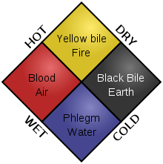
Rational explanations

- In Ancient times Hippocrates (a Greek) developed the idea of the four humours: blood, yellow bile, phlegm and black bile. It was suggested that any imbalance eg. too much phlegm, was the cause of illness.
- Galen was a Greek who was a doctor during the Roman Empire. Galen developed the theory of the four humours by creating a treatment by opposites.
- People continued to believe in Theory of 4 Humours as Galen promoted these ideas.
- People believed Galen had covered everything so his books had all the answers. They were used for medical training.
- Also, Galens ideas fitted in with Christian church which controlled education in Europe in Middle Ages. Galen said the body was created by one god, who had made all parts of the body fit together perfectly. This matched Christian ideas. (Religion-Hindering)
- Others blamed disease on bad digestion, weakness and blockage.

- Some linked it to bad smells from toilets, standing water or rotting items. First suggestions of miasma theory.
- People had no idea that the Black Death of 1348 carried by rats and spread by fleas due to lack of scientific understanding. The Black Death was the name for the bubonic and pneumonic plagues. Symptoms include blisters, high fever, severe headaches, unconsciousness and death.

Key Topic 1.2 Approaches to prevention and treatment
How illness was treated
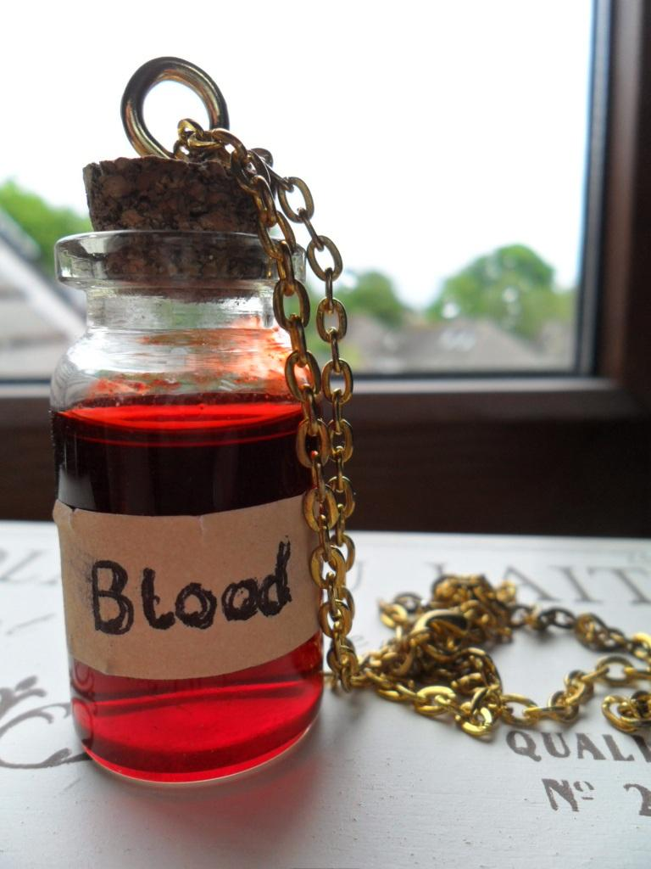
- People in the Middle Ages purged themselves to balance their humours. They used bleeding charts to show where to take blood from.

- People bled regularly to avoid illness – monks bled between seven and twelve times a year.
- Some used leeches to suck out blood. Also did enema (mixture of water and other items) squirted into anus through a pipe attached to pig’s bladder.

- Urology was the study of urine, this was common. The physician would match the patient’s urine against the colours, smell and density on chart. Use of herbal remedies – new books developed such as Bald’s Leechbook which was a collection of treatments. Honey and plantain were common ingredients.
- Decided on best time to carry out treatments using Zodiac man. Believed parts of body linked to signs of Zodiac and planets. Showed doctor when to avoid treating each party of the body.
- Some people prayed to God for forgiveness. During Black Death King Edward III ordered services and processions. 6 foot candles lit as offerings to God. (Religion-Hindering)
- People prayed to God to be merciful and went on pilgrimages to locations such as Canterbury Cathedral (Religion-Hindering)
- Flagellants whipped themselves to get forgiveness for their sins from God (Religion-Hindering)
Who were the medieval Healers?
- Doctors (physicians) trained at universities by reading books by Hippocrates and Galen
- In England the Royal College of Physicians was created in In 1518, by Henry VIII

- Armies took trained doctors to war with them where they gained experience as surgeons on battlefield. (War-Helping)
- However, there fewer than 100 physicians in England and only the rich could afford them.
- Surgeons trained by observing others. They improved their skills through practise. They did basic surgery such as bleeding, removing surface tumours and sewing up wounds.
- Apothecaries (chemists) – these people had no medical training, but sold medicines and groceries
- Quacks – these were travelling barbers surgeons and tooth-pullers. They sold medicines which were supposed to cure everything
- Many people turned to wise women, neighbours and local 'witches'to cure disease
- Women could be midwives but had to have licences after qualifying through an apprenticeship. However, women could not be doctors because they were not allowed to go to university to study medicine.

- Mothers and family members treated most illnesses. Grew herbs for medicine.
- Priests said prayers to help sick and protect from illness. They ran the hospitals and religion focused on caring for sick. (Religion-Helping)
- Hospitals mostly cared for older people who could not look after themselves. Hospitals were run by monks and nuns who provided food, warmth and prayers. Hospitals rarely admitted the sick in case they spread infection.
- Some hospitals were created for guild members (organisations of wealthy tradespeople) for example shoemakers or silversmiths etc. By 1400 there were over 500 hospitals.

Key Topic 1.3 Dealing with the Black Death, 1348-49
Black Death causes
In 1348 the Black Death reached England. At the time, people did not understand what caused the disease, and they did not know how to stop its spread or cure it. There were both supernatural and natural explanations for it, for example, some people said that God had sent it as a punishment, others that the planets were in the wrong conjunction, or that it was caused by ‘foul air'. Sometimes groups of people such as the Jews or nobility were said to be responsible. Even now historians are not sure what caused the Black Death if it was the bubonic plague it would have actually spread when fleas bite an infected rat and then pas the disease onto other rats and humans.
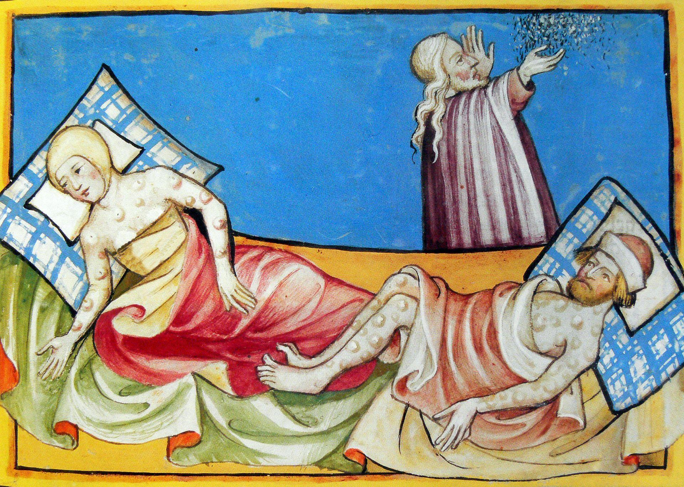
Symptoms of the Black Death
The victims of Black Death suffered a high temperature, headache and vomiting, followed by lumps (buboes) in the armpit or groin. These then went black and spread all over the body, would lead to unconsciousness and death.

Black Death treatments
There were no effective cures or treatments. People relied on prayer or ‘magical cures’ or took practical steps. Some attempts included strong‐smelling posies as a precaution against ‘foul air’. They also ate cool things, cut open the buboes and draining the pus, lighting a fire in the room, tidying the rubbish from the streets and not letting people from other places enter the town. Black Death Impact Between one‐third to a half of the population died.

Key Topic 2: c1500–c1700: The Medical Renaissance in England


Renaissance means ‘rebirth’ or ‘revival of learning’. People at this time focused on ideas of Greek and Romans again and wanted to learn. (Attitudes-Helping). They looked carefully of ideas of Galen as they were worried that in the Middle Ages people may have translated them wrong. New editions of Galen’s books were published.
People in the Renaissance loved enquiry and began challenging old ideas. Doctors began to realise Galen had made mistakes. (Attitudes-Helping). However, not everyone agreed with these new ideas and continued to believe the old ones. (Attitudes-Hindering)

Key Topic 2.1 Ideas about the causes of disease and illness in the Medical Renaissance
Continuity - What ideas about the cause of disease stayed the same?
- Most people continued to believe that Gods caused illness (Religion-Hindering)
- Most people continued to believe in theory of 4 humours.
- Some began to link the fact that dirty places led to more deaths. They believed illness was caused by bad or dirty air – called miasma. (Attitudes-Helping)

Change - What ideas about the cause of disease changed?
- The scientific revolution meant that scientists had changing attitudes and now challenged old ideas. They used experiments to prove findings
- The Royal Society was founded in 1660. They sponsored scientists to research and print findings about physics, botany, astronomy and medicine. The Royal society helped to spread new ideas.

- The printing press was invented in the 1450s, by 1500 they were all over Europe and spread new ideas.
- Thomas Sydenham was a doctor who championed the idea of observation. He believed that each disease was different and it was important to identify the exact disease so that the correct remedy could be chosen to cure it.
- Sydenham wrote a book called Observationes Medicae. This became the standard medical textbook for the next two centuries and include detailed descriptions of how to diagnose many illnesses such as scarlet fever.
- Paracelsus was a doctor who was willing to speak out at a time when could have been killed for it. He said that the Theory of Four humours wrong and illnesses caused by chemicals and should be treated with chemicals. He still believed religion had an impact and said God had sent secret messages about how world works. However most people though he was mad and universities did not teach his ideas. (Individual Genius – Helping)/Attitudes-Hindering)

Key Topic 2.2 Approaches to prevention and treatment in the Medical Renaissance.
Continuity – what ideas about the prevention and treatment of disease stayed the same?
- Continued to focus on good diet and exercise to cure disease.
- Bleeding and purging to balance humours.
- God and King would cure disease – Between 1660 and 1682 over 92,000 people visited the King’s court believing that if Charles II touched them they would be cured of Scrofula (a skin disease)
- Still prayed and wore charms. Many wore Abracadabra charms during Great Plague. (Religion-Hindering)

- Herbal remedies with many written down e.g. Culpeper’s The Complete Herbal was a famous book. New ingredients used as European travels to America and Asia. Rhubarb from Asia used to purge bowels and make people vomit. Opium imported from Turkey and used as an anaesthetic. Tobacco used for a range of problems. (Trade and Communication-Helping)

Change– what ideas about treatment changed?
- Many medieval hospitals were part of monasteries so they closed when Henry VIII closed the monasteries in the 1530s.
- Some free hospitals were set up and these were staffed by physicians rather than monks.
- Some hospitals were taken over by town councils and looked after the elderly poor.
- Inoculation began to be used to prevent against certain diseases – such as smallpox

Who were the healers during the Medical Renaissance in England?
Continuity with Medieval times
- There were still University trained physicians who accepted the ideas of Hippocrates, Galen and Arab doctors. Some were still reluctant to accept Galen could have been wrong. (Attitudes- Hindering)
- ‘Quack doctors’ still made their living through going around towns selling treatments.
- People still visited apothecaries but the apothecary sold and mixed medicines prescribed by physicians.
- Women worked as midwives BUT Women less important from 1620 as Peter Chamberlain invented forceps – these were used to free baby from womb during a difficult birth. After this male physicians said only men should use forceps as only they had been to university to gain anatomical knowledge.

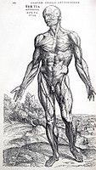
Changes from Medieval time
- Doctors studied the work of Vesalius on anatomy and Harvey on physiology alongside the books of Galen and Hippocrates. This was because their training emphasised the importance of taking a scientific approach.
- Vesalius trained at Louvain, Paris and Padua universities, and ransacked cemeteries for bones and for bodies to dissect.
- Vesalius realised that Galen was wrong, when he discovered that the great man was mistaken about there being two bones in the jaw, and about how muscles were attached to the bone.
- Vesalius said that medical students should perform dissections for themselves, stating that:"... our true book of the human body is man himself."
- Vesalius published 'Fabric of the Human Body' (with high-quality annotated illustrations)Surgeons trained by watching other surgeons and given licenses to do so but still looked down on as not university trained.

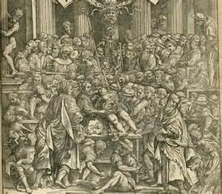

Key Topic 2.3a William Harvey and the Discovery of the Circulation of Blood

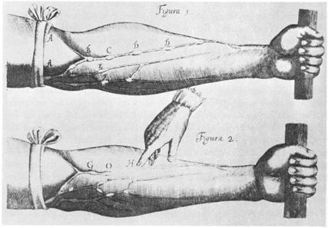
William Harvey (1578-1657)
- Studied medicine at Cambridge and Padua in Italy. Worked as a doctor in London. Became doctor to King Charles I.
- Published his book ‘An Anatomical Account of the Motion of the Heart and Blood’ in 1628 which described how blood circulates around the body. (Individual Genius/Communication-Helping)
- Challenged Galen’s idea that blood manufactured in liver to replace burned up blood and that blood passed from one side of the heart to the other through invisible holes.
- Harvey proved the heart acts a pump, pumping blood around the body by:
- dissecting live cold-blooded animals who hearts beat slowly so he could see the movement of each muscle in the heart
- dissecting human bodies to built up knowledge of the heart
- proved the body was a one-way system by trying to pump liquid past valves and failing to do so
- calculating that the amount of blood going into arteries each hour was three times a man’s weight which showed it was being pumped around. (Individual Genius-Helping)

- Helped by mechanical water pumps in London which may have given Harvey idea that heart is pumping blood. (Technology-Helping)
- Focused on careful dissection, observation and experiment. Spent hours repeating experiments and going over details. Change of attitudes in Renaissance. (Individual Genius/Attitudes-Helping)
- Big impact on future as laid groundwork for future investigations, improved a vital area and showed the importance of carrying out dissection and challenging Galen.
- Harvey’s ideas were only gradually accepted. Many thought he was mad and ignored his theory as he challenge Galen (Attitudes-Hindering)
- Also, was still a lot more to discover about the blood (e.g. blood groups) and his discovery did not make anyone better.
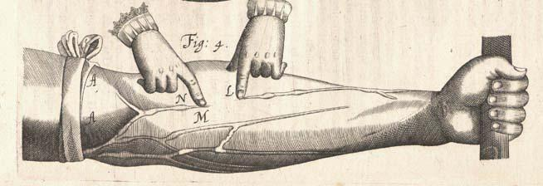

Key Topic 2.3b Dealing with the Great Plague in London, 1665.
Causes of the plague
- Plague had not disappeared after the Black Death in 1348. In 1665 Plague returned to London and killed 75,000 people.
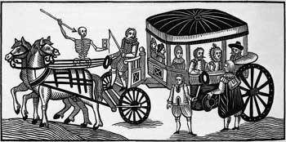
- Explanations for the Plague had not changed since the Black Death and people still believed that God, an imbalance of humours, bad air (miasma) or the movement of the planets could be to blame.

Woodcut, 1630, depicting Londoners fleeing from the plague in a cart

Treating the Victims
- Treatments were very similar to those used against the Black Death. People prayed for the sick, wore religious charms, purged themselves by cutting open buboes. Some people used herbal medicines too.
How to avoid catching the plague
- These were linked to ideas about causes. People held strong smelling bunches of herbs such as lavender or sage under their noses. These were also hug in doorways to stop bad smells entering the house. People stayed at home to avoid contact with others. Some people soaked coins in vinegar when they had to buy things to stop passing on plague
Preventing the spread of plague
- Bills of Mortality were published, to publicise the course of the disease and how many people were buried.
- 'Examiners' and 'searchers' were appointed, who established whether members of a household had contracted the plague. If so, they then shut up the house for a month, and its inhabitants had to stay indoors.
- Constables were appointed, who made sure no one left such houses.

- Bodies were buried at night in huge pits, and mourners were not allowed to attend.
- 'Pest houses' were set up, to quarantine sufferers.
- Householders were ordered to collect all waste, which was then removed by 'rakers'.
- Stray pigs, dogs, rabbits and cats were killed.
These measures unfortunately did not stop the spread of the plague, which only ended when the weather turned cold.

Key Topic 3: c1700–c1900: Medicine in eighteenth and nineteenth century Britain
Key Topic 3.1 Ideas about the causes of disease and illness c1700-1900
- Belief in Gods and 4 Humours fading.
- In early 1800s people still believed that bad air caused diseases.

- Anthony van Leeuwenhoek made a microscope in 1600 and this was improved by Joseph Lister senior who developed a microscope that could magnify things 1000 times. (Science and Technology-Helping)
- Theory of spontaneous generation developed by Felix Pouchet – scientists used new microscopes to study germs on rotting food and decided that bacteria was created by decay.

Louis Pasteur changes ideas
- Louis Pasteur (1822-1895) was a French university scientist, not a doctor. He loved to demonstrate his experiments in public.(Individual Genius-Helping)
- Pasteur worked in alcohol industry in Lille. Realised that bacteria made alcohol sour. Suggested that heating liquids (pasteurisation) would kill bacteria and make them safe to drink.
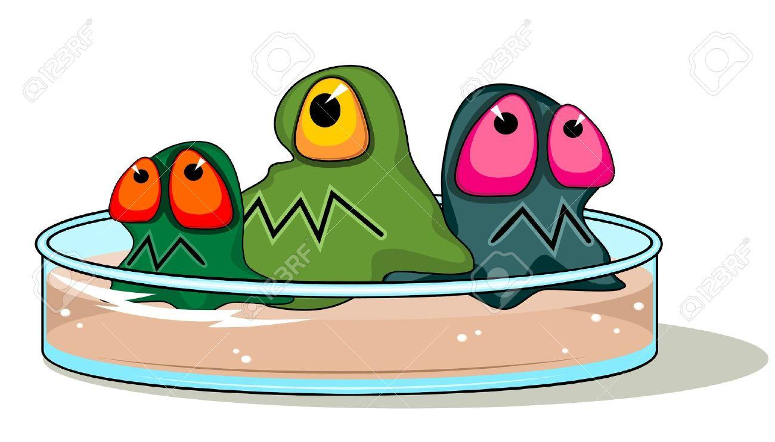
- Pasteur was convinced that germs caused disease but he was mocked by those who believed in spontaneous generation.
- The French government supported Pasteur and paid for his research assistants and a new laboratory to carry out his experiments with specially designed equipment (e.g. swan neck flasks. (Government/Technology-Helping)
- In 1864 he carried out experiments that proved germ theory correct. Showed bacteria caused decay, were not evenly distributed in air. Took sterile flasks into streets of Paris and sealed them – bacteria grew. Bacteria varied depending on location. Stale air included no bacteria and showed heating air made it sterile.
- In 1865 called to help silk industry because disease killing silkworms. Proved disease being spread in air and causing disease in animals. Then began to research human diseases but couldn’t identify specific bacteria.
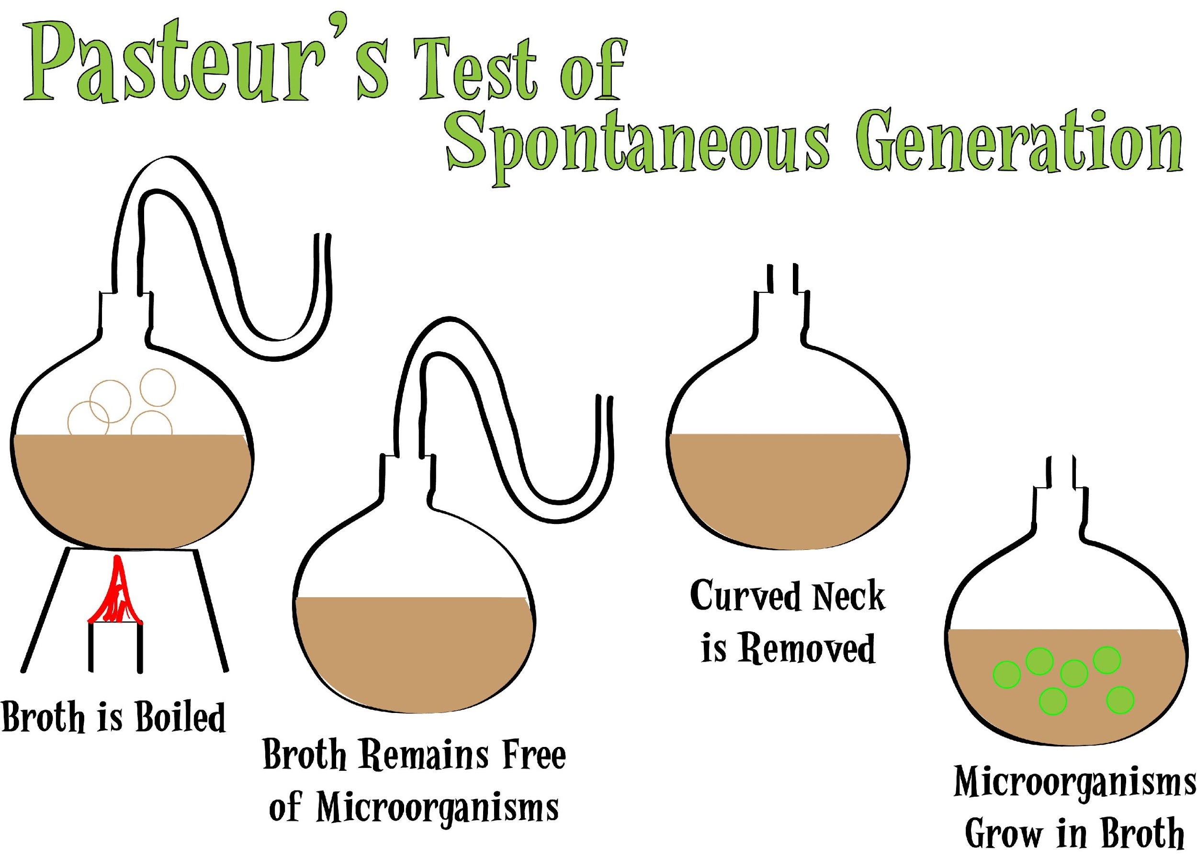

Robert Koch’s ideas about the cause of disease
- Robert Koch, a doctor from Germany, began to study bacteria himself. He was ambitious, focus on detail, worked painstakingly. Increased rivalry between France and Germany in 1870-1871 due to Franco-Prussian War. Wanted to be successful to glorify countries. (Individual Genius/War – Helping)
- Koch investigated anthrax and discovered specific bacterium that caused anthrax. First time specific germ that caused an individual disease been discovered. Proved germ theory.
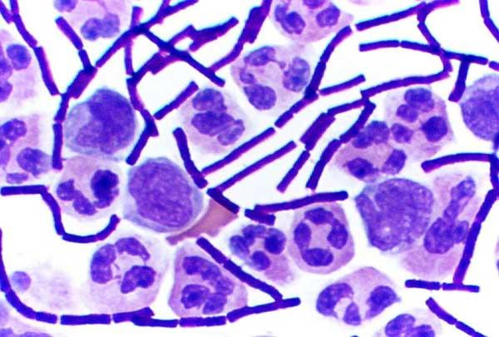
- He then developed a method of proving which bacteria caused disease. He improved methods of studying bacteria. He developed ways of staining bacteria so they could be photographed using a new high-quality photographic lens. (Science and Technology-Helping)
- The first human disease he identified was Tuberculosis.
- Revolution in communications in nineteenth century helped spread of ideas. Quickly reported in newspapers and fast boat and train travel allowed doctors to meet at conferences and learn from each others’ ideas (Communication-Helping)

Key Topic 3.2 Approaches to prevention and treatment
Continuities
- Still use of purging, praying, herbal remedies as past.
- Many illnesses still treated at home – food, warmth and herbal remedies.
- Some also visited ‘quack doctors’ or bought remedies that claimed to cure everything. Made little or no contributed to improvement in health but were cheaper. Were not controlled by government and although they did not work – people got rich from them.

Changes
- Doctors were using new technology like stethoscope and used drugs and herbal remedies to treat.
- Dispensaries appearing to give medicines to doctors. Provide poor with cheap medicine. Many people got treatments from here.
- From 1880s government introduced laws to control making of medicines and by 1900 harmful ingredients removed. Chemical drugs starting to be developed such as aspirin. By 1900 companies like Boots, Wellcome and Beecham set up.

What role did women play?
- Until 1700s women could qualify as surgeons and midwives. However, not allowed to become physicians as needed university training and women not allowed. (Attitudes-Hindering)
- In 1852 a law required doctors to belong to a College of Surgeons, Physicians or Apothecaries (person who dispenses medicine) – all of which were closed to women.
- Women allowed to be nurses as seen with Florence Nightingale and Mary Seacole in 1854.
- Elizabeth Garrett Anderson first woman to qualify as a doctor in Britain. During 1860s she worked as a nurse and attended lectures at Middlesex Hospital. Male students at the Hospital protested against her attending. Elizabeth Garrett passed all the exams to qualify as a doctor but the Colleges of Surgeons and Physicians would not allow her to join. She took the College of Apothecaries to Court which then accepted her as a member before it too banned female members. (Individual Genius-Helping/ Attitudes-Hindering)

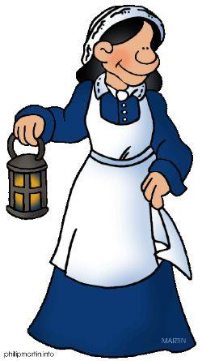
Key Topic 3.2a Nightingale and hospital care
- Nightingale brought discipline and professionalism to a job that had a bad reputation at the time.
- From a wealthy background, she became a nurse despite the opposition of her family.
- Went out to the Crimean War to sort out nursing care in the English camp.
- She made huge improvements in the death rate, due to improvements in ward hygiene.
- She focussed on sanitation in hospitals, ventilation in hospitals (she believed in miasma!) and ensuring that all patients good food supplies.
- When she returned home, she wrote a book ‘Notes on Nursing’ and sets up a hospital in London.
- Her nursing schools concentrated on teaching nurses practical skills but she did not let doctors teach about germ theory because she believed nurses needed to just keep wards clean.

Key Topic 3.2b Approaches to prevention and treatment (Anaesthethics and Anstiseptics)

- In 1750-1800 poor conditions for surgery.
- No anaesthetics so patients held down – focus on speed in surgery which led to accidents.

- No knowledge of germs so dirty environments – surgeons wore own clothes and no antiseptics. Big problems with infections – in hospitals death rates between 25% and 50% after amputations from infections.
Development of anaesthetics
- Laughing gas/nitrous oxide discovered by Humphry Davy 1799. This reduced pain but did not make patients unconscious.
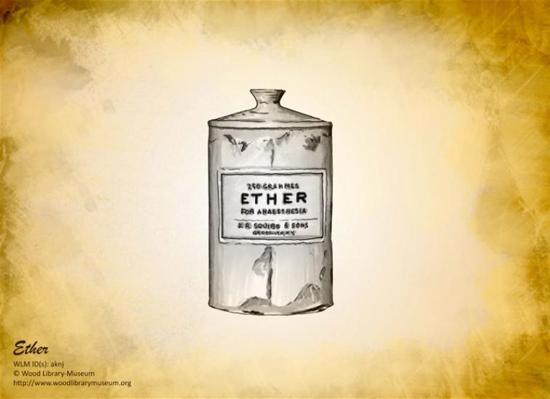
- Ether used from 1847 which was first used by J. R. Liston. However, ether irritated eyes and lungs – causing coughing and sickness. It could also catch flame and smelt bad.
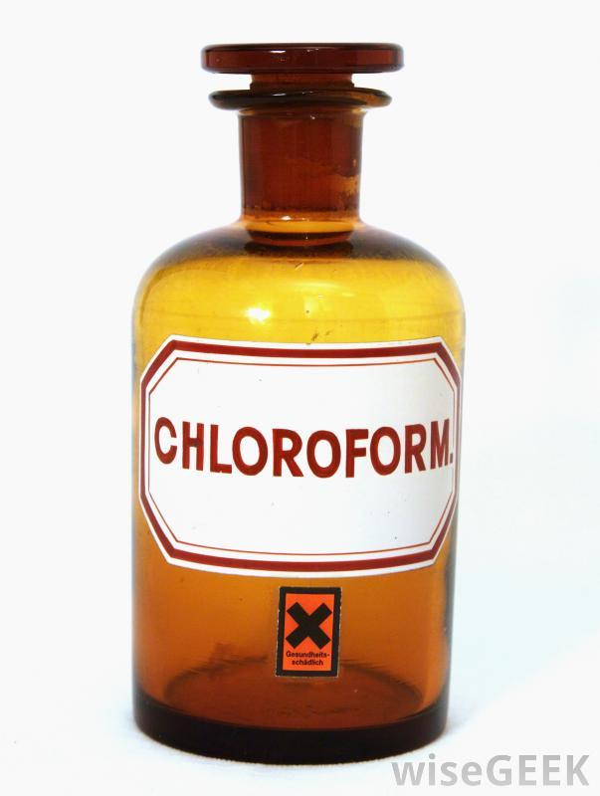
- Chloroform discovered by James Simpson of Edinburgh University in 1847. Experimented with different chemicals to see effect s as an anaesthetic – realised chloroform was very effective. Other surgeons started to use it. However, did lead to sickness and bad taste. Could also result in death as could not control dosage.
- Controlling dosage of chloroform was helped by John Snow when he invented an inhaler to control the dosage
Development of antiseptics
- Had previously used liquids such as wine and vinegar to keep wounds clean as before Germ Theory had no idea what was causing infection in open wounds. Did not wash hands, reused bandages, did not sterilise equipment and wore dirty clothes (Science-Hindering)

Ignaz Semmelweiss
- Noticed that women whose babies were delivered by midwives were much less likely to die that those delivered by medical students.
- He recommended washing their hands in a basin of chlorinated water to reduce risk of infection and called doctors who did not wash it ‘murderers’.
- However, he had little support and no-one built on his ideas. People thought he was a crank and a fanatic
Joseph Lister
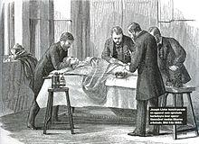
- He used the ideas of Pasteur and Germ Theory which helped to spark his discovery.
- Came up with idea by noticing that carbolic acid had an effect on sewage and prevented smells. He experimented with using carbolic in treating people who had fractures where bone broken through skin. Applied carbolic acid to the wound and used bandages soaked in carbolic to help the wounds heal. Death rates dropped from 45.7% to 15%.
- People began washing hands with carbolic acid and a carbolic spray to kill germs in the air was placed around the operating table.
- 1880 he started the use of antiseptic ligatures in surgery made from catgut.
- In long term other doctors built on ideas as hospitals became cleaner places and longer and more complicated surgery.

Key Topic 3.2c Approaches to prevention and treatment (Public Health)
Public Health Problems in the Early 1800s
- During the late 1700s and the first half of C19th, houses were built as close together as possible as more people crowded into factory towns to work.
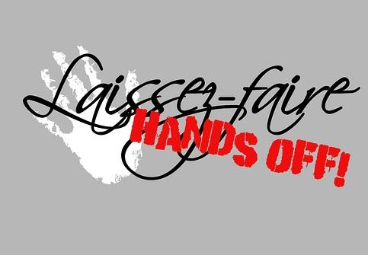
- In these squalid conditions, diseases spread easily and rapidly.
- Some thought that the government should force local councils to clean up their towns.
- But, many believed that the government shouldn’t interfere – this attitude is called laissez-faire.


Edwin Chadwick
- In 1842 he was asked by the government to report on the living conditions and health of the poor.
- Chadwick concluded that poverty was caused by ill health which was caused by the terrible conditions in which people lived.
- In his “Report on the Sanitary Conditions of the Labouring Population” he said industrial towns should:
1. Organise drainage and refuse collection
2. Provide a pure water supply
3. Appoint a Medical Officer of Health

1848 Public Health Act
- In 1848 there was an outbreak of cholera, this put pressure on the government to do something.
- Parliament reluctantly agreed to pass Public Health Act. Although it was not compulsory. The government set up a Board of Health to encourage, but not to force, local authorities to improve conditions. Only a few local authorities took any new measures.
- By 1872 only 50 Medical Officers of Health had been appointed.
- The Board of Health was abandoned in 1854.
1853 John Snow
- In 1854 John Snow proved that there was a link between cholera and water supply.
- He used research, observation and door-to-door interviews to build a detailed map of a cholera epidemic in Broad Street.
- After collecting evidence, John Snow put pressure on water companies to clean up their water supplies (read more about this in Key Topic 3.3b)

1858 Great Stink
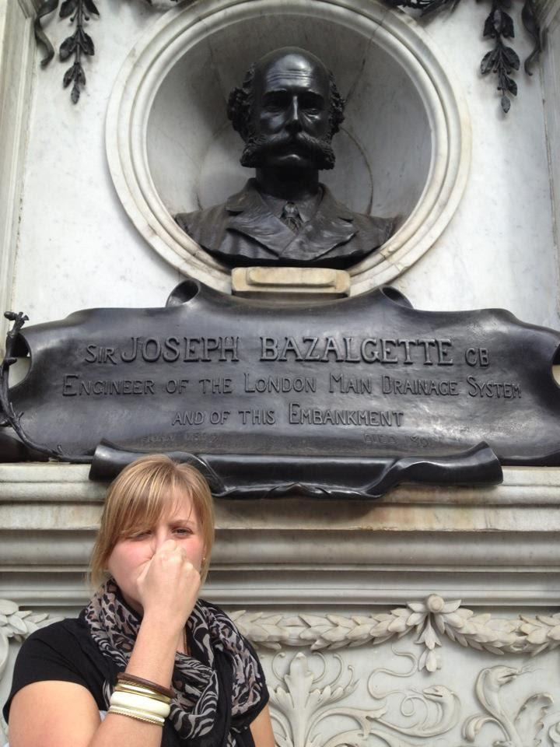
- For years human waste made its way from the latrines in London into the River Thames.
- In 1858 the hot weather caused a ‘great stink’. The bad smell was right under Parliament’s nose.
- Parliament considered moving and had to coat their curtains with a deodorant to get rid of the smell.
- The Great Stink prompted Parliament to sort out London’s sewage and drainage system and to clean up the River Thames. Within a year Sir Joseph Bazalgette had begun to build an extensive system of sewers and drains that are still in operation today.

1875 Second Public Health Act
- Unlike the 1848 Public Health Act, the 1875 Public Health Act actually forced local authorities to introduce the following measures:
- Provision of clean water
- Proper drainage and sewage
- The appointment of a Medical Officer of Health
Key Topic 3.3a Jenner and the development of vaccination
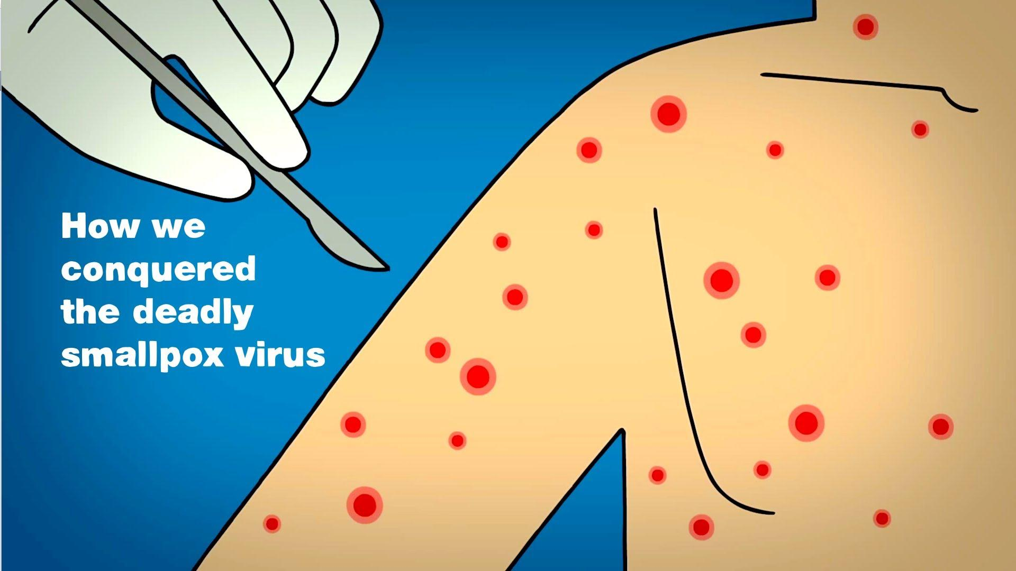
- Smallpox killed more children they any other disease and survivors left scarred.
- To stop people catching it inoculation used in China and other parts of Asia. This involved spreading pus from a smallpox pustule into a cut in the skin of a healthy person. Lady Mary Wortley Montague brought this idea back from Turkey in 1721 where her husband was British ambassador.
- Inoculation became big business in Britain with doctors charging up to £20 per patient for thousands of inoculations.
- However, very risky as if got too strong a dose they could die. (2/3 out of every 100 died) Could also be spread by inoculated person. People could not afford them.
Vaccinations

- Jenner was a country doctor. He heard that milkmaids didn’t get smallpox, but instead a milder cowpox. He realised that vaccinations might work – putting a weaker form of a disease into a patient to build up resistance.
- Jenner investigated and discovered people who had already had cowpox didn’t get smallpox.
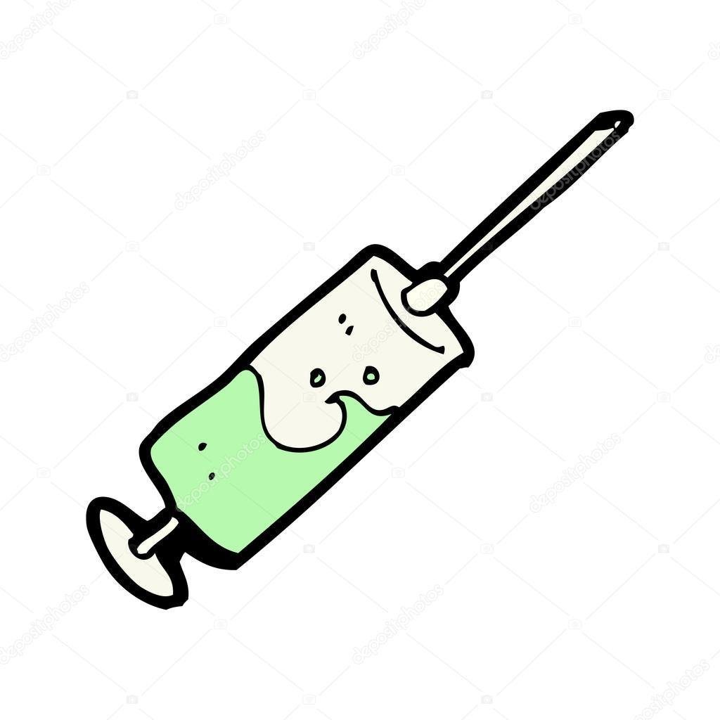
- In 1796 he took a small boy called James Phipps and injected him with pus from the sores of a milkmaid with cowpox. Jenner then injected the boy with smallpox. James Phipps developed cowpox but not smallpox and was vaccinated against it when Jenner tried to give him smallpox.
- In 1798 published book, An Enquiry into the Causes and Effects of Variola Vaccinae, known by the Name of Cowpox, describing vaccination and proved evidence it worked.
- By 1803 vaccination was being used in the USA and in 1805 Napoleon had the whole French army vaccinated (Trade and Communication/Individual Genius-Helping)

- Government helped to spread his idea s – in 1802 and 1807 Parliament gave Jenner £30,000 to develop his work. In 1852 vaccinations were made compulsory in Britain and were strictly enforced until 1887. Led to drop in deaths from smallpox. (Government-Helping)
Opposition to Vaccination
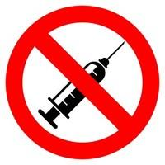
- Many people did oppose vaccination. In 1866 an anti-vaccine league was formed. Some believed it was unnatural to give diseases from animals and against God’s wishes. The Royal Society of Science refused to published his book and said his ideas were too revolutionary. Other people had not heard of Jenner so refused to believe him. Some saw as dangerous as doctors mixed up vaccines and others used infected needles. Some did not like the government telling them what to do in terms of vaccinations – laissez faire attitude. (Attitudes-Hindering)
- Also, government could not decide how much to force people and from 1887 vaccinations were not compulsory. (Government-Hindering)
- Furthermore, Jenner did not know that germs cause disease and could not explain how the vaccination worked. Science was not that developed. (Science-Hindering)

Key Topic 3.3b Fighting Cholera in London, 1854
- Cholera broke out in 1854 in London. Cholera killed victims in less than a day.

- People tried to prevent cholera by burning barrels of tar or vinegar, smoking cigars as protection against bad air, praying or wearing lucky charms, clearing house and burning the clothing and bedding of victims.
- In 1849 John Snow published a book saying that people caught cholera from water not 'bad air' His suggestion was mocked by other doctors.
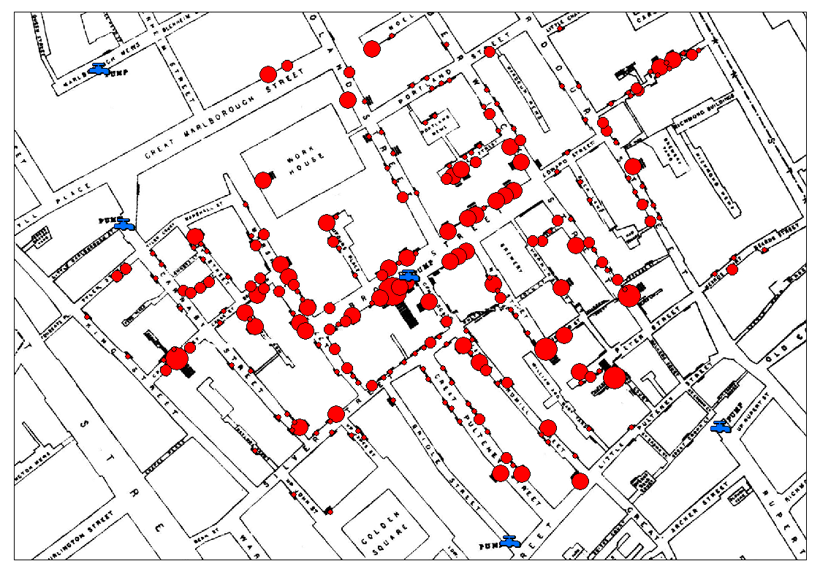
- In 1854 John Snow proved that there was a link between cholera and water supply. He used research, observation and door-to-door interviews to build a detailed map of a cholera epidemic in Broad Street.

- Nearly all the deaths had taken place within a short distance of the water pump.
- Near to the pump, there was a brewery and none of the people there had cholera. The brewery had its own water pump, and the men had been given free beer. They didn’t use the Broad Street Pump at all.
- After collecting evidence, John Snow removed the handle from the Broad Street pump.
- There were no more deaths. It later came to light that a cesspool near to the pump had a cracked lining which allowed the contents to contaminate the drinking water.
- Snow put pressure on water companies to clean up their water supplies.

Key Topic 4: c1900 - present. Medicine in Modern Britain
Key Topic 4.1 Ideas about the causes of disease and illness
The advances after 1900 proved that there is not just one cause of disease. In addition to bacteria we now know there are viral infections, genetic mutations and lifestyle causes that led to disease.

Understanding of disease
- People at this time Understood germ theory and continued to identify specific bacteria and developed methods of targeting them in different ways to cure disease.
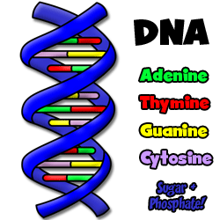
- However viruses were too small to be seen under a microscope and were not discovered until later when more powerful microscopes were developed.
- Watson and Crick discovered DNA in 1953. This helped people to understand that some diseases were genetic. (Down’s syndrome, Alzheimer’s disease, Parkinson’s disease, Cystic Fibrosis, Cancer) (Individual Genius-Helping)
- 1990 The Human Genome Project, led by Watson, set out to map the location of every single one of the 30,000 genes in the 23 chromosomes of every cell in the body. The project involved 18 teams of scientists and the first draft was produced in 2000.
- Scientists have now been able to develop certain genes that pass on hereditary conditions. As a result, there are new techniques for skin grafts, better production of insulin and better vaccines.
Lifestyle Factors as a cause of disease
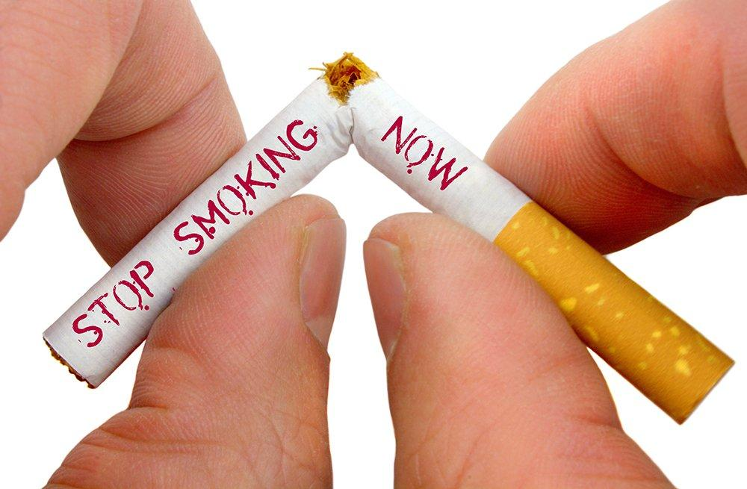
- A healthy diet, exercise and other lifestyle factors have long been suggested as ways to prevent illness, however it was only in the 20th Century that lifestyle choices were linked to certain health conditions,
1. Smoking leads to lung cancer
2. Obesity increases the chance of heart disease or diabetes
3. Drinking too much alcohol have been linked to liver disease
4. Overexposure to ultraviolet radiation can lead to skin cancer.

Developments in Diagnosis
- Blood tests were first introduced to test blood groups. Blood tests were used to diagnose a range of diseases such a cholesterol levels, whether patient has cancer or to check a patients DNA etc. They make diagnosis more accurate.
- The use of medical scans began in 1895 when Wilhelm Röntgen discovered X-rays.
- Advances in computers led to ultrasound scanning using high frequency sound waves.
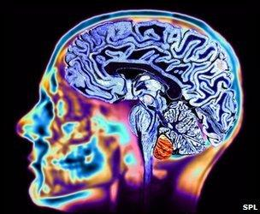
- CT scans were invented in 1972 and MRI scans were invented in the 1970s. They use powerful radio waves to construct images.
- Patients can also now monitor their own body with inventions such as the blood pressure monitor and blood sugar monitors.

Key Topic 4.2 Approaches to prevention and treatment c1900-present.
National Health Service

- At the start of the 20th century access to healthcare was limited. Poor people could afford to go to the doctor to buy medicine.
- In 1901 there were 140 infant deaths for every 1000 births - but today it is less than 5.
- The NHS was introduced in 1948 after WW2. It is a nationalised healthcare system in the United Kingdom. It comprises of free at the point of access medical care in Hospitals, Accident and Emergency units, via General Practitioners (GP's) and via health visitors.
- Patients do not pay for emergency treatments, medical advice, periods in hospital or medical tests.
What problems has the NHS experienced?

- The main problem that the NHS has encountered is its own size. The costs of the NHS has proven to be an issue of great concern ever since the services was introduced.
- Other problems have arisen in terms of staffing and availability of beds for patients, along with arguments about the cost of new drugs and treatments and waiting times.
Development of new drugs
Magic Bullets In this period scientists developed first cures for people who have already become sick with diseases. Vaccines only prevent people getting them. Magic bullets attacked the bacteria developing in the body – made from chemicals and called sulphonamide drugs.
- 1909 Paul Ehrlich (who had been part of Koch’s research team) developed the first chemical Salvarsan 606 which destroyed the harmful bacteria that caused syphilis. It took a number of attempts to find the magic bullet (over 606) and in the end it was lucky it was retested by Dr Hata as they hadn’t notice Salvarsan 606 worked the first time. (Individual Genius/Chance-Helping)

- In 1932 Gerhard Domagk developed Prontosil, the second chemical ‘Magic Bullets’ to cure blood poisoning or septicaemia. Scientists then discovered that the important chemicals in these cures was sulphonamide and drug companies produced more magic bullets for diseases such as pneumonia (Individual Genius-Helping)

Antibiotics (bacteria which kill other bacteria) for more detail see Key Topic 4.3a
- Magic bullets could not kill staphyloccus germs which caused major infections and often killed the victims. This became a cause for particular concern due to the number suffering from it in World War I and World War II (War – Helping)
- The first antibiotic was called penicillin and was used to treat bacterial diseases.
Recent treatments
- Mass production of many drugs as treatments. (However, drugs have led to some problems such as thalidomide which was given to reduce morning sickness during pregnancy – led to children being born with severely deformed limbs)
- Development of customised drugs to cure one person’s health problem
- Gene therapy – using genes from healthy people to cure the sick.

Key Topic 4.3a Key Individuals: Fleming, Florey and Chains development of penicillin
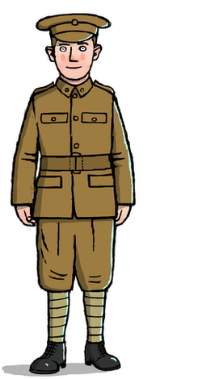
- Magic bullets could not kill staphyloccus germs which caused major infections and often killed the victims. This became a cause for particular concern due to the number suffering from it in World War I (War – Helping)
- 1872 Joseph Lister noticed mould of bacteria called penicillin killed other bacteria. Used this mould to treat a nurse with an infected wound but did not use it again.
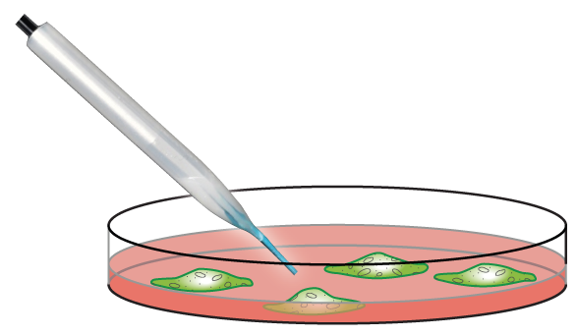
- Alexander Fleming was a doctor who accidentally discovered a mould on a set of culture dishes, which were being used to grow the staphylococci germ (which turns wounds septic). Fleming noticed that where there was mould the germs had stopped developing.
- It was one of Fleming's colleagues who identified the mould as penicillin. Fleming subsequently tested the penicillin on animals, with no ill effects, and also used it to cure a colleague's eye infection.
- After his initial discovery, Fleming did little more than keep a supply of the mould and return to his routine work. It was the scientists Howard Florey and Ernst Chain, who developed penicillin further.
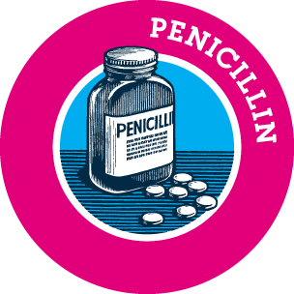
- Florey and Chain were chiefly responsible for the research which led to its success as a drug, although Fleming took most of the credit for the discovery and its subsequent development.
- Fleming had discovered the first antibiotic. However, it was not until the research work of Florey and Chain that penicillin could be produced as a drug. At first supplies of penicillin were very limited, but by World War II it was being mass-produced by the American drugs industry, and given to all soldiers before active service.

