Name: Class:
The Weimar Republic 1918-29 | Page
Impact of WWI on Germany | 2
The Origins of WR | 3
Treaty of Versailles | 4
Political Threats – Left and Right | 5
The Invasion of the Ruhr | 6
Hyperinflation | 7-8
Gustav Stresemann | 9
Societal and Cultural Changes | 10-11
Hitler’s Rise to Power 1919-33 | Page
The Early Years of the Nazi Party | 12
The Munich Putsch | 13
Effects of the Munich Putsch | 14
The Lean Years | 15
The Wall Street Crash | 16
Support for the Nazi Party | 17
How Hitler became Chancellor | 18
Nazi Control and Dictatorship 1933-39 | Page
How Hitler became Fuhrer | 19
The Police State | 20-21
The Churches | 22
Goebbels and Propaganda | 23-24
Nazis and Sport | 25
Nazis and the Arts | 26-27
Opposition | 28-29
Life in Nazi Germany 1933-39 | Page
The Nazis and Women | 30-31
The Nazis and Young People | 32
The Nazis and Education | 33
Employment and the Standard of Living | 34-35
Nazi Racial Beliefs | 36
Persecution of Jews | 37-38
KT1 – The Weimar Republic – 1918-29
The Impact of WWI on Germany
National income was about 1/3 of what it had been. | Workers rebelled against their leaders who they believed had led them to defeat in WWI. | World War One had resulted in many German soldiers causalities. Over 2 million children were left without fathers. | Many people were angry with the monarchy. The king of Germany, Kaiser Wilhelm II was forced to abdicate (step down).
During the war women were called up to work in factories. Many people saw this as damaging to traditional family values and society as a whole. | The war had deepened divisions in German society. | Stresses of war led to a revolution and became a democratic republic – the Weimar Republic. | The German people called the politicians the ‘November Criminals’ for signing the Armistice.
There were huge gaps between the living standards of the rich and poor. | Industrial production was about 2/3 of what it had been. | Germany was virtually bankrupt. | Many poor people were worse off than they had been before the war.
Many German workers were bitter at the restrictions placed in their earnings during the war while factory owners had made vast fortunes. | The German people felt ‘stabbed in the back’ by the politicians who had signed the armistice (peace agreement to end WWI). | Many ex-soldiers and civilians despised the new democratic leaders and came to believe that the heroic leader Field Marshall Hindenburg had been betrayed by weak politicians. | War left 600,000 widows who all needed to be supported financially by the government. By 1925 the state was spending about 1/3 of its budget in war pensions.

Task: Categorise the effects into economic, social and political

EXTENSION – Which was the most important effect and why?

The Origins of WR
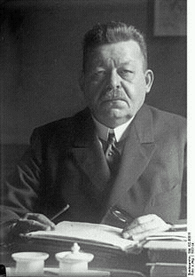
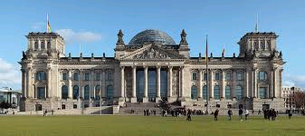
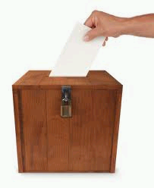
- The National Assembly met in Feb 1919 in Weimar to decide how Germany would now be led. They took 6 months to create the Weimar Republic, which would be governed by the Weimar Constitution. It was a genuine attempt to create a perfect democratic country.
The Weimar Constitution
Head of State
The Government
The Chancellor
- Head of the government
- Chose all ministers
The Cabinet
- Minsters who work with the Chancellor to make decisions
The Parliament
The Reichstag
- Most powerful of the parliament
- Elected by the people every 4 years
The Reichsrat
- Represented regions of Germany
- Also elected every 4 years
The Electorate
All men and women over the age of 20 were given the vote by proportional representation.
- The President was head of the Republic
- Elected every 7 years
- Played no part in day-to-day politics
- Chose the Chancellor
Task: Read through the information and complete a diagram of how the government worked.

Task: Read through the information below and colour code it into strengths and weaknesses of the Weimar Republic.
The Voting Age was reduced to 20 and women were able to vote as well as men. | The system prevented one party getting the majority, which then led to a lack of clear policies. |  | The President was elected by the people. They had the power to choose the Chancellor and if needed could dismiss the Reichstag.
The only way governments could be formed was by coalition (joining together) but this often fell apart. | Central government now had more power. Also, each of the 18 provinces of Germany kept their own local government. |  | This system meant even small parties had a fair chance of seats in the Reichstag. This meant one party could not have too much power.
The Chancellor decided which laws should be passed, but only after they had been approved by the Reichstag and Reichsrat. | The new government had relied on the power of the army to crush rebellions against the new Republic. |  | In an emergency the President did not need the agreement of the Reichstag and could issue a ‘decree’ to pass a law rather than relying on votes.
The Communists and Nationalists hated democracy and the new Constitution, but still were able to gain seats in the Reichstag. |  | Strengths |  | Weaknesses
The Treaty of Versailles
- In June 1919, 37 countries met at the Palace of Versailles to decide the fate of Germany. Germany were not invited. The Big Three - David Lloyd George (UK), Woodrow Wilson (USA) and George Clemenceau (France) had very different aims. They drew up and forced Germany to sign the Treaty of Versailles.
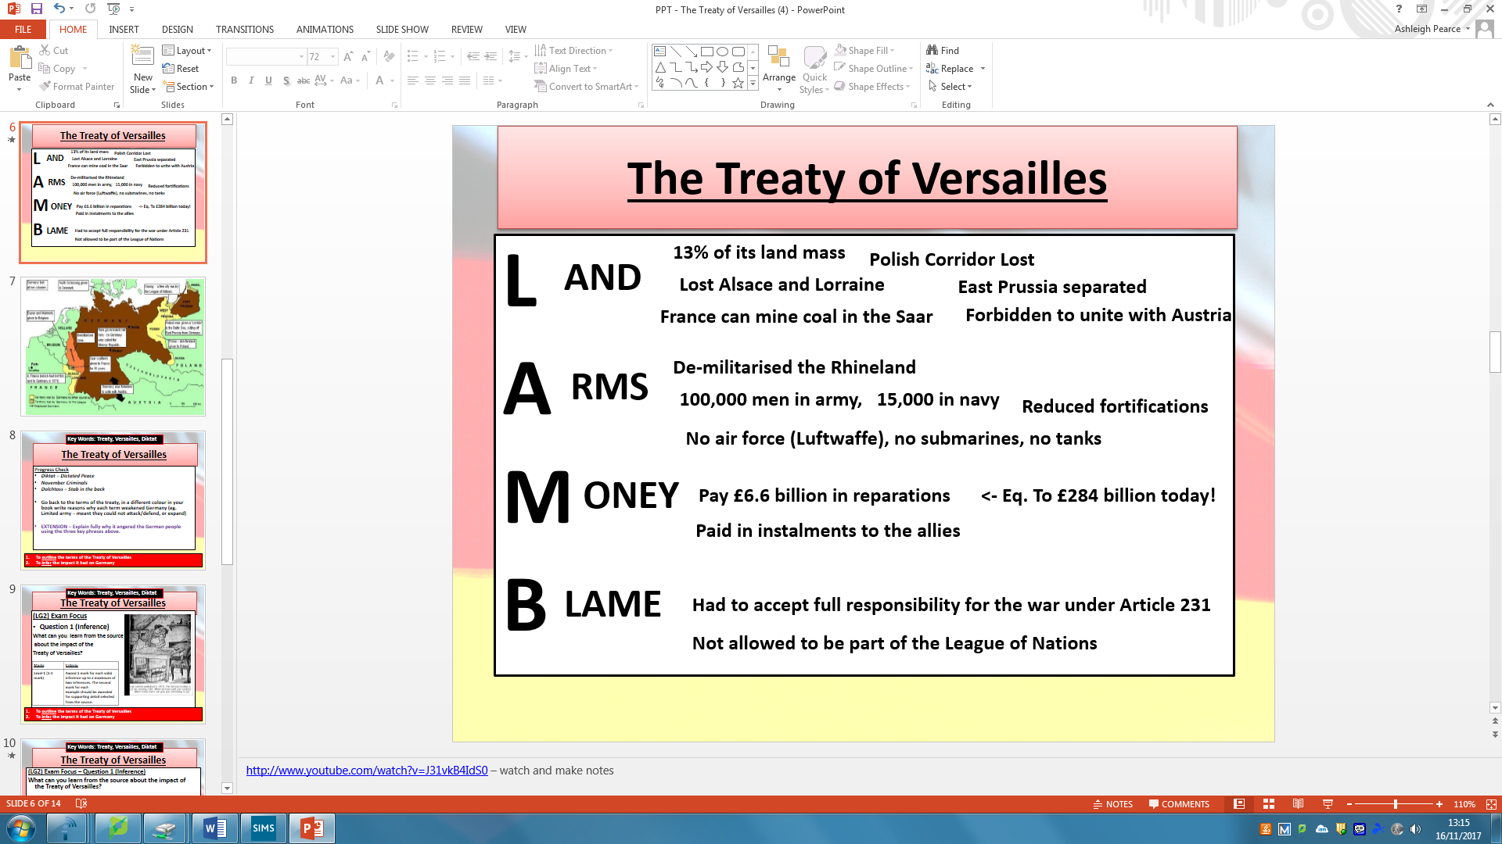How Germany were affected.
Task: Read through the information above and highlight and SFD. Below comment on how each one would affect Germany.
Land | Army | Money | Blame

Quick Quiz
- In which month and year was the Treaty of Versailles signed? (2 marks)

- Who were the ‘big three’? (3 marks)

- How many soldiers were the German army allowed to retain under the treaty? (1 mark)

- Name two land restrictions they had to agree to. (2 marks)

- How much were the Germans supposed to pay the Allies in reparations? (1 mark)

- They also had to accept full blame under which Article? (1 mark)

Threats from the Left and Right
- There were ongoing challenges to the Weimar Republic between the years 1919-22, 376 political murders were carried out. Threats from the left, who believed Germany should be controlled by the people, were a growing threat. Right wing threats, who believed in one strong government leader and army, also were a growing threat.
Task: Read through each of the Revolts and create a drawing for each part of the revolt.
The Spartacist Revolt (Left-wing)
Background
- The Communist party had been set up in 1918 and supported by the Soviet Union.
- The Spartacist League supported the Communist group led by Rosa Luxemburg and Karl Liebknecht.
What happened?
- After the sacking of the chief of police in Berlin, the Spartacists called for an uprising and general strike.
- On the 6th January 1919 over 100,000 workers took to the streets and seized Ebert’s government newspaper offices.
Outcome
- With the support of the army, Ebert creates a Freikorps of around 4,000 ex-soldiers who crush the uprising.
- Its two main leaders Rosa Luxemburg and Karl Liebknecht are murdered. Both were shot and Rosa’s body left in a canal.
The Kapp Putsch (Right-wing)
Background
- The newly formed Freikorp (ex-army soldiers) were becoming difficult for Ebert to control, numbers had reached 250,000 by March 1919.
- They worried about unemployment and were becoming more annoyed at the government.
What happened?
- In March 1920, 5000 Freikorps marched on Berlin led by their figurehead Wolfgang Kapp.
- They declared a new government in Germany and invited the Kaiser to return from exile.
Outcome
- Many government members fled and urged the people to help.
- Many workers went on strike, cutting off gas, electricity, water and transport.
- After 4 days, Kapp realised he could not govern and fled. He was arrested and later died in prison, the rebellion collapsed.
EXTENSION – Which of the two do you think was the biggest threat and why?

The Invasion of the Ruhr
- In 1923, 60 000 French and Belgian troops marched into the Ruhr (an important industrial area of Germany). They seized control of all mines, factories and railways. They took supplies from shops and set up machine-gun posts in the streets.
Task: Read through the information and highlight the SFD. Then answer the questions in the space below.
Germany’s first instalment of £50 million was paid in 1921, but in 1922 nothing was paid. Ebert did his best to play for time and to negotiate concessions from the Allies, but the French in particular ran out of patience. They too had war debts to pay to the USA. So in January 1923 French and Belgian troops entered the Ruhr (quite legally under the Treaty of Versailles) and began to take back what was owed to them in the form of raw materials and goods.  The Ruhr (nicknamed the ‘heart of Germany’) was an important industrial area which was attempting to help the German economy recover. Germany responded to the invasion in a disastrous way, the government ordered the workers to go on strike. This was called passive resistance. That way, if the German workers did not make and produce materials, there would be nothing for the French to take away.  The French reacted to this very harshly by setting up gun points in the streets. They killed over 100 workers and expelled over 100,000 protesters from the region. More importantly, the halt in industrial production in Germany’s most important region led to serious money problems. Because Germany had no money left, the government decided to print out more. This led to hyperinflation and the eventual collapse of the German currency. | - What was the French intention for the invasion of the Ruhr?  - Do you think their actions were justified?  - What was the German reaction to the invasion?  - Why was there a short term political success for Germany?  - What were the long term economic consequences for Germany?

Task: What can you learn from the source about the German reaction to the French invasion of the Ruhr?
_____________________________________________  _____________________________________________  _____________________________________________  _____________________________________________  _____________________________________________  _____________________________________________  _____________________________________________  _____________________________________________  _____________________________________________  _____________________________________________  _____________________________________________  _____________________________________________  _____________________________________________  _____________________________________________ | 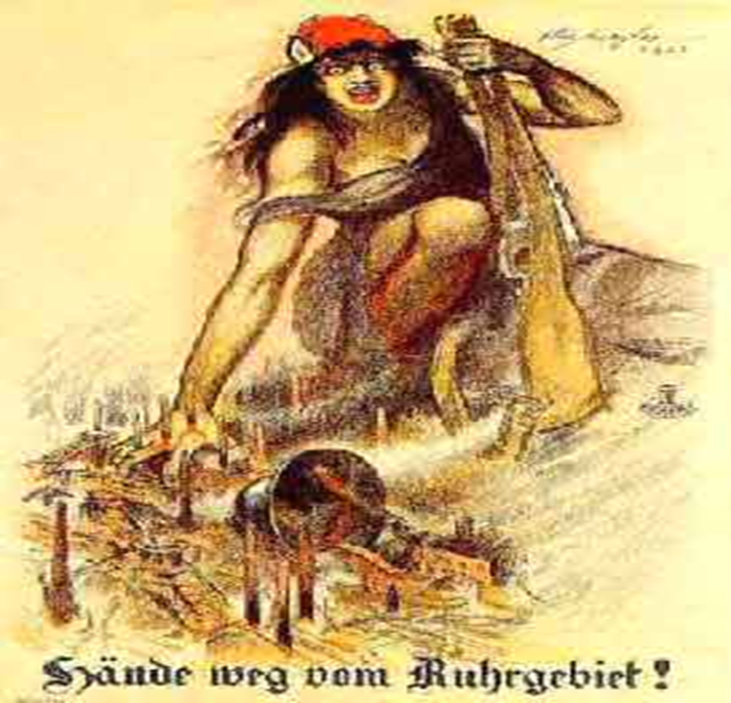  A German poster, published in 1923 ‘Hands off the Ruhr’

Hyperinflation
Task: Read through the statements below and put them in the correct order for the causes of hyperinflation.
The French invaded the Ruhr. | There was hyperinflation. | Germany missed reparations payments. | The Government printed off paper money. | German workers went on strike.
1. | 2. | 3. | 4. | 5.

Task: Use source A to write a definition of what hyperinflation was.
Source A – Data chart showing the rate of hyperinflation in Germany between 1914-1923
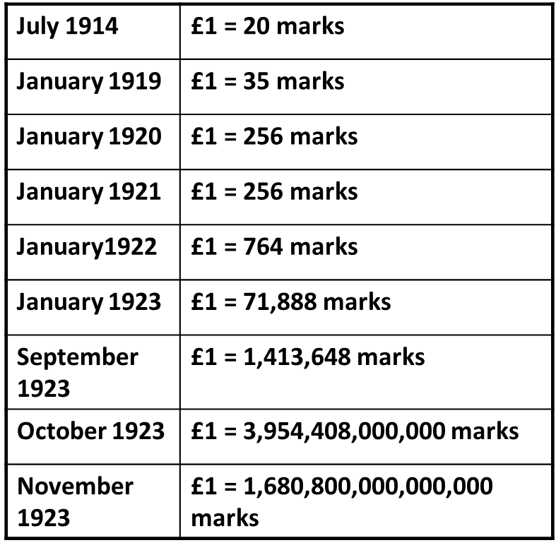

Task: Read through source B and create a list of causes of hyperinflation.
Source B
Alan White and Eric Hadley, Germany 1918-1949 (1990)
Germany began to suffer serious inflation during the war. The German government did not pay for the war by taxing people more heavily. Instead it paid its bills by printing banknotes. Soon there was too much money chasing too few goods. An inflationary spiral had started.
Things got worse at the end of the war. A huge amount in reparations was demanded from Germany. The sum to be paid was fixed at £6.6 billion in 1921. Many foreigners thought that Germany would be unable to pay. They began to lose confidence in Germany's currency. Foreign banks and businesses expected increasingly large amounts of German money in exchange for their own currency. It became very expensive for Germany to buy food and raw materials from other countries. This led to a further increase in prices in Germany.
Late in 1922 Germany failed to pay an instalment of reparations on time. France replied in January 1923: French troops occupied Germany's main industrial region, the Ruhr. The French were determined to make Germany pay every penny she owed. They wanted to keep Germany weak. A weak Germany meant that France was safe from the threat of attack.
The German government ordered a policy of passive resistance in the Ruhr. Workers were told to do nothing which helped the invaders in any way. What this meant in practice was a general strike. The cost of the government's policy was frightening. All the workers on strike had to be given financial support. The government paid its way by printing more and more banknotes. Germany was soon awash with paper money. The result was hyperinflation.
Task: Read through the statements below and colour code them into winners, losers or those who stayed the same.
Weimar Government  ‘There were so many problems, revolutionaries, war debt, that awful Treaty and now this! No-one would loan us the money, other countries just looked on in pity, no-one would help...’ |  | Weimar Government  ‘Everyone is blaming us. How can this be our fault? We couldn’t put up taxes anymore, people just couldn’t afford it. What could we do?’ |  | Weimar Government  ‘We were short of money, there was none coming from the Ruhr and the strikers needed to money. It seemed the answer was to print more. What are people saying about us now? They might start to support the Nazi party!’ |  |  | Foreigner  ‘I feel like I’ve won the lottery! The exchange rate is so good here then I get millions of marks for only a small amount of money.’
Farm owner  ‘Why should I sell my produce for worthless money? I will only accept gold, jewels or foreign money; do you think I’m stupid?’ |  | Debtor  ‘I always said enjoy life – eat, drink and be merry! My family have disowned me. I was in all sorts of debt but thank heaven for inflation! Who’d have thought it? I’m saved!’ |  | Pensioner  ‘I fought for my country and retired on a small pension. I had little put by for little treats, you know! Now I have nothing and if my family don’t help me I will die of starvation. My pension wouldn’t even buy a stamp!’ |  |  | Working-class people  (Shop Worker) ‘I work in a shop and rent the flat above the shop. My wages went up, but never quite as much as prices. However, my rent on the flat was fixed so really it all evened out!’
Working-class people  (Factory worker) ‘Times are hard but we managed. Everyone was poor and we could live for today. I never saved before because I needed every penny to live. My wages were paid by the hour, and they increased by the hour. Life wasn’t so bad.’ |  | Business Owners  ‘I owned a small business selling clothing. No one could afford to buy clothes and I couldn’t pay my rent. A rival offered me a pittance for my business but what could I do? My family had to eat... My shop had been in my family for generations. The government is weak, it doesn’t know what to do!’ |  |  | Business Owners  ‘At the end of the First World War in 1918 I sold my business and retired. By middle class standards I was a rich man. I intended to live from my investments and savings. All my hard earned money went and I had to find a job to live. I’ll never forgive this Weimar government, the Nazis are right!’
Landowners  ‘I bought a whole herd of cattle on credit. After a time I sold one cow and paid off all my debt because the price for one cow now equalled a heard!’ |  | Unemployed People  ‘I have lost my job because of the inflation. There are so many people like me, normal business and trading has virtually stopped, how will I ever get another job?’ |  | Unemployed People  ‘I have no savings; I received benefits from the Weimar government. Prices rose and I was poor, but my benefit rose, not as much as prices, but I wasn’t really so badly off.’ |  |  | Landowners  ‘My money’s all in land and I have many possessions like in the family jewels. Times are hard, but at least I have something real to sell and get me by. I never believed in banks, land is the thing!’
 | Winners |  |  | Losers |  |  |  | Stay the same

Task: Who would you say were worst effected by hyperinflation and why?

Gustav Stresemann
Action Taken | Terms | Effects
Rentenmark (1923) | - New currency introduced by Stresemann to replace Deutschemark  - It was backed by the gold standard and had real value | - Trusted at home and abroad so helped to make economy stable  - Businesses began to recover, but people who lost money never got it back
The Dawes Plan  (1924) | - Germany loaned $25 billion marks from America  - This meant they could start to pay back reparations again, which were reduced to £50 million a year | - The French agreed to leave the Ruhr  - Industrial output doubled and employment, trade and income increased  - Accepting the terms meant other countries began to trust them  - Some Germans were furious they had agreed to pay reparations
The Locarno Pact  (1925) | - Germany, Britain, France, Italy and Belgium agreed not to attack each other if Germany agreed on their new boarders  - The Rhineland would be permanently demilitarised | - It helped other countries begin to trust Germany again and they were treated like equals with the other countries  - Helped Germany gain admittance to the League of Nations  - Stresemann won the Nobel Peace Prize  - Some resented that some of the terms of the Treaty had been agreed
Kellogg- Briand Pact  (1928) | - An agreement between 62 countries, including Germany, that they would not use war to settle disputes  - They instead called for the peaceful settlement of disputes | - Germany was able to build relations with other countries  - This helped countries further their trust in Germany  - However, some Germans believed it made them look weak
The Young Plan  (1929) | - Reparations reduced from £6.6 billion to £2 billion  - Germany are given an extra 59 years to pay in small instalments | - German government were able to reduce taxes and therefore people had more money to spend  - German industry was boosted and more jobs were available  - Some disliked that it would take longer to pay it back, passing it onto the next generation  - However, the Wall Street Crash later in the year meant the USA wanted all of the money back

Task: Read through the information above and highlight the SFD. Summarise each one in the space below.
Rentenmark | The Dawes Plan | The Locarno Pact | Kellogg- Briand Pact | The Young Plan

EXTENSION – Which was the most important and why?

Societal and Cultural Changes

Task: Read through the information below and highlight SFD. Underneath make a list of developments and limitations.
The Unemployment Insurance Act of 1927 set up unemployment and sickness benefits to help anyone who fell out of work. | The value of goods that wages bought (real wages) rose by 25% from 1925 to 1928. |  | Housing improved:  37,000 new homes were built by private companies.  64,000 were built by building associations that were introduced. There was still a housing shortage, but it had eased by 1928.
  Unemployment
  1926 | 2 million
  1928 | - million
The Reich Pension Law of 1920 gave pensions to 750,000 war veterans, 400,000 war widows and 200,000 parents of dead servicemen. |  | Working people actually improved their situation with better real wages, unemployment insurance and lower working hours. What this did, however, was to alienate other groups such as big business, who resented their loss of power and profit, and the lower middle class, who saw their own position threatened by a system which seemed to favour the working classes. | Employment had improved but remained insecure as the loss of savings during hyperinflation still caused hardship.
  Number of students in higher education
  Before WW1 | 70,000
  1928 | 110,000
Because of women’s improved position in the workforce and their newly acquired rights as citizens, women themselves seemed to change. Magazines presented a new generation of women that differed fundamentally from their mothers. | A magazine cover from 1925 comparing modern women (on the left) to those of the past (on the right)  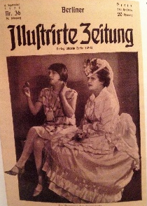 | A woman’s position in politics improved greatly: Women were able to vote and had equal rights with men. By 1932, 112 women had been elected to the Reichstag (10%). Women could enter all professions on an equal basis with men
  Number of women in work
  1918 | 75% (paid the same as men)
  1925 | 36% (paid 33% less than men)
Conservatives and Traditionalists did not like the new opportunities for women and believed they should concentrate on being wives and mothers. | The 1920s saw a huge cultural revival in Germany. Indeed, these years have been seen as the greatest period of experimentation in the whole of German history. As things settled down politically, writers and artists had more chance to try out new ideas. The results were impressive and spread across all areas of the Arts. For example, New Objectivism, Modernism, Expressionism and The Bauhaus Movement. | During this time, films became very popular. The government funded some films such as this science fiction film about life and technology in the 20th Century.
  The Birth Rate
  1913 | 128 out of 1000
  1925 | 80 out of 1000

Developments | Limitations

Task: How far did like improve?
Make a judgement on overall how far life improved in Germany and why, giving SFD to support your answer.

KT2 - Hitler’s Rise to Power 1919-33
The Early Years of the Nazi Party
- Some consider that Hitler’s early life played a part in what was to come later.
- His failure to get a place in an art academy in Munich left him angry, as did the defeat of Germany in WW1 during which he was a soldier.
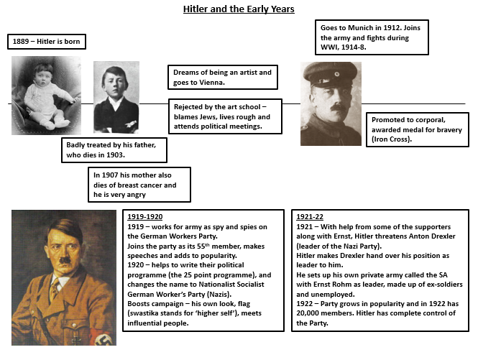

Task: Bullet point key stages in Adolf Hitler’s life in leading up to the early years of the Nazi party

EXTENSION – Add why each stage was important in shaping his beliefs
The Munich Putsch
Why?
- Believed in one leader (not a democracy)
- Weimar Republic in crisis
- Nazi party stronger than ever with 55,000 members
- Hoped to copy the Italian Revolution led by Mussolini

Who?
- Hitler and General Ludendorff
- Over 3,000 supporters including the SA (made up of the Freikorps)

What?
- Nov 8th – burst into a speech by Gustav von Kahr (PM of Bavaria) to force him to support the Putsch
- Hitler expected his help to overthrown the Weimar Government
- They pretended to agree, but told the Nazis they needed to leave to ‘see their wives’ and informed the police
- Nov 9th – Hitler and 3000 Nazis marched into Munich but they were soon stopped by the already informed police
- 16 Nazis were injured/killed and Hitler is shot and arrested soon after

Task: Summarise the key features of the Munich Putsch below

Why? | Who? | What?

EXTENSION – Why was this event important?

Effects of the Munich Putsch
- The Munich Putsch of 1923 (sometimes known as the Beer Hall Putsch) was Hitler’s catastrophic attempt to take over and defeat Ebert’s government.
- However, what might at first seem like a huge failure, actually could be considered a success for Hitler and the Nazi party.

Task: Highlight evidence of success and evidence of failure

The putsch had not been properly planned. Kahr was allowed to leave the beer hall, and the following day he withdrew his support. The German government responded quickly. They ordered the army to crush the revolt. When armed Nazis marched to a military base in Munich they were met by police and soldiers. | Whilst Hitler was in prison, the Nazi party fell apart without their leader. However, he was able to write his infamous book ‘Mein Kampf’ which was read by millions of Germans following his release. | Throughout his time in jail and during the trial, Hitler was often shown in the newspapers, both locally and nationally. This brought the Nazi party a lot of much-needed publicity. The day he was released, thousands came to hear him speak. | The Nazi Party lost 16 members during the Putsch and Hitler himself was shot. Later, however, the Nazi members lost in this event were used as martyrs for their cause against the government. A monument was made to commemorate their efforts.
In jail, Hitler had time to reflect on his actions and realised that the only way to come to power was legally. He hatched a plan of how he was going to gain support through legal means when he was released. | Hitler was sentenced to five years in prison, but only served nine months of his sentence. His visitors nick-named his wing ‘The General’s Hill’ and he was able to receive visitors when he liked. He lived in comfortable surroundings and was able to have contact with the outside world. | After his time in jail, popularity for the Nazi party seemed initially very positive. Many people came to hear Hitler speak on his release. However, throughout the years following, 1924-8, the Nazi party decreased in popularity and numbers. It was not until the devastation of the Wall Street Crash that they gained the support they needed. | 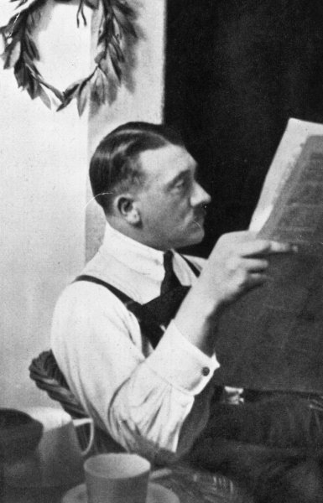

EXTENSION – Overall, was the Munich Putsch a success or failure for the Nazis? Why?

‘The Lean Years’ 1924-28
- Hitler re-launched the Nazi party on 27th Feb 1925 the scene of the failed Munich Putsch.
- 4000 people came to hear him speak and the hall was so full that a 1000 others had to be turned away.
- Following this, Hitler began changing many the organisation of the Nazi Party, in a bid to make it more efficient and ensure their rise.
Political position  - Hitler created his own personal body guards called the SS who were loyal and fanatical followers  - Hitler merged like-minded political parties into the Nazi party  - He was an excellent orator, and many people loved to watch his speeches | Finance  - Hitler gained the support of rich Industrialists and Businessmen which helped to fund the Nazi regime  - Hitler was able to do this by threatening that the communists would take over Germany – if that happened the rich people would lose their businesses
Tactics  - After the failed Munich Putsch, Hitler realised he had to come to power by democratic means rather than force  - He believed that would help him appeal to the German people  - He believed in: racial purity; a strong army; one Fuhrer who has the loyalty of his people; and the expansion of Germany. | Propaganda  - Josef Goebbels was put in charge of propaganda  - He used the latest technology and various methods to spread the ideas of the Nazi party such as: Posters, Speeches, Rallies, Newspapers, Radio Speeches and the Nazi’s own newspaper  - He boosted the Nazi appeal with his clever targeting of individuals with strong and positive messages

Task: Highlight the key features in the information above and then explain how each would help Hitler gain support

Political position

Tactics

Propaganda

Finance

EXTENSION – Why do you think they did not gain the support they hoped for?

The Wall Street Crash
- October 1929 was a very important month the change of support for the Nazis.
- Gustav Stresemann died on 3rd October and many lost faith in the Weimar Republic.
- The Wall Street Crash happened on the 29th October (the collapse of share values on the American stock market), causing world-wide Depression.

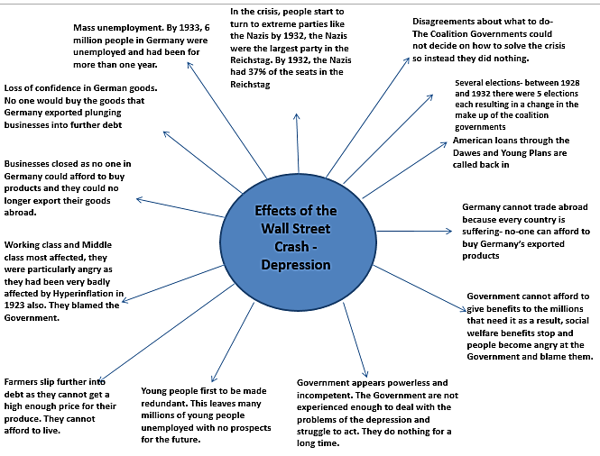

Task: Highlight the key features in the information above and answer the question below

How did the Wall Street Crash help the Nazis gain support?

Support for the Nazi Party
- The Wall Street Crash had catastrophic consequences on America, Germany and the rest of the world. The world was plunged into an economic depression.
- The desperation of some people who were out of work and starving forced them to look for answers, and in this case they needed Arbeit und brot.
The SA  - Sometimes referred to as the ‘Brown Shirts’ because of their uniform and had a strong leader of Ernst Rohm.  - The SA gave an impression of discipline, order and reliability.  - Many people thought the country needed that kind of order and that they could stand up to foreign powers.  - They were prepared to fight the communists – something people in Germany were afraid of. Their army outnumbered the Communists 400,000 to 130,000.  This gained them popularity because… | Adolf Hitler  - He was the Nazis greatest campaigning asset as many admired his strength and power.  - He was a powerful speaker and many people loved to hear him speak. People felt inspired by his words and hoped for a better future under his leadership.  - They believed Hitler was strong enough to restore law and order. They believed he would force other countries to scrap the Treaty of Versailles and treat Germany fairly.  - Hitler was a symbol of the Nazis and his face was used on all kinds of propaganda.  This gained them popularity because…
Propaganda  - Simple, catchy statements on posters helped to appeal to all people. Such as a focus on ‘work’ targeting the unemployed and a focus on ‘bread’ linked to rebuilding Germany’s economy.  - Strong, powerful looking men representing Germany and the ex-army soldiers.  - Hitler himself was often included and compared to the weakness of opposition - Hindenburg  - The Nazis used many forms of propaganda techniques including posters, radio broadcasts, aeroplanes and cinema adverts.  This gained them popularity because… | Unity  - The Nazis offered something to everyone, by appealing to them in different ways.  - Big businesses were convinced that the Nazis were the best protection from the rise of Communists, so they provided financial support.  - The Middle Classes, made up of professionals, supported the Nazis as they believed they could help the country recover.  - The Nazis promised ‘Work and Bread’ to appeal to the working classes.  - Farmers also felt protected by the Nazis, and young people found them exciting.  This gained them popularity because…

Task: Highlight the key features in the information above and explain how each factor gained the Nazis popularity
How Hitler became Chancellor
- Hitler had gained a lot of popularity between the years 1929-33.
- However, the short-term political developments of 1932 also played a very important part of him becoming Chancellor.

Short-term causes
Step One – Hitler’s challenge
March 1932 Hitler challenged Hindenburg for the presidency
He lost by 19.4 million votes to 13.4 million
Despite Hitler’s defeat, he raised his profile hugely

Step Two - Resignation
May 1932, Chancellor Bruning resigns due to rising unemployment

Step Three – Von Papen
May 1932 Von Papen becomes Chancellor
He is an aristocrat - someone who belongs to the richest families in Germany

Step Four – Von Papen’s election
July 1932 Von Papen calls a general election to win more seats for his party - the Centre Party
They fail to win any more seats
Nazis win 230 seats
Step Five – Von Scheicher
November 1932, Von Papen holds new elections again but fails again to win more seats for Centre Party
Nazis win 196 seats
Hindenburg replaces von Papen with General Kurt von Schleicher because Papen has no support

Step Six – Resignation
Von Schleicher resigns when Hindenburg refuses to continue to govern using Article 48
Hindenburg is left desperate and realises he needs someone who has support from the people

Step Seven – Hitler is Chancellor
Believing between himself and Von Papen they could control Hitler, Hindenburg appoints Hitler as Chancellor in January 1933
Von Papen is appointed Vice Chancellor
They believed he would gain support in the Reichstag and control the communists

Task: Complete a brief timeline that shows the steps to Hitler becoming Chancellor

KT3 – Hitler’s Rise to Power 1919-33
How Hitler became Fuhrer
Task: Read through the information and highlight SFD, then complete grid below.
Event | Summarised notes | Rank out of 6 how successful it was
The Enabling Act was presented to the Reichstag on 23rd of March 1933. The intention was that Hitler would be given full power over other parties in the Reichstag
The act was passed with a large majority. By July 14th Hitler had proclaimed a law stating that the Nazi Party was to be the only political party allowed in Germany and all other parties were banned
Hitler now had full power to pass any law he wanted.
Night of the Long Knives - In June 1934, Hitler sent his SS men to wipe out the leaders of the SA and others who had angered him
He was worried about the strength of the SA as they had the power to take over the Nazis if they wanted to. Ernst Rohm, leader of the SA, was forced to commit suicide
Over 85 political opponents of Hitler were murdered, including Kurt von Schliecher and Gustav von Kahr. The threat of the SS, now lead by Heinrich Himmler, was now huge and many people were scared of what they would do
Hindenburg’s death - On the 2nd August 1934, 87 year old Hindenburg, Hitler's last obstacle on his way to total power, died
Hitler used this as an opportunity to seize total power in Germany by elevating himself to the position of Führer, or absolute leader, of the German nation and its people. Hitler now had complete power by combining the position of Chancellor and President into one role – Führer. He could appoint his own men into other positions in parliament.
After Hindenburg’s death, Hitler was able to make sure anyone in authority supported him by making them swear an oath – The Führer’s Oath. The men in the German army swore an oath to Hitler (see below the Hitler’s edited version of the army oath). He also extended this to the courts – all judges had to swear an oath to him. To Hitler now attained absolute power over the German people. Anyone who broke the oath was harshly punished

Extension - Explain which is the most important reason and why

The Police State
There was supposed to be no room for opposition of any kind in Nazi Germany. The aim was to create a totalitarian state which meant that there was to be no other parties other than the Nazi party. Ordinary citizens must divert their whole energy into serving the state and doing what its leader wants. The Nazis had a powerful range of organisations and weapons that they used to control Germany.

Task: Read through information and highlight SFD. Complete grid below.
Group | How did each group help Hitler keep control?
The SS
- The SS was formed in 1925 and was made up of loyal followers of Hitler
- After destroying the SA in the Night of the Long Knives, the SS grew into a huge organisation with many different responsibilities
- Heinrich Himmler was its leader
- Under Himmler, the main responsibility of the SS was to destroy opposition to Nazism and carry out the racial policies of the Nazis
- There were two important sub-divisions of the SS:
  - the Death’s Head unit which was responsible for the concentration camps and the slaughter of the Jews
  - and the Waffen-SS who were special armoured regiments who fought alongside the regular army
The Gestapo
- The Gestapo were a secret state police and possibly the force that was most feared by the ordinary German citizen
- Set up by Hermann Goering and led by Reinhard Heydrich along with the SS
- The Gestapo agents had sweeping powers which meant they could arrest citizens and send them to concentration camps without trial or even explanation
- People were that scared of the Gestapo that often they would inform on each other because of the fear that they would find out anyway and be punished
- By 1939, there were about 160 000 people under arrest for political crimes
Police and the Courts
- The Nazis controlled the magistrates, judges and the courts
- German judges had to swear an oath of loyalty to Hitler
- Top jobs in the local police forces were given to high-ranking Nazis
- They had to report to Himmler of anyone who broke Nazi laws and rules
- By the end of 1934, Hitler controlled the Reichstag, the army and the legal system
- All of the above meant people were rarely given a fair trial
- Hitler also had jail sentences checked, and would make them longer if he thought they were too soft

Concentration Camps
- Concentration camps were the Nazis’ ultimate sanction for their own people and were set up almost as soon as Hitler took power
- They were ran by the SA and the SS
- Prisoners were forced to do hard labour and food was very limited
- Prisoners also suffered harsh discipline, beatings and random executions, most did not make it out alive
- Jews, Socialists Communists, trader unionists, churchmen and anyone else who was brave enough to criticise the Nazis ended up there
- There were different categories of prisoners who wore coloured triangles that represented their category including: Jews, political prisoners, sexual offenders, the work shy, religious groups, foreign groups, and professional criminals
- The first concentration camps were make-shift prisons in disused factories and warehouses but they eventually became purpose-built

Task: Create a mind map of overall why the Nazi State was so successful using the information above.

The Churches
Hitler had some similar beliefs to the churches, such as tradition and family life. However, he saw them as a threat as he wanted all power and trust vested in him. People who believed in God would less likely worship him. All other independent organisations had been already been controlled.
Task: Read through information and highlight SFD. Underneath summarise the effect of the Nazi Party on each religion.
Catholic Churches  One-third of Christians in Germany were  Catholic. Catholics were loyal first and foremost to the Pope, not to Hitler and there were Catholic schools which taught different values to Nazi schools.  In July 1933 Hitler signed a concordat (agreement) with the Pope which said that Hitler agreed to allow Catholics to worship their religion freely and to not interfere with Catholic school in Germany. The Roman Catholic Church agreed that its priests would not interfere in politics and that German bishops had to swear loyalty to the National Socialist regime. However, Hitler broke the terms of the concordat and during the 1930s Catholic priests were arrested and many were sent to concentration camps, Catholic schools had to teach the same as Nazi schools or were closed down and Catholic youth groups like the Catholic Youth League were banned.  The Concordat signed with the Catholic Church did not last long. Once Hitler felt entrenched in power, he ordered Joseph Goebbels to turn the Nazi propaganda machine against the Catholic Church. Monks and nuns were accused of smuggling gold out of Germany while priests were accused of immorality. The Archbishop of Munich-Freising had to be given diplomatic status by the Papacy to save him from arrest (he was made a Papal Legate).  The concerns in Rome were such that Pope Pius XI issued ‘With Deep Anxiety’. It accused Hitler of treating Catholics in Germany in an inhumane manner and breaking the terms of the Concordat. | Protestant Church  Hitler had disagreements with Christians in the Protestant Church. At first some Protestants supported the Nazis as the Nazis had protected them from anti-Christian communists. They allowed Nazi flags to be displayed inside their churches.  These Protestants formed the German Christian Movement and its leader was Ludwig Muller. Hitler made Muller the Reich bishop of Germany in September 1933. Protestant pastors who supported Hitler were allowed to carry on with their church services as normal.  However, this caused a split in the Protestant Church. There were 28 Protestant groups in Germany, and they were merged to form the National Reich Church in 1936. A member of the Nazi party was elected Bishop of the Church. Non-Aryan ministers were suspended.  Church members called themselves German Christians, with "the Swastika on their chest and the Cross in their heart."  Not everyone was happy with the new Church. The Confessing Church was formed by Martin Niemöller in 1934 with 6,000 ministers, leaving 2,000 behind in the National Reich Church. This was a challenge to the Nazis. Around 800 ministers were arrested and sent to concentration camps. Niemöller was arrested in 1937 and sent to Dachau, then Sachsenhausen, until 1945.  Dietreich Bonhoeffer was imprisoned in 1943 and was later executed.

Extension - Explain how this helped to further create Hitler’s totalitarian state.

Goebbels and Propaganda
Josef Goebbels was the Nazi propaganda Minister and set up the Ministry for Popular Enlightenment and Propaganda in March 1934. He intended to control the thoughts, beliefs and opinions of the German people. All aspects of the media were controlled and censored by Goebbels.
Task: Read through the information below and highlight the SFD.
Non-Nazi newspapers and magazines were closed down. Editors were told what they could and couldn’t print, which meant that the German people only read what the Nazis wanted them to know. If an editor refused to follow the Nazis’ orders they would be arrested and sent to a concentration camp.  Official orders from the Minister of Propaganda 1935 “photos showing members of the Reich Government in front of rows of bottles whilst dining must not be published. This gives the ridiculous impression that members of the Government are living it up” | All radio stations were placed under Nazi control. Cheap mass-produced radios were sold to make sure all Germans had them (however, these radios could only access German Nazi stations and could not access foreign radio stations). Sets were installed in cafes and factories and loudspeakers were placed in the streets. It was important that the Nazi message was heard. Hitler and Goebbels regularly made broadcasts and when they did people were expected to stop their daily life and listen wherever they were. | Goebbels also realised the popularity of the cinema. More than 100 films were being made each year and audiences were topping 250 million in 1933. Goebbels ordered that all film scripts/plots should be shown to him before going into production. He realised that Germans were bored by overly political films and instead love stories and thrillers were given pro-Nazi slants. One of the best known was “Hitlerjunge Quex” (1933) which tells the story of a boy who broke away from a Communist family to join the Hitler Youth only to be murdered by Communists. All films were accompanied by a 45 minutes newsreel which glorified Hitler and the Nazis. You could not gain entry to the film once this newsreel had started meaning you had to watch it.
A mass rally was held at Nuremburg every year to advertise the power of the Nazis. Spectacular parades were held on other special occasions and thousands of people would attend surrounded by swastikas whilst they listened to Nazi speakers.  Posters were also cleverly used to put across the Nazi message with the young being particularly targeted. | The National Socialist Society for German Culture was formed. This banned many artists and authors and named them degenerate (e.g. Jewish artists or modern artists as Hitler liked traditional art). The Nazis even hosted an art exhibition called “degenerate art” in 1937. The aim was to show Germans what they should avoid as it would corrupt German society.  All books were carefully controlled and censored by the state to put across the Nazi message. Goebbels encouraged students in Berlin to burn 20,000 books written by Jews, Communists and anti-Nazi authors in a massive bonfire in 1933. Many writers were persuaded or forced to write books that praised Hitler and the Nazis.  Between 1933-39 many artists and authors left Germany altogether. | Many laws were introduced which took away the right of “Freedom of speech”. There was “A law against malicious gossip” which was introduced in 1934 which forbade the telling of anti-Nazi jokes and stories. You could be fined or even sent to a concentration camp if found guilty of these crimes. The Gestapo had many secret informers who would inform on you if they overheard you “spreading anti Hitler lies”.

Task: Use the information above to summarise how each method helped Hitler to control Germany. Give each method a score out of 6 for most successful (1) to least successful (6)
Newspapers
Radio
Cinema/Film
Rallies
Censorship through art
Censorship by law

Extension - Explain fully how this would have indoctrinated the German people.

Nazis and Sport
Goebbels also used sport to influence attitudes. He had the perfect opportunity in 1936 when the Olympics was held in Berlin to show off Nazi power.
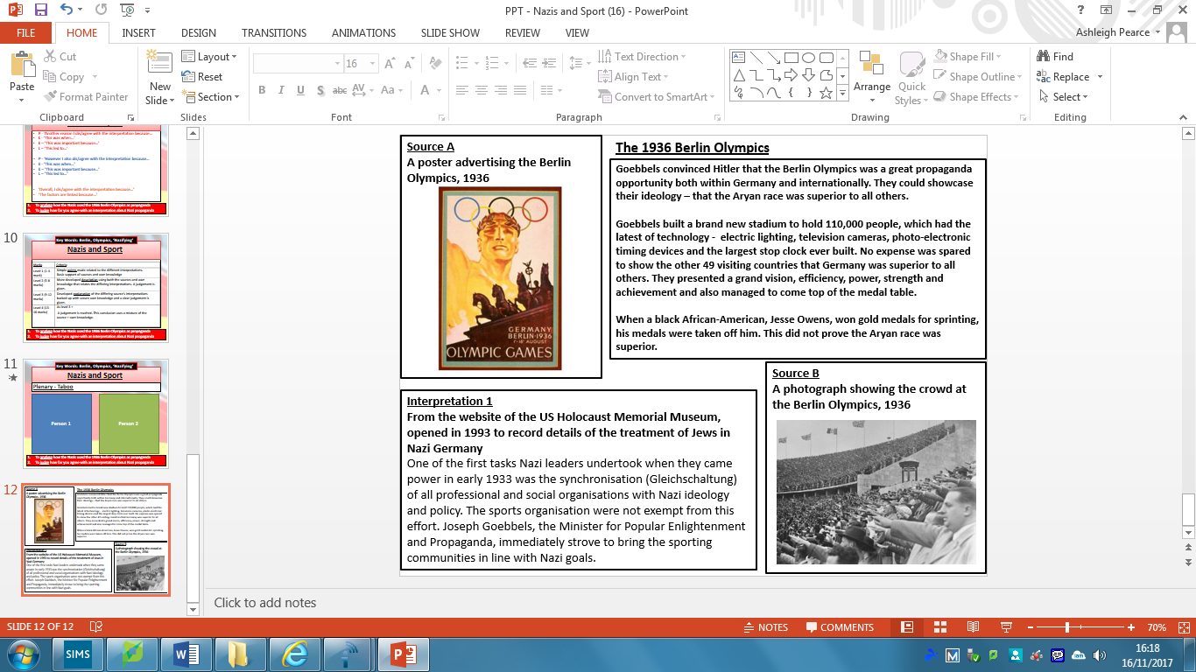

Task: Use the information above to create a mind map on the Olympics of 1936

Extension – Go back and add to your mind map how it linked it to other areas of propaganda.
Nazis and the Arts
The Nazis set up the Reich Chamber of Culture in Sept 1933 which controlled all areas of the Arts. The aim was to ensure all art, architecture, literature, music, film and theatre were consistent with Nazi ideals.
Art  - All artists had to be members of the Reich Chamber of Culture, and all paintings had to be approved.  - Other paintings were removed from galleries such as the work of Picasso and Van Gogh.  - Some artists were considered degenerate (e.g. Jewish artists). The Nazis even hosted an art exhibition called “degenerate art” in 1937 to show Germans what they should avoid as it would corrupt German society. | Architecture  - The Nazis disliked modern architecture and preferred buildings that made Nazi Germany seem powerful.  - All buildings were designed by followers of the Nazis, Hitler’s favourite was Albert Speer. He designed the parade ground for Nazi rallies in Nuremberg and the new Chancellery offices.  - Speer built huge buildings, to instate power. He also used tradition Greek and Roman features to make his buildings seem grand and historic.
Music  - Some types of music were censored, that which Hitler did not like, such as jazz music was banned.  - Jewish composers were also banned as they were seen as inferior.  - Other music was promoted as it emphasised German traditions that the Nazis liked. For example, Richard Wagner was a favourite as well as Beethoven and Bach. | Literature  - All books were carefully controlled and censored by the state to put across the Nazi message.  - All new books could not be published without the approval of the Chamber of Culture.  - Goebbels encouraged students in Berlin to burn 20,000 books written by Jews, Communists and anti-Nazi authors in a massive bonfire in 1933.  - Many writers were persuaded or forced to write books that praised Hitler and the Nazis.

Task: Read through the information above and highlight SFD. Below, explain how each aspect would have added to creating a Nazi ideal.
Art
Architecture
Music
Literature

Task: Think about all of the different aspect of society that Nazi’s had control of and list as many as you can remember below. Next to each aspect, annotate each one with how they effected people
EXTENSION – How would different people be affected? Women, Men, Children, Communists, Jewish, Aryan, Elderly, etc.

Opposition

There was a high level of support for the Nazis from the German people, they won 38% of votes in the 1932 general election, and they were the largest party in the Reichstag. However, not everyone supported Nazi belied and there was some opposition

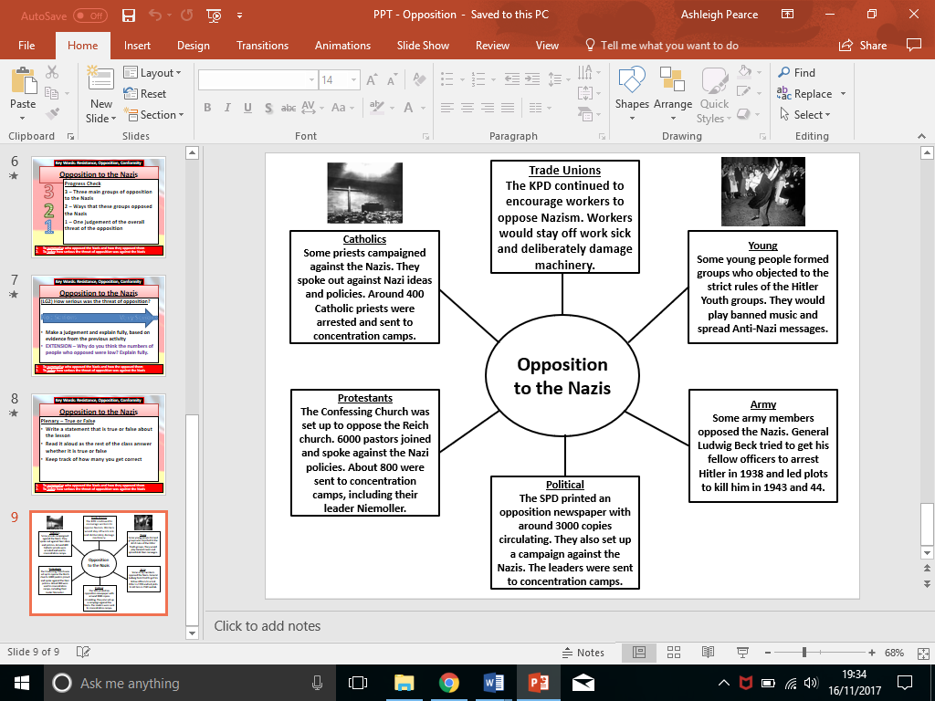

Task: Read through the information above and highlight the SFD. After that, each type of opposition a mark of out 10 for how serious it was and explain why.
Trade Unions
Young
Army
Political
Protestants
Catholics

Task: How serious was the threat of opposition? Use evidence to support your argument.

EXTENSION – Why do you think the numbers of people who opposed were low? Explain fully.

- Not all young people accepted the Nazi ideals as some found it very strict and controlling
- They wanted to listen to their own music and choose their own type of clothes
Task: Summarise how young people opposed the Nazis, describing their actions. Add why each resistance was a threat to the Nazis. Judge how serious each threat was to the Nazis, giving a mark of 10 and explaining your judgment.

The Swing Movement  This was made up of middle-class teenagers who admired British and American culture, clothes, films and music. They listened to English and American songs, particularly American Jazz, and danced dances such as the ‘jitterbug’. They often held illegal dances. They also gathered together to drink alcohol and smoke.  The Nazis warned about these youths and asked others to identify them if they were found. | Summarise | Why was it a threat? | Judgement /10 and why
The White Rose Resistance Group
Led by Sophie Scholl and her brothers, she encouraged passive-resistance against the Nazis. They spread the anti-war messages through distribution of leaflets at the University of Munich. They also spread anti-Nazi messages and helped to defend their Jewish friends. She and her brothers were arrested and executed by Guillotine.

The Edelweiss Pirates
This group was made up of working class youths who did not like the restrictions of Hitler Youth rules. They wore an Edelweiss white flower as their symbol and spread anti-Nazi and anti-Hitler messages. They wanted their own freedom and often carried out their own hikes in the countryside. If they came across any Hitler Youth members, they would often mock them and sometimes attack them
Some more daring Pirates helped to hide Jewish friends, and some were executed for this.

KT4 – Life in Nazi Germany – 1933-39

The Nazis and Women
- The Nazis were a very male-dominated organisation – all Nazi leaders were men.
- Hitler had very traditional views of the role of women as wife and mother.
- He believed the K’s ‘Kinder, Küche, Kirche’ (Children, Kitchen, Church) were a woman's mission in life.

Education
- Girls from the age of ten joined the Jungmadel (Hitler Youth).
- From fourteen they entered the Bund Deutscher Madel (German Girls' League).
- They were taught their role was as a good wife and mother and their place was in the home.- the 3 Ks: kinder, kuche, kirche (Children, Cooking, Church)
- They did have opportunities for outdoor activities such as camping, and some women got the chance to travel

Marriage
- 1933 - Law for the Encouragement of Marriage - which gave newly weds a government loan so that wives could leave their jobs and have children.
- Married professional women were forced to give up their jobs and stay at home.
- 1934 – The Nazi Ten Commandments – Women are encouraged to marry pure German men and have lots of children
- 1935 – Marriages between pure Germans and Jews are forbidden as part of the Nuremberg Laws

Employment
- Women were expected to be home-makers, wives and mothers
- 1934 – Lots of women dismissed from professions, including doctors, civil servants, and teachers
- Discrimination against women applicants for jobs was encouraged
- By the end of the 1930s the Nazis did encourage some women to work to help the war effort but women had to struggle with family demands whilst doing this
- However, even when there was a struggle to cope with war supplies women were still not allowed to serve in the armed forces

Breeding Programme
- The Nazis believed women had biological purpose – to have children
- On Hitler’s mothers birthday, medals for women who had more than 4 children were awarded
- Women received a ‘Gold Cross’ for having 8 children and were given a privileged seat at Nazi meetings – although they never had any say in the meetings
- Lebensborn programme set up to encourage unmarried women to have children out of wedlock if it was with a racially pure SS officer
- Banned contraception and abortion
- By 1939, there was a slight increase in the birth rate, as well as more births outside of marriages

Physical Constraints
- Not allowed to wear make-up, have hair dyed or have perms
- Only to wear flat shoes and no trousers allowed
- No slimming as thought unhealthy and would upset child-bearing
- No smoking allowed as seen as 'un-German‘
- Long hair or put in bun or plaits
- They were also encouraged to keep fit and healthy

Task: Highlight the key features in the information above

Source A
A speech by Joseph Goebbels, the Nazi Minister of Propaganda in 1929.

“The mission of women is to be beautiful and to bring children into the world. This is not at all as………unmodern as it sounds. The female bird pretties herself for her mate and hatches eggs for him. In exchange, the male takes care of gathering food, and stands guard and wards off the enemy.”

Task: Highlight and annotate the source above and complete the chart below focusing on the question:

How useful is this source in finding out about the status of women in Nazi Germany?

 | Useful | Not useful
Content
Nature
Origin
Purpose

EXTENSION – Overall how useful is the source and why?

Nazis and Young People
- The young were seen as the future of the Third Reich so were an important target for the Nazis.
- When the Nazis came to power in 1933 other youth groups were forcibly merged into the Hitler Youth and in December 1936, membership of the Hitler Youth became compulsory.

Boys | Girls
- For boys, military training was essential. Boys were trained to be workers or in the armed forces. They regularly went camping and hiking.  - Boys were taught important skills such as comradeship and loyalty, but also competition and ruthlessness.  - They also took part in rallies and oaths of allegiance to Hitler.  - Boys aged 6 - 10 years joined the Little Fellows (Pimpfe). They did mainly outdoor sports type activities such as hiking, rambling and camping.  - Boys aged 10 - 14 years joined the German Young People (Deutsche Jungvolk). They still did sporting activities but these had a more military emphasis such as parading and marching as well as map reading. They also learnt about Nazi views on racial purity and anti-semitism.  - Boys aged 14 - 18 years joined the Hitler Youth (Hitler Jugend). They were prepared to be soldiers by doing military activities. | - Girls had some of the same activities as boys, such as attending rallies and swearing oaths of loyalty to Hitler. Camping and marching were also compulsory.  - Mainly, girls were trained to be housewives – to cook, iron, make beds and sew.  - They were taught how to marry only Aryan men and the importance of a ‘pure’ German race. They were also told to look forward to having lots of children.  - Girls aged 10 - 14 years joined the Young Maidens (Jungmadel) where they were taught good health practices as well as how to become good mothers and housewives. They also learnt about Nazi views on racial purity and anti-semitism.  - Girls aged 14 - 21 joined the League of German Maidens (Deutscher Madel) where they were further prepared for their roles as the mother of future Germans.

Task: Highlight the key features in the information above. Complete the sentences below:

I think life for boys would have been _____________ because _________________________________________
_____________________________________________________________________________________________
_____________________________________________________________________________________________
_____________________________________________________________________________________________
_____________________________________________________________________________________________
_____________________________________________________________________________________________

I think life for girls would have been _____________ because _________________________________________
_____________________________________________________________________________________________
_____________________________________________________________________________________________
_____________________________________________________________________________________________
_____________________________________________________________________________________________
_____________________________________________________________________________________________

EXTENSION – Who had the better life under Nazi rule and why?

Nazis and Education
- The Nazis did not just control the social time of young people, they also took full control of education.
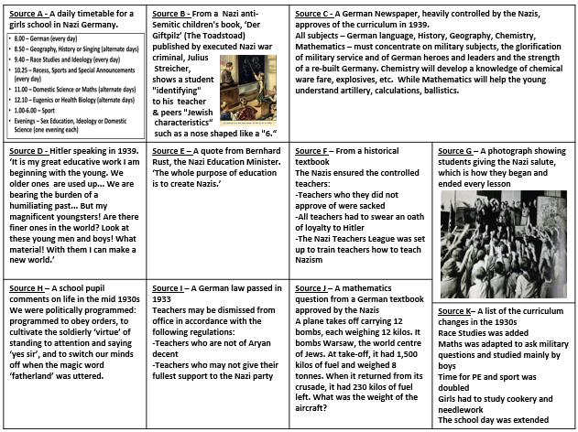
- Under the leadership of the Nazi Education Minister, Bernhard Rust, schools were used as another way to control the views of young people.

Task: Use the sources to infer as many ways as possible that the Nazis used education to control young people
EXTENSION – How effective do you think this indoctrination would have been and why?

Employment and the Standard of Living in Nazi Germany
- Life had been very difficult for people in Germany, and many people were unemployed following the end of WWI.
- Hitler tried to improve life for the majority of Germans - as long as you fitted the Nazi ideal of the Aryan race.
- He introduced many reforms in order to improve the standard of living in Germany and increase employment.
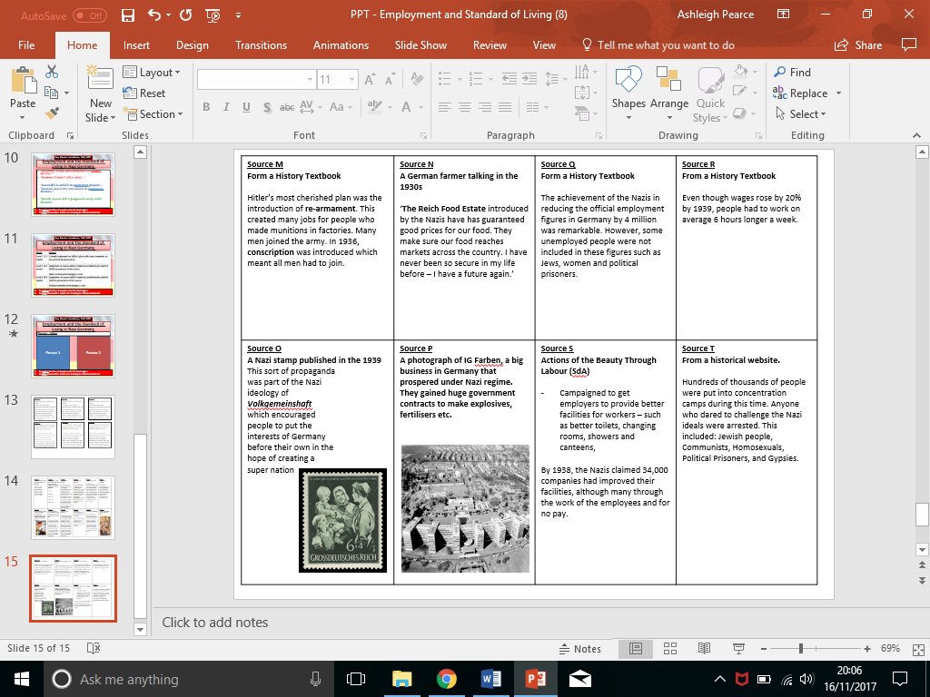
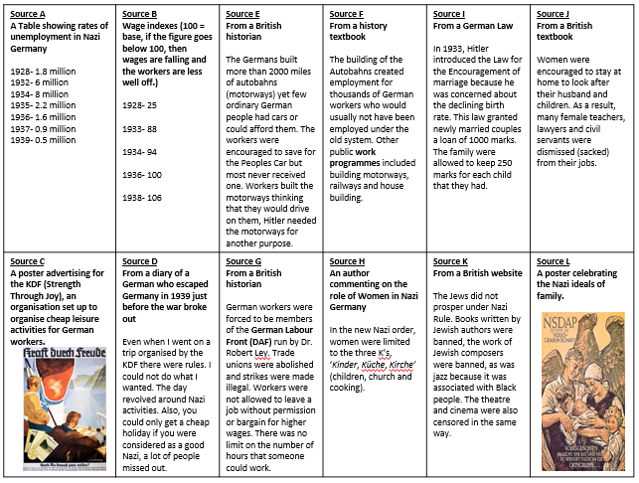

Task: ‘People were better off because of the Nazi policies’. Read through the information and bullet point information into each section.
Agree - people were better off | Disagree – people were not better off

Extension – How did this help Hitler to keep control of Germany?

Nazi Racial Beliefs
- The Nazis believed in two key aspects to ‘purify’ the German nation:
  - Eugenics – The belief of selective breeding, that of pure German blood.
  - Racial Hygiene – The belief that Aryans should only reproduce with other Aryans.

In the 1923 economic depression, the Jews are blamed and Anti-Semitism begins. | In 1925, Hitler explained in Mein Kampf that the Aryan race was superior to all other races. | Throughout the 1930s, the Nazis taught the Slavs (people from the East) were sub-human and should be treat differently. | In early 1933, the Nazis passed a law that made it compulsory for people to be sterilised if they were mentally ill. 400,000 people were sterilised. | During 1933, Jews were banned form government jobs including civil servants and teaching.
From 1933 onwards, children were taught racial hygiene in schools and how people had to have ‘pure blood’. | After 1933, gypsies were arrested and send to concentration camps, as Hitler believed they were ‘a-socials’. | In May 1935, Jews are banned from the army. They also lose their German citizenship and suffer the many Nuremberg laws that follow. | The laws against homosexuality were strengthened in 1935. By the following year, 4,000 had been imprisoned. | In 1936, gypsies were forced to live in special camps with little water and food and no electricity.
By 1938, the number of homosexuals in prison reached 8,000. Many were sent to concentration camps. Laws also encouraged voluntary castration. | In Nov 1938, the Nazis attack Jewish homes and shops in an event known as Kristallnacht. Many are round up and send to concentration camps. | In Jan 1939, the Nazis decided to evict all Jews from Germany and they were evicted from their homes. | All remaining gypsies were rounded up for ‘deportation’ throughout 1939. | By the end of 1939, 5,000 children had been killed with a lethal overdose who were mentally or physically disabled.

Task: Use the information to answer the questions:

- Who did the Nazis target?

- Why did they target undesirables?

- How did the persecution escalate?

Persecution of Jews
- There were only 437,000 Jews in Germany in 1933, less than 1% of the population, but Hitler intended to make the action against them a priority.
- He launched a hate campaign against the Jews, firstly with propaganda then leading onto more serious actions.
The Nuremberg Laws
- They were passed by the Nazis in 1935, and took away citizenship from German Jews
- Jews were also forbidden to marry, or have sexual relations with, non-Jews
- Gradually the laws were added to and took away any civil rights of a Jew
- Jewish children were not allowed to go to school, or play with non-Jews, they were not allowed to own a bike or radio
- Jewish people were not allowed to own businesses , or go university
- Goebbels targeted them through propaganda

Kristallnacht
- Stands for ‘The Night of the Broken Glass’
- In November 1938. a young Jew killed a German diplomat in Paris and the Nazis used this as an excuse to launch a violent revenge on the Jews
- SS officer, who were out of uniform, were issued with pickaxes and hammers and the addresses of Jewish businesses
- They smashed up Jewish shops and workplaces, and burnt down hundreds of synagogues
- 91 Jews were murdered, 20,000 were taken to concentration camps and many more left the country before it was too late
Ghettos
- Jewish people would be moved to special sealed off areas in cities called ghettos
- They would be taken from their homes at any point, and be expected to leave most of their belongings behind
- Able bodied Jews were used for work in the ghettos, but the old and the young were left to suffer in the horrendous conditions
- Food, water and supplies were poorly available, and there was huge overcrowding, resulting in the death of many Jews in the ghettos
The Final Solution
- Special SS units called the Einstatzgruppen were ordered to stage mass killings of the Jewish people – they rounded thousands of them up, got them to dig their own graves, then shot their victims
- At the Wannsee Conference in 1942, the Nazis decided on a more ‘efficient’ way of murdering the Jewish population (they thought the bullets used in the shootings were costing too much money)
- They decided to set up Death Camps, such as the one at Auschwitz, were up to 200 people at once could be killed in the gas chambers followed by the burning of the bodies
- On arrival a person was either kept for work or sent straight to the gas chambers
- Over 6 millions Jews were put to death in these camps, as well as over 5 million over undesirables
Task: Highlight the key features in the information above

Task: Answer the exam question:

Explain why life became increasingly difficult for Jewish people between 1933-38. (12 marks)
- The Nuremberg Laws
- Kristallnacht
_____________________________________________________________________________________________
______________________________________________________________________________________________________________________________________________________________________________________________________________________________________________________________________________________________________________________________________________________________________________________________________________________________________________________________________________________________________________________________________________________________________________________________________________________________________________________________________________________________________________________________________________________________________________________________________________________________________________________________________________________________________________________________________________________________________________________________________________________________________________________________________________________________________________________________________________________________________________________________________________________________________________________________________________________________________________________________________________________________________________________________________________________________________________________________________________________________________________________________________________________________________________________________________________________________________________________________________________________________________________________________________________________________________________________________________________________________________________________________________________________________________________________________________________________________________________________________________________________________________________________________________________________________________________________________________________________________________________________________________________________________________________________________________________________________________________________________________________________________________________________________________________________________________________________________________________________________________________________________________________________________________________________________________________________________________________________________________________________________________________________________________________________________________________________________________________________________________________________________________________________________________________________________________________________________________________________________________________________________________________________________________________________________________________________________________________________________________________________________________________________________________________________________________________________________________________________________________________________________________________________________________________________________________________________________________________________________________________________________________________________________________________________________________________________________________________________________________________________________________________________________________________________________________________________________________________________________________________________________________________________________________________________________________________________________________________________________________________________________________________________________________________________________________________________________________________________________________________________________________________________________________________________________________________________________________________________________________________________________________________________________________________________________________________________

