



Year 11 Design & Technology
(Timbers & Graphics)
Core Theory (40% of the Exam)

Knowledge Organiser

p.6 – 32 Knowledge
p.33 – 46 Exam Questions
p.47-58 Revision Strategies

UNIT SHEETS

This section of your Knowledge Organiser contains the unit sheets for each topic.
Use them to make sure you know what is required at each stage of your learning.

GCSE Product Design Knowledge Checklist

Below is a list of all of the topics we will cover in theory lessons ready for your final exam at the end of Y11. This knowledge organiser covers exam content for the Core section (40% of your examination) only, highlighted below. Write a +, - or = to indicate how you feel about each topic at different points

Core Technical Principles

New & Emerging Technologies | After  teaching | Before  revision | After  revision
Industry & Enterprise
Sustainability
People
Culture
Society
Environment
Production Techniques & Systems
Informing Design Decisions

Developments in New Materials | After  teaching | Before  revision | After  revision
Modern materials
Smart materials
Composite materials
Technical textiles

Energy Generation & Storage | After  teaching | Before  revision | After  revision
Fossil Fuels
Renewable Energy
Nuclear Energy
Energy Storage Systems

Mechanical Devices | After  teaching | Before  revision | After  revision
Different types of movement
Changing direction of movement

Materials & their Working Properties | After  teaching | Before  revision | After  revision
Paper & boards
Timbers
Metals & alloys
Polymers
Textiles

Specialist Technical Principles

Selection of Materials or Components | After  teaching | Before  revision | After  revision
Functionality, Aesthetics, Environmental, Availability, Cost,
Social factors, Cultural factors, Ethical Factors

Forces & Stresses | After  teaching | Before  revision | After  revision
Tension, compressions, torsion, bending, and shearing
Enhancing materials to resist stresses

Sources & Origins, Stock Forms, Types & Sizes | After  teaching | Before  revision | After  revision
Conversion into workable forms
Commercially available types & sizes of materials

Ecological & Social Footprint | After  teaching | Before  revision | After  revision
Ecological issues in the design & manufacture of products
The 6 Rs
Social issues in design & manufacture of products
Understanding the social & ecological footprint left by
designers

Materials | After  teaching | Before  revision | After  revision
Properties of materials
The modification of properties for specific purposes
How to shape & form using cutting, abrasion and addition

Scales of Production | After  teaching | Before  revision | After  revision
One-off, batch, mass, continuous, and Just-In-Time
manufacturing

Selection Techniques & Processes | After  teaching | Before  revision | After  revision
Tools, equipment & processes
How materials are shaped & formed to a tolerance
Commercial processes
Quality Control procedures
Surface treatment & finishes

POWERFUL KNOWLEDGE

In this section you can find the key information your teachers want you to know, understand and be able to recall.

Industry and Enterprise
What you need to know:
- Understand how new and emerging technologies have changed the way we live and how they continue to shape the modern world
- Be aware of how computers and automation have impacted upon the design and organisation of the workplace through the use of robotics
- Understand how innovation can drive product development

Introduction

Design and Technology is the practical application of Science. Design technologists utilise discoveries from Science and turn these into new ideas, materials and products to fulfil human needs. As a Design Technologist your role will be to embrace change and turn ideas into reality. The driving force behind many new inventions is the human instinct to strive for a better and easier life.

To stay at the cutting edge of design and development—designers and manufacturers need to keep up to date with the latest inventions and ideas in materials development, electronics and designing.

Industry and Automation
Prior to the industrial revolution most people lived in the countryside working on the land. As automation developed and led to larger workshops and factories, more people moved away from the countryside to find work in these environments. Gradually a society based on consumerism and enterprise developed around areas of manufacturing—people had money to buy goods and so services and manufacturing areas boomed. This was the start of the society that exists today.
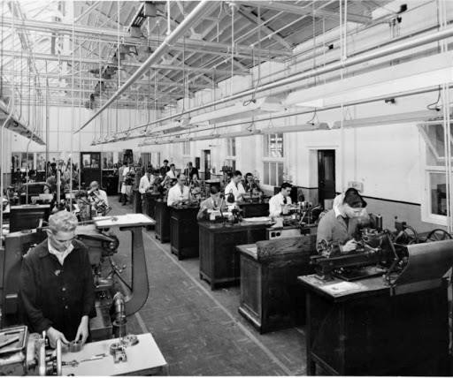
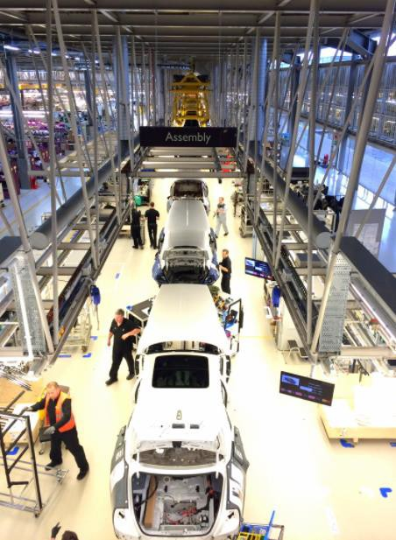
Greater demand for products originally created jobs as the machines needed manual labourers and operators to keep them running. Today with the introduction of intelligent machines and robotic production lines many of these jobs have been lost. Fully automated production lines only require a few highly skilled engineers to ensure that smooth running is maintained.

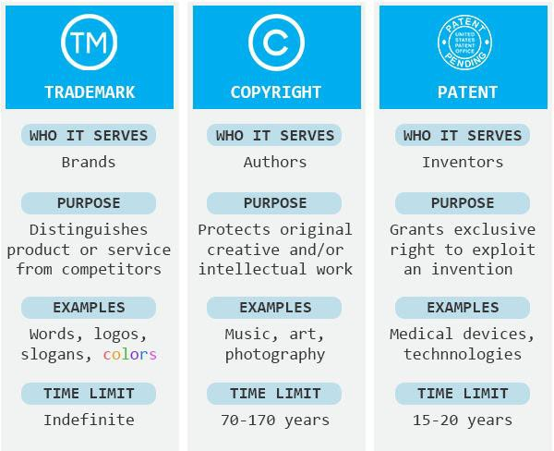
In the 1970s, the Rolls Royce factory would have been full of people and machines, making each part by hand. Now the only people required are for assembly. Most work is done by robots.

The place of work
The development of the internet, improvements in communication technology and the speed of data transfer across the world allows teams of people to collaborate remotely—they don’t have to be in the same, single place of work. Software designed to enable collaborative working allows teams of designers to work on one project from different parts of the world at the same time. Designs can be send to machines to be tested using CAM techniques including CNC machines (i.e. laser cutters) and RPT machines (i.e. 3D printers).

A manufacturing company also needs to consider the layout of its buildings. The work-flow will need to be logically designed to ensure each stage of designing, manufacturing and delivering a product to market is as efficient as possible. This allows a company to minimise unproductive time, unnecessary movement and the waste of materials, making the company as efficient and therefore profitable as possible.
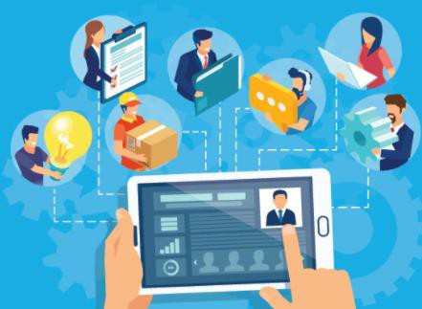

Enterprise
Enterprise in relation to design means that an idea is cultivated into a business proposal that has a commercial viability as a production. The use of the internet and the boom in social media platforms allows creative people to get their ideas noticed by potential investors rather than visiting bank managers or sending proposals out to existing companies.

A number of agencies look out for start-up businesses to invest in, one of the biggest growth areas is in app design and development for smart devices. They ensure that original ideas and inventions remain the intellectual property of the person who invented them. A patent can be applied for. This legal process proves that you are the first person to have registered the ideas. In theory it stops individuals or other companies using a patented idea without permission. You could see a registered logo on a product to show that it has been registered.

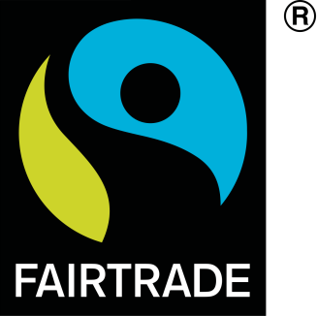
Crowdfunding

This is a popular way for designers and entrepreneurs to raise money to enable the manufacture of their products. Crowdfunding is an internet based way to gain small contributions from many different investors who believe in the product or idea. www.kickstarter.com is an example of a crowdfunding site for design and technology based ideas.


Virtual Marketing and Retail

This means using websites, social media and digital marketing to reach a wider audience to promote a product or idea. Virtual campaigns can use social media to spread the word and have become a popular way to launch product. Blogs and Vlogs are also targeted to appeal to new audiences. A more subtle form is search engine optimisation—companies make efforts to boost their website higher in search engine results. It can also include paid for advertisements in social news feeds or on search results.

Cooperative
A cooperative is an enterprise which is owned and run by its members. The members may be employees or customers. They enable a group of people with the same business interest to have greater protection, they can be a cost-effective way to sell goods, and services are usually based around a community. They are set up to protect the rights of the members.



Fairtrade
Fairtrade is about better prices, decent working conditions, and fair terms of trade for workers in less economically developed countries. It is based in partnership between those who grow the food and those who consume it. The Fairtrade mark means the ingredients in the product have been produced by small-scale farmer organisations that meet Fairtrade standards.

Keywords and terms

Keyword/term | Definition
virtual marketing | The use of sponsored adverts on search engines and social media platforms to spread word of a product or service. Sometimes influencers are used to advertise products on their social media accounts or through YouTube videos.
virtual retail | The use of an online store instead of a physical shop. This can save money as retail outlets can be expensive to let and run.
Fairtrade | A partnership between farmers or growers and manufacturers of products. A Fairtrade partnership means farmers and growers receive fair pay for their goods, but they also have to provide proof that they meet Fairtrade standards in terms of the quality of goods and also good working conditions for employees.
crowdfunding | Where a group, or crowd, of people fund a project or startup enterprise. The idea is that if many people invest a small amount of money a project can be funded with little risk for the investors.
enterprise | A business or company
automation | the use or introduction of automatic equipment in a manufacturing or other process or facility
computer aided design (CAD) | The use of computers to complete designs, whether 2D or 3D
computer aided manufacture (CAM) | The use of machinery such as a laser cutter or 3D printer to manufacture, removing the need for practical skills in humans
computer aided testing (CAT) | The use of computer modelling to test a design. An example of this is computer modelling of aerodynamics in F1
rapid prototyping | Rapid Prototyping is the process of quickly fabricating a physical part, model or assembly using 3D CAD (computer-aided design) data
collaborative working | Collaborative working includes a variety of ways that two or more organisations can work together. It can cover informal networks and alliances, joint delivery of projects or full merger. Collaborative working can last for a fixed length of time or can form a permanent arrangement
commercial viability | the ability of a business, product, or service to compete effectively and to make a profit
computer numerically controlled (CNC) | automated operation of a machine by a computer program

Sustainability and the Environment
- Understand that new technologies need to be developed and produced in a sustainable way
- Be aware of the impact that resource consumption has on the planet
- Understand how the environment can be protected by responsible design and manufacturing
- Understand how waste can be disposed of with the least impact on the planet
- Understand the positive and negative impacts new products have on the environment
What you need to know:

Introduction Sustainability
Our planet has to provide all of our basic human needs—food, shelter, warmth. We use and manipulate many of the Earth’s natural resources to provide these. The sustainability of the planet’s resources is at the forefront of responsible designers’ minds when new technologies are created or discovered.

Resources fall into two categories:
- Finite resources: Are in limited supply or cannot be reproduced. These should be avoided or used only in small amounts for important reasons.
- Non-finite resources: Are in abundant supply, they are unlikely to run out as they can be grown and replaced at the rate they are being used.

We need to measure the impact that the use of resources has on the planet, this includes:
- CO2 emissions – energy needed to produce materials and while they are in use
- Transportation and the distance travelled
- Impact through mining or harvesting to get the resource/material
- Impact on availability – what will be left to use next time?
- Maintenance and repair costs
- Welfare of workers in supplying the material e.g. Fairtrade
- Ethical and moral issues

Carbon off-setting
It is impossible that goods being produced will have no impact on the environment, but companies can promote their products as sustainable and

environmentally friendly if they off-set any negative impact by investing in positive activities that reduce carbon emissions.
A product is considered carbon neutral if it produces zero net emissions
when the life cycle assessment (LCA) has taken all actions into consideration.


A carbon footprint is the amount of greenhouse gases (CO2) released by making, using, and disposing of a product. The more energy required, the bigger the carbon footprint.

Life Cycle Assessment
A company can use a life cycle assessment to assess the environmental impact of a product during the different stages of its life. This is known as ‘cradle to grave’. There are 5 main stages;
- Extraction and processing – how much energy is used to extract raw materials from the earth or produce it through farming and process it for manufacturing.
- Manufacturing and production – The energy needed to manipulate the raw and refined materials into a product.
- Distribution – Packaging and transportation of the product to the end user.
- In use – The energy that the product and any related consumables use during its working life.
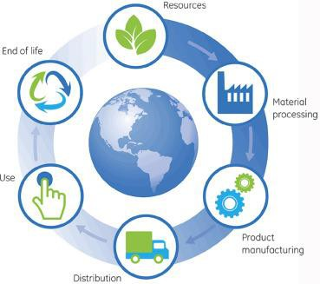
- End of life – The energy that is required to recycle the product and/or dispose of any waste.

A company could then consider:
- Where can energy be saved?
- Where can working conditions be improved?
- Where can emissions be reduced?
- Where can materials be saved?

- Where is the negative effect on communities or natural environments?

How carbon emissions can be reduced
Reduce energy use and CO2 emissions through more efficient user behaviour
Improve energy efficiency with more efficient appliances and buildings
Incorporate renewable energy

Waste Disposal
Purchase carbon off-sets
We need to recycle to ensure that the resources we have will last as long as possible. Strict limits are set in many areas of manufacturing, especially for consumer electronics and the automotive industry. Businesses are charged additional fees to dispose of waste so a reduction in waste will save a company money.

Ecological Issues in the Design & Manufacture of Products – Population Growth
Population has grown quickly since the start of the 20th Century leading to accelerated use of all natural resources. Less than a century ago the population of the planet was less than 2 billion, in 2020 it was 7.8 billion. The impact on the environment due to a larger population using up the resources is increasingly noticeable. New technologies are being developed to try and reduce the negative impact.

The 6 Rs
Today there is greater emphasis on reducing the burden on earth’s natural resources in manufacturing new products. Designers and manufacturers regularly go through a process of

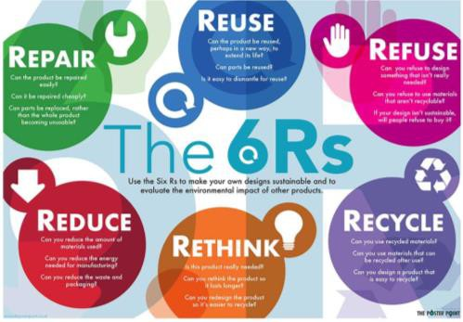
analysis in order to devise sustainable solutions. Following the guidance of the six Rs helps them to see where carbon footprint savings can be made. Consumers are also now more consciously deciding to buy and use products which display consideration for the 6 Rs. The 6 Rs can be placed in order of which has most benefit for the earth, with 1 being the highest carbon footprint savings, and 6 being the lowest.
- Refuse – Is this product, part or process necessary? Simply not using something saves 100% of what you have chosen not to use, for example re-using a carrier bag instead of buying a new one or walking to school instead of being driven.
- Rethink – Consider the impact of a product or process, and perhaps find a more sustainable alternative. For example, buying food products which are locally grown, or designers using a recycled material instead of a new raw material.
- Reduce – This is often the result of refusing or rethinking. The amount of products bought and used by consumers will sometimes reduce, for example carrier bags. In manufacturing reduction can mean the amount of material used in production of a product. An example of this is the amount of plastic used in bottle tops by Coca-Cola, by reducing the size of the cap, the amount of plastic used for manufacture reduces greatly.
- Reuse – reusing products multiple times for the same purpose is sometimes referred to as primary recycling. For example, glass milk bottles which are cleaned, sterilised, and then re-filled with milk.
- Repair – fixing a product which is broken is a very positive step to take, however many products these days are not always repairable.
- Recycle - whilst still being a positive step to take, recycling is actually the stage which has the least positive impact on the environment. Although it does reduce the amount of raw material needed for products and does have benefits, often the process which materials have to go through to be recycled has a high carbon footprint and can actually cancel out some of the benefits.

Keywords and terms

Keyword/term | Definition
CO2 | Chemical symbol for carbon dioxide – a gas which is released into the atmosphere during production, use, and disposal or recycling of many products.
greenhouse gases | Gases such as carbon dioxide and methane which are released and stay in the  earth’s atmosphere, warming the earth’s temperature up.
carbon footprint | The amount of greenhouse gases released by making, using and disposing of a product.
Life Cycle Assessment (LCA) | The process a company may go through to assess and review the amount of greenhouse gases given off in production, use and disposal of a product.
finite | Something which is in limited supply and cannot be reproduced, such as coal
non-finite | Something which is in abundant supply or unlikely to run out, or can be re-grown
sustainability | The ability for something to be maintained over time.
renewable | Something which is in abundant supply or unlikely to run out, or can be re-grown
non-renewable | Something which is in limited supply and cannot be reproduced, such as coal

People, Culture, and Society
What you need to know:
- Understand how technology push and market pull affect consumer choice and employment.
- Understand changes in job roles due to the emergence of new ways of working
- Be aware of changes in fashion and trends, and how they affect designers and manufacturers.
- Understand how new products can have both a positive and negative impact on society

People and Culture
Understanding the market place and the people who will buy and use new products and technologies is important for all designers and manufacturers. When launching a product designers and manufacturers need to consider many different factors. This is because people across the world can have very different needs and tastes. Products selling well in one country can become a complete failure in another.

Culture is the combination of ideas, beliefs, customs and social behaviours of a society or group of people. This can be shown through rituals, fashion and art. Designers need to be aware of the society around them and the cultures within it.

Some parts of the world are still dominated by a single culture, designing in these cultures can be seen as easier as there is less diversity and the majority of the population have similar lifestyles. A negative for manufacturers is that they may require a more limited range of products. In the UK and especially in large cities there is a wide range and mix of cultures - selling a product in this market could be challenging as many more factors need to be considered.

The product design market can quite often be influenced by the ‘latest thing’. Consumers want to be part of a group, to fit in, or to buy into a lifestyle. Designers and manufacturers buy into people’s insecurities and design and make products that people feel they ‘must- have’. Fashion is a great example—the latest designs are only meant to last a season before they are outdated or people have moved on to the next new thing.

Designs influenced by a fashion trend are common. Marketing a product to the correct audience is the key. The font used in an advert could be chosen to give the impression of an expensive product, or a rival company could use a font to imitate a brand leader.
Products can fail for many reasons, one of the easiest mistakes to make is the use of a brand name that means something else in a different language, or using a brand name that when turned into a web address creates a new word with different meaning. This is why market testing is vital!

When the new £5 note was released in 2016 it caused some controversy. What should have been an improved note which showed innovation actually caused offence amongst a huge part of the population. The new plastic notes contain something called tallow – an animal fat based substance. In faiths such as Hinduism and Sikhism, followers will live by a vegetarian diet and avoid using animal based products in daily life.

Society
Most societies are trying to become more inclusive and cater for the needs of the disabled and elderly. New technologies have enabled designers and manufacturers to create products such as tools and household gadgets, building access, and transportation methods which will drastically improve the lives of disabled and elderly people. A designer should consider inclusive design when developing any product – the more people a product will appeal to the more popular it will be. Designers need to be aware of who could be excluded from a product and consider any modifications which could make it more accessible.
Modern technologies play an important role, for example, the use of carbon fibre has allowed disabled people to take part in activities previously not open to them e.g. sports equipment for Paralympians.

The population is ageing as advances in medical care and other factors now lead to people living longer than before. The design of new products using new technologies to meet these needs is increasingly important. Not everyone who lives longer will be as strong or as healthy as the younger generations. Products which address specific difficulties or offer a better quality of life will find a growing market.


Technology Push
Designers, engineers and technologists often use new technological discoveries in the development of new products. Often there is no consumer awareness or demand for the

product. This is called technology push. Current thinking is driven forward and new, exciting developments are created. Research and Development (R&D) departments in large companies ensure new and exciting products can be created. New products need to be developed so that a company is able to be the first to the market and therefore keep their market share, rather than customers going to their competitor! Without R&D many products would never have made it to market.

Market Pull
Market pull is when consumer demand is the driving force behind a development of a new product. If a designer can analyse the consumer market to understand the needs and desires, a ‘gap in the market’ can be filled. Market pull puts pressure on companies to update and improve their product. They can then keep their share of the market through brand loyalty and with new products also attract new customers.
Smartphones are a great example of market pull leading to development of a product, e.g. a combination of features, improved battery life, and the miniaturisation of electronic components.

Digital Development
New technologies are being developed faster than ever before. The growth in digital and social media has begun to impact the sustainability of traditional job roles. Automation is leading to a decreased need for manual labour and therefore a change in job roles and working conditions is inevitable. The human workforce needs to and will up-skill, the jobs people train for will be of a higher value. The workforce will need to be flexible and workers of the not so distant future will be performing tasks which do not exist today. The way we work will be driven by technological change and advances.

Keywords and terms

Keyword/term | definition
manufacturer | maker of products
consumer | buyer or user of products
culture | Culture is the combination of ideas, beliefs, customs and social behaviours of a society or group of people
marketing | the action or business of promoting and selling products or services, including market research and advertising
technology push | advancements of technology which push developments in products
market pull | when customer needs and desires drive product developments
inclusive design | The design of mainstream products and/or services that are accessible to, and usable by, as many people as reasonably possible without the need for special adaptation or specialised design.

Production Techniques & Systems and Quality Control
What you need to know:
- Understand contemporary and potential future use of automation, Computer Aided Design (CAD), and Computer Aided Manufacture (CAM).
- Be able to recognise and characterise the use of Flexible Manufacturing Systems (FMS)
- Understand how Just In Time (JIT) and lean manufacturing contribute to manufacturing efficiencies

Automation
The use of computers in production lines make them flow more easily and lead to less human interaction needed. In the past manual production lines were slower and more expensive to operate than the automated production lines used today. Despite this, some traditional manufacturers still rely on skilled manual labour. Products made in this way tend to be bespoke, low volume and high cost items, including sports cars or high-end furniture.
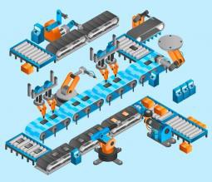
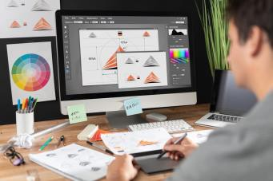
Most manufacturing is still becoming increasingly automated. Automation involves computers using complex software systems that have an overview of many aspects of the production. Production data management is the term used to describe these software systems. All of the data is stored centrally, is updated live and is accessible by all employees who need the most up to date information. This reduces mistakes, ensures that all teams in the company can work together, leads to accurate costing and forecasting production progress.

Computer-Aided design and manufacturing
Computer aided design (CAD) and computer aided manufacture (CAM) are essential to ensure smooth transition between the designing and manufacturing stages of creating products.
CAD is the design of new products using specialist computer based software. CAM uses the CAD files to turn these designs into prototypes or finished products. Many designers still prefer to start sketching an idea using pen and paper in order to express ideas more freely. Once the design has been created CAD can be used to re-sketch accurately and can be used to manipulate and test the design until it is finalised.
Both CAD and CAM work through the use of computer numerical control (CNC). This is when the CAD software generates a series of machine codes which are interpreted by the CNC machine into movements of the machine bed or other actions such as motor speeds to control needles or cutters.

In schools common CAM equipment includes laser cutters, vinyl cutters, computerised sewing and embroidery machines, CNC routers and lathes.

Flexible manufacturing systems (FMS)
This refers to a collection of automated machines that are adaptable and used in production lines where the products being made may change on a regular basis. Manufacturers can respond quickly to changes in the market and consumer demands, it also allows for a reaction to trends and fashion. FMS machines are flexible and adaptable, they are best equipped for batch production. The need for flexibility could add further set up costs to the production. CNC machines are frequently used in FMS as they can be reprogrammed easily so changes are quick, simple and cost effective. Robot arms are also used because they can be programmed to do many tasks. They can also per-form multiple tasks while on one production line, making the FMS capable of real time changes and greater flexibility during manufacture.

Lean Manufacturing
Lean manufacturing is based on an ethos of eliminating waste in manufacture. An increasing number of responsible manufacturers now adopt this principle to save money and resources. This first began in Japan during the 1990’s but has grown in popularity across the world.
Manufacturers are cutting down on the waste they produce by changing the way they operate. An example of this is to use Just In Time production methods (JIT)

Just In Time Manufacturing (JIT)
Using Just In Time production methods manufacturers are able to respond to customer demands more effectively. JIT manufacturing ensures that customers get the right product at the right time and at the right price. A customer’s order will trigger the production proves and the manufacturer makes the product specifically to meet the order. Stock is not ordered until the product will be made, reducing waste and making production more economical as stock is not ordered of not needed.

Advantages of JIT | Disadvantages of JIT
Reduced storage costs as stock is not  stored | Relies on high quality , fast and reliable supply  chains for materials and components
Money is not tied up in unsold stock | All production could stop or be delayed if the  supply chain breaks down
Orders are secured on a deposit or full payment—money is paid before out-lay of  materials and production costs | Stock is not ready to be purchased ‘off the shelf’. Some customers may not want to wait,  so sales could be lost.
Materials are supplied as needed, saves financial outlay on unused materials or  additional storage | A deposit or full balance usually needs to be paid upfront which may be off-putting for  some customers
Stock does not become old, obsolete or out  of date | Discounts from suppliers for purchasing  materials in bulk may not be avail-able
Almost all waste is reused or recycled so
little landfill waste is produced

Advantages of CAD | Disadvantages of CAD
Designs can be altered easily | Software can be difficult to learn
Faster to draw complex designs, so saves labour  costs and development time | Software can be expensive
Design can be saved and historic versions kept and archived. Designs can also be easily copied or  repeat-ed. | There can be compatibility issues with the software
Work can be sent be email for approval and for  manufacture | Security issues—data could be  corrupted or hacked
Teams of designers can work on the same project  simultaneously | Software may need regular updates
Designs can be rendered to look photo realistic  to gather public or target market opinion | Demand on computer memory
Software can process stress testing and associated calculations to predict issues with a  product prior to manufacture | Data could be lost in power cuts

Advantages of CAM | Disadvantages of CAM
Faster than traditional tools | Expensive to set up/buy equipment
More accurate than traditional methods | Training costs and time
High accuracy and repetition | CAM machines need specialist engineers for  maintenance and repair
Machines can operate 24/7 | CAM machines can lead to unemployment due  to replacing traditional skills/jobs
Work can be produced directly from CAD
files

Keywords and terms

Keyword/term | Definition
automation | The use of machinery in place of humans. Often used in mass or continuous production due to the cost and complexity of setting up an automated process
CAD | Computer aided design – the use of computers to draw and edit designs ready for manufacture. Could be 2D or 3D format.
CAM | Computer aided manufacture – the use of machines to create 3D products or parts from a CAD drawing. Examples of CAM include laser cutting, 3D printing and CNC routing
JIT production | Just in time production – a method of manufacture which relies on components or raw materials being delivered just in time for production and assembly. This can save money for companies as they need less space for storage of parts, but relies on organisation and reliable supply chains.
flexible manufacturing systems | This is where a factory may be set up with quite generic machinery rather than specific machines to make a particular thing. For example it could be set up with lathes, milling machines, sanders and drills which can all be used to manufacture many different things
CNC | Computer numerically controlled – a way to run CAM which relies on numbers and programming to run
Kaizen | A Japanese term which means continuous improvement.

Informing Design Decisions
What you need to know:
- Be able to evaluate the advantages and disadvantages of planned obsolescence from different perspectives
- Understand how products can be designed to be repaired and recycled
- Be aware of ethical and environmental concerns when designing with new technologies

Evaluating the use of new technologies
When designers first come up with new ideas for a product they also need to carry out a lot of market research. Market research allows the designer and manufacturer to fully understand the task and have detailed knowledge of the marketplace. Through market research, designers will find out about the latest technologies and materials available to them and they will evaluate the use of these technologies and materials against a number of criteria, including;
- cost
- reliability
- longevity
- sustainability
- recyclability
Even with detailed research, some potential long term issues may still not be known, which is one of the main risks in using new and emerging technologies.

Ethics and the environment


Finding out whether a new technology will have a negative effect on the environment is usually discovered through research and conducting a Life Cycle Assessment (LCA). It is becoming more important, and expected, that companies show they are environmentally and socially responsible. Consumers are also more aware through social media and global news access of the issues surrounding pollution of land, air, and sea – making consumers more demanding on companies to closely monitor their social and ecological footprint.

End of working-life disposal

Considering how a product is to be disposed of at the end of its useful life needs careful consideration. How recyclable or reusable a product is will depend on the materials chosen and how they are joined together – decisions made early in the design process. If a product can be separated into its individual component materials easily it will be easy to recycle and take less time and energy to do so. If the product is also made from fully recyclable materials it potentially means none will end up in landfill or cause contamination to the environment.
Some products are designed to be reused, such as glass milk bottles. Other products can be given new life due to inventive people choosing to reuse them in innovative ways. For example old car tyres can be reused in the building of houses, as swings in playgrounds, or to produce high quality oil. When a product is reused rather than recycled it uses less energy and does not degrade in quality due to being reprocessed.

Responsible end of life design should include; as few materials as possible, recycled or recyclable materials, easy to separate materials and built in re-usability where possible.
Design for maintenance

Less and less products are now designed to be repaired. Ones that are repairable often require specialist tools and home repair is discouraged and harder to achieve. A reason for this is that many products – especially electronic and mechanical devices have become very complex and therefore are beyond the ability of most people to repair them without specialist tools or training. For most companies, they also want customers to buy a new product as soon as possible so that they can make money. If a product breaks after the guarantee has expired they may even offer a discount on a new version to keep the customers loyalty and their business.

Companies will have service contracts with repair firms and can make a profit from organising the repairs for customers – another reason specialist tools are often required, they don’t want just anybody to be able to offer the repair service!

Planned obsolescence
When buying products we expect some to last a long time, and other we expect to throw away after just one use. For example a sofa would be expected to last many years, a pair of headphones a year or two, and a ballpoint pen until it runs out of ink (if not designed to be
re-filled and re-used). Built-in or planned obsolescence is ensuring that a product will only perform its function for a certain length of time. Designers and manufacturers need to consider this for a number of reasons.

Appropriately engineered quality
If a product is only intended to last a short amount of time it would be a waste of materials and energy to make it robust enough to last a long time. A disposable razor has a plastic handle because the non-replaceable blade will become blunt quickly, a cheap polymer like polystyrene is the best material due to it being cheaper to produce.

Upgrading and function
Some products are designed to receive updates or be upgraded. Manufacturers need to decide how upgradable a product needs to be. If a product can be continuously upgraded the chance of new sales will be reduced as customers will wait for a significant upgrade to become available before buying a new model. If the product does not have enough potential for upgrades, again money and sales could be lost as it isn’t seen as good value for money.
The smart phone is a great example of this as it can usually be upgraded a few times, but after a while will stop being able to receive the updates or certain features will stop working.
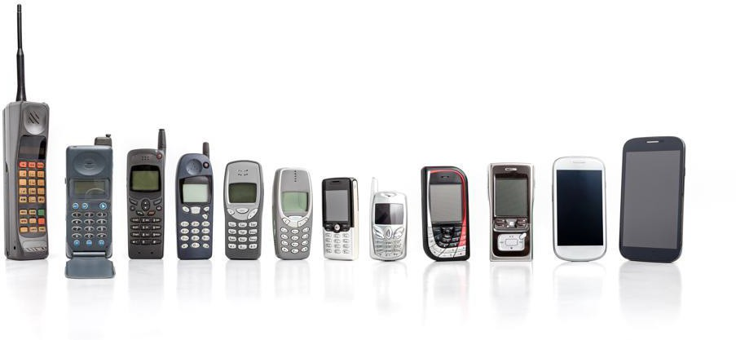

New technologies (technology push)
Changes in materials, manufacturing techniques, technologies and customer desires are guaranteed. Most manufacturers will avoid producing goods that will last a long time because as technology moves on, customers will want newer versions.

Fashion and trends


Many goods are sold as novelty items which are often led by trends in the market, seasons or fashion. The quality of goods will vary depending on how long they need to last for as well as the price point they are manufactured to. Most Halloween or Christmas items are not designed to last more than the current season so getting a couple of years of use out of them is considered a bonus.

Keywords and terms

Keyword/term | Definition
planned obsolescence | A concept where designers make something which purposely becomes out of fashion, behind trends, or breaks in order for customers to buy new products
market research | Research into the wants, needs and requirements of the intended user of a product
trend | A fashion
maintenance | Repair or general upkeep of a product
social responsibility | Social responsibility is an ethical framework and suggests that an individual has an obligation to work and cooperate with other individuals and organisations for the benefit of society at large.
social footprint | Social Footprint is the impact that a company's social policies have on the world, such as its employees, its partners and the society as a whole.
ecological footprint | The impact of a person or community on the environment, expressed as the amount of land required to sustain their use of natural resources.

Modern, Smart, and Composite Materials & Technical Textiles
What you need to know:

Introduction
- The definitions of different material categories.
- Developments made in materials through the invention of new processes.
- That materials can change given a particular stimuli.
- That materials can be combined to create an enhanced material.
Technology is ever-changing and new developments in materials are arising constantly.

The term ‘modern’ materials relates to the emergence of new materials or developments
in existing ones.
New ‘smart’ materials are also being developed constantly, both in response to advances in
technology and needs of users.

Composite materials are created when two or more distinctly different materials are combined together to create a new material with improved properties and functionality.
Modern materials—corn starch polymers
Although classed as a modern material, corn starch polymer have been around for some time. It is due to the recent drive towards more sustainable design that they have been developed further and now become more commercially viable.
Being fully biodegradable if composted, these plastics are a popular option for manufacturers and retailers, as well as users. They are made from the starch taken from vegetable products such as corn and maize. They are not toxic to the environment and will break down quickly in soil. Corn starch polymers cannot be recycled. Two examples of corn starch polymers are:

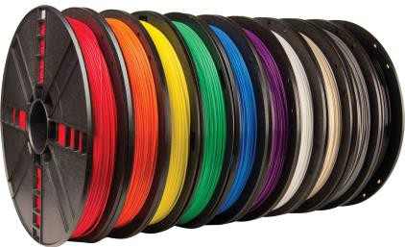
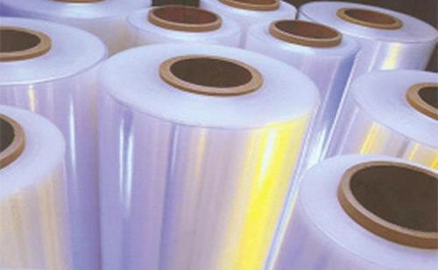
PLA (polylactic acid) is often bought in rolls of filament and used for 3D printing
Polyhydroxybutyrate (PHB) or Biopol™ can be used as a biodegradable plastic film for

Modern materials—titanium
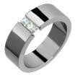



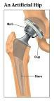

Though titanium is an element, it is rarely used in its pure form. Titanium is often mixed with other elements such as aluminium, vanadium and iron. This gives extra strength, whilst remaining workable and corrosion resistant. Being hypo-allergenic, titanium is often used for artificial joints and dental implants. The high strength-to-weight ratio of titanium makes it suitable for parts for sports cars, aircraft and spacecraft. The ability to polish titanium to a high shine makes it desirable for jewellery and watches.

Modern materials—metal foams
Metal foams are made by injecting gas into the molten liquid forms of metals, usually aluminium or titanium. This means the metals will retain many of their original properties whilst also becoming very lightweight. They are used for many lightweight, load-bearing structures and as impact absorption in vehicles.
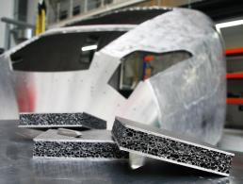
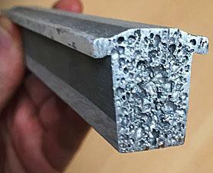

Modern materials—polymorph
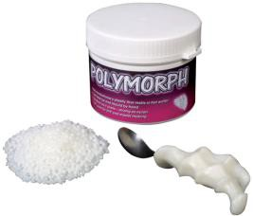
Polymorph is bought in small white granules. Colour can be added with tiny coloured pellets. When heated to 62°, the granules will join together and become one mouldable substance. This can be done by putting the granules in hot water from a kettle. Polymorph can be shaped by hand, and if formed into a thin layer it will be quite flexible. Once polymorph cools down, it will become solid. It can be reheated and reshaped, making it very useful for prototyping.

Composite materials—GRP (glass reinforced plastic)
Made up of very fine strands of glass woven into a flexible cloth, and coated in polyester resin, GRP is a lightweight but strong material. After first manufacturing, GRP is rough

textured and so would be sanded smooth, then primed and painted. GRP is an ideal material for boat hulls, canoes, and water slides.

Composite materials— carbon fibre
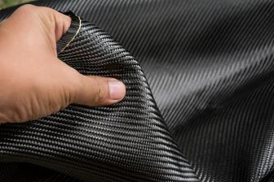
Very similar to GRP but using strands of carbon instead of glass. Carbon fibre has many different advantages, including high strength, lightweight, high tensile strength and high temperature resistance. Carbon fibre is often used for high end bicycles, cars, and formula one cars due to its strength and low weight, though it is expensive to produce.
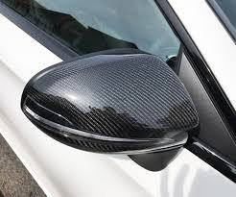

Technical textiles—Gore-Tex®
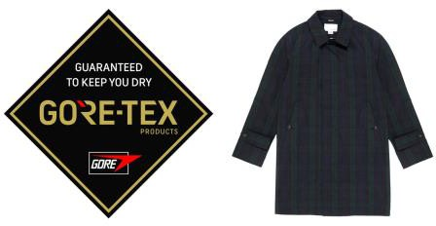
Gore-Tex® is a membrane layer made up of millions of pores per cm² which are smaller than a water droplet. This means that water cannot pass through the membrane, but vapours from inside the fabric (from the wearers’ body). As a result, wearers are warm and dry.

Technical textiles—Kevlar
Made from modified nylon fibres, Kevlar is extremely strong and hard-wearing and has high tensile strength. It is heat resistant and tear resistant. It’s most important uses are protective items like helmets, bullet-proof vests and motorcycle clothing.
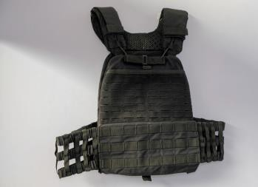
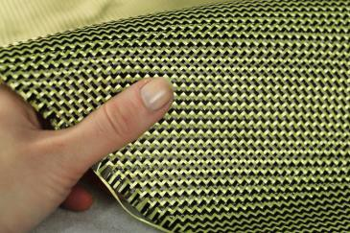

Technical textiles—Microencapsulation
Liquids or solids can be trapped within fibres of microfibre fabrics to then be released by

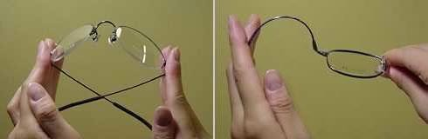
rubbing or heating the fabric. This could be insecticides being released slowly from clothing to protect from mosquitos or fragranced particles being released from clothes during the day. Microfibres are very absorbent but also quick drying.

Smart Materials - Thermochromic pigments
These change colour when heat is introduced. Pigments can be embedded in other materials or paints, or can come in a film. Often used for thermometers and other items which need to indicate a temperature change.
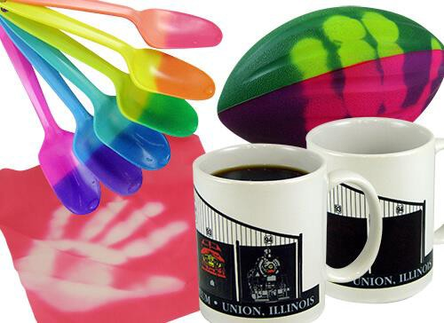

Smart Materials - Photochromic pigments
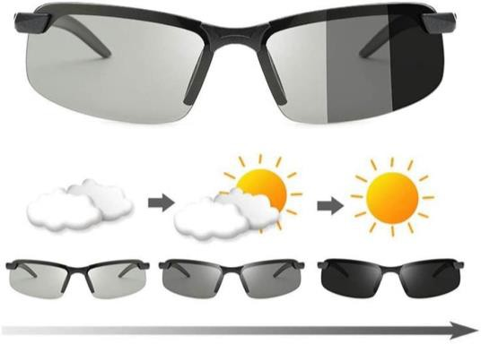
These change colour under exposure to UV light. When out in sunlight, the material will change colour. When taken out of sunlight, it will change back to the original colour. Used for reactive glasses lenses.

Smart Materials - Shape Memory Alloy
Nitinol can be drastically bent and distorted but still return immediately to its original shape when pressure is released. Glasses frames can be made from this material, helping to prevent breakages if glasses are sat on, for example.

Keywords and terms

Keyword/term | Definition
biodegradable | Will rot naturally
recyclable | Can be re-processed and made into something else
finite | Something which is limited or will run out
stimulus | Something which evokes a change or adaptation
alloy | A mixture of two or more metals
photo | Relating to light
thermo | Relating to heat or temperature
aesthetic | Relating to appearance
synthetic | Something which is man made
function | The role or job of a product
pigment | colour

PRACTICE PAGES

In this section of your Knowledge Organiser you will be able to work on practice examples – in class and at home as independent tasks.

Practice Exam Questions – Industry & Enterprise

- Which inventions do you feel have significantly changed the way people live their lives? Justify your response with examples. (6 marks)
…………………………………………………………………………………………………………………………………………………………………………
…………………………………………………………………………………………………………………………………………………………………………
…………………………………………………………………………………………………………………………………………………………………………
…………………………………………………………………………………………………………………………………………………………………………
…………………………………………………………………………………………………………………………………………………………………………
…………………………………………………………………………………………………………………………………………………………………………
…………………………………………………………………………………………………………………………………………………………………………
…………………………………………………………………………………………………………………………………………………………………………
…………………………………………………………………………………………………………………………………………………………………………
…………………………………………………………………………………………………………………………………………………………………………
- Which technological developments in agriculture have led to fewer people being needed to work within the industry? (4 marks)
…………………………………………………………………………………………………………………………………………………………………………
…………………………………………………………………………………………………………………………………………………………………………
…………………………………………………………………………………………………………………………………………………………………………
…………………………………………………………………………………………………………………………………………………………………………
…………………………………………………………………………………………………………………………………………………………………………
…………………………………………………………………………………………………………………………………………………………………………
…………………………………………………………………………………………………………………………………………………………………………
…………………………………………………………………………………………………………………………………………………………………………
…………………………………………………………………………………………………………………………………………………………………………
…………………………………………………………………………………………………………………………………………………………………………
- How could automation have affected the hierarchical structure of an organisation’s
staffing? Give examples. (4 marks)
…………………………………………………………………………………………………………………………………………………………………………
…………………………………………………………………………………………………………………………………………………………………………
…………………………………………………………………………………………………………………………………………………………………………
…………………………………………………………………………………………………………………………………………………………………………
…………………………………………………………………………………………………………………………………………………………………………
…………………………………………………………………………………………………………………………………………………………………………
…………………………………………………………………………………………………………………………………………………………………………
…………………………………………………………………………………………………………………………………………………………………………
…………………………………………………………………………………………………………………………………………………………………………
…………………………………………………………………………………………………………………………………………………………………………

- Why is the ability to sketch and design by hand still considered important by many designers despite the advancement of CAD? (3 marks)
…………………………………………………………………………………………………………………………………………………………………………
…………………………………………………………………………………………………………………………………………………………………………
…………………………………………………………………………………………………………………………………………………………………………
…………………………………………………………………………………………………………………………………………………………………………
…………………………………………………………………………………………………………………………………………………………………………
…………………………………………………………………………………………………………………………………………………………………………
- List the positive effects that full automated robotic production lines have had on employment. (2 marks)
…………………………………………………………………………………………………………………………………………………………………………
…………………………………………………………………………………………………………………………………………………………………………
…………………………………………………………………………………………………………………………………………………………………………
- List the negative effects that full automated robotic production lines have had on employment. (2 marks)
…………………………………………………………………………………………………………………………………………………………………………
…………………………………………………………………………………………………………………………………………………………………………
…………………………………………………………………………………………………………………………………………………………………………
- Explain the low-cost methods of self-promotion and advertising that could be used by young designers to get their ideas noticed. (5 marks)
…………………………………………………………………………………………………………………………………………………………………………
…………………………………………………………………………………………………………………………………………………………………………
…………………………………………………………………………………………………………………………………………………………………………
…………………………………………………………………………………………………………………………………………………………………………
…………………………………………………………………………………………………………………………………………………………………………
…………………………………………………………………………………………………………………………………………………………………………
…………………………………………………………………………………………………………………………………………………………………………
…………………………………………………………………………………………………………………………………………………………………………
- How might staff-owners of a worker owned cooperative be motivated differently to the staff of a non-cooperative style organisation? (3 marks)
…………………………………………………………………………………………………………………………………………………………………………
…………………………………………………………………………………………………………………………………………………………………………
…………………………………………………………………………………………………………………………………………………………………………
…………………………………………………………………………………………………………………………………………………………………………
…………………………………………………………………………………………………………………………………………………………………………
…………………………………………………………………………………………………………………………………………………………………………
…………………………………………………………………………………………………………………………………………………………………………
…………………………………………………………………………………………………………………………………………………………………………
…………………………………………………………………………………………………………………………………………………………………………
…………………………………………………………………………………………………………………………………………………………………………

Practice Exam Questions – Sustainability & the Environment
- Give two examples of finite resources and two examples of non-finite resources. (4 marks)
…………………………………………………………………………………………………………………………………………………………………………
…………………………………………………………………………………………………………………………………………………………………………
…………………………………………………………………………………………………………………………………………………………………………
…………………………………………………………………………………………………………………………………………………………………………
…………………………………………………………………………………………………………………………………………………………………………
…………………………………………………………………………………………………………………………………………………………………………
…………………………………………………………………………………………………………………………………………………………………………
…………………………………………………………………………………………………………………………………………………………………………
- Why should finite resources be avoided or used in limited amounts? (3 marks)
…………………………………………………………………………………………………………………………………………………………………………
…………………………………………………………………………………………………………………………………………………………………………
…………………………………………………………………………………………………………………………………………………………………………
…………………………………………………………………………………………………………………………………………………………………………
- What can a company learn by conducting a life cycle assessment? (3 marks)
…………………………………………………………………………………………………………………………………………………………………………
…………………………………………………………………………………………………………………………………………………………………………
…………………………………………………………………………………………………………………………………………………………………………
…………………………………………………………………………………………………………………………………………………………………………
- What are the 5 stages of the life cycle assessment? (5 marks)
…………………………………………………………………………………………………………………………………………………………………………
…………………………………………………………………………………………………………………………………………………………………………
…………………………………………………………………………………………………………………………………………………………………………
…………………………………………………………………………………………………………………………………………………………………………
…………………………………………………………………………………………………………………………………………………………………………
- Explain the term carbon footprint (3 marks)
…………………………………………………………………………………………………………………………………………………………………………
…………………………………………………………………………………………………………………………………………………………………………
…………………………………………………………………………………………………………………………………………………………………………
…………………………………………………………………………………………………………………………………………………………………………

- Explain how carbon off-setting helps to reduce a carbon footprint. (3 marks)
…………………………………………………………………………………………………………………………………………………………………………
…………………………………………………………………………………………………………………………………………………………………………
…………………………………………………………………………………………………………………………………………………………………………
…………………………………………………………………………………………………………………………………………………………………………
- List the 6 Rs (6 marks)
…………………………………………………………………………………………………………………………………………………………………………
…………………………………………………………………………………………………………………………………………………………………………
…………………………………………………………………………………………………………………………………………………………………………
…………………………………………………………………………………………………………………………………………………………………………
…………………………………………………………………………………………………………………………………………………………………………
…………………………………………………………………………………………………………………………………………………………………………
- Define the term sustainability. (2 marks)
…………………………………………………………………………………………………………………………………………………………………………
…………………………………………………………………………………………………………………………………………………………………………
…………………………………………………………………………………………………………………………………………………………………………

Practice Questions – People, Culture & Society
- List 3 products that would sell well in one country but not in another. Give reasons for your answers. (6 marks)
…………………………………………………………………………………………………………………………………………………………………………
…………………………………………………………………………………………………………………………………………………………………………
…………………………………………………………………………………………………………………………………………………………………………
…………………………………………………………………………………………………………………………………………………………………………
…………………………………………………………………………………………………………………………………………………………………………
…………………………………………………………………………………………………………………………………………………………………………
…………………………………………………………………………………………………………………………………………………………………………
…………………………………………………………………………………………………………………………………………………………………………
- Explain what the positive and negative factors of a global market place are for the manufacturer. (4 marks)
…………………………………………………………………………………………………………………………………………………………………………
…………………………………………………………………………………………………………………………………………………………………………
…………………………………………………………………………………………………………………………………………………………………………
…………………………………………………………………………………………………………………………………………………………………………
…………………………………………………………………………………………………………………………………………………………………………
…………………………………………………………………………………………………………………………………………………………………………
…………………………………………………………………………………………………………………………………………………………………………
- Explain what the positive and negative factors of a global market place are for the consumer (4 marks)
…………………………………………………………………………………………………………………………………………………………………………
…………………………………………………………………………………………………………………………………………………………………………
…………………………………………………………………………………………………………………………………………………………………………
…………………………………………………………………………………………………………………………………………………………………………
…………………………………………………………………………………………………………………………………………………………………………
…………………………………………………………………………………………………………………………………………………………………………
…………………………………………………………………………………………………………………………………………………………………………
- How can a company keep up to date with the latest trends in their sector? (3 marks)
…………………………………………………………………………………………………………………………………………………………………………
…………………………………………………………………………………………………………………………………………………………………………
…………………………………………………………………………………………………………………………………………………………………………
…………………………………………………………………………………………………………………………………………………………………………

…………………………………………………………………………………………………………………………………………………………………………
…………………………………………………………………………………………………………………………………………………………………………
…………………………………………………………………………………………………………………………………………………………………………
- What is market testing? (2 marks)
…………………………………………………………………………………………………………………………………………………………………………
…………………………………………………………………………………………………………………………………………………………………………
…………………………………………………………………………………………………………………………………………………………………………
- Why is market testing important? (2 marks)
…………………………………………………………………………………………………………………………………………………………………………
…………………………………………………………………………………………………………………………………………………………………………
…………………………………………………………………………………………………………………………………………………………………………
- Why would being first to market a new product give a company a competitive advantage?
(2 marks)
…………………………………………………………………………………………………………………………………………………………………………
…………………………………………………………………………………………………………………………………………………………………………
…………………………………………………………………………………………………………………………………………………………………………

- Evaluate how research and development contribute to new technologies or products being developed. (6 marks)
…………………………………………………………………………………………………………………………………………………………………………
…………………………………………………………………………………………………………………………………………………………………………
…………………………………………………………………………………………………………………………………………………………………………
…………………………………………………………………………………………………………………………………………………………………………
…………………………………………………………………………………………………………………………………………………………………………
…………………………………………………………………………………………………………………………………………………………………………
…………………………………………………………………………………………………………………………………………………………………………
…………………………………………………………………………………………………………………………………………………………………………
…………………………………………………………………………………………………………………………………………………………………………

Practice Questions – Production Techniques & Systems and Quality Control

- Why is Kaizen an important concept for many manufacturers? (2 marks)

…………………………………………………………………………………………………………………………………………………………………………
…………………………………………………………………………………………………………………………………………………………………………
…………………………………………………………………………………………………………………………………………………………………………
- How does Kaizen support lean manufacturing? (2 marks)

…………………………………………………………………………………………………………………………………………………………………………
…………………………………………………………………………………………………………………………………………………………………………
…………………………………………………………………………………………………………………………………………………………………………
- Name a product made using JIT manufacturing. (1 mark)

…………………………………………………………………………………………………………………………………………………………………………
…………………………………………………………………………………………………………………………………………………………………………
…………………………………………………………………………………………………………………………………………………………………………
- How would FMS allow a company to respond to trends and market changes? (3 marks)

…………………………………………………………………………………………………………………………………………………………………………
…………………………………………………………………………………………………………………………………………………………………………
…………………………………………………………………………………………………………………………………………………………………………
…………………………………………………………………………………………………………………………………………………………………………
- Explain the term product data management. (3 marks)

…………………………………………………………………………………………………………………………………………………………………………
…………………………………………………………………………………………………………………………………………………………………………
…………………………………………………………………………………………………………………………………………………………………………
…………………………………………………………………………………………………………………………………………………………………………

- Why is it a good idea for companies to invest in product data management software?
(2 marks)
…………………………………………………………………………………………………………………………………………………………………………
…………………………………………………………………………………………………………………………………………………………………………
…………………………………………………………………………………………………………………………………………………………………………
- Why do some people prefer to buy traditionally made products rather than those which have been mass produced? (3 marks)
…………………………………………………………………………………………………………………………………………………………………………
…………………………………………………………………………………………………………………………………………………………………………
…………………………………………………………………………………………………………………………………………………………………………
…………………………………………………………………………………………………………………………………………………………………………

- How can CAD/CAM save money on shipping and transport for companies? (3 marks)

…………………………………………………………………………………………………………………………………………………………………………
…………………………………………………………………………………………………………………………………………………………………………
…………………………………………………………………………………………………………………………………………………………………………
…………………………………………………………………………………………………………………………………………………………………………
- What is meant by a machine being computer numerically controlled? (4 marks)

…………………………………………………………………………………………………………………………………………………………………………
…………………………………………………………………………………………………………………………………………………………………………
…………………………………………………………………………………………………………………………………………………………………………
…………………………………………………………………………………………………………………………………………………………………………
…………………………………………………………………………………………………………………………………………………………………………
…………………………………………………………………………………………………………………………………………………………………………
…………………………………………………………………………………………………………………………………………………………………………

Practice Questions – Informing Design Decisions

- What effect would planned obsolescence have on the use of materials during manufacture?
(3 marks)
…………………………………………………………………………………………………………………………………………………………………………
…………………………………………………………………………………………………………………………………………………………………………
…………………………………………………………………………………………………………………………………………………………………………
…………………………………………………………………………………………………………………………………………………………………………
- Explain the advantages of planned obsolescence for the manufacturer. (3 marks)
…………………………………………………………………………………………………………………………………………………………………………
…………………………………………………………………………………………………………………………………………………………………………
…………………………………………………………………………………………………………………………………………………………………………
…………………………………………………………………………………………………………………………………………………………………………
- Explain the advantages and disadvantages of planned obsolescence for the customer.
(3 marks)
…………………………………………………………………………………………………………………………………………………………………………
…………………………………………………………………………………………………………………………………………………………………………
…………………………………………………………………………………………………………………………………………………………………………
…………………………………………………………………………………………………………………………………………………………………………
- Whis is the manufacture of electronic devices more likely to be affected by planned obsolescence? (3 marks)
…………………………………………………………………………………………………………………………………………………………………………
…………………………………………………………………………………………………………………………………………………………………………
…………………………………………………………………………………………………………………………………………………………………………
…………………………………………………………………………………………………………………………………………………………………………
- What benefits to the environment could a ‘repair before replace’ approach have? (2 marks)
…………………………………………………………………………………………………………………………………………………………………………
…………………………………………………………………………………………………………………………………………………………………………
…………………………………………………………………………………………………………………………………………………………………………
…………………………………………………………………………………………………………………………………………………………………………
- How could the following commonly thrown away items be reused? (carrier bags, plastic drinks bottles, tin cans) (6 marks)
…………………………………………………………………………………………………………………………………………………………………………
…………………………………………………………………………………………………………………………………………………………………………
…………………………………………………………………………………………………………………………………………………………………………
…………………………………………………………………………………………………………………………………………………………………………
…………………………………………………………………………………………………………………………………………………………………………
…………………………………………………………………………………………………………………………………………………………………………

- Discuss the environmental impact of coffee shops using disposable cups. Should they be banned? (5 marks)
…………………………………………………………………………………………………………………………………………………………………………
…………………………………………………………………………………………………………………………………………………………………………
…………………………………………………………………………………………………………………………………………………………………………
…………………………………………………………………………………………………………………………………………………………………………
…………………………………………………………………………………………………………………………………………………………………………
…………………………………………………………………………………………………………………………………………………………………………

Practice Questions – Modern, Smart & Composite Materials and Technical Textiles

- Why are biodegradable products not recyclable? (2 marks)
…………………………………………………………………………………………………………………………………………………………………………
…………………………………………………………………………………………………………………………………………………………………………
…………………………………………………………………………………………………………………………………………………………………………
- Why are corn starch polymers not suitable for use outside? (2 marks)
…………………………………………………………………………………………………………………………………………………………………………
…………………………………………………………………………………………………………………………………………………………………………
…………………………………………………………………………………………………………………………………………………………………………
- Evaluate how corn starch polymers can help to reduce the demand on finite resources such as oil and gas. (3 marks)
…………………………………………………………………………………………………………………………………………………………………………
…………………………………………………………………………………………………………………………………………………………………………
…………………………………………………………………………………………………………………………………………………………………………
…………………………………………………………………………………………………………………………………………………………………………
- What factors make titanium such a good material to be used by the medical profession?
(2 marks)
…………………………………………………………………………………………………………………………………………………………………………
…………………………………………………………………………………………………………………………………………………………………………
…………………………………………………………………………………………………………………………………………………………………………
- Explain how metal foam is effective in absorbing the impact of a car crash. (3 marks)
…………………………………………………………………………………………………………………………………………………………………………
…………………………………………………………………………………………………………………………………………………………………………
…………………………………………………………………………………………………………………………………………………………………………
…………………………………………………………………………………………………………………………………………………………………………
- How could polymorph be used to help a person with arthritis? (3 marks)
…………………………………………………………………………………………………………………………………………………………………………
…………………………………………………………………………………………………………………………………………………………………………
…………………………………………………………………………………………………………………………………………………………………………
…………………………………………………………………………………………………………………………………………………………………………
- How could thermochromic pigments be used for packaging in the food industry? (2 marks)
…………………………………………………………………………………………………………………………………………………………………………
…………………………………………………………………………………………………………………………………………………………………………
…………………………………………………………………………………………………………………………………………………………………………
…………………………………………………………………………………………………………………………………………………………………………

- Explain how thermochromic pigments can be used to indicate a fever in a young child.
(2 marks)
…………………………………………………………………………………………………………………………………………………………………………
…………………………………………………………………………………………………………………………………………………………………………
…………………………………………………………………………………………………………………………………………………………………………
…………………………………………………………………………………………………………………………………………………………………………
- How could a two minute delay in a pair of sunglasses darkening or lightening be an issue to the user? (3 marks)
…………………………………………………………………………………………………………………………………………………………………………
…………………………………………………………………………………………………………………………………………………………………………
…………………………………………………………………………………………………………………………………………………………………………
…………………………………………………………………………………………………………………………………………………………………………
- How could an office building benefit from having its windows coated in photochromic film?
(3 marks)
…………………………………………………………………………………………………………………………………………………………………………
…………………………………………………………………………………………………………………………………………………………………………
…………………………………………………………………………………………………………………………………………………………………………
…………………………………………………………………………………………………………………………………………………………………………
- Explain how a piece of shape memory alloy could be used in a fire detector controlling a sprinkler system. (3 marks)
…………………………………………………………………………………………………………………………………………………………………………
…………………………………………………………………………………………………………………………………………………………………………
…………………………………………………………………………………………………………………………………………………………………………
…………………………………………………………………………………………………………………………………………………………………………
- Discuss the potential benefits of using self-healing concrete in civil engineering projects such as bridges, tunnels and roads. (4 marks)
…………………………………………………………………………………………………………………………………………………………………………
…………………………………………………………………………………………………………………………………………………………………………
…………………………………………………………………………………………………………………………………………………………………………
…………………………………………………………………………………………………………………………………………………………………………
…………………………………………………………………………………………………………………………………………………………………………
- How could QTC be used in an interactive child’s toy? (2 marks)
…………………………………………………………………………………………………………………………………………………………………………
…………………………………………………………………………………………………………………………………………………………………………
…………………………………………………………………………………………………………………………………………………………………………
…………………………………………………………………………………………………………………………………………………………………………

- Why is it difficult to recycle many composite materials? (2 marks)
…………………………………………………………………………………………………………………………………………………………………………
…………………………………………………………………………………………………………………………………………………………………………
…………………………………………………………………………………………………………………………………………………………………………
…………………………………………………………………………………………………………………………………………………………………………
- Explain how a Gore-Tex® membrane stops water from getting in, yet lets water vapour out in both hot and cold environments. (4 marks)
…………………………………………………………………………………………………………………………………………………………………………
…………………………………………………………………………………………………………………………………………………………………………
…………………………………………………………………………………………………………………………………………………………………………
…………………………………………………………………………………………………………………………………………………………………………
…………………………………………………………………………………………………………………………………………………………………………
…………………………………………………………………………………………………………………………………………………………………………
…………………………………………………………………………………………………………………………………………………………………………
…………………………………………………………………………………………………………………………………………………………………………
- How could Kevlar be used to protect students in a school workshop? (3 marks)
…………………………………………………………………………………………………………………………………………………………………………
…………………………………………………………………………………………………………………………………………………………………………
…………………………………………………………………………………………………………………………………………………………………………
…………………………………………………………………………………………………………………………………………………………………………
- How could conductive thread and fabric be used to improve safety features for cyclists?
(4 marks)
…………………………………………………………………………………………………………………………………………………………………………
…………………………………………………………………………………………………………………………………………………………………………
…………………………………………………………………………………………………………………………………………………………………………
…………………………………………………………………………………………………………………………………………………………………………
…………………………………………………………………………………………………………………………………………………………………………
…………………………………………………………………………………………………………………………………………………………………………
…………………………………………………………………………………………………………………………………………………………………………
…………………………………………………………………………………………………………………………………………………………………………

REVISION TOOLS

Use this section of your Knowledge Organiser to support you with revision.
Test yourself and then use the revision resources to help you fill the gaps in your knowledge.

Hexagons Revision Strategy

What is this strategy?
Hexagons is a revision strategy that helps you to map out your learning in a meaningful way. You should begin by thinking about a question or a topic area and write this in your middle hexagon. From this, you will map other related ideas or points. If the side of your hexagon touches another hexagon, the points within them must be relevant to each other.
Example
People may
not understand
Diet
Smokin
g
Exercise
People
under report if illegal
Lifestyle
Data
Drug Relation
Use ships
Alcohol Use
Something
that cant be measured

Why use this strategy?
This approach is effective in helping you organise and break down larger topics. By filling out the hexagons you are also starting to think about how different issues and topics overlap. This can often help you get higher marks in your exams if you are able to think about how different ideas link together, showing your broader knowledge.

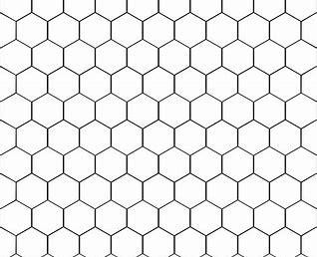

Mind Maps Revision Strategy

What is this strategy?
Mind maps are a revision strategy that helps you to map out your learning in a logical linked way.
This is a very effective way of representing large amounts of information in an attractive, easily remembered way.
You may have used “spider diagrams” - which are very similar. Use a large sheet of plain paper, turned sideways. • In the centre, write the name of the topic that you are going to revise - and add a simple illustration if you wish.
Now draw lines like branches (radiating out from the centre) to represent the main sub-divisions of your chosen topic. Each of these can be illustrated or could be in a different colour - or a different kind of writing.
To make Mindmaps more memorable: 1) Use doodles, pictures and diagrams 2) Use different colours
3) Use different styles of writing 4) Use humour (cartoons) etc. 5) Design your own (don’t just copy other people’s)

Example

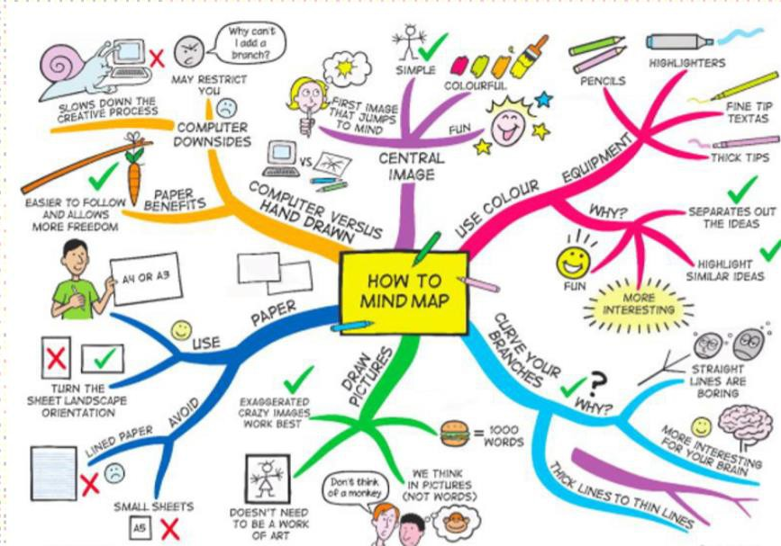

Why use this strategy?
This approach is effective in helping you to organise your key areas or topics, is a very visual format, can be done on large pieces of paper and gives you a way to link work together to help link topics.
Can be used to plan out time slots working around the branches to see what you know or need to do. A quick way to visualise answers to use to write out high mark long answer questions.

Another Example

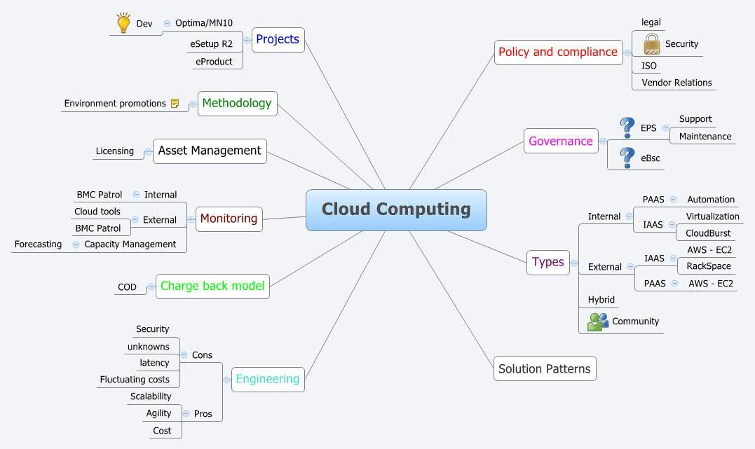

Rainbow Revision Strategy

Rainbow Revision Strategy
What is this strategy?
Rainbow Revision is a revision strategy that helps you organise and colour code your revision in high order questioning relating to, for example, Blooms Taxonomy. You should begin with a list, identify question and introduce challenge as you go. Each question should be a different colour and by the end of the session, you will have created a rainbow. Each question needs to be answered in the colour from the question sheet. This also allows your teacher to check students’ work quickly to the questions you are answering.

Example
Identify what is a hardwood, softwood and manufactured board. Give an example of each of the above. (Give three answers).
Summarise the difference between these three types of wood. Explain the difference between the three types of woods.
Discuss the benefits of using manufactured board rather than a hard or softwood?
Justify why you might choose a hardwood over a softwood to build a boat haul. Give reasons with your answer.


Why use this strategy?
This approach is effective in helping you organise and challenge yourself. Students are able to make their revision colourful and neat. This can often help you get higher marks in your exams as you are able to view and answer your questions in depth.
Why use this strategy?
This approach is effective in helping you organise and challenge yourself. Students are able to make their revision colourful and neat. This can often help you get higher marks in your exams as you are able to view and answer your questions in depth.


Graffiti Wall Revision Strategy
54
Why use this strategy?
This will help you identify information from your key topic or key word, that you have missed and will need to concentrate on.
Graffiti Wall

What is this strategy?
This strategy is used to identify information you remember on key topics.
For this you will need to select a key topic or key word, (to be written in to box). Write everything you know about this topic or key word in the same colour pen. Refer back to you work or notes, any information that has been missed to be added in a different colour pen.

Example

Manual Handling is how you pick up a box. The correct way to pick up a box if to lift with your knees not you back.
Box needs to be held close to your body. Back to be kept straight.
Manual Handling

Graffiti Wall

Revision Clock Strategy

What is this strategy?
The revision clock is a strategy that will allow you break down your revision into small 5 minute chunks. In the centre of the clock you will have the key topic to revise and in the 12 sections you break that topic down and write as much as you know on that sub-topic in 5 minutes. This allows you to get a lot of revision done in a more manageable way rather than just copying notes down.
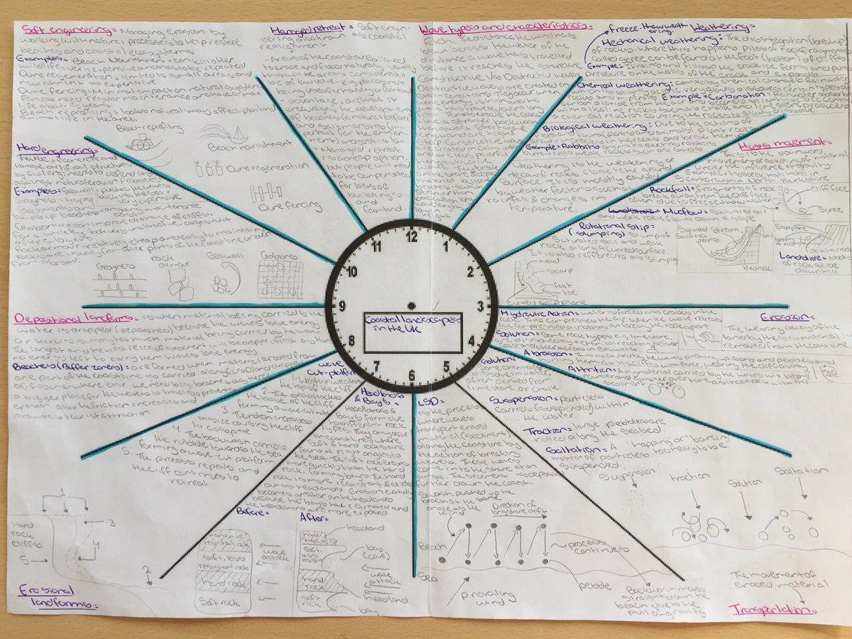
Why use this strategy?
This approach is effective in helping you organise and break down larger topics. By filling out the clock you are also starting to think about how different topics can be broken down. This can often help you get higher marks in your exams if you are able to show a deep understanding of key concepts and topics.

