Crime and Punishment Revision Notes
Outline of Unit (exam board = AQA)
Theme E: Religion, crime and punishment
Good and evil intentions and actions, including whether it can ever be good to cause suffering.
Religion, crime and the causes of crime
- Reasons for crime, including:
- poverty and upbringing
- mental illness and addiction
- greed and hate
- opposition to an unjust law.
Views about people who break the law for these reasons.
Views about different types of crime, including:
- hate crimes
- theft
The aims of punishment, including:
- retribution
- deterrence
- reformation and different Christian views on these.
The treatment of criminals, including:
- prison
- corporal punishment
- community service.
- Forgiveness.
- The death penalty and different Christian views on these
Ethical arguments related to the death penalty, including those based on the principle of utility and sanctity of life.

You should use these notes in conjunction with your notes from your book.

The Law
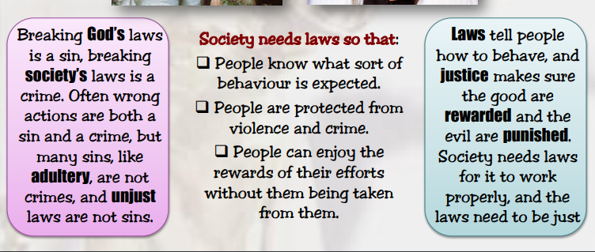
Good and evil intentions and actions, including whether it can ever be good to cause suffering
- Teachings in the Bible show that for Christians the intentions behind an action are crucial – it is not enough just to do the right thing; you should also be doing it for the right reason.
- Jesus teaches that it’s not just wrong to sleep with someone else’s wife but also to think about doing it – you have already committed the sin in your heart even if you haven’t done it in practice: Matthew, chapter 5 says:
²⁷ “You have heard that it was said, ‘You shall not commit adultery.^{]28} But I tell you that anyone who looks at a woman lustfully has already committed adultery with her in his heart. “

- In this country and many others actions that although some would consider to be wrong, are not illegal – committing adultery for example.
- The Law makes rules for people to live by so people can go about their lives without being frightened of being harmed, or having their property stolen. In this way the Law protects people, but it doesn’t necessarily interfere with areas of life that are personal.
- Christian teaching would say that we should be kind, generous, faithful and truthful because this is the right thing to do and ensures that others are treated well. The opposite would be sinful and causes harm, but these things are not a matter of Law in our country.
Can it ever be good to cause suffering?
- Some Christians would argue that it is NEVER right to deliberately do anything that causes harm – it can never be right to kill an innocent person for example.
- Others may argue that we must look at the consequences – it may be that in the short term it is better to cause suffering to avoid more suffering in the long term. This point of view may be taken in Wartime – it is better to go to War and risk people being killed than allow an enemy beat you and bring even more suffering.

Religion, crime and the causes of crime, including:
- poverty and upbringing
- mental illness and addiction
- greed and hate
- opposition to an unjust law

- The reasons that people commit crime is extremely complex and is probably a combination of different factors: poverty, drug abuse, mental illness, conviction of their conscience.
- In the past there has been a belief that criminals were born with a criminal disposition. In the 19th Century Italian Criminologist Lombroso argued that certain people were born with a criminal nature.
- His idea was called ‘atavism’ – he argued that criminals shared similar physical characteristics and were less evolved than the rest of humanity.
- Murders were said to have bloodshot eyes, curly hair and a prominent jaw! 
Most Christians would say that despite human nature carrying original sin we do have freewill and therefore have a choice over how we behave. No one is born ‘evil’ and destined to be a criminal.
- What we become in adulthood is a result of our habits and learnt behaviours in our childhood years.
- It is in our childhood that we learn to be compassionate, empathise with others, learn that other people matter, understand that we can’t always have what we want.
If these lessons aren’t learnt, we may find it harder to resist breaking the law.

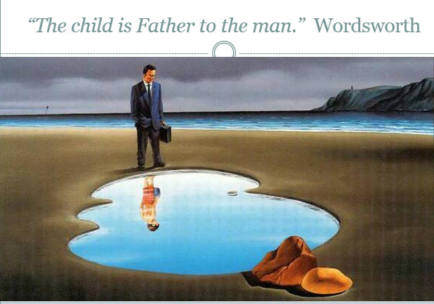

- Other reasons that people may break the law may be because they believe the Law to be unjust – in the 1950s and 60s the Civil Rights Movement in America challenged the Segregation Laws by breaking them:
Rosa Parks refused to give up her seat for a white person as was the law at the time. She was arrested which prompted mass protests against the segregation laws and black Americans’ not being able to votes.


- Some people’s crimes are motivated by hate – in recent years there are even crimes that are called ‘hate crimes’ that focus on the motivation of the crime as well as the action itself. These are usually as a result of prejudice that someone holds against a person or a perceived difference they have. For example some murders are racially motivated or are due to homophobia.
- These crimes seem particularly horrible since the person has done nothing themselves. The law punishes these crimes really harshly.
- Gee and Domnique Walker decided to forgive the killers of their son/brother – it was a hate crime because he was black. They believed that as Christian they had no choice. When asked how many times we should forgive, Jesus answers ‘seventy times seven’ – as many times as necessary. In the Lord’s Prayer Christians pray: ‘forgive us our sins as we forgive those who sin against us …’ No one is perfect and if we don’t forgive others God will not forgive us.

- In the story of the woman caught in adultery:

John 8:1-11 A Woman Caught in Adultery
8 Jesus returned to the Mount of Olives, ² but early the next morning he was back again at the Temple. A crowd soon gathered, and he sat down and taught them. ³ As he was speaking, the teachers of religious law and the Pharisees brought a woman who had been caught in the act of adultery. They put her in front of the crowd.
⁴ “Teacher,” they said to Jesus, “this woman was caught in the act of adultery. ⁵ The law of Moses says to stone her. What do you say?”
⁶ They were trying to trap him into saying something they could use against him, but Jesus stooped down and wrote in the dust with his finger. ⁷ They kept demanding an answer, so he stood up again and said, “All right, but let the one who has never sinned throw the first stone!”⁸ Then he stooped down again and wrote in the dust.
⁹ When the accusers heard this, they slipped away one by one, beginning with the oldest, until only Jesus was left in the middle of the crowd with the woman. ¹⁰ Then Jesus stood up again and said to the woman, “Where are your accusers? Didn’t even one of them condemn you?”
¹¹ “No, Lord,” she said.
And Jesus said, “Neither do I. Go and sin no more.”

- Only God is perfect and is entitled to judge – we are none of us perfect and therefore are not in a position to ‘point the finger’.
- In the case of theft, often the damage caused is people’s feelings of being violated and they no longer feel safe in their home. In this case a method of punishment that has been helpful has been Restorative Justice – where the victim and perpetrator meet and the victim gets a chance to tell the criminal the harm they have caused. The criminal has to face up to what they have done and the consequences of their actions and the victims often feel empowered and no longer a ‘victim’.
- The Prison Reform Trust report success with this approach to punishing criminals and a decrease in re-offending. From a Christian perspective if offers criminals an opportunity to feel remorse and say sorry for their crimes so that they can move on and build a better future for them and their families.
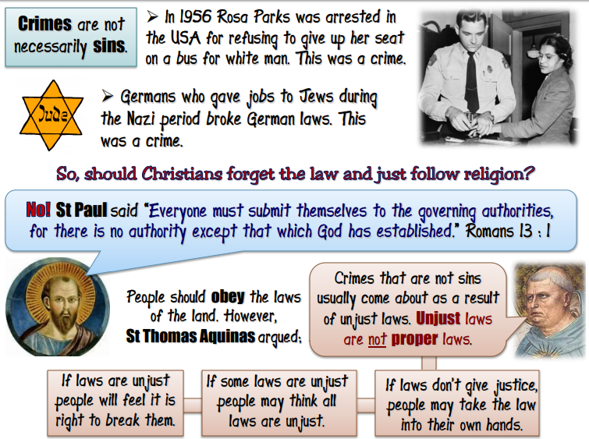

The aims of punishment, including:
- retribution
- deterrence
- reformation and different Christian views on these.
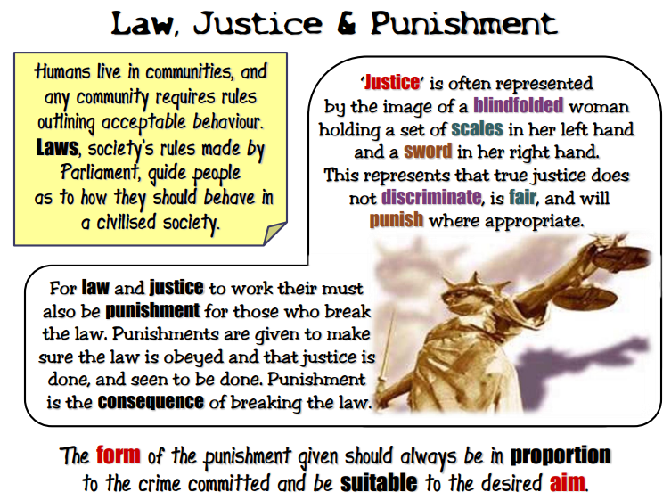
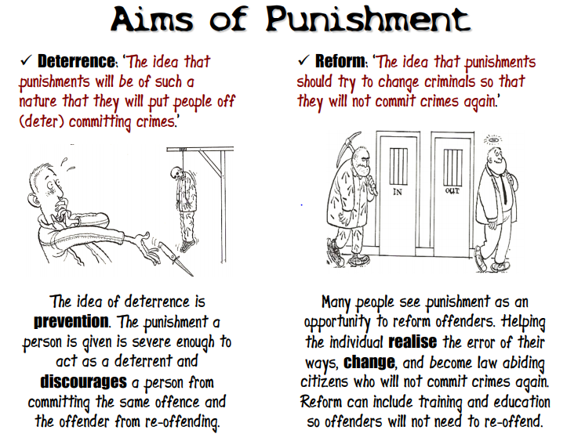
Alternatively, this has to be balanced against giving the criminal a second chance – a chance for redemption. No one is perfect and all deserve a chance of repentance. This means that punishment should encourage the criminal to change and be given a chance to make amends.
Generally, within Christianity there seems to be two key approaches to the punishment of criminals – one is that of Justice and reparation: the punishment should fit the crime and be Justice for the victim. The Old Testament teaches ‘an eye for an eye, a life for a life’. This shows that the focus is on repaying the victim in an appropriate way.
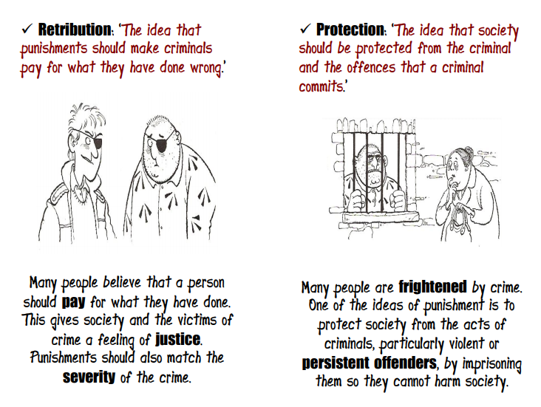

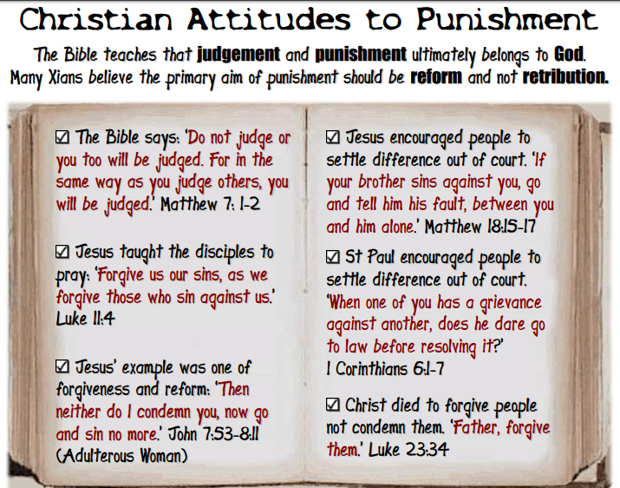
The treatment of criminals, including:
- prison
- corporal punishment
- community service.
- Forgiveness.
- The death penalty and different Christian views on these
Depending on what approach to the PURPOSE of punishment you take will determine your views on different forms of punishment.
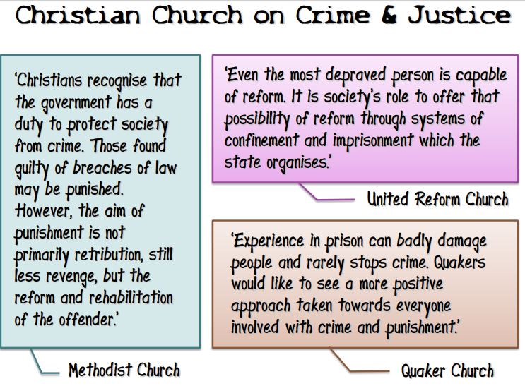

Prison
- The Prison Reform Trust believes that in its current state Prisons are failing – they fail to act as a deterrent and they fail to rehabilitate the prisoners and are chronically over-crowded and under-staffed. Too many of them have mental health and addiction issues which are not tackled and many are not in contact with their families – the thing most likely to stop them reoffending.
Christian, Elizabeth Fry in the C19th campaigned to make Prisons more humane places where prisoners could be rehabilitated and learn how to earn an honest living outside of prison. The Prison Reform Trust continues her work today; and although they are not a religious organisation they hold similar principles that all people, prisoners included, have the right to be treated with dignity.


- Some may point out that prisoners are not forced to commit their crimes and deserve to have their liberty taken away to protect the public. The Law should focus on the victim and not the criminal if Justice is to be achieved.
- Many Christians would say the right thing is somewhere in between – Prison shouldn’t be preferable to normal life, but also it doesn’t make sense not to help prisoners stop reoffending if they are going to keep them out of prison in the future.
Corporal Punishment
This means hitting someone as a form of punishment – it usually involves either parents smacking their children as a punishment or beatings being given out as a punishment when someone breaks the Law.

Community Service
- This is a form of punishment where the offender works off their debt to society in some useful way – like some type of work that will benefit the community – litter-picking, removing graffiti, gardening.
- The idea is that they repay the damage they have done to Society and get some sense of self-worth through the work.
- A Community Service Order may be given hand-in-hand with rehab for an offender who has addiction issues – it gives them a second chance and an opportunity to do something positive. This would fit in well with Christian views of rehabilitation.
- It may also be seen as Justice since the community can see that something is being done – it is not just paying a fine, it forces the offender to face up to their crime.
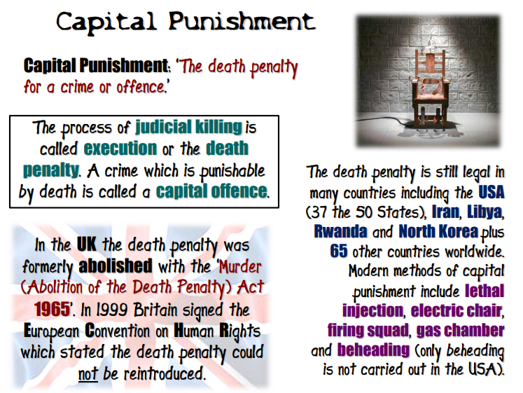

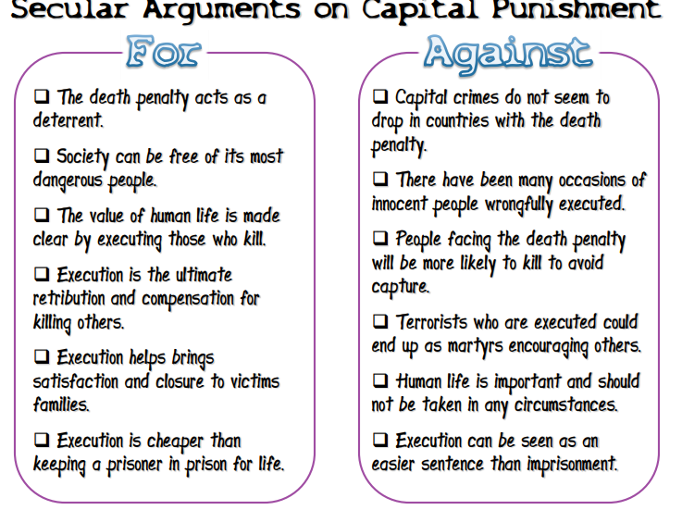
Secular = non-religious
