Christianity: Beliefs and Teachings
The Nature of God
- Despite different Christians (xns) have some differences in their beliefs, worship and practices their belief in ONE God (monotheism) is universal. The Creed says: ‘We believe in One God.’
- They believe that in some way God is creator and sustainer of the Universe.
- Xns believe that God is a personal God who cares and wants a relationship with humans.
- Many xns use terms like: Father, Shepherd and King to help to explain what is like, but they don’t think God is a man.
- Attributes:
God as omnipotent | God is believed to be a ‘supreme being’ who is all-powerful and has ultimate authority. Examples of God’s power include creating the Universe as well as performing Miracles.  God’s power is not only understood as strength and physical power but power over evil and sin – the power to forgive sins.
God as all-loving | This is an essential aspect of God’s nature in xnity – that God is all loving and wants to have a loving relationship with humans. The pinnacle of this is God sending Christ:  “For God so loved the World that he gave his only son, that whoever believed in him shall not perish but have everlasting life.” John 3: 16.  This love means forgiveness and salvation from the punishment for sin.
God as Just | Part of God’s perfect nature includes Justice – not only is God Just (so good must be rewarded and bad punished) but that xns should stand against injustice wherever they meet it – i.e. Racism.
The Problem of Evil https://www.youtube.com/watch?v=qilO5AJjkvw
- One of the problems that is raised by these ideas about God’s nature is the existence of evil and suffering in the world (both natural evil – that which is caused by Nature, and moral evil – that which is caused by the choices humans make).
- The problem was described as the ‘inconsistent triad’ by philosopher J. L. Mackie – he believed that you are trying to believe 3 (tri) ideas that are contradictory. If God was both all-powerful and all-lovng then suffering and evil would not exist since God COULD get rid of it and would WANT to get rid of it.
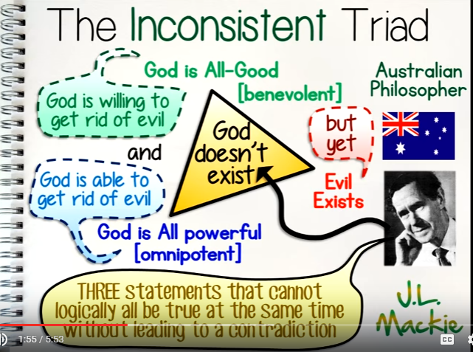
- Classic explanations have tended to say that evil is a result of human freewill and that in order for humans to grow and learn then this world can’t be a perfect paradise – it must have real challenges and trials to overcome or Life would be pointless.
The Oneness of God and the Trinity
- God’s nature (what God is like) is not an easy thing to describe but one way that the Bible uses is through the idea of the Trinity.
- To talk about the ‘oneness’ of God means that there is only ONE God.
- In simple terms the idea of the Trinity is that there are three ‘persons’ all of which are God.
- It is a mystery and attempts by humans to explain it will have limited success.

God
God above us
the Father

God beside us
God among us

God God the
the Son Holy Spirit

- This doesn’t mean that Christians believe in 3 gods, this is explains 3 different aspects of the same thing – a bit like H2O can be in 3 different forms – vapour, ice and liquid – very different but essentially the same.
God the Father- This is expressed in God being creator, almighty and caring.
God the Son - Christians believe that God came to earth as a man to teach people how to live and sacrifice himself so they could be forgiven and have everlasting life. They believe that Jesus rose him from the dead, called the resurrection.
God the Holy Spirit- Christians believe that when Jesus returned to heaven God sent the Holy Spirit to comfort and guide Christians. The Holy Spirit is often represented by a dove – a symbol of peace and hope or sometimes fire – like when tongues of fire appeared over the disciples’ heads at Pentecost.
- There is only ONE God.
- Each ‘person’ of the Trinity is fully God, but different.
- It is worth mentioning that not ALL xns believe in the Trinity. The Unitarians believe that God is one Unity and that Jesus was not the son of God but showed how it was possible to live a life of compassion and forgiveness. 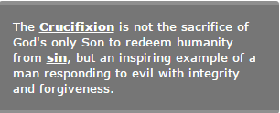
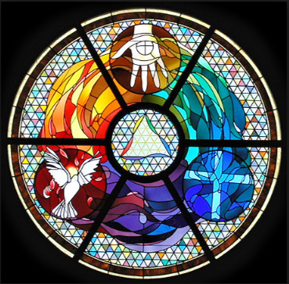

Different Christian beliefs about Creation
- Genesis 1: 1-3 announces God as Creator of the world:
“In the beginning, God created the heavens and the earth. Now the earth was formless and empty and darkness was over the surface of the deep and the Spirit of God was hovering over the waters and God said ‘Let there be light’ and there was light.”

- For many xns it doesn’t matter that Science doesn’t agree with Genesis – it is an ancient myth that shows that God intended the Universe to exist and is in some way responsible for it. They don’t believe the story literally but God is still Creator.
- It is interesting to note that when it says ‘the Spirit of God was hovering over the waters’ it could be read that even though God the Father was creator, God the Spirit was already active in the World.
- No one knows the exact date of Genesis being written but it is around 500BC – around 600 years later John’s Gospel opens with a passage that is very similar:
“In the beginning was the Word, and the Word was with God, and the Word was God. He was with God in the beginning. Through him all things were made; without him nothing was made that has been made.”

- Most xns agree that the Word is referring to Jesus – who entered into the world as Jesus – it shows that the Son was involved in Creation as well as the Spirit and the Father.
- In Genesis God ‘speaks’ everything into existence: ‘Let there be …’ , in John it calls Jesus ‘the Word’. It helps xns to understand the Unity of the Trinity and that all three were there at the beginning of Creation.
- This also becomes an important part of the Incarnation – God becoming flesh – taking on human form in the person of Jesus because it shows that Jesus existed before he entered the World.
The Incarnation and Jesus, the Son of God
https://www.youtube.com/watch?v=xbo9X2X59KU
- A key xn belief is that of Jesus being the Son of God who came down to earth and was born to the Virgin Mary.
- Only Luke and Matthew include nativity stories – maybe John and Mark didn’t think the stories important – or didn’t know about them, however it is clear that both thought Jesus was the son of God.
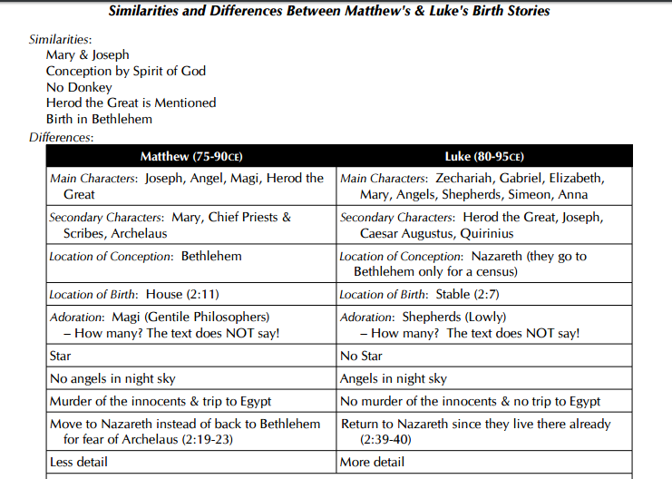
- Both Matthew and Luke have clear indications that Jesus was both divine and human – Matthew suggests that the whole ‘heavens’ recognised the significance of this event and there was a star over where Jesus was born – and the visit from the Kings and angels – in Luke it is the ordinary people who recognise his importance – the shepherds.
- Either way the Son of God enters the world as a baby – humanity at its most vulnerable.
- In John’s Gospel this is the focus of his opening:
“The Word became flesh and made his dwelling among us.” John 1: 14
Jesus is both fully God and fully human - https://www.youtube.com/watch?v=BebZ8-CiDbw

- Jesus was the longed for ‘Messiah’ (saviour) but a spiritual one rather than a political one. He would save the people from sin and evil.
- When Jesus is baptised by John the Baptist (how did he get his name ;-)?) a voice from heaven says: ‘This is my own dear son, in whom I am well pleased.’
This was not a God who stands by and watches suffering, this is a God who has come to earth in the most vulnerable state to stand with humans and be their salvation. To willingly take the punishment for sin, and offer salvation through the resurrection.

The Crucifixion
- The Gospels give detailed accounts of Jesus’ death. He is arrested, tried by the Roman Governor at the time, Pontius Pilate and sentenced to death by crucifixion.
- Victims would be nailed to a plank of wood through their wrists and hauled up onto a post and left to die.
- This terrible death symbolises Jesus taking on the sins of the world even though he was innocent.
- At one point in Mark’s Gospel Jesus cries out ‘My God, My God, why have you forsaken me?’
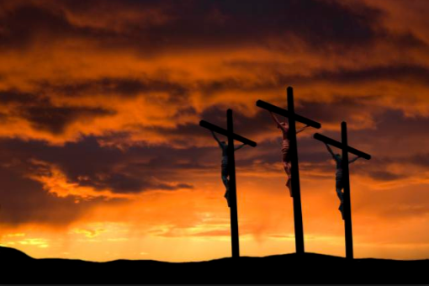
- The crucifixion of Jesus is important for xns today because it shows that if they accept Jesus’ sacrifice and ask forgiveness for their sins they can be saved.
- This doesn’t mean that they won’t suffer in their lives but that suffering can have a meaning. It also means that they know God is no stranger to suffering.
- Christians believe that the son of God died and felt real suffering, despite being innocent.
- For Christians today this is where the Grace of God is fully revealed – Gift Received At Christ’s Expense’ – because of Christ’ sacrifice humans can be forgiven of their sin and have everlasting Life with God. The penalty for sin was paid by Christ on the cross.
The Resurrection
http://request.org.uk/life/beliefs/christianity-basically-the-resurrection/
- It is through the resurrection that the crucifixion gains its meaning. It seemed like a disaster – Jesus being killed – but 3 days later he rises from the dead.
- Most Christians believe that this shows not only God’s power over Nature but also over sin and death.
- The stories in the Gospels differ in their accounts of the resurrection – in one Jesus appears to Mary on her own; in others she has company. The key features seem to include an empty tomb and some encounters with angels or Jesus himself declaring that: ‘He is risen’!
- There is debate how reliable these stories are – some claim that since they were recorded a long time after Jesus lived and died (approximately 70+ years) they cannot be relied upon to give a factual account of what happened. Others point out that since the four gospel accounts don’t all agree with each other they must have been fabricated (made-up). They view the evidence as not reliable enough. In Matthew’s gospel is says there was an earthquake – surely if that was the case everyone would have noticed!
- Christians may argue that something dramatic MUST have happened – or why would a bunch of Galileans be prepared to die for their beliefs??? Something inspired them?!
- A small minority of Christians do not believe in a literal resurrection of Jesus but see it more as a spiritual raising. They either believe our immortal soul lives on or the resurrection is a symbol of how God can forgive our fallen nature and ‘raise us up’ to be better people.
The Ascension
http://request.org.uk/festivals/other-festivals/ascension-day/
- Traditionally, Christians believe that Jesus’ time on earth came to an end when he ascended into heaven.
- In Mark and Luke’s gospel this takes place after Jesus gives them 1 commandment and 1 promise:
He commands them to spread the gospel: “Go into the world and proclaim the good news to every creature.’
He promises that in his absence he would send down the Holy Spirit to be with them – to guide them and comfort them.
- The ascension is important to Christians because it shows them that Jesus is with God (‘seated at the right hand of the Father’) until the day he returns to gather all the faithful to take them to heaven (the coming of Christ) at the end of time.
Belief about the Afterlife
- There are many different beliefs that Christians have about their belief in Life after Death, but most would say that whatever it is, it is eternal life with God.
- They may look at the passage in John when Jesus says: ‘I am the resurrection and the Life, whoever believes in me will not perish but have everlasting life.’ So an afterlife is a promise made to those who ask for their sins to be forgiven and believe in Jesus.
- Some Christians believe that it will be their souls that will be reunited with God after death whereas the body will rot. These are dualists and believe that the body and soul are separate and that the soul is the ‘real me’.
- Other Christians (and traditionally) believe that the soul and body are ONE and cannot be separated. At death the person goes into a ‘sleep-like state’ until Judgement Day where God will rise them up with a new body when they will be judged and their afterlife decided.
- Paul (a prominent early Christian) seemed to believe that there would be a real transformation from the ‘old body’ and the ‘resurrected body’ – some dramatic difference would take place; he says: ‘so it will be with the resurrection of the dead; The body that is sown (on earth) is perishable, it is raised imperishable … it is sown in weakness (weakness to sin?) it is raised in glory, it is sown a physical body it is raised a spiritual body.’ Paul’s letter to the Corinthians
Some have seen that this supports dualist view being that the new ‘me’ is a ‘spiritual body’ but traditionally it was seen as a transformation to a perfect, immortal version of us.
Critics have asked whether a perfect ‘me’ could actually be me? They may doubt that this really makes sense.

The day of Judgement
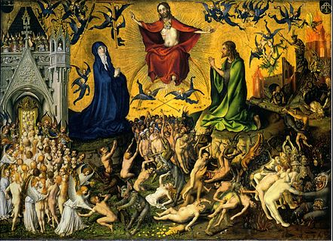
- A key element of Christian belief in an afterlife is the idea of Judgement.
- Christians believe that God is a perfect Judge who knows our hearts and that we cannot hide anything from God.
- In the Apostles’ Creed (declaration of belief) it says: ‘He ascended into heaven, and is seated at the right hand of the Father, and will come to judge the living and the dead. I believe in … the resurrection of the body; and life everlasting…’
- Traditionally Christians believe that when Jesus returns (the second coming) he will judge all humans – the dead will rise up and receive new bodies and they will be judged.
- In Matthews story of the Sheep and the Goats it says that the wicked are caste into the eternal flames of hell and righteous will be rewarded with everlasting life with God. Helping those in need is the same as helping Christ, himself.
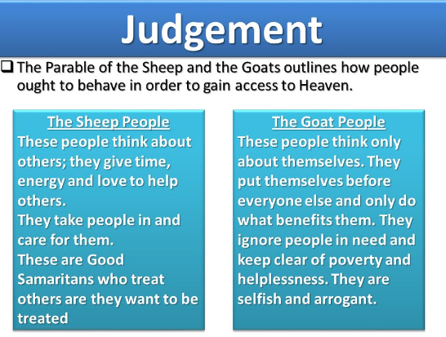
When the ‘sheep and the goats’ ask when they saw Jesus in need and helped him, Jesus replies:
“Whatever you did for the least of these brothers you did for me.”
So, this story seems to suggest that the criteria that Jesus uses for deciding who gets into heaven and who doesn’t is based on how we help the ‘least of these brothers’ – perhaps he means the least important – those people who are usually ignored in society: the homeless, drug addicts, criminals.

http://request.org.uk/life/beliefs/some-thoughts-on-judgement-a-christian-perspective-on-eternal-life/
- Some Christians will point out that it is still important what you believe – and that you need to be forgiven of your sins to get to heaven, Jesus says in John: ‘whoever believes in me …’ so belief is also crucial.
Heaven and Hell
- Traditionally, Christian’s believe that the righteous will be rewarded with heaven – a perfect paradise with God and Jesus, or will be punished for their sinfulness by being sent to hell for eternal suffering.
- The Bible uses imagery of angels, gardens, a holy city full of wondrous things to depict heaven, whereas hell is portrayed as place of burning fire where you will be tortured for eternity by the devil and his demons.
- Many Christians today see these ideas as symbolic and may talk in terms of heaven being ‘with God’ and hell being an ‘absence of God’ – through our own behaviour we chose whether we accept Jesus and are brought into a relationship with him or whether we reject him and put a distance between us and God.
- Catholics teach that no one can immediately enter heaven because they are not perfect so in that case they must be cleansed of their sin first. This happens in a place called PURGATORY – a place where we are cleansed of any unforgiven sin. Some sins may be unforgivable – and called a mortal sin. If you die with this on your soul you go straight to hell, but for less serious sins they can be cleansed in purgatory.
http://request.org.uk/life/beliefs/jesus-teaching-about-eternal-life/
- Some reject the ideas of Hell altogether arguing that if God is all-loving he would send any to hell forever! That would make God immoral and a sadist.
- Some believe that eventually, all will be saved. After we die if we haven’t come to know Christ our existence will continue in some way until we do. It may take some a long, long time, but eventually everyone will get there. God will never give up on anyone!
Sin and Salvation – Grace and Atonement
- The term ‘sin’ refers to those actions or thoughts that are viewed as wrong or immoral.
- Traditionally Christians believe that sin entered the world through the disobedience of Adam and Eve in the Garden of Eden. They were told not to eat from one of the trees (the Tree of the Knowledge of Good and Evil).
- As a consequence of their rebellion against God sin enters the world and human nature is now imperfect – and the natural world is also corrupted as a punishment for their sin.
- The consequences of this Original Sin is separation from God (they have to leave the Garden of Eden) and death – now humans are mortal.
- Traditionally it was believed that now human nature was inclined to be sinful – we were now involved in a constant struggle against our sinful nature.
- It was only through Christ’s sacrifice that we could free from the consequences of sin – death and damnation.
- Bible teachings such as the 10 commandments and the teachings of Jesus off guidance on how to be good BUT it is only through the grace of God that salvation can be gained:
- https://www.youtube.com/watch?v=iilkx8ziAQY
Gift
Received
At
Christ’s
Expense
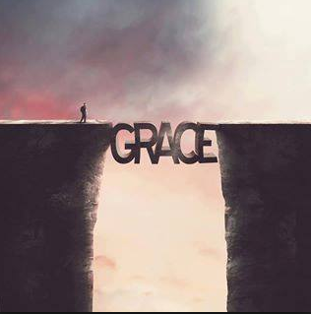

- Salvation is a gift from God – it cannot be earned. Traditionally it was believed that only a ‘perfect sacrifice’ could make up for the sin human’s committed.
- Through human sin they had violated their relationship with God and as a result owed God for their sin – however, it was through Christ’s death that he paid off our debt – he ‘atoned’ for our sin.
I John says: ‘If anyone does sin, we have an advocate (defence lawyer) with the Father – Jesus Christ – the righteous one. He is the atoning sacrifice for our sins, and not only for ours but also for the sins of the whole world.”

https://www.youtube.com/watch?v=G_OlRWGLdnw
- Or Christian’s the atonement gives them reassurance that when they die they will live with God forever, in some form or other!
- Many say that they dedicate their lives to God in gratitude for this amazing sacrifice.
- Some non-Christians may say that there is something fundamentally wrong with the idea of Original Sin – we weren’t created in the Garden of Eden and Science contradicts the view that we all descended from Adam and Eve. Human nature can be selfish (we see evidence for this all the time) but as humans evolve we become more humane and value human rights, equality, compassion and respect more and more.
- Some may say we don’t need Christ to ‘save us’ we need to work out for ourselves how to be better people.
https://www.youtube.com/watch?v=9tpL1K8ZqrU

