GCSE Business
Theme 2.4.2 – Understanding Business Performance
Booster Booklet
Specification
Subject content | What students need to learn:
The use and interpretation of quantitative business data to support, inform and justify business decisions:  ● information from graphs and charts  ● financial data  ● marketing data  ● market data.  The use and limitations of financial information in:  ● understanding business performance  ● making business decisions. | Students are required to use and interpret a range of quantitative business data as part of business decision making. Students could be given numerical information in the form of, for example: charts or graphs which may include financial data such as sales revenue or marketing data, percentage increase in sales volume or market data such as average incomes and use this information in business decision making.  Students also need to be aware of the problems of making decisions using financial information since the figures used can become out of date or can have other limitations. For example, the time period over which the financial performance has been measured could also be a limitation especially in a business where demand is seasonal.

Key terms in this topics
- Financial data – Financial data includes business information such as sales figures, business costs and profits.
- Marketing data – marketing data includes information on advertising spending, customer opinions and product performance.
- Market data – Market data includes information on market size, market growth and characteristics of customers.

Key terms – examples
In the space below, write examples to illustrate the key terms

Key term | Examples
Financial data
Marketing data
Market data

Summary of the topic

Business information can be presented in a number of formats and you will be expected to interpret a variety of business information in your exams. Some information, such as financial information, can be used to interpret a business’s performance. For example, any financial information that demonstrates that the business is growing may indicate success. Rising number of stores, increased turnover or increased market share are positive indicators of success. However, there are many factors that need to be taken into account when judging business performance that may not be indicated in the numbers. A business might increase its number of stores, but could deliver poor customer service or have poor cash flow. It is therefore important to judge business performance on a range of valid and up to date information.

External data, such as market data may not provide indications of business performance, but it may offer an insight into opportunities and threats. Market data may indicate growth opportunities, the development on new market segments and the buying patterns and behaviour of customers. Similarly, market developments may also pose threats to a business that is not able to evolve and adapt. When analysing case study information, you should consider whether the information presented could be an opportunity or a threat for the business in question.

Case study: Paper 2 SAMS 2017 Argos / Sainsbury

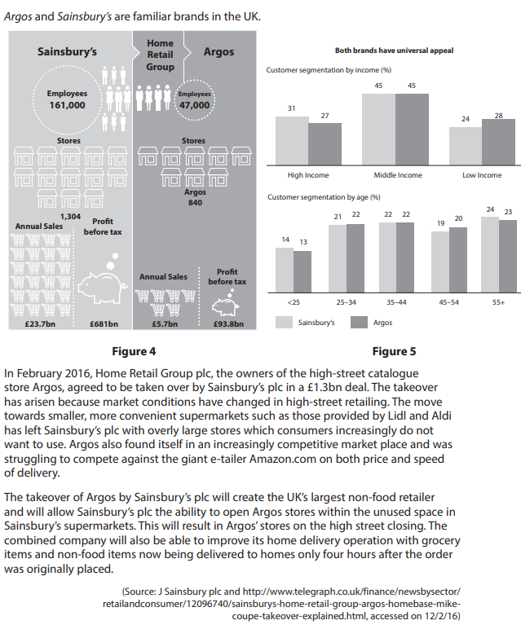

How this case study illustrates/exemplifies the specification content:
The case study illustrates ‘Understanding Business Performance’ in a number of ways:

- Conditions had changed in the supermarket industry with customers preferring smaller, more convenient stores such as Aldi and Lidl.
- Similarly, market conditions for Argos had changed with significant competition from Internet giant, Amazon.
- The Sainsbury’s takeover of Argos created the largest non-food retailer in the UK – this suggesting the takeover led to a company having the largest market share in the UK.
- The case study provides financial data on both companies – sales turnover and profit before tax.
- Employee numbers and number of stores also gives an indication of the size of the two companies.
- The case study provides marketing data on both companies – customer segmentation by income and customer segmentation by age.
- The marketing data suggests that two companies are closely aligned in their customer profiles.

Check your knowledge: questions
- Give two examples of financial data
- Why is market data useful to a business?
- What are the limitations of using data to judge business performance?

Check your knowledge: recall question (previous unit)
- What is the difference between gross profit and the gross profit margin?
- How is the net profit margin calculated?
- What does the average rate of return show?

Interpreting Market Data

The infographic (link here) provides market data for UK disabled consumers. Using the data, answer the questions that follow.

Source: The Purple Pound – Infographic – Purple (wearepurple.org.uk)

- What proportion of UK working adults have a disability?
- What type of business loses the second most amount of money from disabled customers?
- How much do disabled customers spend in the UK each year?
- How might an Ecommerce business use the information presented in this report?
- Describe the characteristics of the market of disabled customers in the UK

Common Assumptions

Price – Revenue - Profit

A common assumption many students make is that increasing the price of a product or service will lead to increased sales revenue. This will be the case IF demand for that product or service remains constant or does not fall too much. Similarly, many candidates make an assumption that increased sales revenue will lead to improved profits. Sales revenue and profit are clearly linked, but sales revenue will only lead to higher profits if the business is able to manage its costs.

Growth is good
Business growth might be indicated in a range of data:
- Sales revenue
- Number of employees
- Number of stores
- Market share

It is fair to assume that a business that is growing is performing well. However, growth can put strain on any business. A growing business could have problems with:
- Customer service
- Meeting customer needs
- Efficiency
- Cash flow
Multiple choice questions
- With reference to figure 4, which of the following statements is true?
- Sainsburys has more than three times the number of employees than Argos
- Sainsburys has more than double the number of stores than Argos
- Argos has higher annual sales than Sainsburys
- Argos has an annual profit more than half that of Sainsburys
- With reference to figure 5, which of the following statements is true?
- Argos’ smallest customer segment by age is 35-44 year olds
- Argos’ largest customer segment by age is 45-54 year olds
- Sainsburys target a higher proportion of high income earners than Argos
- Sainsburys target a higher proportion of low income earners than Argos

Exam Questions

- Explain one way that a business might use market data. (3)

- Explain one limitation of using financial information to judge business performance. (3)

- Outline one way that Sainsburys and Argos are compatible businesses. (2)

- Outline one benefit to Argos of improving its home delivery service. (2)

- Using the information in Figure 2, calculate the average rate of return on the new piece of machinery. (2)

