GCSE Business
Theme 2.4.1 – Business calculations
Booster Booklet
Specification
Subject content | What students need to learn:
The concept and calculation of:  ● gross profit  ● net profit  Calculation and interpretation of: ● gross profit margin  ● net profit margin  ● average rate of return. | Students need to calculate and interpret gross profit margin, net profit margin and average rate of return (ARR). They will also need to understand the concept of gross profit and net profit and how to calculate these.  Gross profit margin shows the proportion of revenue left over after the business has paid for its costs of sales. A business that adds a lot of value would be expected to have a high gross profit margin. Net profit margin is the proportion of revenue left over after the business has paid all of its costs. A business such as Tesco would have a low net profit margin due to the competitiveness of the grocery market. However, if sales are high, this could still generate substantial total profits. Equally, a business with high net profit margins may have low total profits if sales are low. ARR measures the return or profit from a proposed capital project.

Key terms in this topics
- Gross profit = sales revenue – cost of sales
- Net profit = gross profit – all other operating costs and interest
- Gross profit margin = gross profit / sales revenue X 100
- Net profit margin = net profit / sales revenue X 100
- Average rate of return = average annual profit (total profit / no. of years) / cost of investment X 100

Key terms – examples
In the space below, write examples to illustrate the key terms

Key term | Examples
Gross profit
Net profit
Gross profit margin
Net profit margin
Average rate of return

Summary of the topic

In this sub-topic pupils need to understand and calculate several key business calculations that are used to judge the performance of a business. There are two types of profit a business in concerned with. Gross profit is the profit a business makes on its trading activity. It focuses purely on the cost of sales – this is the cost to produce and distribute its product or service. Net profit then takes into account all other business operating costs. Net profit is also called the ‘bottom line’ because it is the profit a business is left with. Net profit can be taxed, reinvested or returned to the owners (shareholders).

The gross profit margin and net profit margin are also two key calculations which compare sales revenue to the two types of profit – the proportion of sales revenue that a business is able to convert into gross profit or net profit (%).

The final calculation is average rate of return (ARR). This calculation is used to assess the how profitable different business decisions / investments are.

Case study: Stimulus from Q3 November 2020, Q2 June 2019 and Q3 June 2019

Re-label figure 1, 2 and 3.
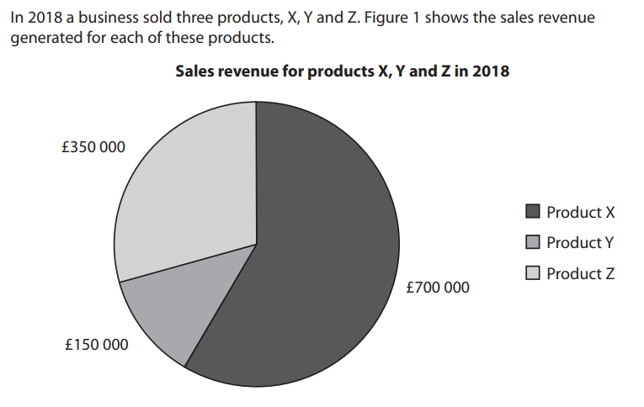

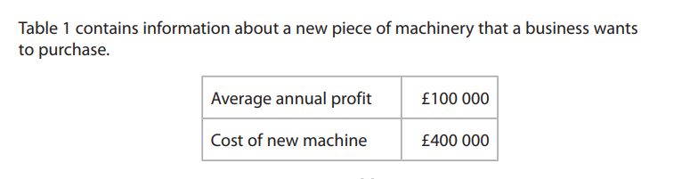
Edit values to £80,000 and £500,000. Add an additional set of numbers in a third row. ‘average annual sales £220,000’

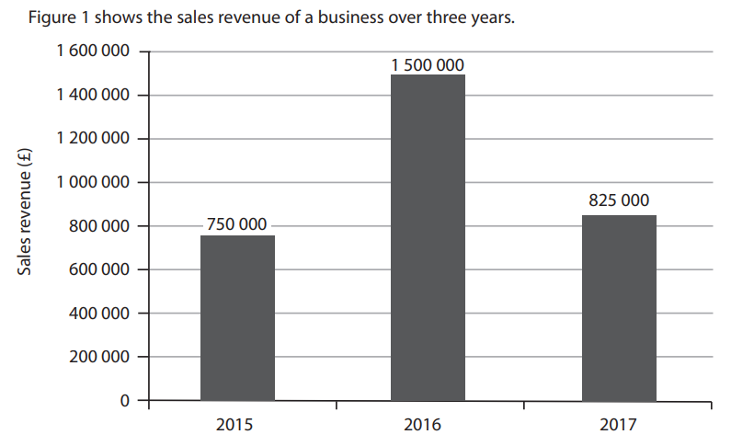

How to interpret financial information in the exam

In your Theme 1 and Theme 2 exam you will be required to answer 3-4 ‘calculate’ questions. The information you require to answer the questions may be presented in various formats. The following advice is given to help you to calculate the correct answer:
- Always write out the formula - this will help you select and organise the numbers from the stimulus.
- When interpreting graphs ensure you understand what the graph is showing you. Interpret the axis, check the scales, check the legend, colours and patterns to ensure you a reading the correct information.
- Some information will not be required to complete the calculation – don’t think you have to use every number in the calculation. It is there to test that you understand the calculation and can select the correct information. Put a small ‘x’ next to any information you don’t need.
- Some important information might be in the stem of the question – not just the table, graph or chart.
- Make sure your answer is written clearly on the line provided in the calculation box.
- Ensure you answer is written to the correct number of decimal places where required.
- Check your calculations for mistakes.

Check your knowledge: questions
- What is the difference between gross profit and net profit?
- What does a net profit margin of 12% show?
- What is the formula to calculate the average rate of return?

Check your knowledge: recall question (previous unit)
- Identify two stages in the sales process
- What is a benefit to a business of providing good customer service?
- Why is feedback from customers important for a business?

Visual Representation of Financial Information

Using the diagram below, explain the relationships between sales revenue, business costs and profit. Tip: the diagram explains the calculations for gross profit and net profit.
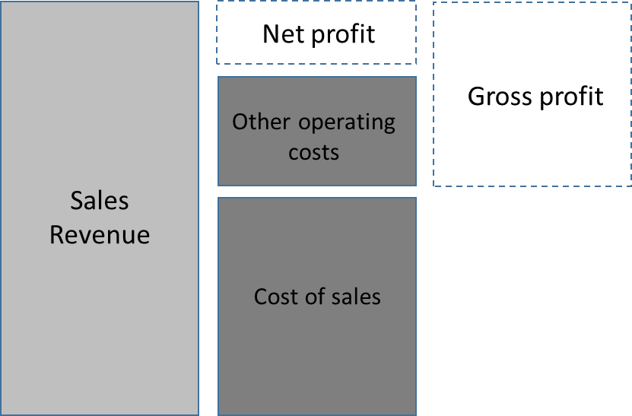

Complete the flow chart below. At the end, fill in the boxes to show the other two ways a business could use profit.

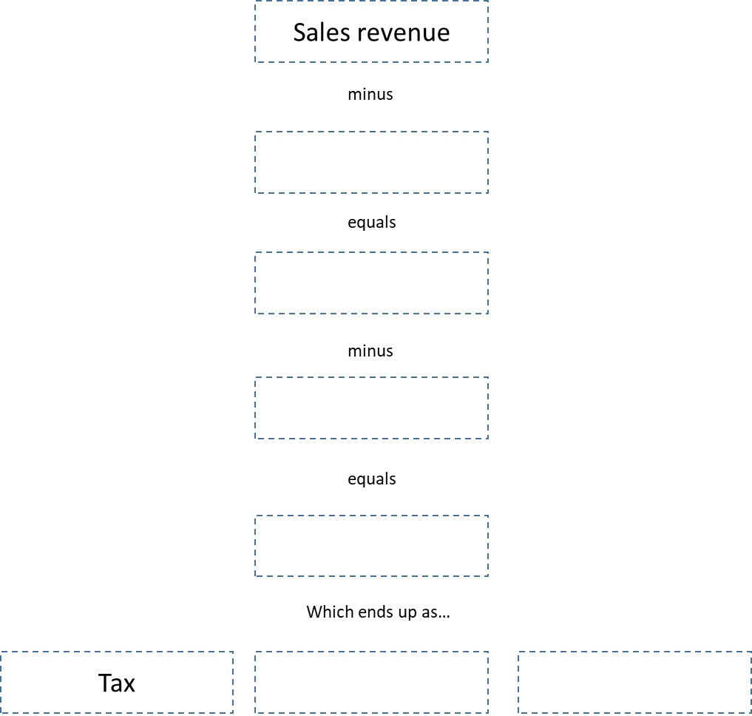

Common misconceptions

Which profit?

It is common for students to mix up the two calculations of profit, especially as the basic calculation of profit is total revenue – total revenue – total costs. This calculation is practically a calculation of net profit. Students need to understand cost of sales in order to appreciate the difference between gross profit and net profit.

Missing margin

When asked to calculate a profit margin, some students might misinterpret this as calculating gross profit or net profit. A profit margin compare gross/net profit to sales revenue and is expressed as a percentage. E.g. a 35% gross profit margin means the business turns 35p of every £1 sales revenue into gross profit.

Multiple choice questions
- A business generates sales revenue of £50,000 from the sale of 210 products. Its gross profit is £20,000. Which of the following is the gross profit margin?
- 2.5%
- 238%
- 95%
- 40%
- Which two of the following are components of a business’s cost of sales?
- Interest
- Legal fees
- Insurance
- packaging
- Rent
- Employee wages

Exam Questions

- Using the information in Figure 1. Calculate the gross profit the business makes from selling Product X, Y and Z based on total cost of sales of £650,000. (2)

<add calculation box>

- Using the information in Figure 2, calculate the average rate of return on the new piece of machinery. (2)

<add calculation box>

- Using the information in Figure 3, calculate the net profit the business makes over the three-year period based on total business costs of £2,600,000. (2)

<add calculation box>

- Using the information in Figure 3, calculate the gross profit for the business in 2016 based on a gross profit margin of 45%. (2)

<add calculation box>

