GCSE Business
Theme 2.3.2 – Working with suppliers
Booster Booklet
Specification

Subject content | What students need to learn:
2.3.2 Working with suppliers  Managing stock:  - Interpretation of bar gate stock graph  - The use of just in time (JIT) stock control.  The role of procurement:  - Relationships with suppliers: quality, delivery (cost, speed, reliability), availability, cost, trust  - The impact of logistics and supply decisions on: costs, reputation, customer satisfaction. | Students need to learn that a business needs to ensure it always has access to stock. It therefore will need to make a number of important operational decisions linked to managing its stock. This includes making a decision on which is the most efficient stock management system to implement.  Students also need to learn that procurement is also very important in allowing efficient production of products and services. Finding and building good relationships with suppliers can help ensure higher quality and lower costs for a business. This also includes the importance of logistics in building a good relationship with suppliers and customers.

Key terms in this topic:

- Stock – the products held by a business in a shop or warehouse for sale to customers. It also includes raw materials held by a business to be used in the production process.
- Bar gate stock graph – a chart used to indicate the level of stock a business is holding at any one time. It can be used to make decisions about when, and how much, new stock should be ordered.
- Just in time (JIT) – a method of stock management that involves procuring stock when it is needed rather than holding stock in a warehouse.
- Procurement - the process of purchasing and obtaining materials, supplies, or equipment.
- Logistics – the organisation and management within a business of the transport of raw materials and goods.

Key terms – examples
In the space below, write examples to illustrate the key terms
Key term | Examples
Stock
Bar gate stock graph
Just in time (JIT)
Procurement
Logistics

Summary of the topic
Students are required to interpret bar gate stock graphs and may be asked to identify from the diagram the amount of buffer stock, the maximum stock level held, the length of time it takes for stock to arrive once it has been re-ordered and the size of a given order. Students will not be asked to draw a bar gate stock graph.

Students also need to understand the use of just in time (JIT) stock control and the factors which lead to the efficient procurement of raw materials: quality, delivery (cost, speed, reliability), availability, costs and trust. These factors could be explored using an industry such as car manufacturing which also provides a useful link with JIT.

Students will also need to know the impact on logistical and supply decisions on costs, reputation and customer satisfaction. For example, a more reliable supplier could possibly be more expensive, raising the business’ costs. However, this would reduce the negative impact on branding and customer satisfaction as the business would be able to improve availability of their product and reduce the likelihood of stock costs. This could be explored by considering where suppliers are often based in order to reduce the shipping times in an industry where demand is constantly changing, but at the same time recognising that the business must be able to meet demand should sudden changes occur; for example in the fashion industry.

Synoptic links to this topic

This topic links with the following areas of the specification:

- 2.2.4 Place
- 2.3.3 Managing quality
- 2.3.4 The sales process

Decisions linked to stock are very important to a business and can have an impact on other business operations. The place element of the marketing mix explores the distribution methods a business will use to provide products and services to meet customer needs. Therefore, the impact of logistics must be considered to allow a business to supply products and maintain its reputation and ensure customer satisfaction. Maintaining good relationships with suppliers will also ensure a business is supplied with stock and raw materials that are high quality and allow it to gain a competitive advantage. This will be vitally important during the sales process. It is far easier to engage with customers if the quality of the product meets there needs and the business has always the correct levels of stock to meet customer demands.

Case study: Elvis and Kresse

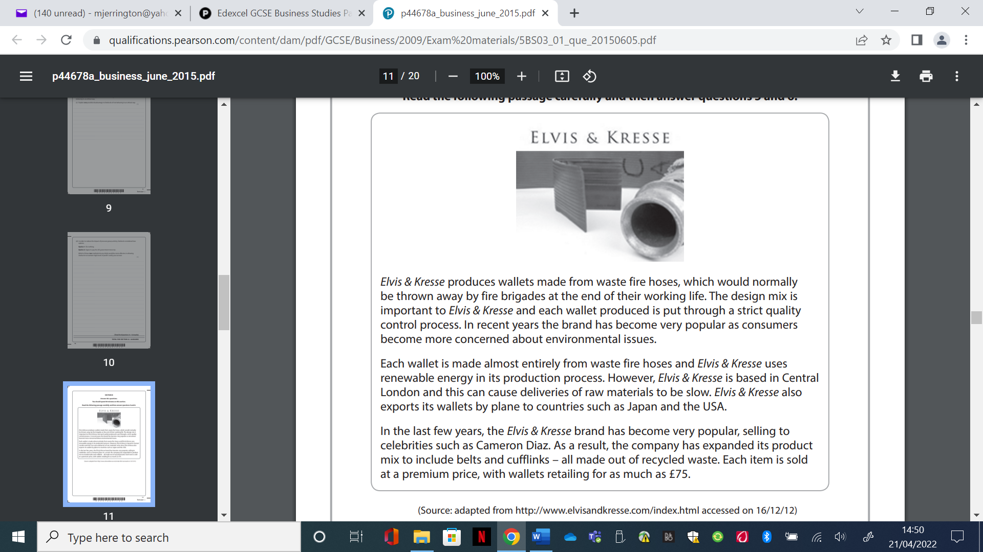
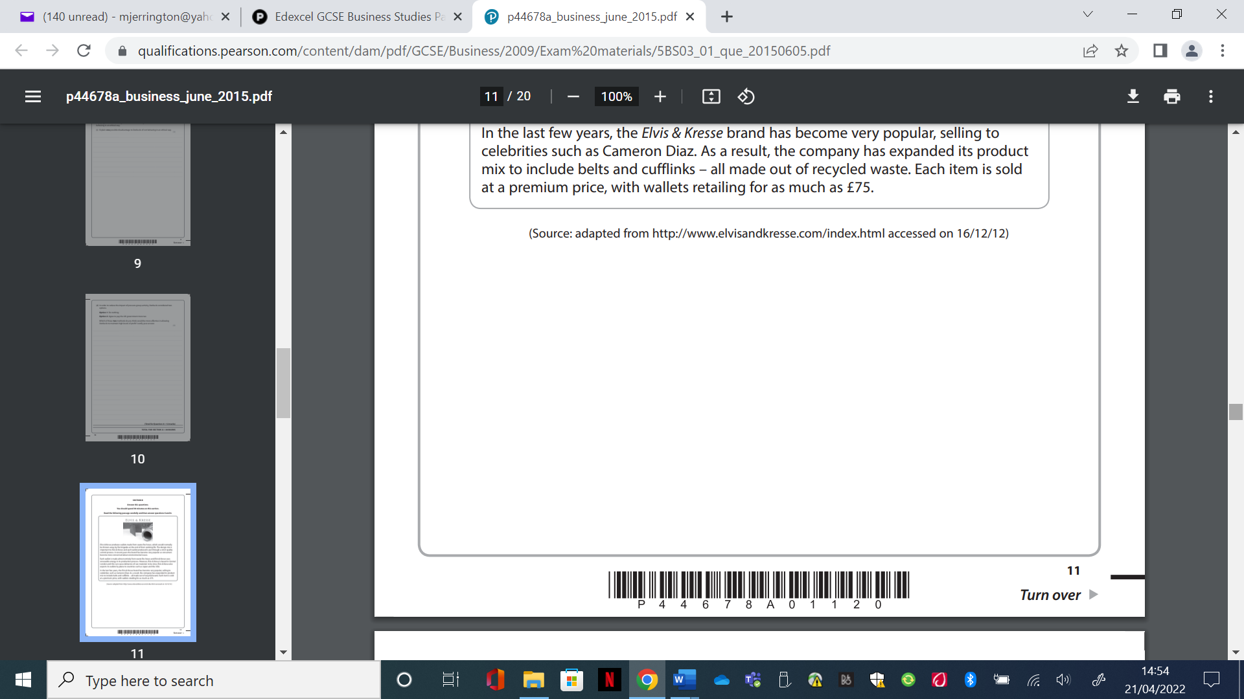

How this case study illustrates/exemplifies the specification content:
The case study illustrates ‘working with suppliers’ in a number of ways:

- Elvis and Kresse gets the raw materials (waste fire hoses) for its wallets from the fire brigade.
- Deliveries of its raw materials can be slow because the business is located in Central London.
- Elvis and Kresse also make cufflinks and belts, which are made out of recycled waste.

Check your knowledge:

- What information is included on a bar gate stock graph?
- What is meant by the term ‘buffer stock’?
- Identify one way a just in time stock management system could reduce costs for a business.
- How could a problem with logistics lead to low customer satisfaction?

Check your knowledge: recall question (previous unit)

1. What is the difference between a good and a service?
2. Identify one difference between job and batch production.
3. How can the choice of production process influence the costs of production?
4. Why can using new technology in the production process increase productivity?

Activity – now try this!

Task One: Just in time stock control

Decide if the statements below are advantages or disadvantages of stock control. Add your answer to the correct part of the table.

Just in time stock control
Advantages | Disadvantages

- As parts are ordered as they are needed there is no wastage
- Parts are not warehoused which is a massive cost saving in terms of premises and staff
- The business will improve their cash flow, as their money is not tied up in stock
- The business won’t be able to meet unpredicted surges in demand
- If the delivery does not turn up in time this can stop the whole production line, which is
- Stock is less likely to go out of date – think of examples!!
- The business won’t be able to quickly replace damaged parts

Task two: Factors to consider when selecting a supplier

The table below identifies a number of factors that need to be considered by a business when selecting a supplier. Below the table are several questions that a business could ask itself when deciding to work with a supplier. Add each question to the relevant factor. The first one has been done for you.

Issue | Question to consider
Reliability | Will the delivered orders be correct?
Payment terms
Price
Capacity
Quality

- Will the delivered orders be correct?
- Can the supplier be flexible if demand fluctuates?
- How and when do we need to pay?
- Does the level of quality provided meet our standards?
- Will the deliveries arrive on time?
- Are the supplier’s prices competitive?
- Does the supplier offer trade credit?
- Can the supplier be flexible if demand fluctuates?
- Could there be any faults with the materials or products?
- What level of quality do we need?
- Can the supplier meet our needs if our business expands?
- What deals or discounts does the supplier offer for bulk purchases?

What have you remembered so far?

Question | True | False
Just in time stock control requires a business to hold buffer stock
Poor relationships with a supplier can increase business costs
The reputation of a business will be affected if it makes poor logistical decisions

Exam Question
- Explain one impact on a business from developing good relationships with its suppliers. (3 marks)

- Discuss the benefits to a business of using Just-in-time stock control. (6 marks)

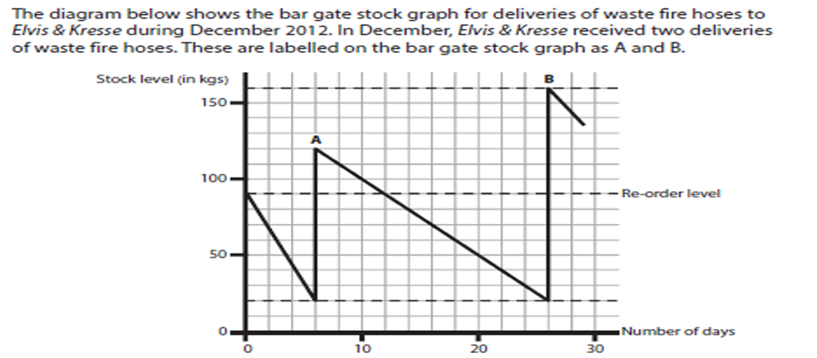

- Identify the level (in kgs) of the buffer stock held by Elvis and Kresse during December 2012. (1 mark)

- Calculate the weight (in kgs) of delivery A. Show your workings. (2 marks)

- Analyse the impact on the logistics of Elvis and Kresse from being located in Central London. (6 marks)

