GCSE Business
Theme 2.3.1 – Business operations
Booster Booklet
Specification

Subject content | What students need to learn:
2.3.1 Business operations  The purpose of business operations:  - To produce goods  - To produce services.  Production processes:  - Different types: job, batch, flow  - The impact of different types of production process: keeping productivity up and costs down and allowing for competitive prices.  Impacts of technology on production:  - Balancing cost, productivity, quality and flexibility. | This is the first subject covered in Topic 2.3 – Making operational decisions. These are key decisions a business needs to make linked to the production of a product or a service. Students need to understand the difference between a product and a service, and the different production processes that a business could use. Students need to understand that this choice will affect productivity and the costs of a business, which in turn will influence the price charged to customers.  Students also need to learn that technology has had a large influence on the production process. When deciding to implement new technology in the production process, a business must measure the impact on costs, productivity, quality and flexibility of production.

Key terms in this topic:

- Goods – a physical product produced using raw materials. Value is added to produce a product that meets customer needs eg a car, pizza, a pair of shoes.
- Services – work done or help provided by a business in return for payment. An intangible offer such as insurance, a haircut, public transport.
- Job production - products are made individually, specifically to customers’ requirements.
- Batch production - groups of products are made together, passing through stages of production.
- Flow production – production using an assembly line to mass produce identical products in a continuous process.
- Productivity – a measure of the effectiveness with which a business produces its products or services. Calculated by measuring the business’s outputs (number of products made) by its inputs (the resources used to make the products or services).
- Flexibility – how easy a business can make changes in order to meet customer needs.

Key terms – examples
In the space below, write examples to illustrate the key terms

Key term | Examples
Goods
Services
Job production
Batch production
Flow production

Productivity

Flexibility

Summary of the topic

The purpose of business operations is to produce goods and services, and the
advantages and disadvantages of the different types of production process should
be considered.

Technology is changing the way in which businesses manufacture their products
and this has an impact on cost, productivity, quality and flexibility. The emphasis in
this sub-topic is on how technology impacts on production decisions and there is no
requirement for specialist knowledge. Students are not required to demonstrate an understanding of this technology in their responses but do need to apply their knowledge and understanding of the impact of such technological developments on the business, such as reducing the cost of product development. Where a specific technology is used as a context, this will be explained in the accompanying extracts.
Synoptic links to this topic

This topic links with the following areas of the specification:

- 2.2.1 Product
- 2.3.3 Managing quality
- 2.4.2 Understanding business performance
- 2.5.4 Motivation

The decisions involved in how a product or service is produced will impact on other areas of a business. The design mix of a product will need to consider how the product is going to be made with relation to the function, aesthetics and costs involved in making the product. The choice of production process will also impact on the quality of the product. There is likely to be balance needed in decision making between the cost and speed of making the product against its quality.

Investing in new technology to increase the efficiency of the production process needs to be measured. One way to do this is to be able to carry out calculations linked to business performance to measure if the investment is going to offer a level of return for a business that makes the initial investment worthwhile.

The choice of production process can have an affect on the motivation of employees. Learning that takes place in this topic can be linked to how businesses motivate employees in 2.5.4.

Case study: Fender guitars

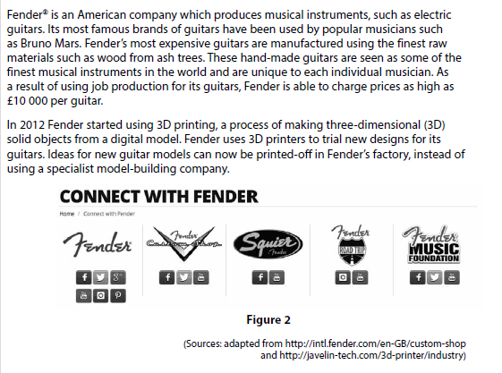

How this case study illustrates/exemplifies the specification content:
The case study illustrates ‘business operations’ in a number of ways:

- Fender makes each guitar by hand using job production. This allows each guitar to be unique for each individual musician.
- The choice of the production process has an impact on the price of a guitar. Prices can be as high as £10 000 per guitar.
- New technology has been used in the production process using 3D printing to trial new designs for the guitars.

Check your knowledge:

- What is the difference between a good and a service?
- State three different types of production process.
- How can the choice of production process influence the price of the product?
- Why can using new technology in the production process both increase and decrease costs?

Check your knowledge: recall question (previous unit)

- List the four elements of the marketing mix.
- How can each element of the marketing mix provide a competitive advantage to a business?
- Identify how the marketing mix could be integrated for the launch of a new electric car.

Activity – now try this!

For each of the production activities in the table below, recommend one appropriate method of production (Job, Batch or Flow). You should give reasons for your recommendation and explain any possible problems that a business may face if they use your production recommendation.

Production Activity | Method of Production | Reason for recommendation | Possible Problems
A specialist tailor makes made-to-measure suits.
A motorcycle manufacturer makes unique motorcycles for individual customers.
A multinational car company produces large number of cars in the UK for export to the rest of Europe.
A local bakery produces a range of bread and cakes for distribution to shops within a 20-mile radius.
A furniture manufacturer produces a range of solid wood items of home furniture.
An oil refinery produces thousands of barrels of oil each day.
A business produces thousands of cans of soft drinks each day. The cans need to filled and labelled.
A small company produces three different models of tents. Each model requires a different frame.
Command Word corner

The booklet at the start of each topic will focus on a command word that is used in the exam. This will provide students with information on how the word is used in the exam and what you can expect. It will offer you advice on how to structure your answer and what examiners are looking for when marking these questions.

The command word for Topic 2.3 is ‘Analyse’.

‘Analyse’ questions:

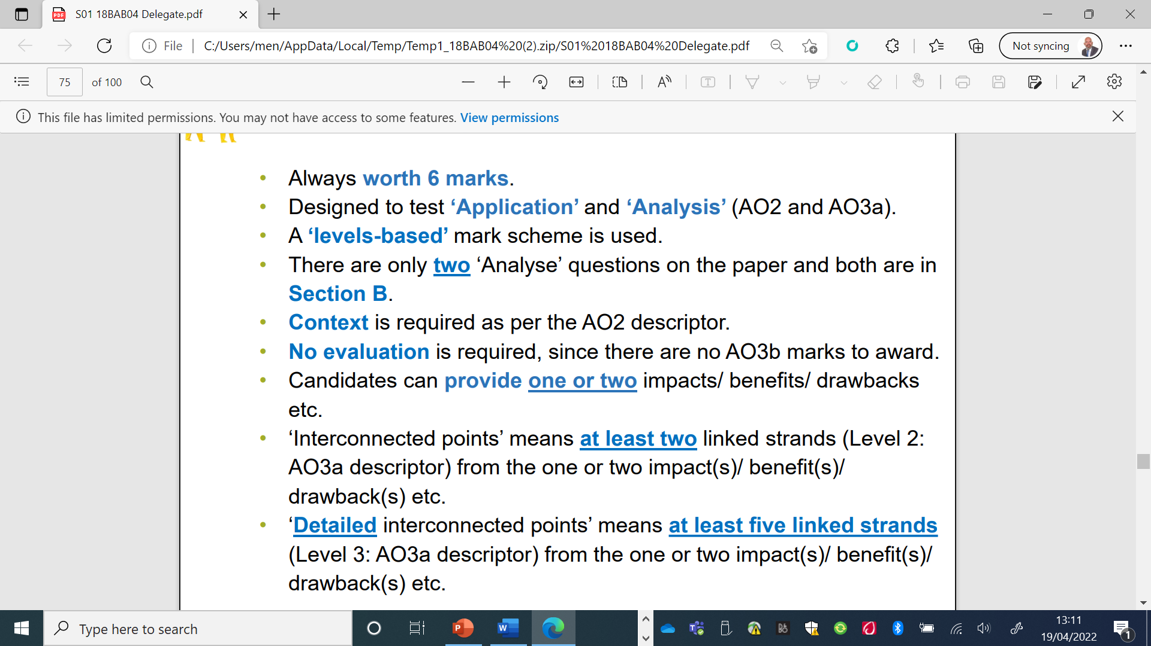

What have you remembered so far?

Question | True | False
Job production is a process where one product is made at a time.
Flow production requires employees to be highly skilled
Using new technology in the production process will increase costs in the short term.

Exam Question

- Explain one advantage to a business from using batch production. (3 marks)

- Fender is considering buying a new piece of machinery for their factory at a cost of £300,000. The table below shows the profit the new machinery will provide

Year | 1 | 2 | 3
Profit | £22 000 | £32 000 | £36 000

Using the information in the table above, calculate, to 2 decimal places the value of the year 2 profit as a percentage of the total profit. You are advised to show your
workings. (2 marks)

- Outline one impact on Fender’s production of using high quality raw materials. (2 marks)

- Fender uses job production to manufacture its hand-made musical instruments.

Analyse the impact on Fender of using job production to manufacture these musical instruments. (6 marks)

