GCSE Business
Theme 2.2.5 – Using the marketing mix to make decisions
Booster Booklet
Specification

Subject content | What students need to learn:
2.2.5 Using the marketing mix to make decisions  How each element of the marketing mix can influence other elements.  Using the marketing mix to build competitive advantage.  How an integrated marketing mix can influence competitive advantage. | This is the final booklet in Topic 2.2 – ‘Making marketing decisions’. This booklet examines how elements of the marketing mix can be used together to help a business build a competitive advantage.  The marketing mix is important for all businesses – large and small. Students need to use their knowledge and understanding of the different elements of the marketing mix covered in the first 4 booklets of this topic. They will use this knowledge and understanding to identify how different elements of the marketing mix link together. For example, an effective promotion campaign may ultimately not benefit the business

Key terms in this topic:

- Integrated marketing mix – a marketing mix that has a theme with each of the 4 elements supporting each other.

Key terms – examples
In the space below, write examples to illustrate the key terms:

Key term | Examples
Integrated marketing mix

Summary of the topic

In this section students will pull together the separate marketing mix elements to understand how they form an interconnected marketing strategy. For example, an internet-based business might charge low prices because it does not face the high costs of an additional retail estate, such as AO.com compared with Currys Digital. Retailers of fashionable clothing such as Abercrombie and Fitch have to promote and price their products in such a way to reflect and reinforce the perceived quality of the clothing. The design mix and the stage at which the product is at in its life cycle could also determine which blend of the ‘4Ps’ is the most appropriate. In almost all circumstances certain elements of the marketing mix will be more important than others depending on factors such as the nature of the product, the amount of competition, the market segment targeted, etc. and students should explore this dynamic.

Students should explore which element or elements of the marketing mix are critical in determining competitive advantage and be able to make judgements about which parts of the marketing mix are the most important in different business contexts.

Synoptic links to this topic
This sub-topic is also a useful revision tool for the topics already covered in Theme 1 as this includes the elements included within a business plan.
- 1.1.1 The business idea
- 1.2.2 Market research
- 1.3.1 Business aims and objectives
- 1.3.2 Business revenue, costs and profits
- 1.4.2 Business location
- 1.4.3 Marketing mix
- 2.2.1 Product
- 2.2.2 Price
- 2.2.3 Promotion
- 2.2.4 Place

The marketing mix is important in a wide range of business areas. For example, Business Location, covered in 1.4.2, is associated with Place. Market research (1.2.2) provides businesses with information on what products to sell, how to best promote them and where they should be sold. The marketing mix will ultimately determine the profitability of a business.

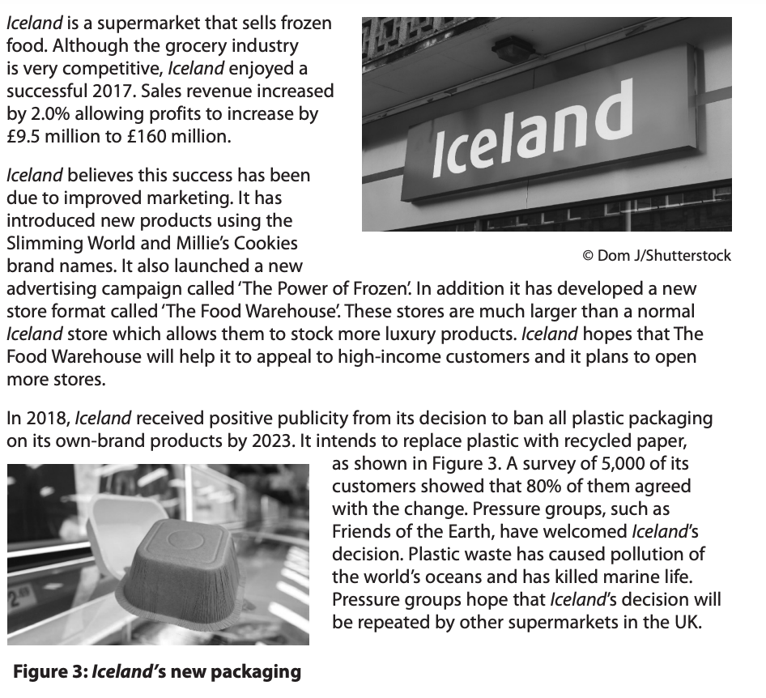
Case study: Iceland
Source: Edexcel GCSE Paper 2 (Section C) – June 2020

How this case study illustrates/exemplifies the specification content:
The case study illustrates ‘Using the marketing mix to make decisions’ in a number of ways:
- Iceland is developing the ‘Product’ element of the marketing mix by introducing new brands, such as Millie’s Cookies and Slimming World.
- At the same time, and to support the new types of products, Iceland is developing its ‘Promotion’, through a new advertising campaign called ‘The Power of Frozen’.
- In addition, Iceland is developing the ‘Place’ element. It is changing the format of some stores to help them appeal to different types of customers. ‘The Food Warehouse’ will give customers different experience with more luxury products.
- By reducing its reliance on plastic, Iceland’s products will use different packaging. Also, this decision will help Iceland to use promotion which persuades customers that it cares about the environment. It has received positive publicity becase of this decision
Check your knowledge:

- Give 3 examples of promotion that a business might use.
- Which two elements of the marketing mix do you think are most important for the following products?

- Apple iPhone
- Domino’s Pizza
- Lidl
- Petrol station

- What is meant by an integrated marketing mix?

Check your knowledge: recall question (previous unit):

- How does a retailer differ from an e-tailer?
- Suggest two advantages of e-tailing for a business.
- Suggest two reasons might e-tailing reduce costs for a business.

Activity - now try this…

For each pair of elements of the marketing mix, describe an example of how they might link together. An example is provided.

Elements of the 4Ps | How these elements link together…
Product and Place | A business may create a product by using market research information. If a business creates a very successful product that meets customer needs, but does not distribute it effectively (Place – for example, by not having it available in enough retail stores - then the new product is likely to fail.
Price and Product

Place and Promotion

Price and Place

Product and Promotion

Common misconceptions

- It is a misconception to think that a success in one area of the marketing mix – means the business will be successful.

What have you remembered so far?

Statement | True | False
‘A great product will always be a success; it does not matter about the other parts of the marketing mix’
An integrated marketing mix means a business needs to spend the same. Amount of money on each element.
The level of competition in a market will influence all elements of the marketing mix for a business.
Exam Questions

- Multiple choice

Which one of the following is not an element of the marketing mix? (1 mark)

Select one answer

A Packaging
B Place
C Price
D Product

- Explain one reason a business should only rely on the Product element of the marketing mix. (3 marks)

- Discuss the benefit to a business of having an integrated marketing mix. (6 marks)

- Analyse the benefit to Iceland of using the marketing mix to make decisions. (6marks)

