GCSE Business
Theme 2.2.4 – Place
Booster Booklet
Specification

Subject content | What students need to learn:
2.2.4 Place  - methods of distribution: retailers and e-tailers (e-commerce) | This is the fourth booklet in Topic 2.2 – ‘Making marketing decisions’. This booklet examines the ‘place’ element of the marketing mix.  ‘Place’ refers to how a business gets its product to the. customer. This includes the way that customers access the product and how it is delivered. Place also refers to the physical location of a business. Students need to understand the different distribution methods that businesses use to get the product to customers.  Students will learn about traditional methods such as retailing, and will also understand how technology influences ‘Place’ through such aspects as e-commerce and e-tailing.

Key terms in this topic:

- e-commerce – selling online rather than in a physical store.
- e-tailer – an electronic retailer that sells goods and services using the internet, such as through an e-commerce website, rather than through physical premises.
- Place - ‘Place’ refers to how a business gets its product to the. customer. This includes the way that customers access the product and how it is delivered.
- Retailer – a traditional way of distributing goods and services to customers. It involves selling products through a shop or other physical building.

Key terms – examples
In the space below, write examples to illustrate the key terms:

Key term | Examples
e-commerce
e-tailer

Place

Retailer

Summary of the topic
‘Place’ refers to how a business gets its product to the. customer. This includes the way that customers access the product and how it is delivered. Place also refers to the physical location of a business.

Students need to understand two distribution methods: retailers and e-tailers (selling direct to the consumer via the internet). There is no requirement to know other methods of distribution such as via a wholesaler. The intention of this topic is for students to consider how most goods and services in the UK are distributed.

Students and teachers could consider how Amazon has provided a platform for smaller retailers to sell direct to consumers via its website.

Synoptic links to this topic
This sub-topic is also a useful revision tool for the topics already covered in Theme 1 as this includes the elements included within a business plan.
- 1.1.1 The business idea
- 1.2.2 Market research
- 1.3.1 Business aims and objectives
- 1.3.2 Business revenues, costs and profits
- 1.4.2 Business location
- 1.4.3 Marketing mix

You should be able to recognise that business planning is based on a wide range of areas. You have covered many of these in this Theme.

Case study: SportShoes.com
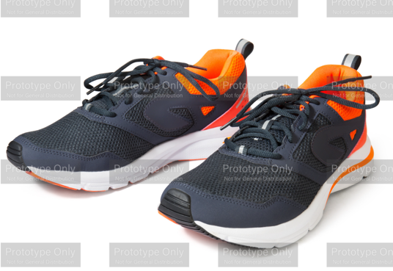
SportShoes.com is an online retailer that specialises in sporting equipment, particularly sports shoes such as trainers. It offers more than. 12,000 products including running shoes, clothing and hiking equipment.

SportShoes.com stocks leading brands and features lots of expert advice on its website. Customers can talk to an expert using LiveChat, as well as reading articles and interacting with other runners through the site’s MyRunspiration Community.

Customers can easily order products using the website, and can choose a range of delivery options.

Source: Adapted from Edexcel GCSE textbook p196

How this case study illustrates/exemplifies the specification content:
The case study illustrates ‘Place’ in a number of ways:

- SportShoes.com operates using e-commerce, rather than a traditional retailing approach. The business does not have physical stores.
- SportShoes.com is an e-tailer – it sells its products using its website.
- The business uses e-commerce techniques such as providing information and support through its website. Rather than customers talking to an assistant in person, as they would in a shop, they can use the website or the LiveChat function.
- Products can be ordered through the website.

Check your knowledge:

- Give 2 examples of businesses that are only e-tailers (they do not have physical stores).
- Why is ‘Place’ a key element of the marketing mix?
- What are the differences between retailing and e-tailing.

Check your knowledge: recall question (previous unit):

- Give 3 examples of promotion that a business can use.
- Why is ‘Promotion’ a key element of the marketing mix?
- How might a business use technology to improve its promotion?
- What is meant by targeted advertising?

Activity - now try this…

Use the table below to show the advantages and disadvantages of Retailing and e-commerce

Business | Retailing | e-commerce
Definition

Advantages

Disadvantages

Common misconceptions

- Businesses do not only have one approach to ‘Place’. Many businesses have physical stores, factories and/or premises as well as opportunities for customers to purchase products using a website (e-commerce).

What have you remembered so far?

Question | True | False
Retailers only have physical shops or premises.

A benefit of e-tailing is that a business does need to own or rent physical premises.
Retailing involves customers actually visiting a. business to buy its products.
Exam Questions

- Multiple choice:

Which one of the following is a method a business can use to distribute its product to customers? (1 mark)

Select one answer

A Cash-flow forecasting
B Sponsorship
C Vending machine
D Viral advertising

- Explain one drawback for a business of using retailing as its main way of selling goods and services. (3 marks)

- Outline one disadvantage to SportShoes.com of not having physical premises. (2 marks)

- Analyse the impact on the owners of SportShoes.com of relying solely on e-commerce. (6 marks)

