GCSE Business
Theme 2.2.3 – Promotion
Booster Booklet
Specification

Subject content | What students need to learn:
2.2.3 Promotion  - appropriate promotion strategies for different market segments: advertising, sponsorship, product trials, special offers, branding.  - the use of technology in promotion: targeted advertising, online, viral advertising via social media, e-newsletters. | This is the third booklet in Topic 2.2 – ‘Making marketing decisions’. This booklet examines the ‘promotion’ element of the marketing mix. It builds on the marketing mix that was covered in Theme 1 – 1.4.3.  Promotion is a key element of the marketing mix. Students will learn about different types of promotion, and will recognise which types are appropriate in different situations. For example, a large global brand may choose to sponsor a famous sports man/woman, or a team with a national or international profile. A local take-away may decide to use special offers. Both are types of promotion.  Students need to understand the growing importance of the role technology plays in promotion. Social media is used for targeted advertising. Technology can be less expensive form of promotion for a business, and can help ensure a wide reach for any promotional campaign.

Key terms in this topic:
- Advertising – messages paid for by businesses that are designed to inform and influence people who read them.
- Branding – the promotion of a product or business by means of advertising or a distinctive design or name.
- E-newsletters – electronic publications from a business that are sent by email or social media.
- Product trials – a way of persuading customers to try a product by providing it for free, sometimes for a limited amount of time.
- Promotion – the methods a business uses to persuade customers to buy its products.
- Special offers – also referred to as sales promotions. Typically, a discount on price to attract customers to buy a product.
- Sponsorship – where a business pays to have its name/brand associated with a particular individual, event or team.
- Targeted advertising – advertising aimed at particular market segments.
- Viral advertising – using social networking to increase sales or boost brand awareness.

Key terms – examples
In the space below, write examples to illustrate the key terms:
Key term | Examples
Advertising
Branding

E-newsletters

Product trials

Promotion

Special offers

Sponsorship

Targeted advertising

Viral advertising

Summary of the topic

Different promotion strategies are appropriate for different products or services and the market they are aimed at. How and why businesses are making increasing use of technology, such as using social media, as part of their promotional activities is explored in this section. For example, many businesses – in addition to their websites - have now have apps that can be downloaded onto mobile devices. This allows customers or potential customers to be targeted with offers that are personal to them. They can also provide a two-way platform so that customers can interact with the company to build customer loyalty.

There is no requirement for students to have a technical understanding of the technology behind these promotional methods.

Synoptic links to this topic
This sub-topic is also a useful revision tool for the topics already covered in Theme 1. It builds on 1.4.3 and links to some later topics.
- 1.1.1 The business idea
- 1.2.2 Market research
- 1.4.2 Business location
- 1.4.3 Marketing mix
- 2.2.2 Price
- 2.2.3 Promotion
- 2.2.4 Place
- 2.2.5 Using the marketing mix to make business decisions

Case study: Kentucky Fried Chicken

Read the case study before consider the points below.

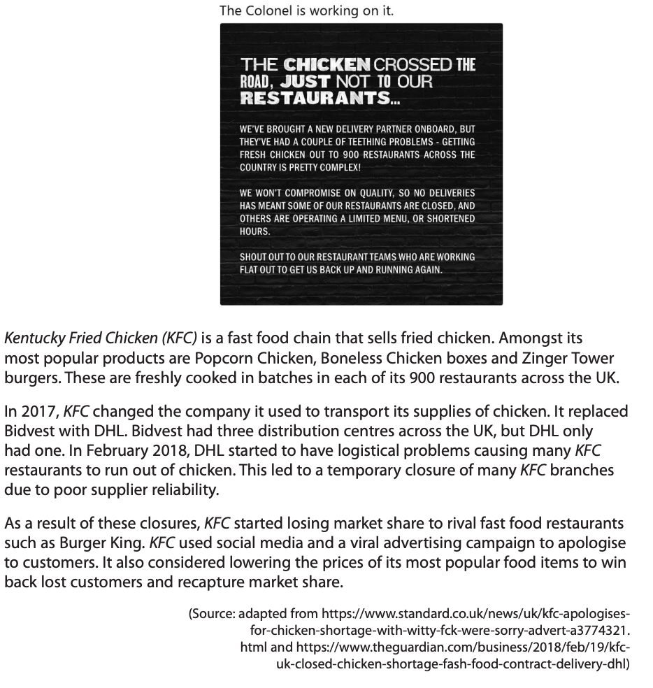
Source: Section B - Paper 2 (June 2020)

How this case study illustrates/exemplifies the specification content:
The case study illustrates ‘Promotion’ in a number of ways:
- Kentucky Fried Chicken (KFC) brands some of its products to give them a clear identity. For example, Popcorn Chicken, Zinger Tower burgers and so on. Such branding is a form of promotion.
- After a set-back – the lack of supply of chicken to its stores – KFC used promotion strategies to help win back customers.
- KFC used technology to communicate with customers regarding its supply issues and some stores temporarily closing.
- KFC used a viral advertising campaign to apologise to its customers. Look closely at the advertisement at the top of the case study.
- KFC considered special offers – lowering its prices – to win back lost customers.

Check your knowledge:

- Give 3 examples of business sponsorship – think of actual teams, individuals or events sponsored by a business.
- What does a business gain from sponsoring a team, individual or event?
- How might technology benefit a business in terms of its promotion?
- How does use of targeted advertising benefit a business?

Check your knowledge: recall question (previous unit):

- What is a pricing strategy?
- Explain how competition might affect the pricing strategy of a business.
- What is the benefit to a business of a high-margin pricing strategy?

Activity - now try this…
Look at the different methods of promotion. Give each a score out of 5 for each category.

 | E-newsletters | Sponsorship | Viral marketing
Cost

Reach – how many people will see it?

Control – how easily can the business control the message?
Precision – how easily can the business target different market segments?
Overall effectiveness

Common misconceptions

- Not all methods of promotion are appropriate for all businesses. A viral advertising campaign is more suitable for a national or international business.
- Just because a promotion campaign uses social media, does not mean it is low cost. Businesses can spend vast sums of money on campaigns that will use social media. However, businesses can use social media to reach a wide range of customers and this need not cost lots of money.

What have you remembered so far?

Question | True | False
A brand is always a product which is very expensive.

Special offers involve s business reducing the price of a product to tempt customers to purchase.
E-newsletters are an expensive form of promotion and can only be used by larger businesses.
Exam Questions

- Multiple choice:

Which one of the following is a form of promotion for a business? (1 mark)

Select one answer

A Business plan
B Market segment
C Target market
D Viral advertising

- Outline one benefit to KFC of using viral advertising. (2 marks)

- Explain one benefit to a business of promoting its product using social media. (3 marks)

- Analyse the impact on KFC of using special offers to attract customers. (6 marks)

