GCSE Business
Theme 2.2.2 – Price
Booster Booklet
Specification

Subject content | What students need to learn:
2.2.2 Price  - pricing strategies  - influences on pricing strategies: technology, competition, market segments, product life cycle | This is the second booklet in Topic 2.2 – ‘Making marketing decisions’. This booklet introduces the ‘price’ element of the marketing mix. It builds on the marketing mix that was covered in Theme 1 – 1.4.3.  Price is how much a customer needs to pay to buy a product. Businesses need to set a price for their product. But how should this price be decided upon? There are different approaches to this decision. Students will learn about different types of pricing strategy

Key terms in this topic:

- High-margin pricing strategy – a pricing strategy that aims to maximise the profit margin of the business. Typically, this price will be higher than for rival products.
- High-volume pricing strategy – a pricing strategy designed to increase the volume of sales. Typically, this involves a lower price than rival products.
- Pricing strategy – how a business decides on the price to charge for a product.

Key terms – examples
In the space below, write examples to illustrate the key terms:

Key term | Examples
High-margin pricing strategy
High-volume pricing strategy
Pricing strategy

Summary of the topic
Price is linked to product (2.2.1) as different methods of pricing are relevant for each stage of the product life cycle. Students could make contrasts with the high margin, lower volume pricing strategies used by Waitrose and contrast with the lower margin, higher volume strategy used by Tesco. Specific pricing strategies are not required, although students need to understand why businesses choose a given price and the rationale behind that decision; for example, to reflect the brand or quality of the product.
Technology is allowing new pricing models to be adopted. For example, Candy Crush Saga uses a freemium strategy where the initial game is free of charge and then users have to pay extra for additional features in the game. Since these features are essentially part of the game, charging for them generates a very high profit margin. Another example could be the existence of price comparison websites which has made markets significantly more price competitive, restricting the prices that can be charged and resulting in lower profit margins for the business. An example of this is the car insurance market.
Market segments (see booklet 1.2.3) can influence pricing strategy. Businesses will often target different types of customers with a product at a different price. This is intended to meet the needs of each particular market segment. For example, car companies produce a range of models aimed at different customers. Cheaper models can be aimed at customers with lower income, such as younger people, whereas top of the range models are more expensive and aimed at higher income customers.
Another factor that could influence price are the level of competition. For example, grocery prices are decreasing due to the entrance of Lidl and Aldi into the food retail market. Lots of competition tends to cause businesses to reduce their price.
The product life cycle (see booklet 2.2.1) is also a factor which can influence pricing strategy. For example, during the introduction phase, 4K television manufacturers chose to price their products at a high price and aimed their product at a high-income market segment. During the growth phase, when sales are rising, businesses can also maintain a high price strategy. This also applies in the maturity phase, at which point the product is established and sales are high. During the decline phase, the business may need to reduce price to maintain sales.
Synoptic links to this topic
This sub-topic is also a useful revision tool for the topics already covered in Theme 1. It builds on 1.4.3 and links to some later topics.
- 1.1.1 The business idea
- 1.2.2 Market research
- 1.3.1 Business aims and objectives
- 1.3.2 Business revenues, costs and profits
- 2.2.1 Product
- 2.2.3 Promotion

Case study: Lounge

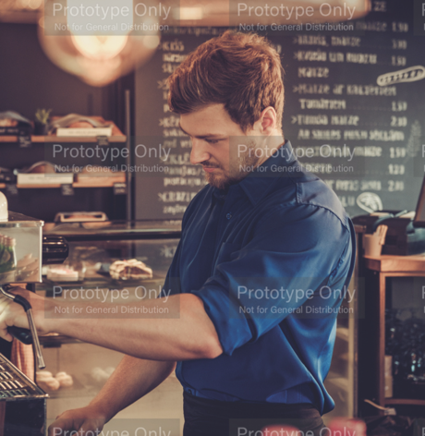
Lounge is a fashionable coffee shop in Sheffield. It is located on a major high street, next to trendy bars and restaurants. Rent and property prices in this part of the city are high.

The décor and interior of Lounge gives it a relaxed and modern vibe. The business prides itself on the quality of its coffee, which is made from a blend supplied by an independent coffee roasting company.

The average price of a cup of coffee is £4.25. This is more expensive than at some other cafes nearby. One of the reasons for this is to reflect the quality of the product.

Source: Adapted from Edexcel GCSE textbook p182

How this case study illustrates/exemplifies the specification content:

The case study illustrates ‘Price’ and the marketing mix in a number of ways:

- Lounge sets a high price for its coffee. This is because the cost of the ingredients is high as it uses high quality ingredients from an independent supplier.
- Price is also high to ensure the business covers other costs, such as the high rent in this part of the city.
- A high price strategy also helps to maintain the atmosphere within the coffee shop.

Check your knowledge:

- Give 2 examples of how technology might influence pricing strategies of businesses.
- Suggest one way that the product life cycle influence the pricing strategy of a business?
- Why are market segments important for a business when deciding on a pricing strategy?

Check your knowledge: recall question (previous unit):

- What are the 4 stages of the product life cycle?
- Suggest two extension strategies for a product that has become less fashionable.
- Give one disadvantage to a business of only focusing on one element of the design mix.

Activity - now try this…

For the following products, research the price and explain what type of strategy the business is using when making this pricing decision.

Product | Price | Reasons for pricing strategy
Costa Cappuccino

Big Mac meal

Nike Air Zoom Alphafly

Domino’s pizza

Fiat 500x

What have you remembered so far?

Question | True | False
Businesses producing a similar product must charge the same price.
At the decline phase of the product life cycle, businesses usually choose to lower price.
If a business needs to increase sales, a high-volume pricing strategy is better than a high-margin strategy.
Exam Questions

- Multiple choice:

Which one of the following will influence the pricing strategy of a business? (1 mark)

Select one answer

A Business plan
B Limited liability
C Market research
D Type of customer

- Explain one benefit to a business of using a high-margin pricing strategy. (3 marks)

- Outline one factor that might influence the pricing strategy at Lounge coffee shop. (2 marks)

- Discuss the impact of the product life cycle on the pricing strategy of a business. (6 marks)

