GCSE Business
Theme 2.2.1 – Product
Booster Booklet
Specification

Subject content | What students need to learn:
2.2.1 Product  The design mix:  - function, aesthetics, cost  The product life cycle:  - the phases of the product life cycle  - extension strategies.  The importance to a business of differentiating a product/service | This is the first booklet in Topic 2.2 – ‘Making marketing decisions’. This booklet introduces the marketing mix before examining the ‘product’ element of the marketing mix. It builds on the marketing mix that was covered in Theme 1 – 1.4.3.  Students should understand the components of the design mix, and the role this plays when a business is developing a new product.  Students need to understand the product life cycle. They should understand the 4 stages as well as the role of extension strategies.

Key terms in this topic:
- Aesthetics – refers to the visual attractiveness of something. The look and feel of a product.
- Design mix – the three aspects of design that a business needs to consider when developing a product. The. three elements are aesthetics, cost and function.
- Extension strategies – actions that a business can take to lengthen the product life cycle and encourage a growth in sales during the decline phase.
- Function – how well a product works for the customer. How well a product does its job.
- Marketing mix – the 4 Ps of marketing which are Product, Price, Promotion and Place.
- Product – a good or service
- Product life cycle – the amount of money coming in and going out of the business.
Key terms – examples
In the space below, write examples to illustrate the key terms:

Key term | Examples
Aesthetics
Design mix

Extension strategies

Function

Marketing mix

Product

Product life cycle

Summary of the topic
The focus of this topic is for students to consider each of the four elements of the marketing mix for a larger business and to then consider how, to an extent, certain elements of the marketing mix can influence other elements and be used in an integrated way to build and influence competitive advantage. For example, for many larger businesses, the ability to exploit economies of scale is likely to mean that price becomes a much more important element of the marketing mix, especially for mass market products. This could be contrasted with smaller businesses operating in niche markets where product tends to be a much more important element. In Theme 2 it is likely that students will have to consider how a larger business uses the marketing mix, whereas in Theme 1 the aim was to introduce the marketing mix to students.
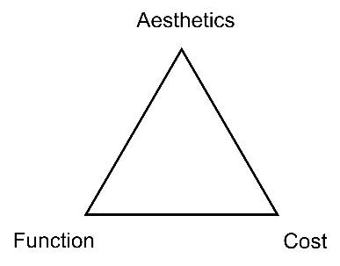
The design mix can be shown graphically (see above) and shows the three elements - aesthetics, cost and function. Different elements of the design mix may be more important depending on the nature of the product or service being considered. For example, the function and aesthetics of an Apple iPad are arguably more important than the cost, as it is these elements that allow it to stand out in its market. The resultant higher costs of production are more than recouped by the ability to charge higher prices.

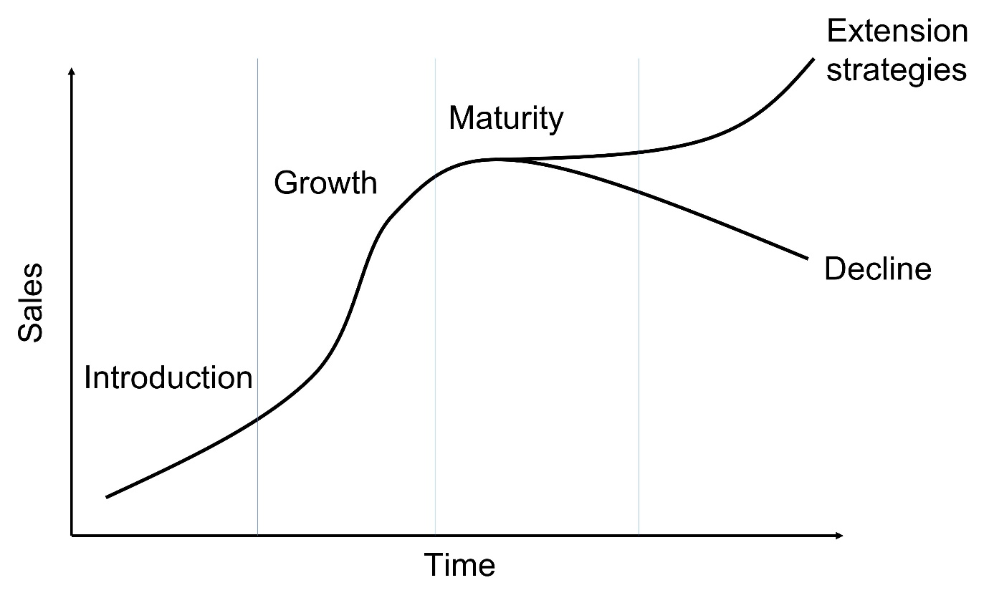

The four phases of the product life cycle (introduction, growth, maturity and decline) are explored and students should be able to recognise that the life cycle of a product is dependent on factors such as how dynamic the market is and how strong the product’s brand name is, etc. The product life cycle is shown (Above). Notice how extension strategies extend the product life cycle. Extension strategies will lengthen the product life cycle. For example, lowering price, re-branding, re-positioning and increased advertising. Students will not be required to draw the product life cycle in an examination, but it is important to understand how this diagram is constructed and drawing one may help students to consolidate their understanding.
This section also considers methods of differentiating a product or service and the reasons why this is important.

Synoptic links to this topic
This sub-topic is also a useful revision tool for the topics already covered in Theme 1. It builds on 1.4.3 and links to some later topics.
- 1.1.1 The business idea
- 1.2.2 Market research
- 1.4.2 Business location
- 1.4.3 Marketing mix
- 2.2.2 Price
- 2.2.3 Promotion
- 2.2.4 Place
- 2.2.5 Using the marketing mix to make business decisions
You should be able to recognise some of the different elements of the marketing mix – and the product element in particular – in different areas of the course.

Case study: GoPro
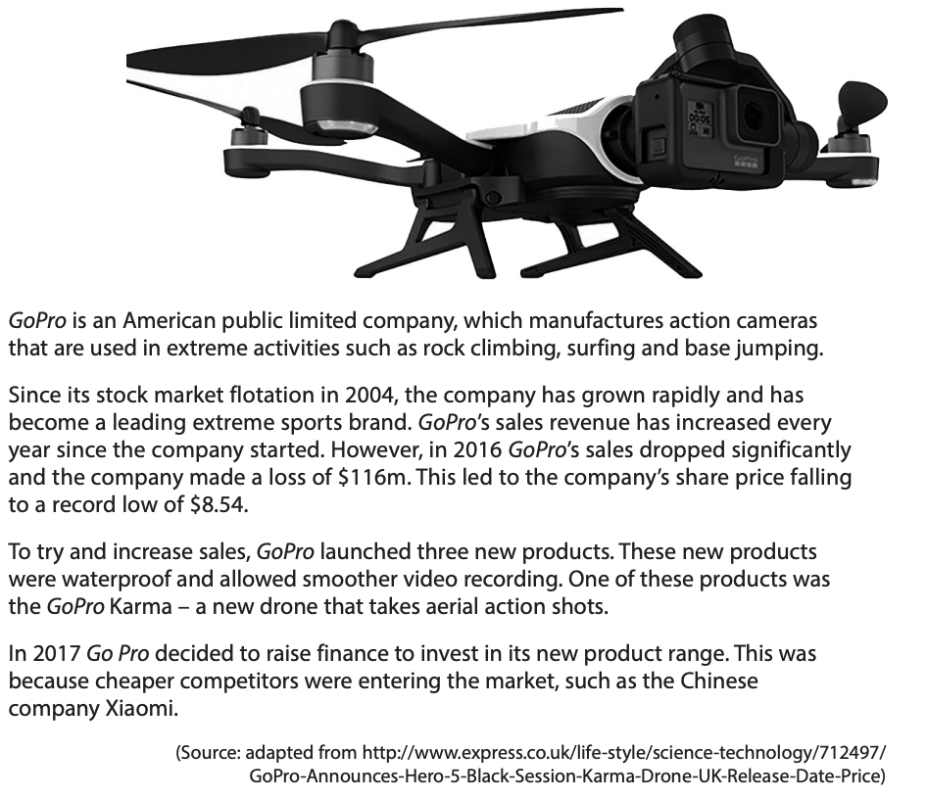

Source: Extra Assessment Material – Set 2 (Section C)
How this case study illustrates/exemplifies the specification content:
The case study illustrates ‘Product’ and the marketing mix in a number of ways:

- The case study illustrates the importance of Product for GoPro.
- GoPro relies on developing and manufacturing new products, to meet the needs of its consumers.
- GoPro has launched three new products, including the GoPro Karma, a drone which takes action shots. One of the reasons for developing new products is the existence of competitors.
- GoPro have used the design mix when developing new products like the Karma.
- GoPro have used the product life cycle

Check your knowledge:

- What is meant by the term ‘aesthetics’?
- What are the 4 stages of the product life cycle?
- Identify one extension strategy that GoPro have used.

Check your knowledge: recall question (previous unit):

- What is meant by the term ‘ethics’?
- Define the term ‘pressure group’.
- Why could there be a trade-off for a business between ethics and profit?

Activity - now try this…
Identify which stage of the product life cycle each statement describes.

 | Introduction | Growth | Maturity | Decline
Growth of sales is slow.

Sales begin to fall. The product loses popularity.
Sales are low as product awareness is low.
Sales are at their peak.

Repeat purchases of the product.

Lots of promotion to attract the attention of customers.
In this stage, sales increase rapidly. The product become more popular.

Command Word corner: ‘Discuss’
The booklet at the start of each topic will focus on a command word that is used in the exam. This will provide students with information on how the word is used in the exam and what you can expect. It will offer you advice on how to structure your answer and what examiners are looking for when marking these questions.

‘Discuss’ questions

- Always worth 6 marks
- Designed to test understanding and analysis. (AO1b and AO3a)
- A ‘levels-based’ mark scheme is used.
- There is only one ‘Discuss question on the paper, at the end of Section A.
- No context is required as there are no AO2 marks to award
- No evaluation is required, since there are no AO3b marks to award
- Will always be of the nature ‘Discuss what the likely impact/benefit/drawback etc.’
- Candidates can provide one or two impacts/benefits/drawbacks etc.
- ‘Interconnected points’ means at least two linked strands (Level 2 AO3a descriptor) from the one or two impact(s)/benefit(s)/drawback(s) etc.
- ‘Detailed interconnected points’ means at least five linked strands (Level 3 AO3a descriptor) from the one or two impact(s)/benefit(s)/drawback(s) etc.

Common misconceptions

- It is not true that the three elements of the design mix are all equally important for all products.
- It is a misconception to think that the product life cycle for all product is identical. In reality, they vary from product to product. Some products have a very short life cycle. Some are very long. Think of a product like Coca Cola.

What have you remembered so far?

Question | True | False
‘Function’ is an element of the design mix.

Updating a product with new features and design is an example of an extension strategy.
In the product life cycle, growth of sales is highest in the maturity stage.

Exam Questions

- Multiple choice:

Which one of the following is an element of the design mix? (1 mark)

Select one answer

A Cost
B Price
C Product
D Quality

- Explain one benefit to a business from improving the aesthetic element of a product’s design mix. (3 marks)

- Outline one extension strategy GoPro could use of the Karma (2 marks)

- Discuss the benefit to a business from using the design mix when developing new products. (6 marks)

