GCSE Business
Theme 2.1.4 – Ethics, the environment and business
Booster Booklet
Specification
Subject content | What students need to learn:
The impact of ethical and environmental considerations on businesses:  ● how ethical considerations influence business activity: possible trade-offs between ethics and profit  ● how environmental considerations influence business activity: possible trade-offs between the environment, sustainability and profit  ● the potential impact of pressure group activity on the marketing mix. | This section considers the impact on a business from ethical and unethical behaviour and explores whether there is a trade-off between ethics and profit. In its simplest form students would probably argue that there is since being ethical leads to an increase in costs. However, businesses such as Lush have shown that ethical behaviour can be a valuable source of added value.  There are numerous real-world contemporary examples to use when covering this section, ranging from Starbucks’ reported tax avoidance to Volkswagen’s reported falsification of emissions and fuel efficiency ratings. Pressure groups can impact on businesses that behave in an unethical manner and can be an important method of keeping unethical businesses in check. Ethical behaviour by businesses may be more or less important in certain markets. For example, Nestlé Baby Milk Action has been generally unsuccessful in persuading Nestlé to abandon its African powdered milk range.

Key terms in this topics
- Ethical decisions – a decision made by a business that is motivated to ensure there is a positive impact (or no negative impact) on stakeholders or the environment.
- Sustainability – whereby a business operates in a way that conserves finite resources and does not damage the environment.
- Pressure group – an organisation (not-for-profit / charity) that has the aim the influence business to act ethically and sustainably.

Key terms – examples
In the space below, write examples to illustrate the key terms

Key term | Examples
Ethical decisions | Pret A Manger has the aim to ensure all its food packaging will be 100% recyclable, degradable or reusable by 2025.
Sustainable business
Pressure groups

Summary of the topic

Most private businesses have an objective to be profitable. To be profitable a business must effectively manage its costs, whilst doing what it can to maximise sales revenue. In the pursuit of profitability some businesses may take decisions and act in a way that has a negative impact on its stakeholders or the environment. In this topic pupil should consider some of the scenarios that face businesses where they may have to face trade-offs between profitability and other ethical choices such as caring for its workers, protecting the environment or acting sustainably.

The key is to consider the extent to which these types of decisions do lead to a trade-off – a situation where a business way to weigh up the benefits and drawbacks or alternative choices. For example, a trade-off might be putting up wages to keep employees happy vs the cost to profit margins or the choice to introduce ‘greener’ environmentally friendly materials in the production of its products vs a decision to keep minimise its variable costs.

Pupils should understand that sometimes acting ethically or running a sustainable business can cost more, take longer and be more complex and therefore there may be a trade-off with profitability. However, this can be a narrow and simplistic view of business. There are many examples where the most ethical and sustainable businesses are the most profitable. Ethical business practices are a way to add value and differentiate from competitors.

Furthermore, it is now an expectation of customers and society that all businesses should act responsibly and practices such as sustainable sourcing of materials, being honest and open with customers and treating small suppliers fairly is essential for any business that expects operate in competitive markets – acting ethically has become a threshold to compete rather than a factor that can give a business a competitive advantage. Indeed, any business that does not act ethically is more than likely to receive negative exposure from environmental pressure groups such as Green Peace or PETA.

Case study: Sainsburys case study from June 2019 Paper 2 exam
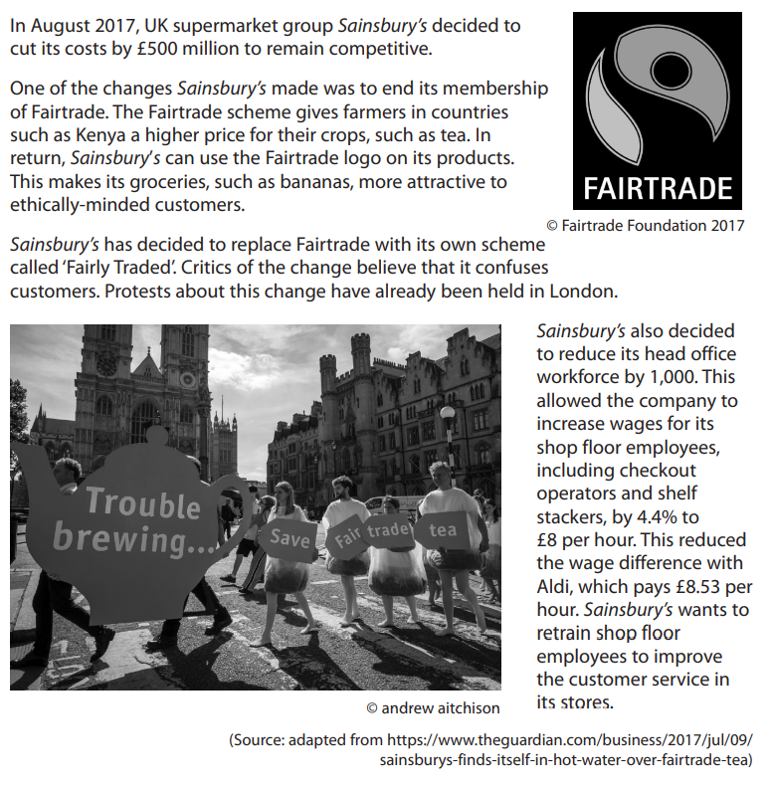

How this case study illustrates/exemplifies the specification content:
The case study illustrates ‘Ethics the environment and business’ in a number of ways:

- The Fairtrade Scheme is globally recognised to support suppliers such as farmers and growers by ensuring they receive a fair price for their products. The Fairtrade Scheme helps support business sustainability because these farmers and growers can afford to invest into their businesses.
- Sainsbury’s decision to leave the Fairtrade Scheme is not an unethical decision in itself, if the company chooses to maintain the ethical business practices that go with the logo. However, not being part of the Fairtrade Scheme might lead to trade-offs being made to maintain profitability.
- Sainsbury’s decision to introduce its own range of ‘fairly traded’ products. If the business has made this choice to mislead its customers then this is an example of unethical decision-making.
- Increasing pay to £8.53 per hour for its shop floor workers is an ethical decision because it is an example of treating employees fairly. However, 1000 workers at Sainsburys head office may have lost their jobs through redundancy. If Sainsburys had not done this its overall wage bill would have risen and profit margins would have fallen – or would they?

Check your knowledge: questions
- Why might a business choose to operate ehtically?
- Give an example of a business practice that is unsustainable?
- How might a pressure group influence a business?

Check your knowledge: recall question (previous unit)
- What is a tariff?
- How might a business adapt in order to compete internationally?
- What is a multinational?

Ethical trade-off?

For each of the scenarios below, explain how the decision could a. lead to a fall in profits b. lead to a rise in profits.

Fall in profits | Scenario | Rise in profits
Scenario 1
A business decides to remove all plastic packaging from its products.
Scenario 2
A business decides to increase wages of its 600 employees by £1.10 per hour.
Scenario 3
A restaurant chain switches its suppliers of groceries to local producers that produce their goods within a 10 mile radius of the restaurants.
Scenario 4
An opticians makes the decision that £1 of every sale will go directly to a guide dogs for the blind charity.

Common misconceptions

Being ethical lowers profitability?

There are examples where making ethical decisions can increase business costs. However, as acting ethically is a way to add value, businesses can off-set any increase in costs with increasing prices. Some ethical decision might actually lead to costs falling. For example, if a business improves working conditions of worker’s productivity could rise and this could reduce the cost per unit. Making a decision to source products locally could actually reduce delivery costs whilst at the same time reducing a firm’s carbon footprint.

Synoptic links to this topic

This sub-topic is closely linked to some aspects of Theme 1. Such as as:
- 1.2.4 The competitive environment – as ethical business practices are a way to add value it can therefore help a business to compete.
- 1.5.1 Business stakeholders – it is important for a business to understand the needs of all stakeholders. Meeting the expectations of all stakeholders is an example of sustainability.

There are also many links with topics throughout Theme 2. For example, ethical business practices can have a big impact on the marketing mix, the operations of a business and employee motivation.

Multiple choice questions
- Which of the following to help a business reduce its environmental impact?
- Importing raw materials from India
- Increasing packaging to protect its products
- Using sustainably grown materials
- Switching from petrol to diesel delivery vans
- Which two of the following is an example of an unethical business practices.
- Paying employees’ salaries in-line with competitors
- Informing customers of additional costs once they have placed an order
- Making products that customers are able to repair themselves
- Using non-renewable energy in the production process
- Funding community projects
- Negotiating new contracts with employees
- Disclosing full information of ingredients on packaging

Exam Questions

- Explain one way a pressure group could damage of business’s reputation. (3)

- Outline one impact on Sainsburys of the wages of shop floor employees. (2)

- Analyse the impact on Sainsbury’s of its decision to leave the Fairtrade Scheme. (6)

- Sainsburys are considering two options to improve its reputation with customers.

- Introduce 100% recycled packaging in its products.
- Launching a campaign to raise money for a homelessness charity.

Justify which one of these options Sainsburys should choose. (9)

