GCSE Business
Theme 2.1.3 – Globalisation and Business
Booster Booklet
Specification
Subject content | What students need to learn:
The impact of globalisation on businesses:  ● imports: competition from overseas, buying from overseas  ● exports: selling to overseas markets  ● changing business locations  ● multinationals.  Barriers to international trade:  ● tariffs  ● trade blocs.  How businesses compete internationally:  ● the use of the internet and e-commerce  ● changing the marketing mix to compete internationally. | The market for goods and services is becoming increasingly global and interconnected in nature. As a result of this, exporting goods and services abroad and facing competition from foreign imports has become much more common place. It has also presented opportunities for businesses to relocate to low-cost locations overseas and there are plenty of examples of UK companies that have taken advantage of lower labour costs abroad; for example, Dyson vacuum cleaners are manufactured in Malaysia. Barriers to international trade, such as tariffs have a significant impact on a business’s ability to compete internationally. Many UK businesses are facing challenges following Brexit.  The global market has created opportunities for internet-based e-commerce companies to sell beyond their national boundaries. The challenges faced by competing internationally are also explored in this unit and any business competing on an international stage will been to consider how it might need to change and adapt for different markets.

Key terms in this topics
- Globalisation – The integration of economies and businesses through international trade.
- Imports – buying from abroad - bringing goods and services into a company
- Export – selling abroad – selling goods and services to international markets
- Multinational – A business organisation that has operations in multiple countries
- Tariff – a tax on imports (paid by the buyer)
- Trade bloc – a group of countries that have a common set of trading rules

Key terms – examples
In the space below, write examples to illustrate the key terms
Key term | Examples
Globalisation | Coffee is a global commodity. Business in the coffee industry are part of a global network. Key coffee growing countries include Brazil, Vietnam and Colombia. Major multinational businesses such as Nestle and Starbucks sell coffee to consumers in countries all over the world. The coffee industry is a global network of growers, suppliers, manufacturers and retailers.
Imports | A major import for the UK in pork from Denmark.
Exports | A major export for the UK is pharmaceuticals. Each year the UK sell around £28 billion of drugs and cosmetics worldwide.
Multinational | McDonalds is a global giant with restaurants in over 120 countries.
Tariff | The tariff in imports of butter into the EU is €1.90 for every kilo. If an EU importer of butter buys 100 kilos of butter from new Zealand they would pay a tariff of €190 regardless of the price of the butter (most tariffs are charged based of a percentage of the price e.g. 10%)
Trading Bloc | The EU is an example of a trading bloc. The EU has no internal trade barriers and a common set of external barriers (placed on non-EU countries).

Summary of the topic

As businesses grow they have more scope to be affected by global forces and the opportunities and threats that this poses. We live in a global economy and whether or not a business sells internationally, it is likely that some aspect of its operations have a global component. For example, its raw materials, products or partners are likely to come from a different country. This means all businesses will be affected by global forces that affect international trade – many businesses are an importer and/or an exporter, therefore they will be affected by rules and regulations around international trade and the factors that affect global process.

In order to compete internationally most businesses will have to adapt. This might simply involve changing its prices and packaging, but often a business will have to consider where it manufactures its products, how it can use Ecommerce and how it might have to adapt its marketing mix to meet the needs of international consumers. Even if a business does not export or operate overseas, it could still face competition from international firms who target its customers. In many markets, consumers have to option to buy locally or import from abroad.

Case study: Tesla study from November 2021 Paper 2 exam
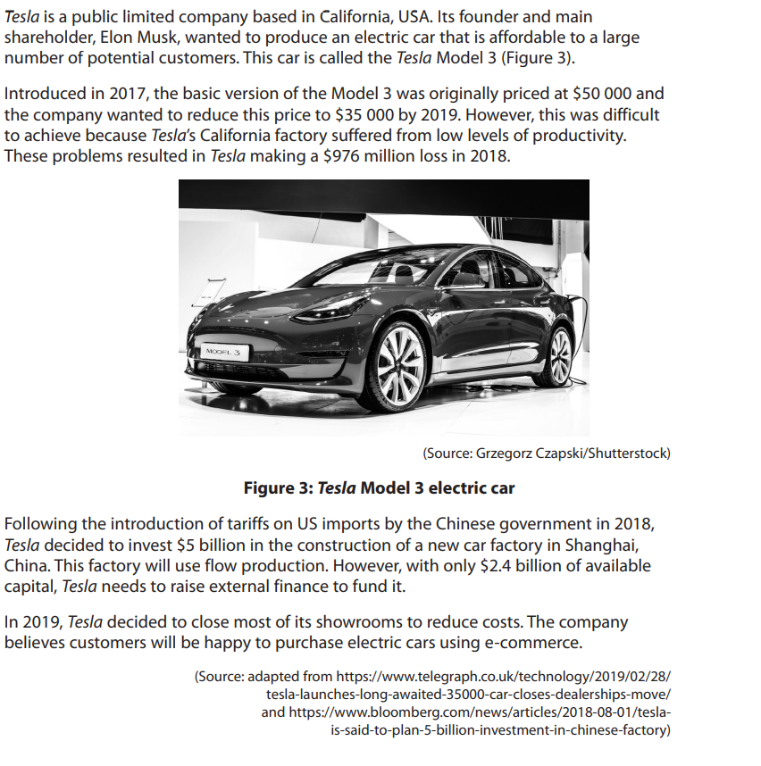
How this case study illustrates/exemplifies the specification content:
The case study illustrates ‘Globalisation and Business’ in a number of ways:

- Tesla is a multinational company because it has operations in a number of different countries. Tesla makes its cars in USA, Germany and China.
- The tariff imposed on US exports to China made Tesla cars more expensive to export to China. In order to improve competitiveness and avoid the tariff, Tesla set of its own factory in Shanghai. This meant Chinese buyers would not have to pay the tariff making the Tesla Model 3 more affordable.
- Tesla have adapted to compete internationally by closing its showrooms to focus on selling via Ecommerce. This means that customers can purchase a Tesla Model 3 online without having to visit a showroom. This is one strategy a business might take to trade globally.
- Tesla also moved production from California to China due to low levels of productivity. Globalisation means that some companies choose to manufacture their products in countries where labour costs are lower or they have better access to raw materials. The cost to pay workers in China is a lot cheaper than the USA.

Check your knowledge: questions
- Why might a business choose to operate in a different country?
- What opportunities does globalisation offer a small business?
- How might the removal of a tariff have a negative impact on a business?

Check your knowledge: recall question (previous unit)
- Why might a business change its objectives from profit maximisation to survival?
- What is a not financial objective?
- Why might a business choose to become a public limited company?

Opportunity, Threat or both?

For each of the scenarios below, explain whether you believe there to be an opportunity a threat or both for the business in question. Using your knowledge or business and globalisation ensure you explain why and the potential impact on the business.

Scenario | Opportunity, Threat or both?
Scenario 1
A rival of a large supermarket chain in the UK merges with a small UK supermarket and plans to open 15 new stores in the South over the next 3 years.
Scenario 2
A UK exporter of agricultural machinery finds out that a new trade deal between the UK and India has been agreed. There will be zero tariffs on imports and exports of heavy machinery between the UK and India.
Scenario 3
A small UK producers of gin sets up and launches a new Ecommerce website.
Scenario 4
Following the UKs decision to leave the European Union, a UK exporter of cheese seeks out new trading relationships with buyers in Eastern European countries including Armenia, Andorra and Turkey.

Common misconceptions

Who pays a tariff?

Some pupils get mixed up when discussing tariffs. A common mistake is that a tariff is paid by the exporter when in fact it is paid by an importer normally as a percentage of the price charged by the exporter. A tariff is placed on imports by the government and the money raised by the tariff goes to the government – it is not additional revenue for the exporter.

Topic Links

This topic is closely linked to some of the topics studied in 1.5.4 The Economy and Business and 1.5.5 External Influences. For example, factors such as incomes and unemployment might affect how attract an international market is for a business. Similarly, exchange rates will determine the cost of imports and the demand for an exporter’s products abroad. Although you will not directly be tested on these topics in your Theme 2 Paper, it is useful to explore these links when answering questions on business and globalisation.

Multiple choice questions
- Which of the would be the impact of an appreciation (rise) in the value of the pound?
- More expensive for importers
- Cheaper for importers
- Cheaper for exporters
- No change for importer or exporters
- What would be the impact on a UK importer of a tariff placed UK exports to the EU.
- The cost of imports would fall
- The cost of exports would fall
- The demand for UK exports would rise
- The cost of imports would not change

Exam Questions

- Explain one way a could change its marketing mix to compete internationally. (3)

- Outline one impact on Tesla of a tariff placed on US exports by China. (2)

- Analyse the impact on Tesla of a global price rise in the cost of oil. (6)

- Tesla are considering two options to increase the number of car sales in Europe.

- Open a new car factory in a European country.
- Launching an advertising campaign to target European buyers.

Justify which one of these options Tesla should choose. (9)

