GCSE Business
Theme 2.1.2 – Changes in Business Aims and Objectives
Booster Booklet
Specification
Subject content | What students need to learn:
Why business aims and objectives change as businesses evolve:  ● in response to: market conditions, technology, performance, legislation, internal reasons.  How business aims and objectives change as businesses evolve:  ● focus on survival or growth ● entering or exiting markets  ● growing or reducing the workforce  ● increasing or decreasing product range. | Topic 1.3.1 introduced aims and objectives for businesses starting up and as a business grows in size and evolves its objectives can change. Innocent drinks could be used as an example here. Initially the company had ethical considerations at its heart but as it has grown, Coca-Cola has taken an increasingly larger stake in the business and as a result the importance of some of the original objectives has declined. The growth of Aldi and Lidl at the expense of the traditional supermarkets is another example of how changing market conditions and entering of new markets can encourage a business to changes its objectives.

Key terms in this topics
- Market conditions – Can refer to a range of factors that determine how attractive a market is for a business including the level of competition, size and growth of the market and the pace of change.
- Business performance – How well a business achieves its aims and objectives such as profitability.
- Business survival – A businesses ability to cover its costs and keep trading.
- Entering a markets – Whereby a business starts to sell its products or services to a new group of customers or develops a new product or service aimed at a different target market.
- Product range – The number of variations of product line or range of services offered by a business.

Key terms – examples
In the space below, write examples to illustrate the key terms
Key term | Examples
Market conditions | The consumer technology market is very competitive with a range of popular brands such as Samsung, Panasonic and LG. The market is also very dynamic and fast-paced with companies innovating to develop new products to gain a competitive advantage. New product lines are released regularly, typically every six months.
Business performance | How well a business is able to achieve its objectives such as financial and non-financial objectives.
Business survival | Whereby a business is able to generate enough revenue to cover its costs and continue to operate.
Entering a market | In 2019 Land Rover launched its first electric vehicles, thereby entering the electrical vehicle market segment competing with other car manufacturers such as BMW and Nissan that operate in this segment.
Product range | In the past 20 years, McDonalds has increased its product range to include some healthier options such as smoothies and salads.

Summary of the topic

The business environment is dynamic and this means that business objectives are likely to change. Business objectives change as businesses grow. For example, a growing business may set targets to enter new markets, increase its product range and set higher revenue and profit targets.

However, businesses can face challenging circumstances such as rising costs, uncertainty in demand, changing customer needs and increased competition. Under these conditions a business might adopt its objectives to be less ambitious or focus on efficiency and costs reductions. In challenging circumstances, a business might set an objective to survive.

Case study: Iceland case study from June 2020 Paper 2 exam

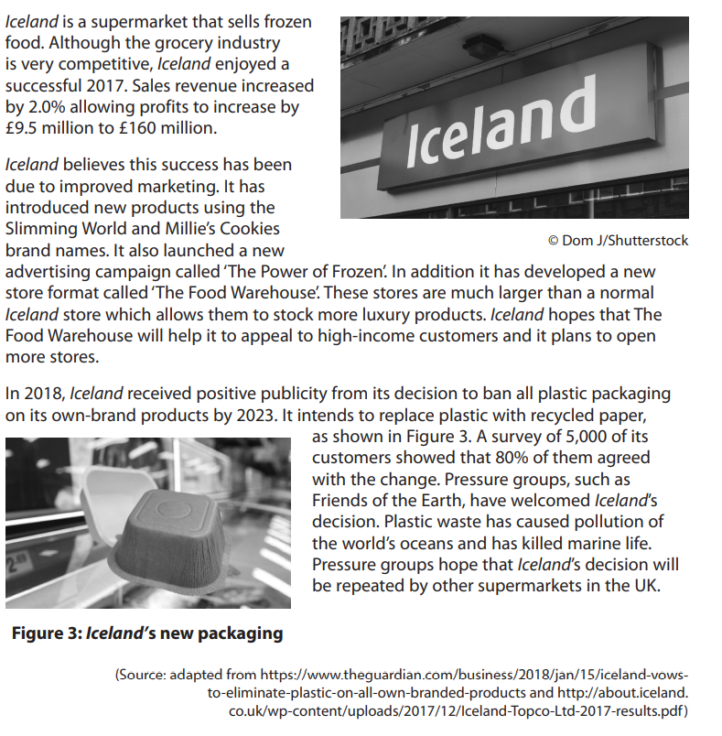

How this case study illustrates/exemplifies the specification content:
The case study illustrates ‘Changes in business aims and objectives’ in a number of ways:

- Iceland’s increased sales revenue of 2% leading to an increase in profits of £9.5 million demonstrates growth and could lead to the company increasing its financial objectives to achieve a higher revenue / profit.
- Introducing new product lines and entering new markets is a sign that Iceland is successful and a growing business. Iceland may not have set these objectives 5-10 years ago.
- Iceland may have responded to the lobbying of pressure groups such as Friend of The Earth to set more sustainable business objectives such as reducing the amount of plastic in their packaging.

Check your knowledge: questions
- How might business objectives change as a business grows?
- How might a business’s non-financial objectives change?
- How might a business’s objectives change in challenging market conditions?

Check your knowledge: recall question (previous unit)
- What is a public limited company?
- What is the difference between a takeover and a merger?
- Give an example of internal growth.

Adapting Objectives

For each of the two scenarios below, give examples of how each business’s objectives might be adjusted to fit the scenario. You should try to identify three objective changes. For example, you could consider how each firm may change its profit objectives.

 | Scenario 1 | Scenario 2
 | A business has experienced growing popularity of its products and market research has shown that customers value and respect its brand image. In the last year the firm has doubled its workforce and introduced several new product lines. | A business has experienced rising materials costs which have significantly reduced its profit margins. Furthermore, A rival firm has recently launched a product that they believe to be more advanced and competitively priced.
Change 1
Change 2
Change 3

Multiple choice questions
- Which of the following is an example of external growth?
- Retained profit
- Takeover
- New products
- Targeted a new demographic of customer
- Which of the following is a feature of a public limited company?
- Stock market flotation
- Unlimited liability
- A single business owner
- Private investment

Exam Questions

- Explain one way a growing business might change its objectives. (3)

- Outline one impact of increased competition for a business. (2)

- Analyse the impact on Iceland of the decision to ban all plastic packaging on its own-brand products by 2023. (6)

- Evaluate how Iceland’s new store format, the ‘Food Warehouse’ might affect its business objectives. (12).

