GCSE Business
Theme 1.5.2 – Technology and business
Booster Booklet
Specification

Subject content | What students need to learn:
1.5.2 Technology and business  Different types of technology used by business:  - E-commerce  - Social media  - Digital communications  - Payment systems  How technology influences business activity in terms of:  - Sales  - Costs  - Marketing mix | Students need to learn that technology changes rapidly and can have a huge impact on a business. It is important for businesses to keep up to date with changes in technology and the different ways it can be used. Technology can help a business be more efficient and can help meet customer needs.  Students also need to learn that technology can influence business activities in various ways. A business can use new technology to help meet customer needs and to generate increased sales. It can also have an impact on the costs of running a business and be used in all four areas of the marketing mix.

Key terms in this topic:
- E-commerce – the process of using the internet to carry out business transactions.
- Social media - communication among people in which they create, share, and/or exchange information and ideas in virtual communities and online platforms.
- Digital communications – communication between people using SMS (text messaging), email and online platforms.
- Payment systems – methods used to pay for products and services by businesses and its customers.
- Marketing mix – decisions made by a business to attract customers. A combination of decisions linked to price, product, place and promotion.
Key terms – examples
In the space below, write examples to illustrate the key terms

Key term | Examples
E-commerce
Social media
Digital communications
Payment systems
Marketing mix

Summary of the topic
Students do not need to specifically know about different types of social media or payment systems. However, students need to be aware of how developments in the area of technology might impact on sales, costs and the marketing mix of a business. For example, ‘social media’ (in broad terms) is cheap to set up and can be used to communicate with a wide range of stakeholders, including potential customers. For example, students will have
examples of how small businesses they know, such as a hairdresser, use social
media by having a Facebook page or a Twitter feed. These real-life examples can
be used to good effect.

In a similar way, payment systems can be examined in broad terms. The rise of e-commerce means customers increasingly pay online using credit/debit cards.
Contactless payment systems, such as with contactless credit/debit cards, Apple
Pay and Android Pay, are growing in popularity. These make life more convenient
for customers and so a business with such systems may have a competitive
advantage over one that does not. However, installing such systems incurs a cost
for the business.

Synoptic links to this topic
This topic links with the following areas of the specification:

- 1.1.1 The dynamic nature of business
- 1.4.2 Business location
- 1.4.3 The marketing mix
- 1.5.5 External influences

Technology has a major influence on business decisions and activities. New technology can be a key reason for entrepreneurs coming up with new business ideas. New technology allows products and services to be created that were previously not possible. The location of businesses can also be affected by online technology. If a business decides to sell its products using e-commerce then it may not need a retail premises.

Social media has had a large impact on the marketing mix of businesses. The wide use of devices such as smart phones now means that people can always be in contact with the internet. The growth of social media platforms have provided new methods for businesses to communicate with their customers.

Case study: Meringue Bakery

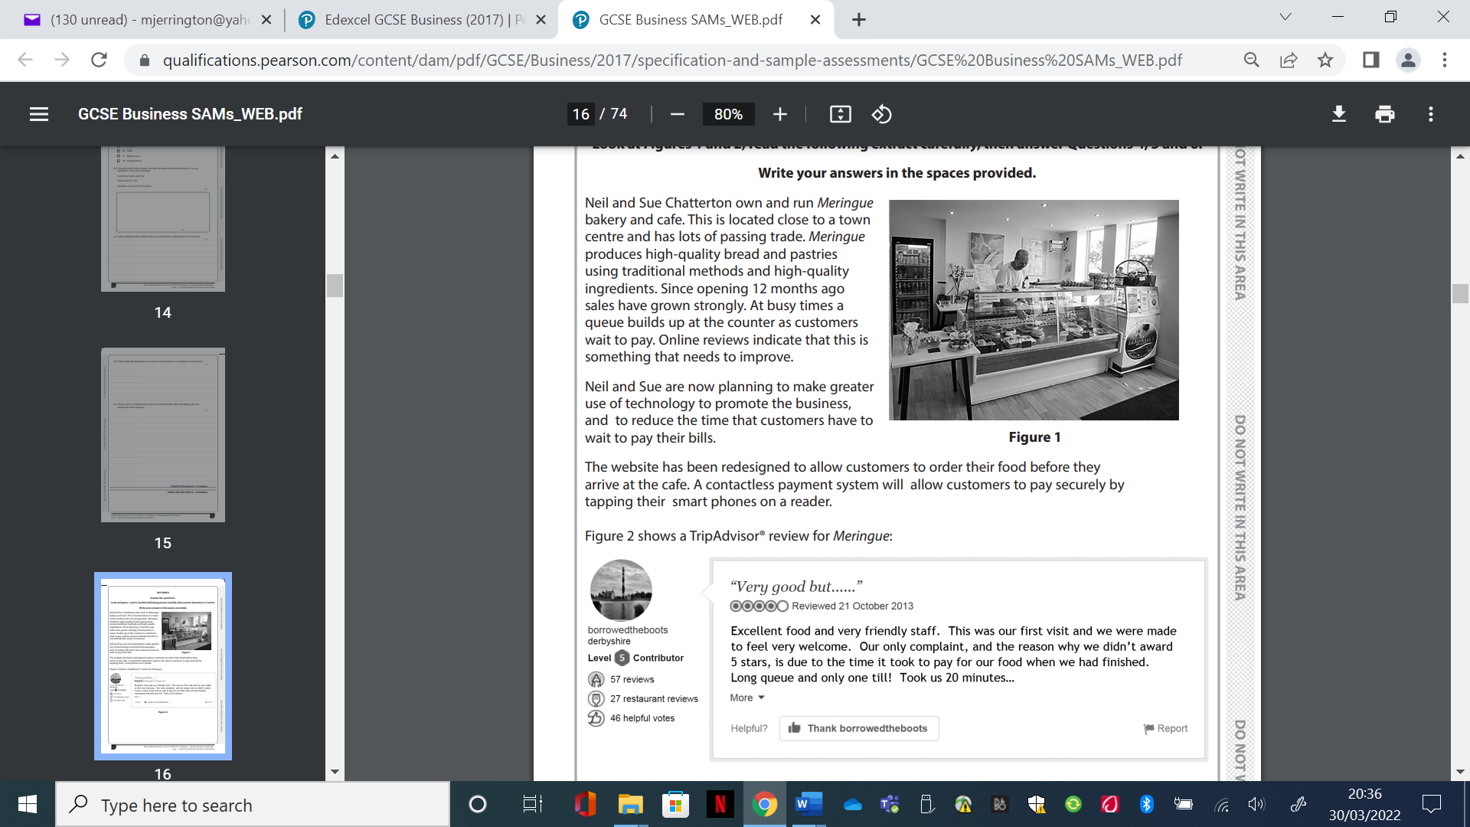
Source: https://qualifications.pearson.com/content/dam/pdf/GCSE/Business/2017/specification-and-sample-assessments/GCSE%20Business%20SAMs_WEB.pdf

How this case study illustrates/exemplifies the specification content:
The case study illustrates ‘technology and business’ in a number of ways:

- Meringue’s website has been redesigned to allow customers to order food in advance
- A contactless payment system will allow customers to pay for their food using smart phones.
- Social media is being used by customers to post reviews about the business.

Check your knowledge:

- State three different types of technology used by business.
- What affect will technology have on business costs?
- Give two ways that technology can influence the marketing mix.

Check your knowledge: recall question (previous unit)

- List five different business stakeholders.
- How can a pressure group influence business activity?
- Identify two stakeholders that might be in conflict over levels of pay in a business ?

Activity – now try this!
Complete the following table by deciding if each statement is either an advantage or a disadvantage of using e-commerce.

Advantages of using e-commerce | Disadvantage of using e-commerce

Statements
- Customers may be concerned about possible fraud and the security of their accounts
- It can be hard for a business to provide high levels of customer service
- It is more convenient for customers to place orders
- New technology can be expensive to install
- It allows a business to sell to more customers in different countries
- Customers can not see or fully inspect a product before they buy it
- It can reduce business costs as it may avoid opening a retail outlet
- It can make the ordering process easier for customers

What have you remembered so far?

Question | True | False
An email is a type of digital communication
Social media only allows customers to post positive comments
There are five elements to the marketing mix

Exam Questions

- Outline one reason why Meringue has allowed customers to order food on its website. [2 marks]

- Explain one way technology can affect the costs of a business. (3 marks)

- Analyse the impact on Meringue of using new technology for its payment systems. (6 marks)

- In order to promote its food products Meringue considered two options:

Option 1: use newspaper and magazine adverts

Option 2: use social media.

Which of these two options do you think would be most effective in increasing sales?

Justify your answer. (9 marks)

