GCSE Business
Theme 1.5.1 – Business stakeholders
Booster Booklet
Specification

Subject content | What students need to learn:
1.5.1 Business stakeholders  Who business stakeholders are and their different objectives:  - Shareholders (owners), employees, customers, managers, suppliers, local community, pressure groups, the government  Stakeholders and businesses:  - How stakeholders are affected by business activity  - How stakeholders impact business activity  - Possible conflicts between stakeholder groups | This is the first subject covered in Topic 1.5 – Understanding external influences on business. External influences are factors outside a business’s control. Students need to learn what these influences are and ways in which a business can respond to them. One of the external influences could be stakeholders. Students need to be able to identify who stakeholders are and that they have different objectives. These objectives can influence a business.  Students also need to learn how each stakeholder group can affect a business and how business activities can change as a result. The different objectives of stakeholders can create conflict in a business. Student should be able to identify the potential conflicts and identify ways to resolve any conflict.

Key terms in this topic:

- Stakeholder – anyone who has an interest in the activities of a business or could be affected by business activities.
- Shareholders – investors who have bought shares in a limited company and are part-owners of a company.
- Pressure groups – a group of people who join together to try and influence businesses or the government for a particular cause.
- Conflict – a serious disagreement between two or more different parties.

Key terms – examples
In the space below, write examples to illustrate the key terms

Key term | Examples
Stakeholder
Shareholders
Pressure groups
Conflict

Summary of the topic
Students need to understand the role of stakeholders in small businesses and how
they can impact on the business. Different stakeholders have different objectives
and these differences can give rise to conflict. Students could consider a business
and identify the different stakeholders. They could explore how objectives differ
and how this might give rise to conflict. It is possible to carry out this activity based
on the stakeholders of their school or college before considering a business.

Synoptic links to this topic
This topic links with the following areas of the specification:

- 1.2.1 Customer needs
- 1.3.1 Business aims and objectives
- 1.3.4 Sources of business finance
- 1.5.5 External influences

There is a wide range of different stakeholders, each with different needs and objectives. Meeting customer needs is vital in the success of a business, so customers will heavily influence the decision making of a business. Businesses will have financial and non-financial aims which will differ between businesses. The influence of different stakeholders can play a significant part in what the aims of a business are. Financial aims will be particularly important to limited companies who need to make profit to provide a return to investors. If a business has used share capital as a source of finance then the investors will expect decisions to be made that allow their investments to grow. Any decisions made by a business will be affected by external influences such as the economic climate and legislation, both of which are driven by government strategy.

Case study: KFC
KFC is considering building a new restaurant on playing fields opposite a large secondary school. The new restaurant will create 20 new jobs (part time and full time) and the senior management team of KFC know the new branch will keep the business on track with the growth plans of KFC in the UK. The Government will welcome a new branch due to new job opportunities and the prospect of receiving on employee incomes and business profits.

Market research shows that people in the local area are in support of the new development as it will create jobs and people will find it easier to buy their favourite chicken meals. However, there are some members of the local community that are not happy due to the loss of fields for people to play sports and to provide space for dog-walking. They have decided to form a pressure group aimed at preserving the playing fields and to encourage KFC to choose a different location for its new restaurant.

Source: Writer’s own words 29/03/2022

How this case study illustrates/exemplifies the specification content:
The case study illustrates ‘business stakeholders’ in a number of ways:

- KFC has a range of different stakeholders including customers, managers, the government and pressure groups.
- Stakeholders have different objectives. Some want the restaurant to open, whilst others are against it.
- There is possible conflict between stakeholders. Some members of the local community are happy because new jobs will be created but the pressure group are worried about the loss of the playing field.

Check your knowledge:

- State four different stakeholders in business.
- What is a pressure group?
- Give two reasons why the government may be affected by business activity.

Check your knowledge: recall question (previous unit)

- List three things that would be included in a business plan.
- How would a business plan help to minimise risk when starting a new business?
- Why might a bank be interested in seeing a business plan?

Activity – now try this!
Complete the following crossword using the clues provided.

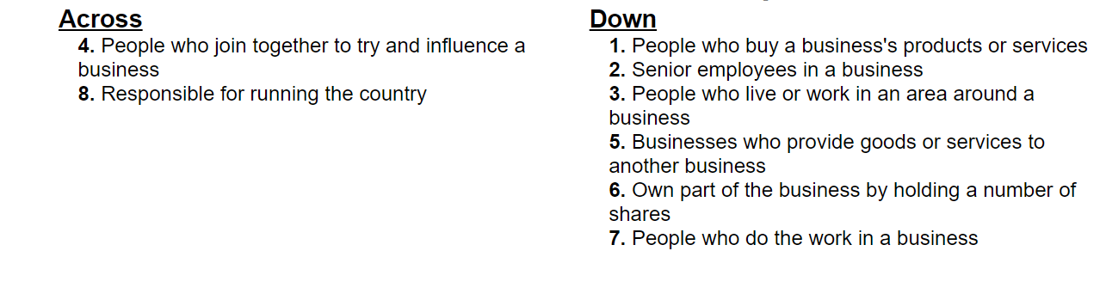
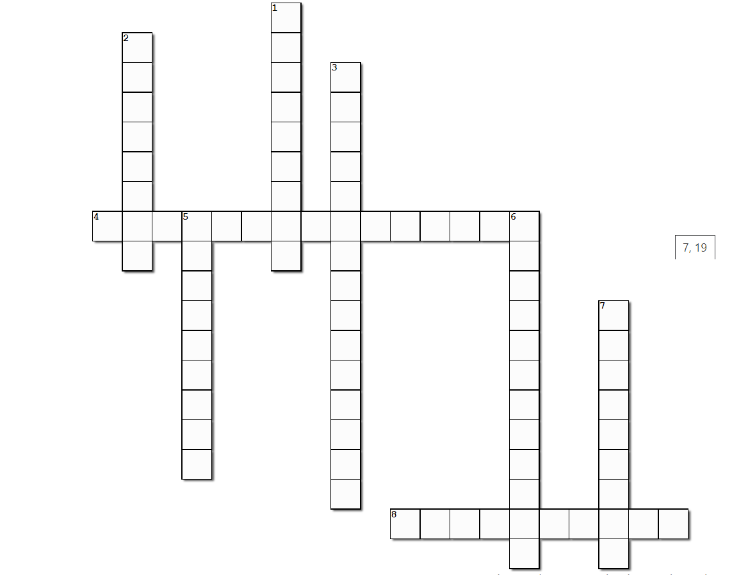

Command Word corner

The booklet at the start of each topic will focus on a command word that is used in the exam. This will provide students with information on how the word is used in the exam and what you can expect. It will offer you advice on how to structure your answer and what examiners are looking for when marking these questions.

The command word for Topic 1.5 is ‘Identify’.

‘Identify’ questions:

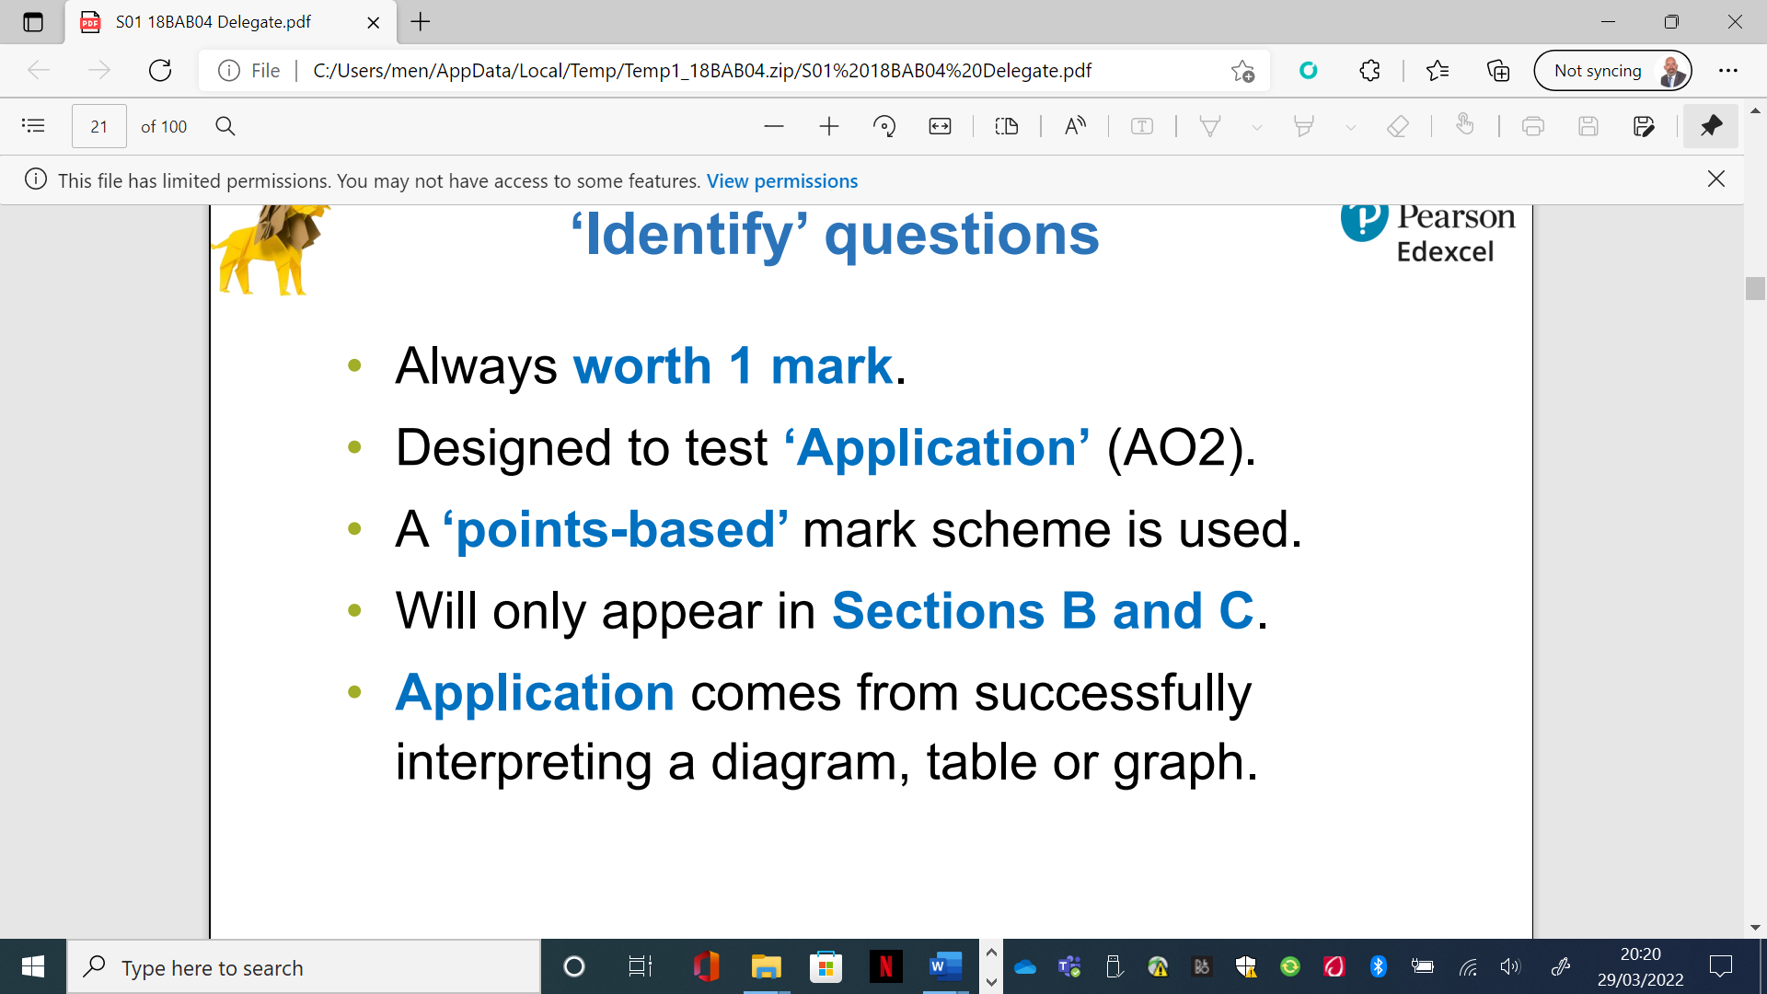
What have you remembered so far?

Question | True | False
A shareholder is a stakeholder of a limited company
Stakeholders are always in agreement with each other
Stakeholders are unable to influence business activity

Exam Questions

- State one stakeholder group of KFC (1 mark)

- Outline one way KFC could impact on the nearby secondary school [2 marks]

- Explain one possible stakeholder conflict that could exist between employees and owners of a business (3 marks)

- The owners of KFC have to choose one of the following two options in order to continue to grow the business and meet the business’s aims:

Option 1: Open the new branch opposite the secondary school

Option 2: Choose a different location for the branch

Justify which of the two options KFC should choose to achieve their aims.
(9 marks)

