GCSE Business
Theme 1.4.4 – Business plans
Booster Booklet
Specification
Subject content | What students need to learn:
1.4.4 Business plans  The role and importance of a business plan:  - to identify: the business idea; business aims and objectives; target market (market research); forecast revenue, cost and profit; cash-flow forecast; sources of finance; location; marketing mix.  The purpose of planning business activity:  - the role and importance of a business plan in minimising risk and obtaining finance. | This is the final booklet in Topic 1.4 – ‘Making the business effective’. This booklet examines the importance of business plans. It shows how it involves some of the aspects you have covered in this Topic.  Setting up a business is complex. It involves carrying out a range of activities and co-ordinating a number of resources. For this reason, it is important that entrepreneurs plan these activities before they start to set up a new business.  Students need to understand the different components of a business plan (see first bullet point – left). This booklet builds on these earlier topic areas. Market research, location decision, profit and cash-flow forecasts and marketing mix details are all contained within a business plan. In addition to ensuring the entrepreneur has thought about these aspects, the business plan is important if the business needs to obtain finance, for example through a bank loan.

Key terms in this topic:

- Bank loan – a fixed sum of money lent by a bank to an individual or a business for a specific purpose.
- Business plan – a document that outlines how an entrepreneur is going to set up a new business.
- Cash-flow – the amount of money coming in and going out of the business.
- SMART objectives – goals for a business that are Specific, Measurable, Achievable, Realistic and Time-bound.

Key terms – examples
In the space below, write examples to illustrate the key terms:

Key term | Examples
Bank loan
Business plan

Cash-flow

SMART objectives

Summary of the topic
You are not required to know the format of a business plan or produce a business plan. You will need to know the role and importance of a business plan, identify the elements it contains and its role in reducing risk for a small business. For example, by increasing the sources of finance available, a clear, well-detailed business plan may encourage a lender (such as a bank) to offer finance at a lower rate of interest. Alternatively, a venture capitalist may be persuaded to invest in the business due to the quality and detail of the plan.
The business plan will contain details of the aims and objectives of the business. This is an outline of what the business wants to achieve. These objectives should be SMART – Specific, Measurable, Achievable, Realistic and Time-bound – so that the entrepreneur can measure their success against these objectives.
Synoptic links to this topic
This sub-topic is also a useful revision tool for the topics already covered in Theme 1 as this includes the elements included within a business plan.
- 1.1.1 The business idea
- 1.2.2 Market research
- 1.3.1 Business aims and objectives
- 1.3.2 Business revenues, costs and profits
- 1.3.3 Cash and cash-flow
- 1.3.4 Sources of finance
- 1.4.2 Business location
- 1.4.3 Marketing mix

You should be able to recognise that business planning is based on a wide range of areas. You have covered many of these in this Theme.

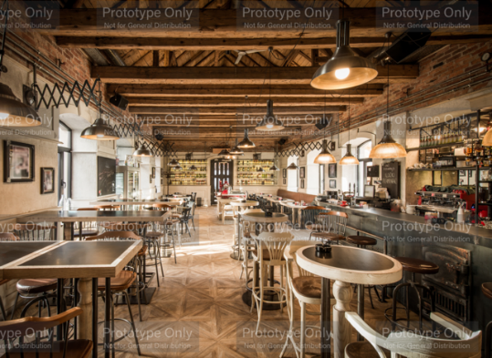
Case study: Chez Liz Resto Bar

Chez Liz Resto Bar opened in Cornwall, Canada, in 2016. It is owned by husband and wife team Lizanne and Gilles, and the running of the business is supported by their two sons, Derik and Janik. The restaurant seats 97 people, with seating both inside and at an outside patio area. It took several months to renovate the premises before opening to customers.

To help fund the renovation, Lizanne and Gilles borrowed from their bank through a business loan. To allow this loan, the they had to produce a business plan and show this to their bank manager. She was keen to see that the plans for the business were clear so that Lizanne and Gilles would be able to repay the loan. Their business plan included cash-flow forecasts, details of the marketing mix and information on the market research that had been carried out. The bank wanted to know that the business would be profitable so that it would be able to repay the loan.

Source: Adapted from Edexcel GCSE textbook p105
How this case study illustrates/exemplifies the specification content:
The case study illustrates ‘Business plans’ in a number of ways:
- The business premises for Chez Liz Resto Bar have been renovated. This has involved the owners – Lizanne and Gilles – spending their own money as well as borrowing money from their bank.
- Lizanne and Gilles have produced a business plan. This is a document that outlines how they are going to set up and run the business.
- The bank will require a detailed business plan before they decide whether to lend the funds to Lizanne and Gilles. However, the business plan is also useful in itself, to allow Lizanne and Gilles to ensure they have done everything they can to ensure the business is a success.
- The business plan contains some key information, such as cash-flow forecasts, details of the marketing mix and information on the market research carried out.
- A business plan is a way of reducing risk for a business.

Check your knowledge:

- Give 3 examples of information that should be included in a business plan.
- How might producing a business plan reduce the risk for an entrepreneur starting a new business?
- Why would a bank be interested in a cash-flow forecast for a new business?

Check your knowledge: recall question (previous unit):

- What are the 4 elements of the marketing mix?
- Suggest two ways that the development of digital communication might impact on the marketing mix of a business?
- Give one disadvantage to a business of only focusing on one element of the marketing mix.

Activity - now try this…

For each of the businesses below, write an example of a SMART objective.

Business | SMART objective
A market trader selling fruit and vegetables at the weekend.

A children’s nursey offering pre-school care in your local area.

A chain of three fish and chop shops in the North East.

A manufacturer of ladies clothing selling to a high street fashion chain.
Lizanne and Gilles opening Chez Liz Resto Bar.

Common misconceptions

- It is a misconception to think that there is a set format and design of a business plan. This is not true. In this qualification you will not be required have knowledge of the format of business plans.
- Although a business plan is an important document and something it is sensible for an entrepreneur to produce, it is not a statutory document. It is not illegal if a business does not have a business plan.

What have you remembered so far?

Question | True | False
A business plan contains financial information, such as cash-flow and profit forecasts.
A bank will require a business plan to help decide whether to lend money to a business.
A business plan is a legal document and business owner must produce one.
Exam Questions

- Multiple choice

Which one of the following will be included in a business plan? (1 mark)

Select one answer

A Details of market research
B Photographs of staff members
C Staff names and addresses
D Venture capital

- Explain one reason why it is important to include financial information in a business plan. (3 marks)

- Outline one way a business plan could help Lizanne and Gilles when opening Chez Liz Resto Bar. (2 marks)

- Analyse the impact on the owners of Chez Liz Resto Bar of having a detailed business plan. (6 marks)

