GCSE Business
Theme 1.4.3 – The marketing mix

Booster Booklet
Specification
Subject content | What students need to learn:
- The marketing mix  What the marketing mix is and the importance of each element:  - price, product, promotion, place  How the elements of the marketing mix work together:  - balancing the marketing mix based on the competitive environment  - the impact of changing consumer needs on the marketing mix  - the impact of technology on the marketing mix: e-commerce; digital communication. | This is the third booklet in Topic 1.4 – ‘Making the business effective’. This booklet introduces the marketing mix – the combination of four factors that businesses need to consider if they are to be a success. The four factors are price, product, promotion and place. They are referred to as the ‘4Ps’.  Students need to understand the different components of the marketing mix and how they work together. For example, .  Consumer needs change over time and a business may need to change aspects of its marketing mix to reflect these changes. For example, many fast food providers now offer food using delivery services such as Deliveroo or Just Eat. The ‘place’ aspect of the marketing mix has changed as customers require more convenience.

Key terms in this topic:

- Digital communication – any form of communication from a business that is carried out using email, social media or text message.
- Marketing mix – using the internet to carry out business transactions.
- Price – the amount a customer needs to pay to receive the product.
- Product – the actual good or service that the business is offering for sale.
- Promotion – the range of activities a business uses to make customers aware of its products and to encourage customers to buy them.
- Place – where a customer can buy the product a business sells. This could be online, in a store, from a vending machine and so on.

Key terms – examples
In the space below, write examples to illustrate the key terms:

Key term | Examples
e-commerce
Labour

Proximity

Summary of the topic
The nature of the business will influence the location decision and you need to consider the implications of the proximity to market, labour, materials and competitors on business location decisions. For example, a plumbing business may choose to locate close to an area with a high population to be close to its market. Consideration also needs to be given to how e-commerce might affect location decisions and whether fixed premises are even needed. Increasingly, through the internet, it is easier to set up and run a business as the physical location is less important than the product being offered.

Synoptic links to this topic

This topic links with the following areas of the specification:

- 1.1.1 The dynamic nature of business
- 1.1.2 Risk and reward
- 1.1.3 The role of business enterprise
- 1.2.1 Customer needs
- 1.2.4 The competitive environment
- 1.3.2 Business revenues, costs and profits
- 1.3.3 Cash and cash-flow

Although this is quite a short topic, it actually has direct links with many areas of the specification. Location decisions are based partly on customer needs and on the nature of competition in a market. If the market is very competitive, a business may need to. Strive to keep down costs to ensure cash-flow is strong. The business may choose not to have fixed premises and opt for an e-commerce approach as a way of keeping down costs.

The following case study provides an example of how Frog Bikes uses the marketing mix.

Case study: Frog Bikes

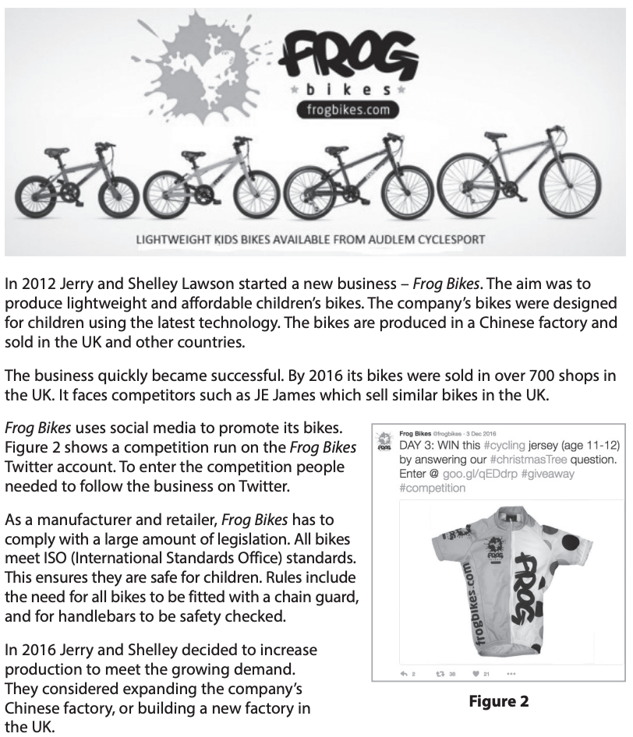

Source: Extra Assessment Material – Set 1 (Section B)

How this case study illustrates/exemplifies the specification content:
The case study illustrates ‘the marketing mix’ in a number of ways:
- Some elements of the marketing mix can be clearly seen in the case study
- Product - the business produces a certain type of product – children’s bicycles.
- Promotion – Frog Bikes promotes its products in a number of ways, including through social media. Figure 2 in the case study shows a social media post where a prize can be won. This is designed to promote Frog Bikes and its products.
- Place – the case study points out that Frog Bikes sells its bicycles in over ‘700 shops in the UK’. This is how the business gets its product to customers.
- Customers who buy children’s bicycles are interested in the safety features of these products. Frog Bikes has addressed these consumer needs by introducing additional safety features in its bicycles.
- The case study also shows the impact on technology on the marketing mix. Frog Bikes use e-commerce and the social media as part of its marketing mix.

Check your knowledge:

- What factors will influence the price that Frog Bikes charges for its bicycles?
- State one advantage and one disadvantage of using social media to promote a product.
- Identify 4 methods of promotion that a business can use.

Check your knowledge: recall question (previous unit):

- What is meant by e-commerce?
- Why might an entrepreneur decide to fixed premises rather than e-commerce when setting up a business.
- Give an advantage and a disadvantage for a business of choosing a location close to lots of competitors.

Now try this

In the table below are a number of statements about a business decision. For each statement, identify whether this relates to the Price, Product, Promotion or Place element of the marketing mix:

 | Price | Product | Promotion | Place
A business launches an updated version of an existing product.
A soft drink manufacturer decides to sell a drink through vending machines.
A clothing manufacturer sponsors a top football team.
A local pizza restaurant decides to charge the same for a pizza as a local competitor.
Frog Bikes opens a store which sells its own bicycles.
A local café creates an advertising leaflet and posts this to local houses.
A cinema offers ‘buy one get one free’ tickets between 15.00-17.00 during weekdays.

What have you remembered so far?

Question | True | False
To be successful, all businesses will have the same type of marketing mix.
Promotion is more important than Price for most businesses.
Social media can help a business to reduce the cost of promotion.

Exam Questions

- Multiple choice

Which one of the following is the range of activities a business uses to make customers aware of its products and to encourage customers to buy them? (1 mark)

Select one answer

A Place
B Price
C Product
D Promotion

- Explain one benefit to a business of using digital communication as a way of informing customers about its products. (3 marks)

- State one advantage to a business of charging a lower price than competitors. (1 mark)

- Outline one way that Frog Bikes responds to changing consumer needs. (2 marks)

- Analyse the impact on a business having a balanced marketing mix. (6 marks)

