GCSE Business
Theme 1.3.3 – Cash and Cash-flow
Booster Booklet
Specification
Subject content | What students need to learn:
1.3.3 Cash and cash-flow  The importance of cash to a business:  ● to pay suppliers, overheads and employees  ● to prevent business failure (insolvency)  ● the difference between cash and profit.  Calculation and interpretation of cash-flow forecasts:  ● cash inflows  ● cash outflows  ● net cash flow  ● opening and closing balances. | Students need to understand the important role cash and cash-flow play in the effective running and survival of a business. In this topic students are introduced to the important concept of liquidity and the approaches a business might take to ensure it is able to pay its short-term costs such as purchasing stock and paying bills.  Students are introduced to the financial planning tool of cash –flow management and need to understand how a cash-flow forecast is calculated.

Key terms in this topics
- Cash – funds available to a business to pay short-term running costs.
- Insolvency – Where a business is unable to pay its running costs
- Cash inflows – any flow of cash into a business
- Cash outflows – any flow of cash out of a business
- Cash-flow forecast – a table used to calculate the cash position of a business over time.
- Net cash flow – the difference in a given time period between cash inflows and cash outflows
- Opening balance – A business’s cash balance carried forward into the next period (e.g. next month)
- Closing balance – the difference between a business’s net cash flow and opening balance.
Key terms – examples
In the space below, write examples to illustrate the key terms
Key term | Examples
Cash
Insolvency
Cash inflows
Cash outflows
Net cash flow, opening balance and closing balance.

Summary of the topic

Cash is extremely important factor in the successful running of a business and avoiding insolvency. A business might be able to make a profit if it can produce a product at a cost and then sell it at a higher price. However, most businesses have to make significant investments and expenditure before they receive a steady stream of revenue from sales. This is the point where a business may become insolvent

Effective cash-flow forecasting can help a business understand when it might experience cash-flow problems. It can then attempt to manage its expenses and maximise cash inflows to ensure the business is solvent.

Case study: Dress to Impress

Insert here stock photo of “florst” to support student understanding

Sophie is the owner of Dress to Impress. Her store sells a wide variety of party essentials and premium fancy dress costumes. Her business is well-established and makes a healthy annual profit that Sophie can live off. However, Dress to Impress is very seasonal with sales fluctuating throughout the year. Her busiest months are October, when people buy costumes for Halloween, and New Year, another popular time for people to hold fancy dress parties.

Sophie has had cash-flow problems in the past and now uses a cash-flow forecast to plan her finances. Sophie has gradually grown her stock of fancy dress clothing since she opened her store in 2017 and recently has begun renting a small container to hold some of the items she cannot fit into her store. Sophie owns the majority of the clothes but some of the most expensive items she rents from a third-party so her customers can rent the items. Sophie also keeps a large stock of party essentials such as balloons and decorations so that she can always meet demand in the busy months.

How this case study illustrates/exemplifies the specification content:
The case study illustrates ‘cash and cash-flow forecasting’ in a number of ways:

- Sophie runs a seasonal business. Seasonal businesses may find it more challenging to manage cash flow as they will not have a regular in flow of cash.
- Sophie holds a large stock of party essentials – this may ‘tie up’ cash that could be used to help her pay running costs.
- Sophie also rents some of her clothing. This could be another way for her to keep cash outflow low as she will only rent the items when there is demand for them.

Check your knowledge: questions
- What is insolvency?
- How is net cash flow calculated?
- Why would a business use a cash-flow forecast?
- How is the closing balance calculated?

Check your knowledge: recall question (previous unit)
- How is break-even calculated?
- How is break even measured?
- What are the three lines represented on a break-even chart?

Fill in the Gaps

Fill in the gaps to complete the calculation of a cash-flow forecast.

-
Closing balance
=
+
=

Now try this

Using the following information complete the cash-flow forecast below.

- Stock purchased: £15 000 in January, £5 000 in February, March and April
- Rent: £1 500 per month
- Bank loan: £10 000 paid into bank account in March
- Wages: £6 500 per month
- Distribution costs: £2 000 in January, £1 600 in February, £1 800 in March, £400 in April.

 | January | February | March | April
Receipts | (£) | (£) | (£) | (£)
Sales | 17 000 | 12 000 | 15 000 | 6 000
Total receipts
Expenditure
Total Expenditure
Net cash flow
Opening balance | 5 000
Closing balance
Multiple choice question
- Which of the following would not feature on a cash-flow forecast?

Select one answer.

- Net cash flow
- Opening balance
- Profit
- Closing balance

Common misconceptions

Cash does not necessarily mean cash!

The concept of cash refers to any money that is readily available to purchase materials, equipment and stock and pay the running costs of a business. This can include actual cash (such as the notes and coins) or money held in a bank.

Cash is not profit

Cash is the available money a business holds at a given time to make pay for business costs. On the other hand, profit is the difference between total costs and total revenue which is calculated over a period of time. A business can be profitable but lack adequate cash-flow.

Exam Questions

Sophie has produced a cash-flow forecast for Dress to Impress between September and November.

- Calculate the missing values in the cash-flow forecast below. (3 marks)

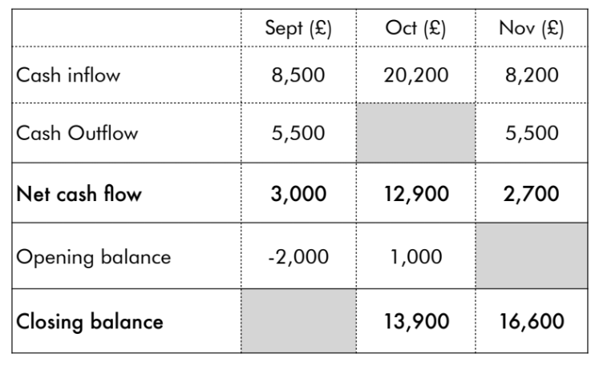

- Outline one way that Sophie could improve cash flow of Dress to Impress (2 marks)

- Analyse the importance of cash-flow forecasting for Dress to Impress. (6 marks)

