GCSE Business
Theme 1.3.2 – Business revenues, costs and profit (Part B)
Booster Booklet
Specification
Subject content | What students need to learn:
1.3.2 Business revenues, costs and profits  The concept and calculation of:  - Break even level of output  - Margin of safety  Interpretation of break-even diagrams:  ● the impact of changes in revenue and costs  ● break even level of output  ● margin of safety  ● profit and loss. | Students need to understand how the importance of break even analysis for a business, how it is calculated and how to interpret break even charts.  Students will also need to understand the concept of break even is central to determining a business’s ability to make a profit (or loss)  This second part of topic 1.3.2 builds on Part A and the important concepts of fixed and variable costs, revenue and profit.

Key terms in this topics
- Break even – a point where a business is able to cover its total costs – the business makes neither a profit or a loss.
- Break even level of output – Fixed costs / price – variable cost per unit. The quantity of products a business needs to produce and sell in order to break even.
- Margin of safety – The difference in the level of output (or sales) and the break even point.

Key terms – examples
In the space below, write examples to illustrate the key terms
Key term | Examples
Break even
Break even level of output
Margin of safety

Summary of the topic
Break even is an important business concept and the heart of successful financial management. The concept of break even brings together several key calculations to produce a model that can be used to make important business decisions. In your exams you may be asked to calculate break even, interpret break even charts or infer how business decisions could impact the break even level of output.

Break even analysis allows entrepreneurs to ask and answer important ‘what if?’ questions. For example, what would happen if we could lower our variable costs by £2 or what if we could sell an extra 100 units? Break even is closely linked to the study of business operations and Topic 2.3 Making Operational Decisions.

Case study: Katy Beckett Florists

Insert here stock photo of “florst” to support student understanding

Katy Beckett is a self-named premium florists based in Chesterfield. In the space of three years, Katy has grown her brand to become a thriving local business. The success of Katy Becketts comes from the rare and exotic flowers sold in the shop and the eye-catching store front that stands out on the local high street. Following the success of the Chesterfield branch, Katy decided to open a second shop in the nearby town of Matlock.

In April the Chesterfield shop sold 300 bouquets of flowers. The average price of each bouquet was £55. Total fixed costs were £6 000 and total variable costs were £9 000.

How this case study illustrates/exemplifies the specification content:
The case study illustrates ‘costs, revenue and profit’ in a number of ways:
- Key financial information has been shared in the case study to illustrate various costs and prices. Financial information in a case study can be presented in various ways formats, such as tables, graphs or in the text itself. It is important to interpret and understand the information you are being presented with and what key financial information can be calculated from it.
- When presented with financial information it helps to write down the key formulas for cost, revenue and profit. You can then pull from the case study the important information that you need. For example, writing down the formula for break even (fixed costs / price – variable costs per unit) and then exchanging the values from the case study of question into this formula.
Check your knowledge: questions
- How is break even calculated?
- How is break even measured?
- What are the three lines represented on a break even chart?

Check your knowledge: recall question (previous unit)
- Give two examples of a fixed cost for a business.
- What will be the outcome if a business’s total costs exceed total revenue?
- What is the different between revenue and profit?
Now try this

Katy Beckett currently runs two flower shops. One in Chesterfield and a second in Matlock. Katy is concerned that the Matlock shop is not making as much profit as she had hoped and has decided to investigate the finances of each shop using break even analysis. Produce a break even chart for the Chesterfield and Matlock shops using the financial information provided (the total revenue line has already been added for the Chesterfield shop).
- Using the break even formula, calculate the break even point for each shop
- For each break even chart add and label total fixed costs, total costs and total revenue
- On each chart identify and label the break-even point
- On each chart identify the margin of safety.

Financial Information | Chesterfield Shop | Matlock Shop
Total fixed costs | £4000 | £6000
Average sales per customer | £40 | £50
Average variable cost per customer purchase | £24 | £30
Sales per month | 425 | 340

Monthly break-even chart: Katy Becketts (Chesterfield)
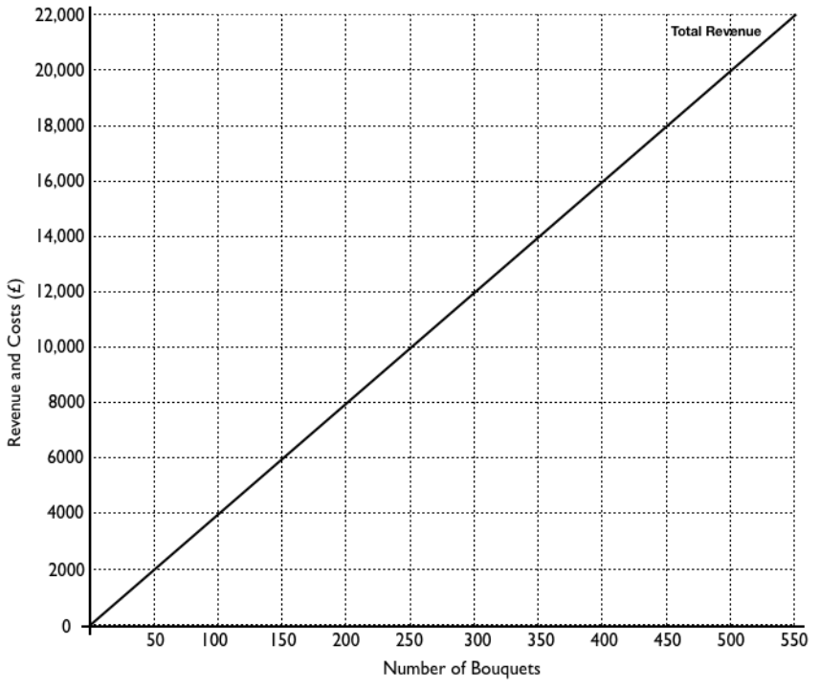

Monthly break-even chart: Katy Becketts (Matlock)

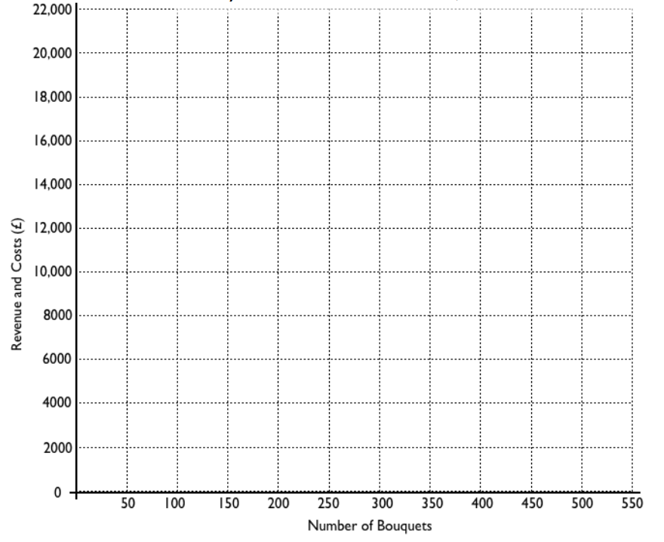

Extension question: Which of the two shops is the most profitable?

Common misconceptions

Reading break-even charts

There are two points on a break even chart where lines cross. Break even is the point where total revenue intersects total costs. Total revenue also intersects fixed costs but this is not the break even point.

Variable costs (per unit)

The calculation for break even level of output is: fixed costs / price – variable costs per unit. A common mistake made by students is to use total variable costs in this calculation instead of variable costs per unit (for one).

Synoptic links to this topic

You will this topic links with the following areas of the specification:

- 2.2.2 Price
- 2.3.1 Business operations

In topic 2.2.2 you will learn about price and pricing strategies. Any pricing decisions by a business will directly affect the break even level of output. In topic 2.3.1 you will learn about production methods. Different production methods will influence the costs and output of a firm, again, this is key to breaking even and maximising profit.

Exam Questions

- Calculate break even for the Chesterfield shop in April. (2 marks)

- Calculate the margin of safety for the Chesterfield shop in April (2 marks)

- Explain one way that a business might lower its break even point. (3 marks)

