GCSE Business
Theme 1.3.2 – Business revenues, costs and profit (Part A)
Booster Booklet
Specification
Subject content | What students need to learn:
1.3.2 Business revenues, costs and profits  The concept and calculation of:  ● revenue  ● fixed and variable costs  ● total costs  ● profit and loss  ● interest | Students need to understand how key financial information is calculated for a business. This includes how business costs can be categorised and calculated.  Students will also need to understand how revenue and profit is calculated and the key distinctions between these two important concepts.

Key terms in this topics
- Fixed costs – Costs that do not change in the short-term with the level of output. Fixed costs are also called running costs (overheads) that have to be paid.
- Variable costs – Variable costs change and are linked to the level of output.
- Total costs – Total fixed costs + total variable costs
- Revenue – Price x quantity sold (the income generated by a business when selling its products and services)
- Profit Total revenue – total costs (profit is one reward for successfully running a business)
- Interest – a charge (%) on loaned (borrowed) money or the return paid on savings.

Key terms – examples
In the space below, write examples to illustrate the key terms
Key term | Examples
Fixed costs
Variable costs
Total costs
Revenue
Profit

Summary of the topic

These calculations are the foundations all of business activity. Students are not only required to be able to calculate and understand these calculations, but over the course of study, be able to analyse the factors that impact on a business’s ability to manage its costs and maximise revenue in order to achieve its profit objective. All aspects of Theme 1 and Theme 2 can be linked back to costs, revenue and profit.

Case study: Katy Beckett Florists

Insert here stock photo of “florst” to support student understanding

Katy Beckett is a self-named premium florists based in Chesterfield. In the space of three years, Katy has grown her brand to become a thriving local business. The success of Katy Becketts comes from the rare and exotic flowers sold in the shop and the eye-catching store front that stands out on the local high street.

Katy has reviewed the pricing of her bouquet of flowers and has decided to make a number of changes to the designs, which will have a knock-on effect to the costs and pricing. Katy offers customers three standard size of bouquet. In March, the Chesterfield store sold 150 small bouquets, 120 medium bouquets and 60 large bouquets.

Bouquet | Variable cost per bouquet | Selling price
Small | £15 | £30
Medium | £22 | £45
Large | £34 | £62

Following the success of the Chesterfield branch, Katy decided to open a second shop in the nearby town of Matlock.

Figure 1 shows the total costs and revenue from July to September for the second shop in Matlock.

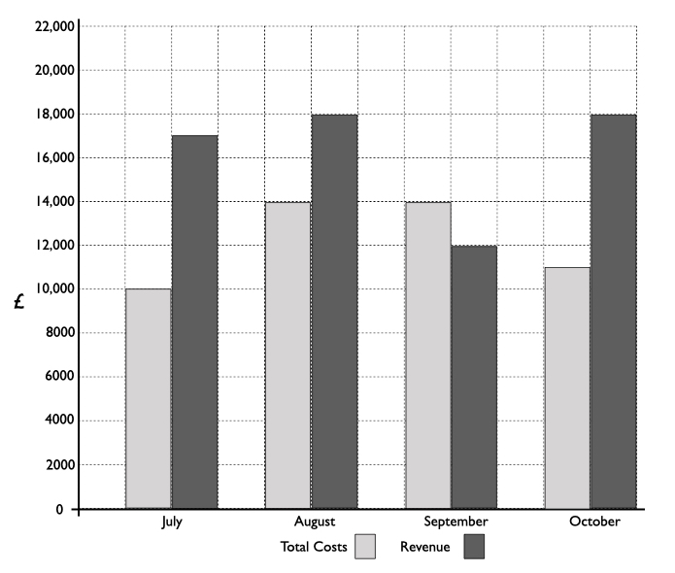

Figure 1. Katy Beckett’s (Matlock) total costs and revenue
How this case study illustrates/exemplifies the specification content:
The case study illustrates ‘costs, revenue and profit’ in a number of ways:

- Key financial information has been shared in the case study to illustrate various costs and prices. Financial information in a case study can be presented in various ways formats, such as tables, graphs or in the text itself. It is important to interpret and understand the information you are being presented with and what key financial information can be calculated from it.
- When presented with financial information it helps to write down the key formulas for cost, revenue and profit. You can then pull from the case study the important information that you need. Sometimes there may be financial information that is not necessary (a distractor) from the calculation you need to complete.

Check your knowledge: questions
- What is the difference between a variable cost and a fixed cost?
- Give two examples of variable costs for a business
- How is revenue calculated?
- How is profit calculated?

Check your knowledge: recall question (previous unit)
- What is an example of a financial objective?
- Why are business aims and objective important?
- What is a social objective?

Now try this
Looking at the table of business costs below. Categorise each cost into fixed or variable.
Cost | Fixed? | Variable?
Business insurance
Raw materials
Distribution
Salaries of managers
Packaging
Utility bills
Advertising
Rent
Wages
Multiple choice questions
From the Katy Beckett’s (Matlock branch) Costs and Revenue chart, which of the following is true?
- Revenue fell between July and October
- The most profitable month was October
- The least profitable month was September
- The business did not make a profit in August

Common misconceptions

Total cost or per unit?

There are several common mistakes students make when calculating costs.
- When calculating total costs, students sometimes forget to multiply variable costs per unit by total output and therefore only add the variable costs for one unit to fixed costs.
- Students sometimes confuse fixed and variable costs and multiply total fixed costs by total output. The business will only have to pay total fixed costs once!
- When calculating total costs, student sometimes multiply fixed costs and variable costs instead of adding them together.

Revenue is not profit, profit is not revenue

Students often mix up these two very important, but different, concepts. For example, a student might make the assessment that if a business increases its prices it will make more profit. This might eventually be true, but in the first instance, an increase in price may increase revenue if demand remains stable. Revenue comes before profit, but a business can generate large revenues without making a profit if total costs is greater than revenue.

Multiple choice questions
From the Katy Beckett’s (Matlock branch) Costs and Revenue chart, which of the following is true?

A Revenue fell between July and October
B The most profitable month was October
C The least profitable month was September
D The business did not make a profit in August

Exam Questions

- Calculate the total revenue from bouquets for the Chesterfield shop in March. (2 marks)

- Total fixed costs for the Chesterfield shop in March were £3,900. Calculate total costs for the Chesterfield shop in March. (2 marks)

- Using the information in Figure 1, calculate the profit made by the Matlock branch between July and October. (2 marks)

- Katy agreed to take out a £3,000 loan with an interest rate of 12%. If Katy repays the loan three months early the total cost of interest will be £200. Calculate the savings Katy will make should she repay the loan early instead of incurring the full rate of interest. (2 marks)

