GCSE Business
Theme 1.2.3 – Market segmentation
Booster Booklet
Specification

Subject content | What students need to learn:
- Market segmentation  How businesses use market segmentation to target customers:  - Identifying market segments: location, demographics, lifestyle, income, age  - Market mapping to identify a gap in the market and the competition. | Students need to understand that a business will want to target specific customers. Rather than trying to sell its products or services to everyone, the business may try just to sell to certain groups of customers. Students will need to learn that a market can be divided into segments which can be identified by location, demographics, lifestyle, income and age.  Students also need to learn that market mapping can be used to identify a gap in the market. This could be used to identify a group of customers whose needs are not being met by competitors.

Key terms in this topic:

- Segmentation – the process if breaking something up into smaller parts.
- Demographics – information and statistics that relate to the structure of the population.
- Lifestyle – the way in which customers live their lives, including the things they lie to do in their spare time.
- Market map – the process of creating a diagram that maps all of the products in a market against two common features, for example price and quality.

Key terms – examples
In the space below, write examples to illustrate the key terms

Key term | Examples
Segmentation
Demographics
Lifestyle
Market map

Summary of the topic
Market segmentation is the division of a market into customer groups, each of
which has distinct preferences. Markets can be segmented by location,
demographics, lifestyle, income and age. Businesses provide products that are
often aimed at particular market segments. Students could visit local small
businesses to explore the extent to which their products and/or services are aimed
at particular market segments.

Market mapping refers to evaluating business ideas, goods and/or services by
setting out the features of the market, product or service on a diagram. A market
map is used to identify key features of a market to consider the extent to which
gaps exist in the market. The map comprises two axes with each representing two
features. Examples of features that can be used to produce a market map are:
price (high/low), quality (high/low), range of products (small/extensive) and
number of outlets (one/numerous). Students could produce their own market maps
based on different business types in the local area.

Synoptic links to this topic

This topic links with the following areas of the specification:

- 1.2.2 Market research
- 1.2.4 The competitive environment
- 1.4.3 The marketing mix

A business will carry out market research to identify its potential customers. A business may then decide to target specific groups of customers because it may feel its products and services are more relevant to their customer needs.

When doing this it is important to understand the competitive environment to help spot a gap in the market. This could help the business understand the strengths and weaknesses of the competition to help make marketing decisions linked to the marketing mix.

Case study:
Sally is a fitness instructor at a local sports centre. She is now considering setting up her own business as a personal trainer. Sally’s research shows that people are more interested in health and fitness. Sally has conducted some research into who her main competitors will be and has found out there are a number of gyms in the local area, but there are not many personal trainers.

Sally will charge £25 per hour. She is flexible in terms of the location of her customers and will travel within a 10-mile radius. She hopes to attract a younger market segment by using social media and online promotion. She aims to differentiate her service in a number of ways:
• Using social media to communicate directly with her customers, offering daily motivational reminders.
• Filming parts of the customer’s training session and posting it online for them to evaluate their performance on their own device.
Source: Business Paper 1: Investigating small business. Sample assessment material for first teaching September 2017

How this case study illustrates/exemplifies the specification content:
The case study illustrates ‘market segmentation’ in a number of ways:

- Sally has segmented the market by lifestyle. She is targeting customers who like to keep fit.
- Sally also hopes to attract a younger market segment, therefore using age to segment the market.
- The research shows that there are a number of gyms in the area but not many personal trainers. This could be a gap in the market for Sally.

Check your knowledge:

- Identify four different ways a business could use to segment the market.
- How can demographics be used to segment the market?
- What is a market map?

Check your knowledge: recall question (previous unit)

- What is a gap in the market?
- List three methods of primary market research.
- How is secondary market research different than primary market research?
- What is meant by the term qualitative data?

Activity – now try this!

Use the market map diagram below to plot the position of each of the UK supermarkets listed underneath.

Can you identify a gap in the market once you have completed the market map?

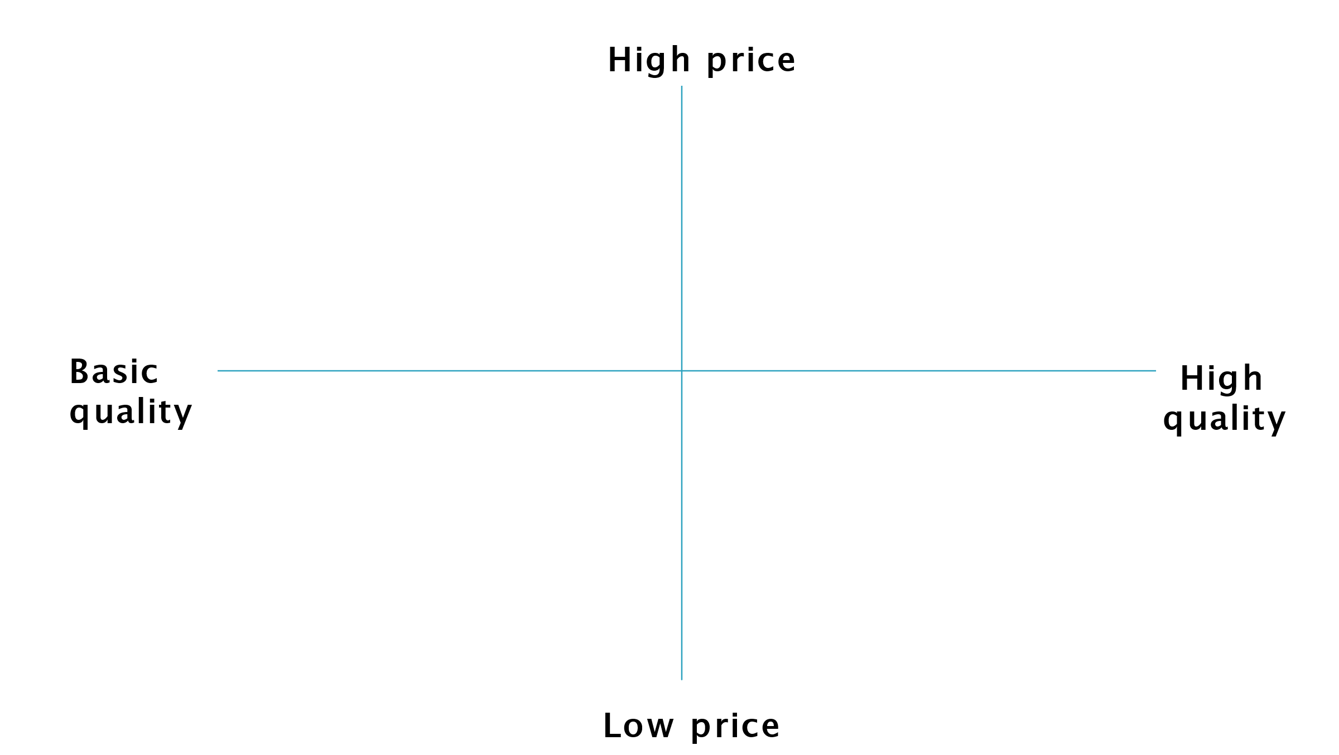

Waitrose, ASDA, LIDL, M&S Simple Food, Aldi, Tesco, The Coop, Farm Foods
What have you remembered so far?

Question | True | False
Segmentation allows a business to target specific customers
Income can be used to segment a market
Market mapping helps a customer to find the location of a business

Exam Questions

- Multiple choice

Which one of the following can be used to segment a market?

Select one answer

A Unique selling point
B Gender
C Branding
D Customer needs

- Outline one benefit to Sally from aiming her business at a specific market segment. (2 marks)

- Explain one way market mapping can be used to identify a gap in the market. (3 marks)

- In order to target more customers Sally is considering two options:

Option 1: People earning high incomes in the local area

Option 2: Group classes just for female customers

Justify which one of these two options Sally should choose. (9 marks)

