GCSE Business
Theme 1.2.2 – Market research
Booster Booklet
Specification

Subject content | What students need to learn:
- Market research  The purpose of market research:  - To identify and understand customer needs  - To identify gaps in the market  - To reduce risk  - To inform business decisions.  Methods of market research:  - Primary research: survey, questionnaire, focus group, observation  - Secondary research: internet, market reports, government reports  The use of data in market research:  - Qualitative and quantitative data  - The role of social media in collecting market research data  - The importance of the reliability of market research data | Once an entrepreneur has identified a business opportunity, they will have to carry out research to help them decide if the idea is likely to be successful. This topic explores the use of market research to help make this decision.  Students need to understand the purpose of market research and how it can be used to understand customer needs (covered in 1.2.1), and to help identify a gap in the market. This will help reduce risk for an entrepreneur and help them to make important business decisions.  Students also need to learn the different methods of market research that can be used. This includes both primary and secondary research methods.  The methods used will help the business to collect data. Students need to understand this data can be both qualitative and quantitative. They also need to understand the growing importance of social media to collect market research data, and the different methods can mean that the reliability of market research data can vary.

Key terms in this topic:

- Market research – the process of gathering information about the market and customer needs to help inform business decisions.
- Primary research - any type of research that you collect yourself. The data has not been collected before. It is also known as field research. Examples include surveys, questionnaires, focus groups and observation.
- Secondary research - is also known as desk research. The data has already been collected and published. This includes gathering research from places such as the internet, market reports and the government.
- Qualitative data – this is non-numeric data that and aims to find out people’s opinions and what they think.
- Quantitative data – numerical data that can be analysed mathematically using statistics.

Key terms – examples
In the space below, write examples to illustrate the key terms

Key term | Examples
Market research
Primary research
Secondary research
Qualitative data
Quantitative data

Summary of the topic

Entrepreneurs use market research to identify what customers want. This research
has many uses; for example, research helps an entrepreneur to identify gaps in the
market and business opportunities, and therefore to reduce the risk associated with
a business idea. Research data should be used on an ongoing basis to inform
decisions.

Primary research involves obtaining data first hand to match the specific needs of
the business. Examples include surveys, questionnaires, focus groups and
observations. Social media can be a valuable means for a business of collecting
market research data; for example, through feedback from Facebook and Twitter
accounts. Examples of social media data could be considered to understand how the information might be useful to a business.

Secondary research includes data from other sources, such as internet reports,
market reports from businesses such as MINTEL and government reports.
Quantitative data is numerical and can be analysed statistically. Qualitative data
comes from interviews and depth studies, where the information is more specific
and cannot easily be converted to numerical data. For example, an entrepreneur
may discuss with customers plans for new products. The feedback can inform these
plans, but could not readily be tabulated. Effective market research will usually link
the quantitative and qualitative findings to help build a picture of likely customer
preferences and behaviour, enabling the business to identify and anticipate
customer needs and wants.

The advantages and disadvantages of both primary and secondary research should
be explored. Consideration should be given to cost and accuracy to determine
which is the more appropriate based on the size of the business. Small businesses
are unlikely to be able afford extensive market research exercises.

Students could explore sample size and representation as well as bias as means of
considering the reliability of data but are not expected to look at sampling
techniques.

Synoptic links to this topic

This topic links with the following areas of the specification:

- 1.2.1 Customer needs
- 1.2.3 Market segmentation
- 1.4.3 The marketing mix

Market research is vital in helping to understand customer needs. It will also help a business to make informed decisions. This could include which customers in a market are most likely to buy the product or service. The research will inform a business if there is a gap in the market where customer needs are not being met.

Once the business has identified customer needs using market research, it can then make decisions linked to the marketing mix. These decisions have a better chance of success if they are based on accurate research.

Case study: Pod Point

Erik Fairbairn started POD Point in 2009. Based in the UK, the business builds and supplies charging systems for electric cars. Erik felt that the demand for such cars was going to grow and saw a business opportunity. POD Point is a way of charging an electric car at home.
Sales were promising and primary market research indicated that more customers wanted an easier way to charge their cars at home. The business decided to expand. In 2014 POD Point raised £1.5 million through the crowd funding site Seedrs. In 2017 it raised a further £1.5 million using CrowdCube website.

By 2017 the business had over 25,000 customers, many of whom are in other countries. For example, 20% of revenue comes from exports to Norway. Each new customer is asked to follow POD Point on Twitter so the business can continue to gather their opinions on new ideas.

The business uses market research data that suggests that the demand for electric cars will continue to rise. Figures 3 and 4 show examples of market research in the car industry.

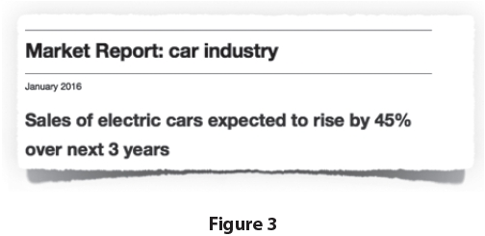

(Source: adapted from http://startups.co.uk/the-entrepreneur-erik-fairbairn-pod-point/)

Figure 4 shows the market share of models of electric cars in selected European countries in 2016.

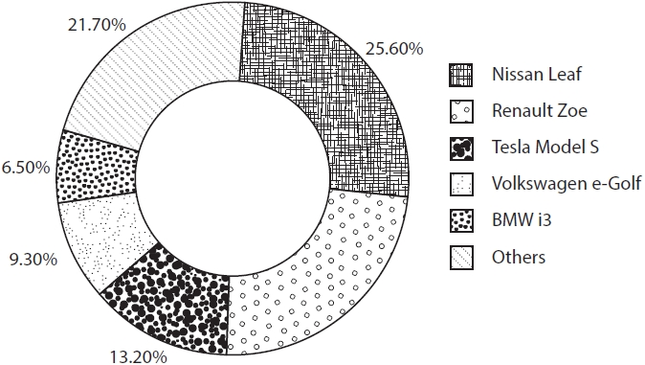

(Source: adapted from https://cleantechnica.com/2016/05/30/topelectric-cars-uk-norway-netherlands-germany-france/)
Figure 4

How this case study illustrates/exemplifies the specification content:
The case study illustrates ‘market research’ in a number of ways:

- Primary market research was used to identify that customers needed an easier way to charge their cars at home.
- New customers are asked to follow Pod Point on Twitter to help gather data from them using social media.
- Secondary market research was used to indicate that the market for electric cars was going to continue to grow.

Check your knowledge:

- List four reasons why a business would collect market research.
- How would a business collect market research using a focus group?
- What is the difference between primary and secondary market research?
- What is the difference between qualitative and quantitative data?

Check your knowledge: recall question (previous unit)

- List four customer needs.
- What would happen if a business failed to identify the needs of its customers?

Activity – now try this!

Use the statements to complete the table comparing the advantages and disadvantages of primary and secondary market research

 | Primary research | Secondary research
Advantage
Advantage
Disadvantage
Disadvantage

Statements

- The information will be up-to-date and relevant.
- It is convenient as it can be collected from home.
- You can help explain the question to avoid confusion.
- It can be time consuming to collect.
- It is relatively cheap to gather the data.
- Information could be old and out of date.
- People are often reluctant to take part in the research.
- Information may not be specific to business needs.

What have you remembered so far?

Question | True | False
Market research increases the risks of starting a business
‘Observation’ is a method of collecting primary research
All data collected using social media is reliable

Exam Questions

- Multiple choice

Which one of the following is a secondary market research method?

Select one answer

A Focus group
B Market report
C Questionnaire
D Survey
- Outline one disadvantage to Pod Point of using qualitative data for market research. (2 marks)

- Explain one benefit to a small business of carrying out market research. (3 marks)

- Discuss the importance to a small business of collecting reliable market research. (6 marks)

- Analyse the impact on Pod Point of using social media to collect market research. (6 marks)

