GCSE Business
Theme 1.2.1 – Customer needs
Booster Booklet
Specification

Subject content | What students need to learn:
- Customer needs  Identifying and understanding customer needs:  - what customer needs are: price, quality, choice, convenience  - the importance of identifying and understanding customers: generating sales, business survival | This is the first subject covered in Topic 1.2 – Spotting a business opportunity. This topic explores how small businesses can identify business opportunities using enterprise and entrepreneurship, which were covered in Topic 1.1. Students need to understand that identifying and understanding customer needs are an important part in spotting a business opportunity. Customer needs change constantly, and an entrepreneur must be able to understand what customers want if they want to come up with a successful business idea.  Students also need to learn the importance to a business of identifying and understanding its customers. This is vital in ensuring the business generates sales and therefore survives.

Key terms in this topic:

- Choice – an act of choosing between two or more possibilities
- Customer needs - things that customers require when purchasing a product or service.
- Convenience- a product or service’s ability to fit in with a customer’s lifestyle or routine. How easy something is to use or how easy it is to access a location.
- Consumer – someone who buys and uses goods and services.

Key terms – examples
In the space below, write examples to illustrate the key terms:

Key term | Examples
Choice
Customer needs
Convenience
Consumer
Summary of the topic
Customer needs are varied and change over time. Businesses need to respond to
this changing nature of need. Customer needs are price, quality, choice and
convenience.

Customers typically want a combination of price and quality that meets their needs.
This does not necessarily mean that customers always want the cheapest price –
the aim is to obtain the highest level of quality for an acceptable price. For
example, customers at low-cost food retailers do not buy the products in the
knowledge that the food is of low quality, but rather that it is of an acceptable
quality for the price they pay. A visitor to an expensive restaurant may pay a lot
more than a meal in a neighbouring restaurant but if the high price delivers the
quality required, then this is an example of their needs having been met.

Choice is something increasingly demanded by customers and businesses need to
respond to this consumer preference. Students could consider the product range of
a typical coffee shop, with a wide choice of drinks and snacks to meet different
needs.

Identifying and understanding customer needs is closely linked to business success.
Where a business is successful in providing goods and services that customers
want, it is more likely to generate sales.

Synoptic links to this topic

This topic links with the following areas of the specification:

- 1.1.3 The role of business enterprise
- 1.2.2 Market research
- 1.4.3 The marketing mix
- 1.5.1 Business stakeholders

All small businesses stem from business ideas by entrepreneurs, and when learning about customer needs you will understand that business ideas will only be successful if they provide something that customers want. Therefore, a business should carry out market research to help identify customers needs and then go on to make decisions linked to the marketing mix to help satisfy those needs e.g. a suitable price. Customers are a business stakeholder so their interests must always be considered when making business decisions.

Case study: Zoella Beauty

Zoe Sugg, known to her fans as Zoella, is an entrepreneur and a star of YouTube. She has enjoyed success with her fashion and lifestyle vlog (video log) and has become a celebrity as well as an entrepreneur. After starting her lifestyle blog, ‘Zoella’, in 2009, she soon had thousands of followers. Zoe extended the blog to a YouTube channel and by 2015 had 7.5 million subscribers.

In September 2014 Zoe launched her own brand bath and beauty range, called Zoella Beauty. The brand logo is shown in Figure 2. Zoella Beauty products are stocked by major retailers, including Superdrug and Boots. The business also uses e-commerce to sell its product range.

In 2014 Zoella Beauty earned revenue of £400 000. However, the competitive environment for beauty products aimed at younger females is becoming more crowded. Rivals include retailers such as Lush.
Source: Pearson Edexcel Additional Assessment Materials Summer 2021

How this case study illustrates/exemplifies the specification content:
The case study illustrates ‘customer needs’ in a number of ways:

- Zoella Beauty has a range of different bath and beauty products to offer customers a choice.
- The products are stocked by Superdrug and Boots, as well as being available online. This makes it more convenient for customers to buy the products.
- Zoella Beauty earned revenue of £40 000 in 2014, showing the importance of understanding customer needs to generate sales.

Check your knowledge:

- State four customer needs.
- Give two examples of businesses that provide convenience to customers.
- Why would understanding customer needs be important for business survival?

Check your knowledge: recall question (previous unit)

- What is the difference between a good and a service?
- Identify three ways a business could add value.
- Give an example of a risk that an entrepreneur takes when starting a business enterprise.

Activity – now try this!

Match the words with the correct definitions of customer needs:

PRICE
Making customers life easier, solving a problem or being in an easy to reach location.

QUALITY
Offering a variety of goods and services to select from.

The amount that is paid for a product or service.

CHOICE

Ensuring the product or service meets the expected standard
CONVENIENCE

Command Word corner ‘Calculate’

The booklet at the start of each topic will focus on a command word that is used in the exam. This will provide students with information on how the word is used in the exam and what you can expect. It will offer you advice on how to structure your answer and what examiners are looking for when marking these questions.

The command word for Topic 1.2 is ‘Calculate’.

‘Calculate’ questions:
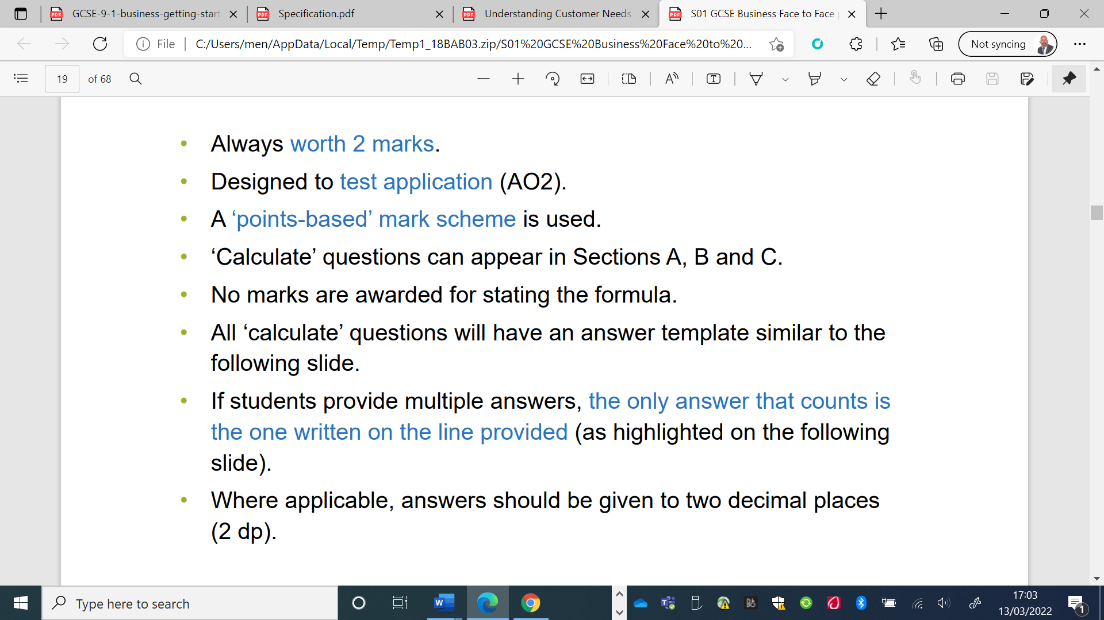

What have you remembered so far?

Question | True | False
‘Promotion’ is a customer need
Customers prefer to have a range of products to choose from
Generating sales will help a business to survive

Exam Questions

- Multiple choice

Which one of the following is a customer need?

Select one answer

A Place
B Price
C Product
D Promotion

- Outline one way that Zoella Beauty meets customer needs. (2 marks)

- Explain one reason why it is important for a business to understand customer needs. (3 marks)

- Discuss the impact on a business if it failed to identify its customers needs (6 marks)

- Analyse the impact on Zoella Beauty of selling its products in more than one major retailer (6 marks)

