GCSE Business
Theme 1.1.3 – The role of business enterprise

Booster Booklet
Specification

Subject content | What students need to learn:
- The role of business enterprise  The role of business enterprise and the purpose of business activity:  - to produce goods or services  - to meet customer needs  - to add value: convenience, branding, quality, design, unique selling point  The role of entrepreneurship:  - an entrepreneur: organises resources, makes business decisions, takes risks. | This booklet builds on the previous two topics. Students will learn that businesses produce goods and services to meet the needs of consumers. To succeed, businesses need to provide goods and services that consumers want. Businesses aim to add value to their products. Added value is the difference between the cost of inputs such as raw materials and the price that customers are willing to pay.  Another key focus of this topic is entrepreneurship. Entrepreneurs organise resources – people, equipment and buildings – to produce goods and services. They make decisions about these resources and ultimately take risks. Any decision taken by an entrepreneur involves some risk. For example, deciding to employ one more worker adds to costs, which may reduce profitability.

Key terms in this topic:

- Added value – the difference between the selling price of a product and what it cost to produce.
- Entrepreneur - someone who creates a business, taking on financial risks with the aim of making a profit from the business.
- Goods – entrepreneurial activity. Can also refer to a business or company.
- Services – non-physical items, such as hairdressing.
- Unique selling point (USP) – something that makes a product stand out from its competitors.
Key terms – examples
In the space below, write examples to illustrate the key terms:

Key term | Examples
Added value
Enterprise
Entrepreneur
Unique Selling Point

Summary of the topic
Businesses produce goods and services to meet the needs of consumers. Goods are physical products, such as bicycles, computers and pens. Services are non-physical items and include things such as hairdressing, bus/train journeys and music streaming services.

To succeed, businesses need to provide goods and services that consumers want – this is at the heart of the role of business and enterprise in an advanced economy like the UK. By identifying and supplying what consumers want, businesses are more likely to succeed. Consumers benefit from this dynamic process. Students could consider local examples of the role of small businesses in meeting consumers’ needs; for example, through shops and businesses in local high streets.

Businesses aim to add value to their products. Added value is the difference between the cost of inputs such as raw materials and the price that customers are willing to pay. Methods to add value are: convenience, branding, quality, design and unique selling points (USPs). When studying this unit, try to find real examples to illustrate this concept. For example, the price of loose vegetables in a supermarket could be explored and compared with the price of the same vegetables which are either peeled or chopped in advance. In this case, the higher price is possible due to the convenience that this affords consumers. Another example can be found in a local music shop which sells vinyl records and allows customers to listen to these before they buy. This USP gives the business the chance to add value and charge a higher price than rival music stores.

Entrepreneurship is the pattern of behaviour of entrepreneurs. Entrepreneurs organise resources – people (workers), equipment and buildings – to produce goods and services. They make decisions about these resources and ultimately take risks. Any decision taken by an entrepreneur involves some risk; for example, deciding to employ one more worker adds to costs, which may reduce profitability.

Synoptic links to this topic

This topic links with the following areas of the specification:

- 1.1.1 The dynamic nature of business
- 1.1.2 Risk and reward
- 1.1.3 The role of business enterprise
- 1.2.1 Customer needs

This topic has direct links with many areas of the specification and is a foundation for the whole course. All small businesses emerge from business ideas by entrepreneurs, and the entrepreneurship they demonstrate. When investigating the topics in Theme 1 you will explore the issues and skills involved in starting and running a small business.
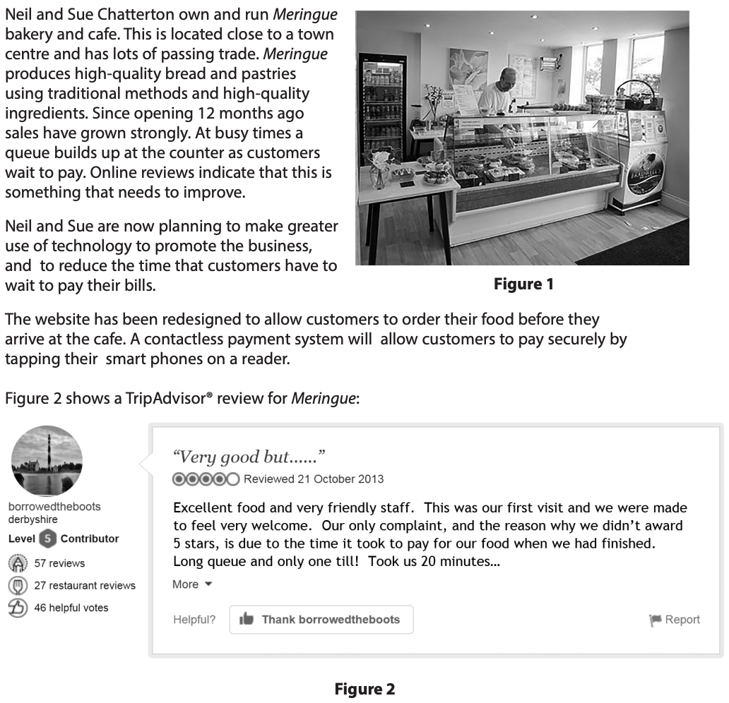
Case study: Meringue bakery and cafe
Source: Sample Assessment Material – Paper 1 (Section B)
How this case study illustrates/exemplifies the specification content:
The case study illustrates ‘the role of business enterprise’ in a number of ways:

- The business produces a product – cakes, bread and pastries.
- The owners – Neil and Sue – are entrepreneurs. The own and run Meringue Bakery.
- Neil and Sue demonstrate entrepreneurship – they make decisions and take risks. For example, they have spent money on a new website and a new contactless payment system.
- Meringue adds value to its products by an emphasis on quality.

Check your knowledge:

- Give one way – other than quality – that Meringue adds value to its product.
- Why is the launch of a new website a risk for a business like?
- What are the risks that an entrepreneur might face when starting a new business?

Check your knowledge: recall question (previous unit):

- What are two rewards for entrepreneurs from running their own business?
- What is the formula for calculating profit?
- Give two reasons why a small business might fail.

Command Word corner: ‘Outline’
This section will provide you with information on how a specific command word is used in the exam, and what you can expect. It will offer you advice on how to structure your answer and what examiners are looking for when marking questions with this command word.
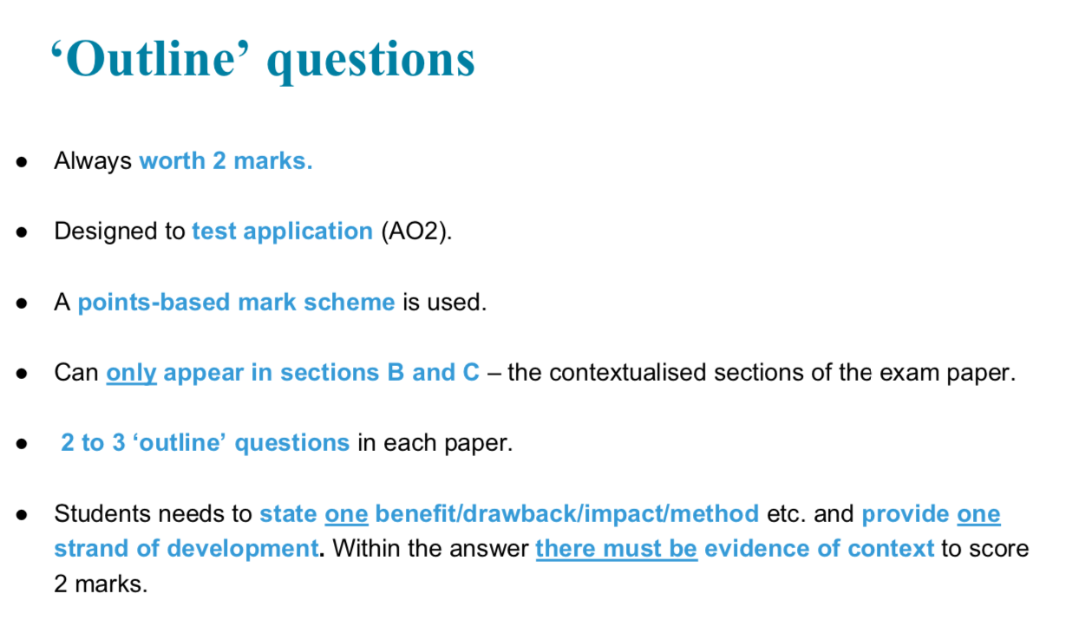

E.g. Outline one risk that Neil and Sue take as owners of Meringue bakery (2 marks)

………………………………………………………………………………………………………………………………………….
………………………………………………………………………………………………………………………………………….
………………………………………………………………………………………………………………………………………….

Common misconceptions

- The role of business enterprise: to produce goods and services - It is a common misconception for students to mix up goods and services. Goods are physical products, such as mobile phones, cars and clothing. Services are non-physical items, such as hairdressing or a bus journey.

- The role of entrepreneurship – It is a common misconception for students to confuse the idea of ‘organising resources’ as a role of an entrepreneur. These resources can include people. Small business employ people – this is a resource that businesses use. If people – workers – are not organised effectively, the business is likely to be less successful.
What have you remembered so far?

Question | True | False
Added value can be achieved by business creating a USP for its product
An entrepreneur is someone who works for a large business

Entrepreneurship involves making decision and taking risks in a business context.
A train journey is an example of a ‘good’

Exam Questions

- Multiple choice

Which one of the following describes the role of an entrepreneur? (1 mark)

Select one answer

A A willingness to take risks
B Being able to work alone
C Being employed by a large organisation
D Having sufficient money to start a business

- Explain one way that a business can add value. (3 marks)

- State one service that Meringue Bakery provides for its customers. (1 mark)

- Outline one way that Meringue Bakery meets customer needs. (2 marks)

- Analyse the impact on Meringue Bakery of introducing a new contactless payment system. (6 marks)

