GCSE Business
Theme 1.1.1 – The dynamic nature of business
Booster Booklet
Specification

Subject content | What students need to learn:
- The dynamic nature of business  Why new business ideas come about:  • Changes in technology  • Changes in what consumers want  • Products and services becoming obsolete  How new business ideas come about:  • Original ideas  • Adapting existing products/services/ideas | This is the starting topic of the GCSE Business course. It provides an opportunity for students to consider what is a business and where do ideas for businesses come from. Students need to understand that business ideas often come from change. Consumers needs change constantly and businesses need to respond to this. The ability of businesses to produce products and services also can also change due to new technology and better ideas replacing existing products and services.  Students also need to learn that business ideas stem from two main sources. A business idea could be original, and never have been thought of before. Alternatively, many business ideas are based on existing products and services, with entrepreneurs finding ways to adapt and improve them.

Key terms in this topic:

- Enterprise – entrepreneurial activity. Can also refer to a business or company.
- Entrepreneur – someone who creates a business, taking on financial risks with the aim of making a profit from the business
- Consumer – someone who buys and uses goods and services.
- Obsolete – out of date or not used anymore

Key terms – examples
In the space below, write examples to illustrate the key terms

Key term | Examples
Enterprise
Entrepreneur
Consumer
Obsolete
Summary of the topic
Businesses are dynamic. This means they respond to what consumers want. Some business ideas are formed by entrepreneurs spotting possible gaps in the market. Others are formed by entrepreneurs believing they can offer better than what already exists in the market. Students should be able to give examples of why new business ideas come about due to:

- Changes in technology

- Changes in what consumers want

- Products/services becoming obsolete.

The rise of web technologies and the use of smart phones create opportunities for new business ideas. There are many examples of new businesses that use web-based technologies, such as web development, photo editing and printing, and specialist retail businesses. Consumer taste changes impact on the popularity of goods and services. Think of local examples where new businesses have opened up and how these might reflect changing consumer preferences. For example, high streets now tend to have lots of coffee shops and cafés, consider whether this is a consumer trend. As people increasingly become interested in keeping fit and healthy, so opportunities for individuals to become personal trainers increase. As products become obsolete these give rise to new business ideas. For example, many petrol station forecourt car washes have closed and have been replaced by car washing enterprises. New business ideas can come from original ideas or from adapting existing products/services/ideas. Try to find examples of both to compare.

Synoptic links to this topic
This topic links with the following areas of the specification:

- 1.1.2 Risk and reward
- 1.1.3 The role of business enterprise
- 1.2.1 Customer needs

This topic has direct links with all areas of the specification and is a foundation for the course. The title for theme 1 of the GCSE Business course is called Investigating small business. All small businesses stem from business ideas by entrepreneurs, and when investigating the topics in theme 1 you will explore the issues and skills involved in starting and running a small business. Coming up with a good idea for a business is the starting point for any entrepreneur to be successful when running a small business.

Case study: Swoon Editions: The Story
In 2012 Debbie Williamson quit her job in digital product development to start her own business, an online furniture manufacturer called Swoon Editions. The aim of the business was to enable its customers to buy hand-made furniture at cheaper prices than the mainstream market, along with the convenience of using an online process.

The business idea came about by Debbie and her friends recognising that, when renovating their homes, the cost of buying new furniture was too expensive. ‘Every idea starts with a problem’, states Debbie. She went on to create a business to solve this problem.

The ‘Eureka moment’ for Swoon came when she was on holiday in India. She met the furniture manufacturers behind one of the upmarket UK high street interiors brands, and realised the extent of the profits they were making on each item.

The brand name has become established in the market. Swoon Editions has gained over £5 million in venture capital investment over the past three years. The business has seen a 300% growth in sales and employs 60 staff across London. Debbie was awarded the prestigious title of Women in Business at the Startups Awards 2015.

Source: www.swooneditions.com/about/our-story

How this case study illustrates/exemplifies the specification content:
The case study illustrates the ‘the dynamic nature of business’ in a number of ways:

- Customers wanted something different than already existed. They wanted hand-made furniture but at cheaper prices.
- Technology has changed allowing the convenience of buying the furniture online.
- Debbie’s new business idea came from how she thought she could adapt an existing service. She created the business to solve a problem of the high price of furniture when people were renovating their homes.

Check your knowledge:

- State three reasons why new business ideas come about.
- Identify one business idea that has come from an original idea.
- Why would a business adapt an existing product or service to come up with a new business idea?

Command Word corner
This section will provide you with information on how a specific command word is used in the exam, and what you can expect. It will offer you advice on how to structure your answer and what examiners are looking for when marking questions with this command word.

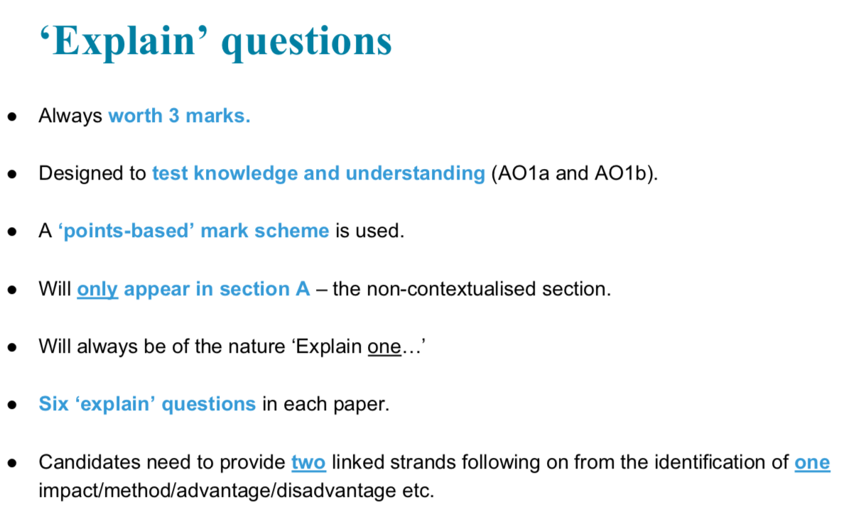
Common misconceptions

- Why new business ideas come about? - It is a common misconception that an entrepreneur has to have lots of experience in coming up with new ideas. Many ideas come from satisfying what customers want and are usually not complex. Business is dynamic and changing all of the time, so new opportunities for business ideas will always happen.

- How new business ideas come about? – It is a common misconception that all new business ideas are original and involving an entrepreneur coming with an idea for a brand-new product. In reality, most business ideas come from thinking of how to improve or change existing products and services. Also, many business ideas do not change anything. They simply take an existing idea and offer it new customers.

What have you remembered so far?

Question | True | False
Changes in technology does not influence new business ideas
Obsolete means that something is now out of date
All new business ideas replace existing products and services
Exam Questions

- Multiple choice

Which one of the following is a reason why new business ideas come about?

Select one answer

A Identify a market segment
B Increase business costs
C Products and services becoming obsolete
D To increase the qualifications of the owner

- Outline one impact of new technology on the idea to start Swoon Editions. (2 marks)

- Explain one advantage of adapting existing products when coming up with a new business idea. (3 marks)

- Discuss the impact of new technology on the reasons for new business ideas (6 marks)

- Analyse the impact on Debbie starting Swoon Editions of changes in what customers want (6 marks)

