GCSE CITIZENSHIP
Students follow the AQA GCSE Citizenship Studies course in Year 9 and Year 10 in which they will gain a deeper knowledge of democracy, government and law, and develop skills to create sustained and reasoned arguments, present various viewpoints and plan practical citizenship actions to benefit society.
They also gain the ability to recognise bias, critically evaluate argument, weigh evidence and look for alternative interpretations and sources of evidence, all of which are essential skills valued by higher education and employers.
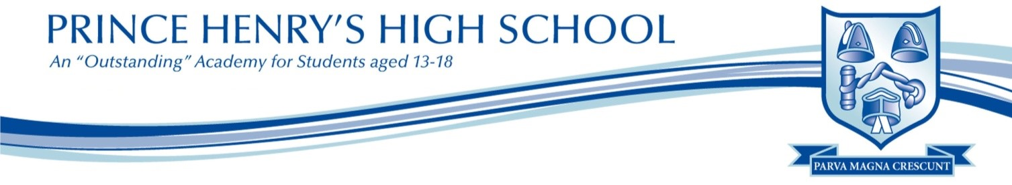
During Year 9 and 10, students have two lessons of Citizenship per cycle in which they cover the following units:
- Life in Modern Britain
- Politics & Participation
- Rights and responsibilities
- Active Citizenship

Students sit two external examinations at the end of Year 10 in order to achieve the full GCSE.

