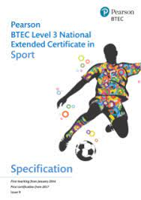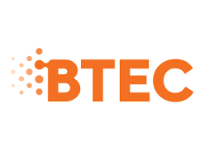
Induction Material 2022

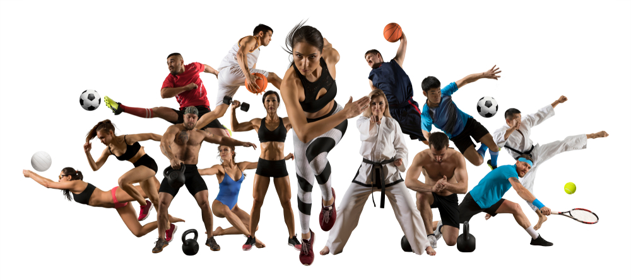

Overview
This stimulating and challenging vocational course is for students who intend to study for a degree in Sport or pursue a career in the Sports Industry. It covers a wide variety of topics including both the theory and practical aspects of sport. This is a two year course, equivalent to one A Level.
Studying BTEC Sport at PHHS could lead to:
● A degree in Sports Studies, Sport and Exercise Science, Sports Management, Sports Injury or Rehabilitation.
● A career as a PE teacher or Sports Coach.
● A career working within the Fitness Training Industry, Leisure Centres, Sports Development and Coaching are also popular, as are careers in Sports Therapy.
● Apprenticeships within the sports industry for example within Fitness Training or Sports Marketing.
Even if students don’t intend to pursue a career in sport, the course develops:
● Transferable skills such as team work, leadership experience, and confidence and communication skills that will help students excel in all manner of careers
● A life-long passion for sport and a healthy lifestyle that will complement any future career choices

Course Outline
The following table gives you a basic overview of how the two-year course (Extended Certificate) looks.
Content Overview | Assessment Overview
- Anatomy and Physiology  (Musculoskeletal system, respiratory system, cardiovascular system & energy systems).  Unit 1 | 80 marks  90 minute written exam paper.
- Practical Sports Performance  (Rules/laws, skills, techniques & tactics needed for individual and team sports. Self-analysis).  Unit 7 | Written assignments and practical performance.
- Fitness Training and Programming for Health, Sport & Well-being.  (Lifestyle factors, Health monitoring tests, Nutritional needs, Training programmes, Components of Fitness).  Unit 2 | 60 marks.  150 minute written paper based on a pre-released case study.
- Professional Development in the sports industry.  (Career & job opportunities in the sports industry, skills audit to inform a career development plan and recruitment activities).  Unit 3 | Written assignments
There will be two units delivered per year. With units one and seven in Year 12 and Units two and three in Year 13.
In each Year, you will have nine lessons over a two-week timetable. In Year 12, six of the lessons will cover the content in Unit one, with the other three used on unit seven. While in Year 13, six lessons will be used for unit two and three for unit three. With different units being delivered simultaneously having good organisation is essential!

Skills needed
- An interest/passion for Sport! If you are the sort of person who keeps up to date with the world of sport and loves participating and talking sport then this is the course for you! This course is designed for individuals with a genuine interest in sport and good sporting general knowledge, as much of the course will involve linking the theory learnt to sporting examples.

- Good level of fitness. You must be currently playing, at least, one sport and ideally you will be doing an individual and a team sport. Students will not be directly assessed on their sporting ability. However, there are practical elements of the course that require students to be motivated, enthusiastic and willing to take part.

- An interest in new concepts and an enjoyment of classroom work. Some of the work will build on topics introduced at GCSE, but in the main, you will looking at new content throughout the course.

- Organisational skills. With different units being delivered, it is essential that you bring the correct work/equipment on the right day.

- Good time management and the ability to work independently. You must be able to balance your schoolwork and sporting activities alongside any other commitments, such as part-time work etc. Successful students will be highly motivated and able to consistently meet coursework deadlines.

- Lessons will be mostly classroom based therefore concentration is key!
Assessment

Unit 1 - Will be assessed with a written exam, which is taken in May/June 2023 (Year 12).

Unit 2 - Will be assessed through a set assignment by the exam board and will be externally assessed. (Year 13).

Unit 3 – Will be internally assessed through written assignments and then subject to exam board sampling of your teachers grading. (Year 13).

Unit 7 – Will be internally assessed through written assignments and then subject to exam board sampling of your teachers grading. (Year 12).

Should you finish the course at the end of Year 12, by completing Units 1 and 7, you will have completed the Pearson BTEC Level 3 National in Sport Certificate.
Should you complete all four units across the two years, then you will have completed the Pearson BTEC Level 3 National in Sport Extended Certificate.

How can I get ahead in BTEC Sport?

The following pages give you some activities that you can have a go at for each of the different areas of the course. These are non-essential tasks, but by giving them a go, you will be helping to develop many of the skills and some of the knowledge that will make the new course easier for you. Good luck!

Course Specification
Please use the address below to have an in-depth look at the course specification. By doing this you will get to see all of the different areas we cover.

https://qualifications.pearson.com/content/dam/pdf/BTEC-Nationals/Sport/20161/specification-and-sample-assessments/btec-l3-national-cert-in-sport-spec.pdf
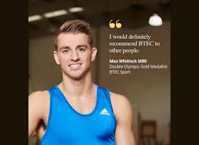

Unit 1 – Anatomy & Physiology
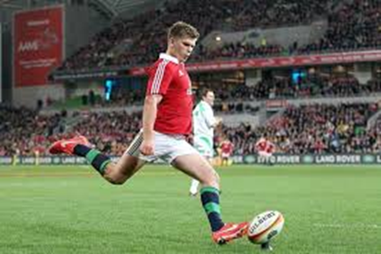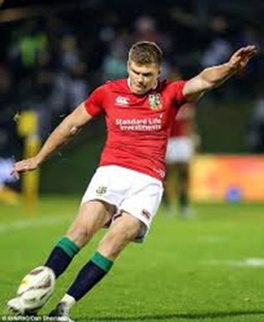

Looking at the two pictures of Owen Farrell, can you identify what types of movements are taking place at the knee and shoulder? If so, which muscles are the prime movers and the antagonists? Can you name the different bones that are used in this action? What type of joints are found at the knee and shoulder?
Find pictures from your own chosen sport and analyse the movements as per above.

Unit 2 – Fitness Training and Programming for Health, Sport and Well-Being
Think about your own lifestyle and what pressures may affect your ability to train or compete. Consider five factors that may limit the amount of time you have for sporting activities. How could you begin to overcome these pressures?
As well as being physically fit, it is important to follow a balanced diet.
What do you understand by a balanced diet & the benefits of a healthy diet?
Undertake a food diary for a week and analyse how balanced your diet is.
https://www.cdc.gov/healthyweight/pdf/food_diary_cdc.pdf
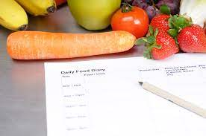
Unit 3- Professional Development in the Sports Industry
What is the social history of your sport?
Choose a sport that you enjoy or that interests you, and research the history and development of that sport in the UK.
Try and find reasons for the way that the sport developed: for example, did it begin in public schools, is it played in rural or urban areas or is it derived from another sport (e.g beach volleyball from traditional volleyball)?

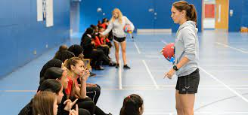

Unit 7- Practical Sports Performance

At this stage, the best thing that you can do is to develop the depth of your knowledge for an activity of your choice. Therefore, you need to read, watch, talk, play and train for your sport whenever possible!
Identify the website and location of your sport’s National Governing Body (NGB). What are the major rules and issues in your sport?
