A Level
Philosophy, Ethics & Christian Theology
Transition Work
– Year 11 to 12
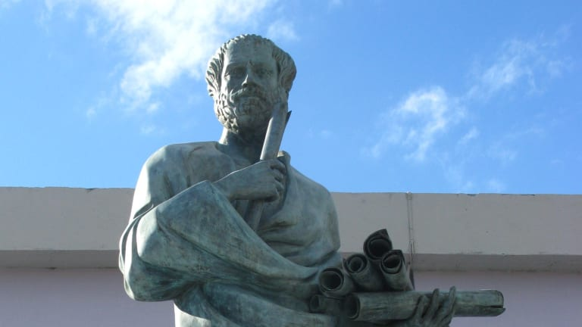
Be a free thinker and don't accept everything you hear as truth. Be critical and evaluate what you believe in.
Socrates

Introduction
Welcome, year 11! This is your transition work for A level Philosophy, Ethics & Christian Theology, which you’ve chosen to take at A level this September or are thinking about it. The pack is designed to give you a flavour of what the A Level is all about.
- It sets out the content of the course.
- The skills that it will help you develop.
- Suggestions of reading, podcasts, films, clips, and more for you to explore to give you a flavour of what to expect and get your brain going!
Course Content
A Level Religious Studies is divided into three papers:
Philosophy of Religion
- Ancient Greek Philosophy
- Body + Mind
- Arguments for the existence of God
- Religious Experience
- The Problem of Evil
- Religious Language
- Attributes of God

Ethics
- Natural Law
- Utilitarianism
- Kantian Ethics
- Situation Ethics
- Euthanasia
- Business Ethics
- Conscience
- Sexual Ethics

Christian Theology
- Augustine on Human Nature
- Death + the Afterlife
- Knowledge of God
- The Person of Jesus Christ
- Christian Moral Principles + Actions
- Pluralism + Secularism
- Gender Theology
- Liberation Theology + Marxism

Each section will be examined by a two-hour exam at the end of the course – where you will need to complete three essays.
Skills you will develop
As well a body of knowledge that you will acquire as well as understanding it an essential part of this subject is evaluation and analysis.
Analysis involves looking at an idea and really ‘pulling’ it apart, thinking about the consequences of a particular view, it’s impact on other views, whether or not it is built on some assumption or faith position.
Evaluation requires you to scrutinise an idea and explore whether or not it is valid – looking at different points of view and critically weigh-up the relative merits of it. Evaluation requires you to come to some conclusions. Essentially, that is what the judges do when they taste the bakes in ‘Bake Off’ – they think about the appearance, taste, texture, rise, etc and reach a conclusion.
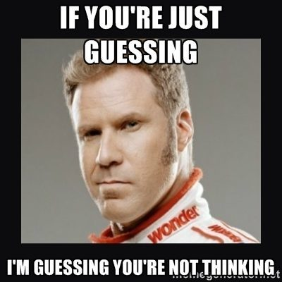
Learning to think for yourself and be critical is a fundamental skill that you will learn and a skill that you can take into all areas of study. The workplace need people who are not boxed in by what they think they know, they want people who look for unconscious bias, that listen to others and reserve judgement; that are flexible and creative thinkers – whether they work for a big company, the military or setting up a new business.

What can I do to get ‘A Level’ ready?
I have put together a selection of books (novels and subject specific), short stories, films, podcasts, video clips and thought-experiments for you to have a look at.
Choose a couple of things to look at every week just to keep your brain in gear. September will come round quickly!!
Books – non-fiction
The Pig who wants to be Eaten – Julian Baginni
The Blind Watchmaker – Richard Dawkins
Ethics in the Real World – Peter Singer
Philosophy for Dummies

Books – fiction
Cider House Rules – John Irvin
Knowledge of Angels – Jill Paton Walsh
The Colour Purple – Alice Walker
My Sister’s Keeper – Jodie Picoult
The Ones who walk away from Omelas – Ursula Le Guin

YouTube
Crash Course: what is philosophy?
What is Ethics? The Ethics Centre
The School of Life channel – loads of interesting stuff
Radio 4 ‘Beyond Belief’ – loads of great episodes

Films
Blade Runner (1982)
Saving Private Ryan
The Truman Show
Minority Report
Million Dollar Baby

Podcasts
- The Partially Examined Life
- Philosophy Bites
- Very Bad Wizards (combines psychology)
- The Philosophy Guy (looking at philosophy in films)
- Making Sense with Sam Harris
Choose one you like.
TED Talks
How reliable is your memory – Elizabeth Loftus
Why we make bad decisions – Dan Gilbert
Militant Atheism – Richard Dawkins
We should all be feminists – Chimamanda NgoziAdichie
Philosophy in Prison – Damon Horowitz
Are you there God? Playlist – 11 talks
The habits of happiness – Matthieu Ricard

Philo

Thought Experiments
These are experiments that you can do with your mind – thinking the ideas through and making decisions.
Write down your conclusions – or organise a discussion around the tea-table or on zoom with your friends to see what they think.
Number One - The Experience Machine
Nozick asks us to imagine a machine that could give us whatever desirable or pleasurable experiences we could want. "Superduper neuropsychologists" have figured out a way to stimulate a person's brain to induce pleasurable experiences that the subject could not distinguish from those she'd have apart from the machine. He then asks, if given the choice, would we prefer the machine to real life?
Nozick also believes that if pleasure were the only intrinsic value, people would have an overriding reason to be hooked up to an "experience machine," which would produce favourable sensations.
Reasons not to plug in
Nozick provides us with three reasons not to plug into the machine.
- We want to do certain things, and not just have the experience of doing them
"It is only because we first want to do the actions that we want the experiences of doing them." (Nozick, 43)
- We want to be a certain sort of person
"Someone floating in a tank is an indeterminate blob." (Nozick, 43)
- Plugging into an experience machine limits us to a man-made reality (it limits us to what we can make)
“There is no actual contact with any deeper reality, though the experience of it can be simulated." (Nozick, 43)
What do you think?

Number Two - The Trolley problem.
Foot's original formulation of the problem ran as follows: A trolley is running out of control down a track. In its path are five people who have been tied to the track by a mad philosopher. Fortunately, you could flip a switch, which will lead the trolley down a different track to safety. Unfortunately, there is a single person tied to that track. Should you flip the switch or do nothing? A utilitarian view asserts that it is obligatory to flip the switch. According to simple utilitarianism, flipping the switch would be not only permissible, but, morally speaking, the better option (the other option being no action at all).
An alternate viewpoint is that since moral wrongs are already in place in the situation, flipping the switch constitutes a participation in the moral wrong, making one partially responsible for the death when otherwise the mad philosopher would be the sole culprit. An opponent of action may also point to the incommensurability of human lives. Under some interpretations of moral obligation, simply being present in this situation and being able to influence its outcome constitutes an obligation to participate. If this were the case, then deciding to do nothing would be considered an immoral act if one values five lives more than one.
Related problems - the fat man Judith Jarvis Thomson offered the following variant:
As before, a trolley is hurtling down a track towards five people. You are on a bridge under which it will pass, and you can stop it by dropping a heavy weight in front of it. As it happens, there is a very fat man next to you - your only way to stop the trolley is to push him over the bridge and onto the track, killing him Number to save five. Should you proceed?
Resistance to this course of action seems strong; most people who approved of sacrificing one to save five in the first case do not approve in the second sort of case This has led to attempts to find a relevant moral distinction between the two cases.
One clear distinction is that in the first case, one does not intend harm towards anyone - harming the one is just a side effect of switching the trolley away from the five. However, in the second case, harming the one is an integral part of the plan to save the five. This is an argument Shelly Kagan considers, and ultimately rejects, in The Limits of Morality.
So, some claim that the difference between the two cases is that in the second, you intend someone's death to save the five, and this is wrong, whereas in the first, you have no such intention. This solution is essentially an application of the doctrine of double effect, which says that you may take action which has bad side effects, but deliberately intending harm (even for good causes) is wrong.
On the other hand, Thomson argues that an essential difference between the original trolley problem and this version with the fat man, is that in the first case, you merely deflect the harm, whereas in the second case, you have to do something to the fat man to save the five. Thomson says that in the first case, nobody has any more right than anyone else not to be run over, but in the second case, the fat man has a right not to be pushed in front of the trolley.
What do you think?
Finally, the Meaning of Life – when you finish reading them have a go at writing what YOU think the answer might be!
Someone had the idea of asking the inmates of the Big Brother House about the ‘meaning of life’ which sparked a series of articles in the press – have a look at these quotes:
1."To love each other, if the whole world was to love each other properly, we'd all be unlocked to go upstairs."
Pete Big Brother Housemate
2.“Why should there be a meaning? Isn't life just one of those slightly peculiar things that has happened, like the Giant's Causeway? What is the meaning of them? What would a meaning of life mean?”
Hugo Rifkind Journalist and philosopher
3.“There are two very different meanings to life. First there is what people find that makes their individual lives worth living; second to survive and reproduce and so preserve and propagate their genes.” Richard Dawkins Evolutionary Biologist
4.“To worship God and to dedicate yourselves to him through every good action that you do that shows devotion and obedience. We can compare this worldly life to a game. A game is temporary. When the referee blows the whistle, it comes to an end but we can prepare for life in the hereafter with God, a life that will never end.”
Ibrahim Mogra Iman
5.“One must be prepared to venture forth into new experiences even though you do not know what you will find. Throughout life you must grasp every opportunity. The purpose of life is to live it and to live it to the full — not just surviving or hoping, but overcoming life's challenges. And in living it you will find the divine, which is already in each of us. When we find the divine that already exists in us, we find meaning. One must have the courage to be oneself and find where that leads.”
Antony Sutch Benedictine monk
6.“I believe in making the most of every minute of life — though that is more about navigation than meaning. Navigating life is about getting through each day without having any regrets about how you spent it. Make sure you enjoy your days and find them as fulfilling as possible. Beyond that, to give your life meaning you need to find out what it is that makes you happy. Ideally, in an altruistic world, the things people find to make them happy will also make other people happy, and improve their lives in some ways. I think people increasingly see their happiness and the meaning in their lives, as bound up with the happiness of others.”
Brent Hoberman Founder of lastminute.com
8.Asking what is the meaning of life seems senseless to me. Words, numerals and other signs have meanings, because they have been designed to carry meanings. Life is not like that. It can have any meaning you choose to give it. If, for you, it is a brief interval of light in the endless darkness before and beyond it, or the gateway to eternity, or the vale of soul-making (as Keats said), or a period for cramming in as much sex, booze and football as possible, then, for you, that is its meaning. But it will be a meaning you have given it.”
John Carey, Author

